Journal of December 2017
Indian Academy of Obstetrics & Gynaecology Vol. 1, Issue 1
Editorial
Strategies to reduce MMR by advocating Dutta’s innovative techniques
Dilip Kumar Dutta
MD, PhD, FRCOG (Hon), FICOG, FIAMS, FICMCH, MAMS, DACOG (USA), DPS (Germany)
Chairman, Indian College of Obstetrics & Gynecology (2015)
Dean, India Academy of Obstetrics & Gynecology (IAOG) 2017
Vice Chairman, ISAR Bengal 2015-2017
National Editor of ‘Jogi Journal’ (2015-2017)
Director, GICE, Kalyani, Nadia, WB Author of 36 books (Obstetrics and Gynaecology)
Honorary Editor, Journal of the Indian Medical Association (JIMA)

It’s a known fact that 500 lakh pregnant mother die each year in the world, in developing countries the MMR is approximately 30/1 lakh live birth which spirals upwards to approx. 350-450 per 1 lakh maternal deaths in developing countries. Hence considering this above fact, it is the developing country which requires utmost attention to reduce maternal deaths which are preventable. India being a diverse country with rich being super rich and poor being extremely poor with minimal or no access to quality healthcare. Problems in india:
Cause of morbidity to pregnant mothers – Direct causes include eclampsia, anemia, sepsis, PPH, others include obstructed labour and other indirect causes.
Where is the lacking? – failure in health care, lack of transport facility, lack of manpower, and other socio-political commitments How to improve this scenario? – solving rural health problem by making outreach and awareness programmes to them, making skilled doctors available to rural population, provide them proper care during child birth and post partum care. Prevention, early detection and treatment of complication of pregnancy, provision of
_______________________________________
Received: 5 November 2017
Accepted: 10 November 2017
Published online: 1 December 2017
Citation: Dutta DK. Strategies to reduce MMR by advocating dutta’s innovative techniques. J Indian Acad Obstet Gynecol
2017; 1(1): 1-4
clean and safe vaginal delivery and prompt action and management of obstetrical emergencies. Following are the commonest problems faced in rural India and various methods have been adopted by authors for prevent-ing MMR.

Problem 1 (atonic uterus noted during caesarean section)
Uterine atony was found to be the most common cause of PPH. The ability to identify which women will experience atony is limited and with or without risks factors. Till date a lot of work have been done to prevent uterine atony and also develop evidence based medical and surgical interventions to save the uterus for fertility preservation in future. Paramount importance for every obstetrician is to prevent PPH due to uterine atony during emergency LSCS by early detection, assessment of the severity and search for specific causes. Life threatening PPH can be a nightmare to the obstetrician and requires an active multidisciplinary management to prevent maternal morbidity and mortality.
© Indian Academy of Obstetrics & Gynaecology 2017 1
dutta’s Scoring:1,2 Scoring method to be used during caesarean section was formulated keeping rural India in head. As it is known that to prevent uterine atony various methods are being used but in a haphazard manner, medical management if fails then B lynch sutures, step wise devascularisation, vertical sutures, tamponade or finally internal iliac artery ligation is done. But Dutta’s technique involves an easy observational method and scoring system which enables the surgeon to identify grave
Dilip Kumar Dutta
risk patients or uteruses which are atonic and treat in a systematic manner. So here the uterus is divided in various parameters like shape and size, rugosity, tone, placental localisation, and time of placental expulsion and scoring were given (Tables 1-3). Approximately 130 women were selected for Group A, 100 for Group B, and 70 for Group C. Early diagnosis and management of uterine atony during emergency/elective LSCS after adopting Dutta’s score were found to be not only reduce intra and post operative blood loss but also was found to maintain a satisfactory hemoglobin level and hemodynamic status. Maternal mortality was found to be nil. This randomised trial highlighted the importance of prompt treatment in Group C to reduce intra and post operative blood loss and maternal morbidity and mortality.
Problem 2 (Placenta previa-except increta and percreta detected during caesarean suddenly) Placenta previa, abruption placenta and uterine rupture are three important causes of ante partum hemorrhage seen frequently at ter-tiary care level hospital claiming high maternal mortality and morbidity. Till date present existing different surgical techniquesadopted during LSCS to deal with excessive bleeding after placental separation site from Major degree Placenta Previa have not been found to be effective method to control intra- operative hemorrhage. This has led to high incidence of maternal mortality and morbidity. Hence to prevent intra-operative hemorrhage during LSCS operation due to major degree placenta previa Author had advocated new surgical technique (Dutta’s)3,4 in a stepwise manner to reduce maternal mortality and morbidity.
existing technique includes following steps :
BABY DELIVERED  PLACENTA DELIVERED  OXYTOCIN /ERGOMETRINE GIVEN  IF BLEEDING NOT CONTROLLED THEN SURGICAL TECHINUES USED LIKE B/L UTERINE LIGATION/ B/L INTERNAL ILLIAC LIGATION / HYSTERECTOMY. dutta’s techinique :
BABY DELIVERED  BILATERAL UTERINE ARTERY LIGATION  INJ TRANEXAMIC ACID
Table 3 — Management Protocol
Table 1 — Criteria of scoring
Uterus | 0 | 1 | 2
Shape and size | Broad  and flat  (discoid) | Less elevated, narrow, hard  and globular shape | More elevated, narrow  Hard and globular shape Present in both surfaces
Rugosity | Absent | Present either in anterior  or posterior surface
Tone | Soft | Firm | Hard, contracted
Placental Localisation | Lower segment | Fundo anterior | Fundo posterior
Time of  Placental Expulsion | >5 min | 3-5 min | <3 min
Table 2 — Distribution of scoring in Groups
Groups | Pattern of Scoring | Total Score
Group A | Shape and size-2  Rugosity-2  Tone-2  Placental Localisation-1 to 2 Placental expulsion – 1 to 2 | 8 to 10
Group B | Shape and size-1  Rugosity-1  Tone-1  Placental Localisation-1 to 2 Placental expulsion – 1 to 2 | 5 to 7
Group C | Shape and size-0  Rugosity-1  Tone-0  Placental Localisation-1 to 2 Placental expulsion – 1 to 2 | <5
1000MG STAT  OXYTOCIN INFUSION 1520U STAT  PLACENTA PLUS MEMBRANES
DELIVERED AND CHECKED  IF TEAR /
LACERATION THEN SUTURE ACCORDINGLY  UTERINE WOUND CLOSED IF NO
BLEEDING.
 | Oxyt* | Methy erg** | Carboprost | Lateral compression on upper segment of uterine wall | Anterior posterior uterine wall compression | Isthmus compression | Misoprostol 800mcg per rectal
Group A (Score 8-10) | 10U | - | - | - | - | - | -
Group B (Score 5-7) | 15U | 0.25mg | - | - | Yes | - | -
Group C (Score <5) | 20U | 0.5mg | 250mcg | Yes | Yes | Yes | Yes
2 JIAOG | Vol. 1 | Issue 1 | December 2017
It was observed from a study (done in tertiary care hospital in rural india) that good effectiveness to control bleeding and intra operative blood loss less than 300 cc were seen in 89 (94.68%) cases respectively. Six (6.3%) cases required underlying interrupted suture for bleeding from placental bed. Subtotal cesarean hysterectomy was advocated in 3 (3.28%) cases due to fail-ure to control uterine atony. Immediate post operative bleeding less than 200 cc was found in 81 (86.16%) cases. Maternal mortality was found to be absent. Maternal morbidity was seen in 12 (12.76%) cases. Subsequent menstrual cycles were found to be normal in 80 (87.91%) cases and repeated pregnancy was ob-served in 26 (28.57%) cases indicating non effect on gonadal function. concluSion
Dutta’s new surgical technique during LSCS for major degree placenta previa was found to be simple, safe and quick procedure. It reduces perfusion pressure, permits time for further steps, thereby avoiding unnecessary ligation of bilateral internal iliac arteries and caesarean hysterectomy. Maternal mortality and morbidity were also found to be reduced. This technique is suitable for rural based hospital in absence of adequate blood transfusion facility.
Problem 3 (third stage complications during vaginal delivery at low resource settings) Low resource setting problems may arise due to nonavailablity of experienced doctor or lack of medications. Hence low resource setting can be a challenging place to manage emergencies. Hence proper utilization of existing staff and nurses so that they can be of help to prevent PPH or in a wider sense help in reaching our goals of reducing MMR.
So keeping above in head author had devised an easy protocol which can help in achieving the above goal to some extent. Three groups of patients were divided in a study done in low resource setting as mentioned below5 (Table 4).
Group A (N-100) : After delivery baby is put on mother’s abdo-men till placental expulsion.
Dutta’s technique
Group B (N-100) : After delivery baby is put on labour cot till placental expulsion with misoprostrol 600mg orally.
Group C (N-100) : Baby is separated before the expulsion of placenta (i.e. following cessation of cord pulsation) with 10U oxytocin IM within 1 min of placental expulsion.
So what are the advantages of above method ?
- Sustained uterine contraction and retraction (92%) probably due to Fetal weight on mother’s abdomen (acts as fundal pressure),
- Fetal movement (acts as massage to uterus), psychological change of mother after seeing the baby on her abdomen that leads to early (<5 min) and sustained uterine contraction and retraction,
- Early expulsion of placenta (98%), minimal (immediate) post partum blood loss (92%),
- Non requirement of drugs (misoprostol or oxytocin) and instrumentation,
- Avoidance of unnecessary clamping and pulling of cord when uterus is still not contracted,
- Normal temperature of the baby will be maintained due to contact with mother skin,
- Baby can be easily put on breast for early sucking, after placental separation, Postpartum transfer of blood to fetus is rapid, Technique is safe and do not interfere normal progress of vaginal delivery of placenta, Do not interfere with the psychology of mother,
- Minimum training of midwife / health worker will help to apply this technique.
- Suitable technique for rural women of Asian countries where women are ill nourished having less blood volume and lower antenatal haemoglobin value.

Table 4 Showing the number of patients along with the uterine contraction and retraction followed by placental expulsion time required
Groups &  No of Patients | Uterine Contraction and Retraction (minute) |  |  | Pl | acental Expulsion (min | ute)
 | Excellent (<5mins) | Good (5-10mins) | Moderate (>10mins) | <5 min | 5-10min | 10min
Group A (N=100) | 92% (92) | 8% (8) | - | 98% | 2% | -
Group B (N=100) | 76% | 24% | - | - | 10% | 90%
Group C (N=100) |  | 16% | 84% | - | 12% | 88%
Comparative Analysis of Clinical Observation of Three Different Groups
Observations | Group A (N - 100) | Group B (N - 100) | Group C (N - 100)
Uterine contraction & retraction | Excellent (92%) <5 min | Good (76%) >10min | Moderate (84%) >10min
Placental expulsion | Early (98%) < 5 min | Late (90%) >10 min | Late (88%) > 10 min
Post partum blood loss | Less (92%) < 100 cc | More (76%) >100-150 cc | More (84%) > 150 cc
Retained placenta | Nil | Yes (2.1%) | Yes (3%)
Inversion of uterus | Nil | Nil | Yes (1%)
JIAOG | Vol. 1 | Issue 1 | December 2017 3 Dr Dilip Kumar Dutta
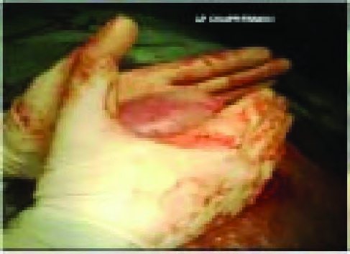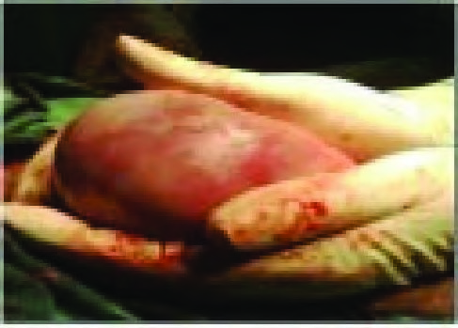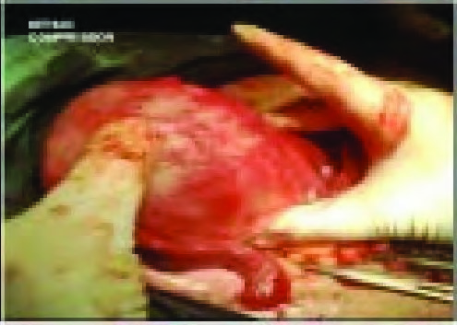
Fig 1 — AP Compression Fig 2 — Lateral compression Fig 3 — Isthmic compression

concluSion
This study clearly shows that placing the baby on mother’s abdomen after delivery till the expulsion of placenta, early breast feeding and misoprostol (600 mg) minimize the complications of third stage of labour at low resource setting. And it also implies that this method can reduce the PPH and MMR where active management of third stage of labour is not adopted routinely.
Hence these are the small effort taken by author to prevent maternal death and periodic training of doctors either through CME’s or conferences along with training of nursing staff and ANM’s are done to learn small tricks and techniques to prevent preventable causes of maternal death specially in rural outreach areas.

reFerenceS
- Dutta DK, Dutta I. Uterine Atony – An Innovative Dutta’s Scoring System for Elective Cesarean Section. J South Asian Feder Obstet Gynaecol 2015: 7(3); 113-17.
- Dutta DK, Dutta I. Dutta’s scoring technique for early detection and management of uterine atony during emergency LSCS- A randomized trial. Asian J Med Sc 2014; 5 (2): 29-33.
- Dutta DK, Dutta I. A noble approach to prevent post partum haemorrhage during LSCS for major degree placenta previa - A comparative analysis. J Evol Med Dent Sc 2013; 2 (23): 4252-9.
- Dutta DK, Dutta I. Management of major degree placenta previa during LSCS operation - A new surgical technique (Dutta’s). Asian J Med Sc 2013; 4:1-7.
- Dutta DK, Gon Chowdhury R, Dutta I. Prevention of third stage complications during vaginal delivery at low resource setting – A comparative analysis. J Evol Med Dent Sc 2015; 4 (40): 6926-30.

4 JIAOG | Vol. 1 | Issue 1 | December 2017

