Email: jiaog2017@gmail.com Website: www.iaog.in

Official Journal of
Indian Academy of Obstetrics & Gynaecology
JIAOG
Vol. 2 | Issue 2
January 2021

Journal of
Indian Academy of Obstetrics and Gynaecology

Email: jiaog@iaog.in
Website: www.iaog.in

Journal of Indian Academy of Obstetrics and Gynaecology
Vol. 2 | Issue 2 | January 2021
Official Journal of
Indian Academy of Obstetrics & Gynaecology

Indian Academy of Obstetrics & Gynaecology
A – 9/7, Kalyani, Nadia, West Bengal 741235 India
Email: jiaog@iaog.in
website: www.iaog.in

Printed, Published and Owned by Dilip Kumar Dutta on behalf of Indian Academy of Obstetrics & Gynaecology and printed at Bishnupriya Printers, Market # 2, Shop # 70, Kalyani, Nadia, West Bengal and published at A-9/7, Kalyani, Nadia, West Bengal. Editor Dilip Kumar Dutta.

Indian Academy of Obstetrics & Gynaecology
A – 9/7, Kalyani, Nadia
West Bengal, India
PIN – 741235
Email: jiaog@iaog.in
website: www.iaog.in

© All rights reserved.
No part of this publication can be reproduced, stored in a retrieval system, or transmitted in any form or by any means, electronic or mechanical, without written permission from the publisher.

Disclaimer:
The opinions and information expressed in this Journal reflect the views of the authors and not of the Journal or its Editorial board or the Publisher. Publication does not constitute endorsement by the Journal. Journal of Indian Academy of Obstetrics and Gynaecology is not responsible for the authenticity or reliability of any product, gadget, equipment or any claim by the medical establishments/manufacturers/ institutions or any training programme in the form of advertisements appearing in Journal of Indian Academy of Obstetrics and Gynaecology and also does not endorse or give any guarantee to such products or training programme or promote any such thing or claims made so after.

Printed at:
Bishnupriya Printers
Market # 2, Shop # 70
Kalyani, Nadia, West Bengal
bishnupriyaprinters@gmail.com

JOURNAL OF INDIAN
ACADEMY OF
OBSTETRICS AND GYNAECOLOGY
Official journal of Indian Academy of Obstetrics & Gynaecology

Chief Editor
Dilip Kumar Dutta
Director, Gynaecological Institute of Clinical Excellance
Kalyani, Nadia, West Bengal
Email: editor.jiaog@iaog.in
Executive Editor
Manidip Pal
Professor, Obs & Gyn, College of Medicine & JNM Hospital, WBUHS, Kalyani, WB
Email: executive.editor.jiaog@iaog.in

Associate Editors
M K Saha
Professor, Obs & Gyn, Andaman Nicober Islands Institute of Medical Sciences, Port Blair
Email: mksaha@rediffmail.com

Soma Bandyopadhyay
Professor, Obs & Gyn
Katihar Medical College, Katihar, Bihar
Email: somapb@gmail.com

N Nabakishore Singh
Professor, Obs & Gyn, Regional Institute of Medical Sciences, Imphal, Manipur
Email: drnaba_naorem@yahoo.co.in

Bharti Maheshwari
Senior Consultant Gynaecologist, Meerut, UP
Email: bhartinalok123@gmail.com

Ranita Roy Chowdhury
Associate Professor, Obs & Gyn
College of Medicine and JNM Hospital (WBUHS), Kalyani, Nadia, West Bengal
Email: ranitasinha@gmail.com

Assistant Editor
Saubhagya Kumar Jena
Professor, Obs & Gyn, AIIMS, Bhubaneswar
Email: drsaubhagya@gmail.com
Indranil Dutta
Associate Professor, Obs & Gyn, IQ City Medical College, Durgapur, WB
Email: drindranildutta@gmail.com
Tripti Sinha
Associate Professor, Obs & Gyn, Nalanda Medical College and IGIMS, Patna, Bihar
Email: triptisinha0304@gmail.com
Lavanya Kumari Sarella
Professor, Obs & Gyn, Rangaraya Medical College, Kakinada, Andhrapradesh
Email: lavanyakumarisarella@yahoo.com

Plagiarism Checking Committee
Shakuntala Chhabra
Emeritus Professor, Obs & Gyn, Mahatma Gandhi Institute of Medical Sciences, Wardha
Email: chhabra_s@rediffmail.com
Gokul Chandra Das
Professor, Obs & Gyn, Tomo Riba Institute of Health & Medical Sciences, Naharlagun, Arunachal Pradesh
Email: gokulchandradas@rediffmail.com
Banasree Bhadra
Professor, Obs & Gyn, College of Medicine & JNM Hospital, WBUHS, Kalyani
Email: banasree22@yahoo.com

Mriganka Mouli Saha
Assistant Professor, Obs & Gyn, College of Medicine & JNM Hospital, WBUHS, Kalyani
Email: itsmemriganka@yahoo.com

Epidemiologist cum Statistician
Ritesh Singh
Associate Professor, Community Medicine
AIIMS, Kalyani
Email: drriteshsingh@yahoo.com
Advisory Board

International
Christopher B Lynch, Emeritus Professor, Milton Keynes University Hospital (NHS Trust), UK
Email: christopherbl@aol.com
Paul Riss
Professor, Urogynaecology, Medical University of Viena, Austria
Email: paul.riss@gmail.com
Sayeba Akhter (Bangladesh), Ex Professor & Head, Obs & Gyn, Dhaka Medical College and Hospital, Dhaka, Bangladesh
Email: sayeba.akhter@gmail.com
Ashma Rana, Professor, Obs & Gyn, TU Teaching Hospital, Kathmandu, Nepal
Email: ashmarana2011@gmail.com
National
S N Basu
Sr Consultant, Obs & Gyn, Max Healthcare, New Delhi
Email: sn.basu@maxhealthcare.com
Ch Manglem Singh
Professor, Obs & Gyn, Jawaharlal Nehru Institute of Medical Sciences, Imphal, Manipur
Email: drcmsingh@hotmail.com
Arup Kumar Majhi
Professor, Obs & Gyn
R G Kar Medical College, Kolkata
Email: drarupkmajhi@yahoo.com

Tapan Kumar Bhattacharyya
Principal, Shri Ramkrishna Institute of Medical Sciences and Sanaka Hospital, Durgapur, WB
Email: tapan.bhattacharyya@gmail.com

Editorial office
A – 9/7, Kalyani, Nadia, West Bengal, India, PIN - 741235
E-mail – jiaog@iaog.in, Website: www.iaog.in

Journal of Indian Academy of Obstetrics and Gynaecology January 2021
Vol. 2, Issue 2

To
All Medical Fraternity

As Editor of Journal of Indian Academy of Obstetrics & Gynaecology I feel glad to inform you that Volume 2, issue 2 of Journal of Indian Academy of Obstetrics & Gynaecology is going to release on 15th January 2021. It gives me immense pleasure to publish the third volume on this auspicious occasion of “Makar Sankranti”.

We have focused on many evidences based scientific research papers covering original article, book review, case reports etc. In this time of pandemic, the highlight is on covid-19 infection and its consequences.

Till date no evidence based scientific (Lancet 12 February 2020) research showed that covid19 can affect both mother and baby. Due to immune compromise and physiological alterations during pregnancy - pregnant mother's (who had history of respiratory tract disease or diabetes etc.) are likely to susceptible to covid19 as compared to general population. Due to above facts pregnant mothers were required additional preventive measures to prevent any covid19 transmission to them and baby.

Key preventive measures

Basic - Mask sanitizer, social distancing and stay home.

Following measures.

- Oral hygiene > Brush teeth after every meal, Gargle twice daily by antiseptic mouth lotion, avoid oral sex .
- Nasopharynx hygiene > mild hot Inhalation by saline or others, don't touch with fingers, nasal spray or drop if indicated.

- Eye hygiene > Better use power less spectacles/sunglasses, don't rub by fingers, use tissue paper.

- Respiratory hygiene >covering mouth and nose, during cough or sneeze use tissue paper (disposed it)or bent elbow.

- Pelvic hygiene >Use tissue paper or hand shower after passing stool, use any sanitizer lotion , avoid sex.
- Breast hygiene > care for breast and nipple.
- Rest> 8hrs night/ 4 hrs day , foot end to be raised and left lateral positions (while sleeping) , try to avoid supine position.
- Water intake > sufficient amounts of water(3 to 4 litres)preferably hot mild water, avoid cold water.
- Diet>well balanced diet and, frequent meal and fruits.
- Drugs > Iron, calcium, vitamin c, mineral.
- Transport > Avoid transport work from home by internet, mobile ect
Care

High quality care before, during and after child birth.
Mental care - is required with support all throughout pregnancy and childbirth.
If any symptoms like fever, cough or difficulty in respiration- immediately inform Doctors or health workers or health care providers by telephone, what's App or email.
Breast feeding
Wearing mask, wash hand before or after feeding, routinely clean and disinfect, holding Newborn skin to skin, share a separate room with baby.
ANC clinic>as advised of doctors or health care providers
Third semester >Social distancing, stay away from public places; avoid contact with suspected or infected covid19.

Child birth

In a hospital with well equipped with the presence of multidisciplinary doctors or facilities.
It is the total team effort of IAOG to make this Journal one of the highest rated journal in future.
I strongly believe that scientific fraternity of post graduate students, residents, teachers as well as practitioners will be benefited from this journal.
Our sole intention has always been to reduce the maternal mortality by innovative, evidence based scientific paper which will be acceptable to the obstetricians and gynecologists.

Thanking you

Dilip Kumar Dutta
Chief Editor
Journal of Indian Academy of Obstetrics and Gynaecology

Journal of Indian Academy of Obstetrics and Gynaecology January 2021
Vol. 2, Issue 2

Contents

Guest Editorial:

Role of critical care units: Obstetric hdu/icu
Alpesh Gandhi
........................................................................................1 - 7

Original Article:

Demographic evaluation of sterilization operation at Naihati state general hospital
Dilip Dutta, Indranil dutta, Ranita Roy Chowdhury

................................................................................................8 - 12

Medical management of persistent hemorrhagic ovarian cyst – a pilot study
Soma Bandyopadhyay

................................................................................................13 - 17

A study on the trend of vaginal delivery versus caesarean section- an institutional record based retrospective observational study
Rahul Chaudhury, Gairik Bera, Ranita Roy Chowdhury, Manidip Pal

................................................................................................18 - 25

Camp sterilization vs hospital sterilization –a long term follows up
Dilip Kumar Dutta, Indranil Dutta, Ranita Roy Chowdhury

................................................................................................26 - 30

Feto-maternal outcome among covid-19 positive women delivered in a level iii covid hospital at moradabad, western up
Nupur Nandi, Amita Azad, Garima Bajpai

................................................................................................31 - 36

An analysis of maternal mortality – 3 years study in a tertiary care hospital
Suvobrata Sarkar, N Lavanya, Ranita Roy Chowdhury
................................................................................................37 - 41

Case Report:
A case of massive hematometra and hematocolpos with imperforate hymen
Shraddha Kiran Swami, Oby Nagar, Suwaram Saini, Manish Bhardwaj
................................................................................................42 - 45

A case of placenta percreta in a post-caesarean patient with scar rupture at 30 weeks of pregnancy – management
Anindita Jana, Abhijit Halder, Nupur Nandi, Pijush Bepari, Sagar R. Gaikwad
................................................................................................46 - 49

Book Review:

D C Dutta’s textbook gynecology
Soma Bandyopadhyay

................................................................................................50
Author’s Guidelines
........................................................................................51 - 53
Subscription Form
........................................................................................54

Journal of Indian Academy of Obstetrics and Gynaecology January 2021
Vol. 2, Issue 2

Guest Editorial

Role of critical care units: Obstetric HDU/ICU

Alpesh Gandhi

Honourable President of FOGSI

INTRODUCTION
MMR in developed countries is < 20. MMR in India is 130 (2015) and in some of the states of India, it is even > 250. Every year 300000 pregnant women die in the world. If quality obstetric health care is provided in time, then we could save nearly 80% of these women in the world. Maternal mortality is "JUST THE TIP OF THE ICEBERG". There is a vast unseen base to this iceberg which is known as maternal morbidity (Near Miss). Maternal near miss case means a woman (in pregnancy/labor/ puerperium) who almost died due to any life-threatening complications but survived. For every maternal death that occurs, between 11 - 223 women experience a ‘near miss’ event in pregnancy.
Any pregnant woman can develop life threatening complications with little or no advance warning which can lead to physical, social, economic and psychological consequences of complications. All such women need access to quality maternal health services that can detect and manage life threatening complications.
In Europe and US, about 0.1 to 0.9% of women during pregnancy or labour require intensive care and monitoring. In India it varies from 8-16%.
Quality maternal health care means facility for invasive monitoring, skill-based services, skilled and experienced persons and 24hours monitoring. All these can be best accomplished in an obstetric ICU set up where services from expert and trained medical, nursing and technical staff is available. They use Sophisticated State-of-the-art equipment, technology for intensive monitoring and immediate life-saving interventions and organ support that may be necessary.
What is a High Dependency Care Unit (HDU)?
A high dependency unit is an area in a hospital, where patients can be cared for more extensively than on a normal ward, but not to the point of intensive care. So, it is known as intermediate care units. Patients may be admitted to an HDU because they are at risk of requiring intensive care admission (step up) or at the same time, patients in the Intensive Care Unit who have had an improvement in their condition require a stay in the High Dependency Unit (HDU) before admission to a general ward (step down). The HDU is similar to ICU except that patients admitted to the HDU are usually less ill or beginning to recover from their operation. It is called step-down, step up, progressive & intermediate care units. HDU would not normally accept patients requiring mechanical ventilation, but could manage those receiving close monitoring. Patients with multi organ failure cannot be admitted in HUD. HDU will suffice when organ support is not vital. HDUs are the wards for people who need more intensive observation, treatment and nursing care than is possible in a routine ward but slightly less than that given in intensive care. The ratio of nurses to patients is 2:1 which is slightly lower than in intensive care but higher than in general wards. It can be established in most obstetric unit in a room which is equipped for it. HDU is an option which fulfils the need of tertiary care centre.
Why dedicated Obstetric ICU/ HDU are required?
In developing countries like in India, incidence of high-risk pregnancy is approximately 7 to 8%. Care of critically ill patients is a unique challenge in obstetrics. When things go wrong in obstetrics they go wrong very fast. Any pregnancy can develop life threatening complications at any time with or without any warning. Medical conditions might present risk to the pregnancy. Pregnancy may modify the disease state. Drug therapy may be affected by altered pharmacokinetics. Drug therapy may have impact on the foetus. All these high-risk pregnancies can be saved by quality maternal health services, means 24 hrs vigilant monitoring with immediate life-saving interventions and organ support. This can be possible with facility of skill-based services in a dedicated critical care set up with sophisticated state-of-the-art equipment and technology. Obstetric patients are relatively young and healthy & they do recover rapidly.
Critically ill obstetric patient is safer in Obstetric HDU/ICU than MICU & SICU.
Usually Obstetric HDU/ICU is a part of obstetric department, near to Labour room and Operation theatre and so whenever is required, obstetric patient can be shifted easily and promptly to LR or Operation theatre. This is not routinely possible with MICU. Shifting of patient is very difficult particularly when patient is obstetric. In MICU & SICU, ICU beds do not have the facility to be converted into labour table.
Usually NICU is also nearer to obstetric department and so neonates can be taken care easily and promptly which may not be there with MICU/SICU. Obstetric HDU and Obstetric ICU are nearer to each other in the obstetric department and so step up and step-down facility can be used easily, which is not easily possible with MICU/SICU.
In Obstetric HDU/ICU, a trained or experienced senior dedicated full-time obstetrician is available, and staff is dedicated and in trained in obstetric complications/emergencies.
Foetal monitoring is only possible in obstetric HDU/ICU, which is also not possible in MICU/SICU. Expenditure of hospital in maintenance of ICU decreased significantly because of Obstetric HDU.
Studies: In one study, objective was to establish the utilisation of high dependency care in a tertiary referral obstetric unit. Data of pregnant or recently pregnant women admitted to the obstetric high dependency unit from 1984 to 2007 were included to evaluate the admission rate. Four years' information of an ongoing prospective audit was collated to identify the indications for admission, maternal monitoring, transfers to intensive care unit, and location of the baby. The result was, the overall HDU admission rate is 2.67%, but increased to 5.01% in the most recent four years. Massive obstetric haemorrhage is now the most common reason for admission. Invasive monitoring was undertaken in 30% of women. Two-thirds of neonates (66.3%) stayed with their critically ill mothers in the HDU. Transfer to the intensive care unit was needed in 1.4 per 1000 deliveries conducted. Study concluded that obstetric high dependency care provides holistic care from obstetricians and anaesthetists while retaining the opportunity of early bonding with babies for critically ill mothers.
Another Study was conducted in the Rotunda Hospital, Dublin with 121 beds. It incorporates a two-bedded HDU, established in June 1996. Patients were also subdivided into those transferred to ICU in the period January 1994 to June 1996 (before on-site HDU facilities were available) and those transferred to ICU between June 1996 and June 1998 (after the HDU was established).
The total number of deliveries was 14096 before the establishment of the HDU and 12070 after. 123 patients were admitted to the HDU during the study period June 1996 to June 1998, representing 1.02% of all deliveries. 17 patients were transferred to a general ICU, 12 before the HDU was established (representing 0.08% of all deliveries) and 5 after (0.04%). Before the HDU was established, length of stay in ICU was 3 days and 2.0 days after HDU. Prior to development of on-site HDU facilities at the hospital, ICU utilisation rate was 0.08% which decreased to 0.04% following the establishment of this facility. Although not statistically significant, there is an apparent trend toward decreased ICU admission rates following the establishment of the HDU. Transfer to ICU in the group before HDU, was necessitated predominantly by obstetric complications, with haemodynamic instability as a result of haemorrhage being the commonest ICU admission diagnosis. Following the advent of the HDU, the need for mechanical ventilation became the major indication for maternal ICU admission with an increasing number of patients with haemodynamic instability being managed within the HDU. Duration of ICU stay was short in both groups; interestingly, although not statistically significant, there is a trend toward reduced duration of ICU stay perhaps reflecting the availability of HDU care on discharge to the referring centre.
Wheatley et al. suggested that early intervention and treatment of the critically ill obstetric patient might prevent serious complications and avoid the need for ICU. In their study, almost 60% of the patients admitted to ICU could have been managed appropriately within the HDU setting. Study concluded that a population of critically ill obstetric patients can be managed successfully in an obstetric HDU with the advantage of concurrent expert obstetric and critical care management.
In another study conducted at Liverpool Women’s NHS Foundation Trust, Liverpool, UK. In England, the Critical Care Minimum Data Set (CCMDS) was used to assess critical care activity. 4608 women were delivered and 239 (5.18%) were admitted to the HDU. Average length of stay was 1.97 days.

Obstetric HDU - Obstetric ICU and Triaging policy:

Safe Maternity is viewed as a basic human right worldwide. There is an agreement about the need for intensive care facilities for high risk and critically ill obstetric patients. In UK, nearly 30% hospitals are having HDU facility. All the referral Hospitals should have Obstetric HDU and all the District referral hospitals and Medical Colleges should have both Obstetric HDU and Obstetric ICU, if prerequisite are fulfilled for it’s establishment. It is recommended that all pregnancies with complications may be managed in Obstetric HDU/ Obstetric ICU after initial examination in Triage area. Patients may be transferred directly to Obstetric HDU/ICU from an emergency department if required, or from a ward if they rapidly deteriorate, or immediately after surgery if the surgery is very invasive and the patient is at high risk of complications.

Obstetrician will take decision depending on the clinical condition and severity of illness, whom to admit in obstetric HDU/ICU or who will require routine care / delivery. During examination, a quick initial assessment is required to decide if she is an emergency or complicated case.
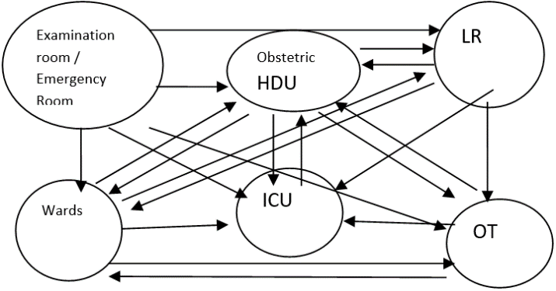
Obstetric Patient with following conditions / diagnosis may require admission in Obstetric HDU:

a. Hemodynamic instability
b. Respiratory dysfunction,
c. Neurologic complications.
d. Acute kidney injury
e. Haematological complications

Patient with following parameters require admission in Obstetric HDU/ICU:
Obstetric HDU | Obstetric ICU
- Systolic Blood Pressure <90 or >160 mm of Hg  - Diastolic Blood Pressure <50 or >110 mm of Hg  - Mean Arterial Blood Pressure <60 mm of Hg  - Heart Rate < 60 or >110 per minute  - Respiratory Rate: > 25 per minute  - Urine < 0.5ml /Kg/Hour (< 30 ml per hour)  - Any organ dysfunction | - Systolic B.P. < 80 mm Hg, or 30 mm Hg below patient’s usual B.P.  - Heart rate <50 or >140 beats / minute  - RR < 8 or >35 per minute  - U/O < 400 ml in 24 hrs, or < 160 ml in 8 hrs and unresponsive to simple routine measures.  - GCS < 8 in the context of non-traumatic coma.  - Any unarousable patient.  - S. sodium <110 or >160 mmol L  - S.potassium <2.0 or > 7.0 mmol L  - pH < 7.1 or > 7.7  - PaO2 < 6.6 kPa and/or PaCO2 > 8.0 kPa.  - SaO2 < 90% on supplemental oxygen.  - Need for advanced  respiratory support  - Inotropic support  - DIC  - Multi-organ failure  - ARDS

SCOPE OF HDU: Following conditions may require admission in Obstetric HDU/ICU
Obstetric Complications | Pregnancy with Medical Complications
- Pregnancy / Labor Pain with Severe Anemia (< 7 gm %) and its complications. | - Pregnancy with Gestational Diabetes.
- Accidental Hemorrhage- Placental abruption, couvelaire uterus | - Pregnancy with diabetic Ketoacidosis
- Post Partum Hemorrhage | - Pregnancy with Cardiac Diseases
- Placenta Previa | - Pregnancy with Jaundice
- Adherent Placenta and other placental abnormalities. | - Pregnancy with Thyrotoxicosis
- Obstetric hysterectomy | - Pregnancy with Thyroid storm
- Severe Preeclampsia/ Hypertensive crisis | - Pregnancy with Pheochromocytoma
- Eclampsia | - Pregnancy with other endocrinal crisis like addison’s disease etc.
- Broad ligament hematoma | - Post-operative ARF and other renal problems
- HELLP Syndrome | - Leukemia and other hemolytic disorders.
- Pregnancy with DIC | - Pregnancy with Dengue
- Sepsis & systemic inflammatory response syndrome (SIRS). | - Pregnancy with complications of Malaria
- Pregnancy with Thrombophylias. | - Pregnancy with Asthma and other respiratory problems.
- Multiple gestation with complications | - PPCM-Postpartum cardiomyopathy
- Pregnancy with complications due to uterine anomaly and pathologies | - Pregnancy with appendicectomy or any other surgical emergency
- Hydatidiform Mole | - Pregnancy with OHSS. (Ovarian Hyperstimulation syndrome)
- Ruptured Ectopic | - Pregnancy with Acute Pancreatitis
- Burns during pregnancy | - Pregnancy with Trauma
- Perforation during abortion | - Pregnancy with Poisoning
- Postoperative patients requiring hemodynamic monitoring, or intensive nursing care | - Pregnancy with Cancer
- Pulmonary edema due to peri-operative fluid overload, CCF, complication of severe pre-eclampsia or tocolytic therapy with β-agonists etc.

Many other such conditions when obstetrician decides that it is appropriate to admit the patient in Obstetric HDU/ ICU.
Isolation: Pregnancy with H1NI, Pyometra, HIV and infectious diseases should be admitted in Isolation Room in Obstetric HDU/ ICU.
Setting Up of HDU: Obstetric HDU should be a special part of an Obstetric unit. It should be near ICU and LR/OT. There should be at least one fully equipped obstetric theatre within the delivery suite. Where this is not possible, a lift, for the rapid transfer of women to theatre must be available. It should have nearby facility of Blood bank, fully equipped laboratory, radiology department and nearby NICU care. There should be provision for Emergency exit point in case of disasters.

PERSONNEL-STAFFING
Obstetrician leads the Obstetric HDU/ICU. He/she will decide when to call and whom to call from the list of multidisciplinary teams whenever is required, for management of the obstetric patient.
Obstetric HDU working team consists of Incharge-Experienced/Trained Full Time Obstetrician, EmoC/Medical Officers round the clock, Obstetric nursing staff (24x7) nursing staff to patient ratio should be 1:2. Obstetric Anesthetists, Physician, Neonatologists, Surgeon, Radiologist’s services should be made as an assured service. It is ideal to have back up support of these specialists and super specialists on call, if and when required.
For Obstetric ICU working team consists of Experienced/Trained Full Time Obstetricians, Obstetric Anesthetist, EmoC/Medical Officers round the clock. Obstetric support staff (24x7) nursing staff to patient ratio should be 1:1. All staff should be adequately trained in recovery care and cardiopulmonary resuscitation.
Services of Critical Care specialist or physician, neonatologist, surgeon, nephrologist, cardiologist, and radiologist should be assured on call. There should be back up support of other specialists and super specialists on call, if and when is required like Hematologist, Neurologist. Endocrinologist, Pulmonologist, Vascular Surgeon etc.
Monitoring & Management at HDU:
History - record the date, time and reason for requesting this level of care, name of clinician contacted, a summary of the current problems, review of the patient’s observations and finding on clinical examination and a plan for ongoing care. Future review should be completely documented
Immediately Initial assessment and resuscitation should be done.

Maternal observation: Temperature, Blood pressure, Heart rate, Respiratory rate, Transcutaneous oxygen saturation, Hourly Urine output should be recorded at least hourly in the acute phase of the illness.

Following Management is done as per case requirement:
Management: It includes initial assessment of the condition and resuscitation of the patient whenever required. Maternal organ function monitoring of cardiovascular, renal, pulmonary, hepatic, cerebral is done. Baseline and specific investigations as indicated are advised. Primary conditions like severe preeclampsia, hemorrhage, sepsis etc are treated. Anti-convulsant therapy is given, whenever is required. Inj. MgSO4 is given as per protocol for Eclampsia patient. Fluid balance and electrolytes correction is taken care. Foetal condition is checked by CTG. Fluid therapy in the form of Crystalloid /Colloid/Blood is given. Utero-placental oxygen delivery is maintained. Left lateral position is given, if required. Oxygen via face mask, if required. Noninvasive and invasive Monitoring like B.P., RR, H.R., Pulse, SPO2, ABP, CVP, ABG’s, hourly UOP, lungs functions and others is done. Broad spectrum antibiotics are given for sepsis if requires to cover Gram negatives & anaerobes after discussion with microbiologist. Proper care for nutrition is taken. Enteral and parenteral nutrition is given. If required, inotropes are given. Pain management is done. Appropriate clinicians from relevant specialties are involved. Final Management is individualized and depends on the underlying clinical Condition.
Watch for other parameters mentioned earlier for admission in ICU. Approximately 2-3% of patients admitted to the obstetric HDU will require transfer to ICU. Portable monitoring with facility for invasive monitoring must be available to facilitate transfer of obstetric patients to the ICU.
Care for Foetus in Obstetric HDU/ICU:
Generally, fetal morbidity and mortality reflect maternal condition closely. Simple measures such as avoidance of supine hypotension and oxygen via face-mask can improve uteroplacental oxygen delivery. Fetal condition should be observed by continuous electronic fetal heart monitoring. Corticosteroids should be given If < 34 weeks. Labor & Delivery is planned as per maternal indication or fetal indication. When required, delivery of a baby is considered.

Guidelines and Protocols to be followed

As HDU care involves management of critically ill obstetric patients, guidelines and protocols should be in place to encourage appropriate responses to these critical situations and justify actions that are sufficient and efficient, neither excessive nor deficient.

Discharge from Obstetric HDU to Ward:
Decision of discharging of a patient from Obstetric HDU is taken when a patient's physiologic status has been stabilized, patient is hemodynamically stable and the need for intensive monitoring is no longer necessary. When there is no active bleeding, no further continuous intravenous medication or frequent blood tests required, no invasive monitoring is required, no supplementary oxygen is required and patient is ambulatory, then the patient is discharged from obstetric HDU/ICU and transferred to a ward. When transferring a woman from HDU to the ward, a personal and detailed handover of care should be given. Average time in HDU is usually 24-72 hours. Patient should be discharge with full written document.
Indications of transfer from HDU to ICU: When patient needs for advanced respiratory support, further inotropic support is required, pt develops DIC, Multi-organ failure, Adult respiratory distress syndrome and she is transferred to ICU for further care and support.
Transfer to ICU: When RR is outside the range 7 to 35 breaths / minute, Pulse is outside the range 40 to 140 beats / minute, B.P. < 80 mm Hg, or 30 mm Hg below patient’s usual B.P., U/O < 400 ml in 24 hrs, or < 160 ml in 8 hrs and unresponsive to simple measures , GCS < 8 in the context of non-traumatic coma, any unarousable patient, S. sodium outside the range 110 to 160 mmol L, S. potassium outside the range 2.0 to 7.0 mmol L, pH outside the range 7.1 to 7.7, PaO2 < 6.6 kPa and or PaCO2 more than 8.0 kPa, SaO2 < 90% on supplemental oxygen.
Conclusion: The majority of women during their pregnancy, labor and postnatal period require routine obstetric care. A small but significant number, however, require critical care related to the pregnancy itself, aggravation of a preexisting illness or complications of the delivery. Any pregnant woman can develop life threatening complications with little or no advance warning which can lead to physical, social, economic and psychological consequences of complications. All such women need access to immediate maternal quality health services that can detect and manage life threatening complications.
HDU provides a level of care in between general ward and ICU set up. Women not requiring ventilator support can be managed in HDU, reducing the burden of ICUs. Treatment cost reduces, and above all it requires less expenditure to establish and manage HDU. A dedicated obstetric HDU with the knowledge, familiarity, experience and expertise of a senior obstetrician and a specialist team would be the best place to monitor and treat the critically ill obstetric pts. It allows continuity of antenatal, intra-partum and postnatal care can be provided by the same team. Delivery of the baby takes place in a more familiar and better-equipped environment with minimal disruption of mother-to-baby bonding. Care in an obstetric HDU may avoid exposure of the critically ill pregnant mother to a potentially hazardous ICU environment with the risk of hospital-acquired infection. Patient satisfaction may be increased since it has more liberal family visitation policies. When patient needs for advanced respiratory support, inotropic support or when patient develops DIC, Multi-organ failure, adult respiratory distress syndrome, she is transferred to obstetric ICU for further care and management. Obstetric patients with High risk pregnancy and critical ill patients can be managed better in Obstetric HDU/ICU which is not possible in routine ward which will ultimately reduce MMR and morbidity.

References:
1. Lancet, May-2013
2.ICU Planning and Designing in India – Guidelines 2010, Guidelines Committee (ISCCM)
3.Guidelines of GOI on Obstetric HDU/ICU.
4. The role of a high‐dependency unit in a regional obstetric hospital, M. Ryan , V. Hamilton,
5. M. Bowen P. McKenna,, Anesthesia, 07 July 2008
6. Wheatley, E, Farkas, A & Watson, D. Obstetric admissions to an intensive therapy unit. International Journal of Obstetric Anesthesia 1996; 5: 221– 4.
Received: 13.01.2021
Accepted: 13.01.2021
Published online: 15.01.2021
Citation: Gandhi A. Role of critical care units: Obstetric HDU/ICU. J Indian Acad Obstet Gynecol. 2021;2(2):1-7.

Journal of Indian Academy of Obstetrics and Gynaecology January 2021
Vol. 2, Issue 2

Original Article

DEMOGRAPHIC EVALUATION OF STERILIZATION OPERATION AT NAIHATI STATE GENERAL HOSPITAL

DILIP DUTTA¹, INDRANIL DUTTA², RANITA ROY CHOWDHURY ^{3}

ABSTRACT
Objective: Sterilization operation, being one of the popular methods of population control is increasingly performed in Naihati State General Hospital. The purpose of this study is to highlight the demographic evaluation of sterilization cases at this institution
Methods: This study was undertaken at Naihati State General Hospital, Nadia, W.B. from January 2010 to December 2018. A total of 1625 cases were reported to have undergone sterilization operation. Interval sterilization in the form of laparoscopy (48%) and mini-laparotomy (23%) were found to be more acceptable than postpartum (9.6%) sterilization cases.
Most of the women 67.0% were in the age group of 25-34 years with parity of 2 to 3 constituting 74.5%and 84.2% of cases. About 48.6% patients belonged to lower income group and 35.6% middle income group respectively.
86.8 % were from Hindu community and 13.2 % were from Muslim community. Educational status showed that 44.2% patients were illiterate, 30.2% educated up to class VI, 21% up to Class VIII and high school level 4.6% respectively.
It appeared from this study that acceptability of sterilization operation at Naihati State General Hospital were found to be better in spite of low socio-economic status. It goes without saying that better understanding and acceptance of family planning programme by the rural population of Naihati. However socio-economic status of the families of rural population have to be improved further to reach higher target of sterilization operation cases and acceptance of other forms of spacing contraceptives.
Keywords: sterilization, population, demography

INTRODUCTION
Permanent sterilization is a preferred method of contraception worldwide. In spite of popularization of temporary methods, it is used by 2/3rd of married women using any contraception. It has a low incidence of complications and failure rate and is cost-effective. Various socio-demographic factors play a role in acceptability of this method. It has an important role in controlling the total fertility rate.
It is being increasingly performed in health centre. The purpose of this study to highlight the demographic evaluation of sterilization operation cases at Naihati State General Hospital.
MATERIALS NEED METHODS
This study was undertaken at Naihati hospital of Nadia district of West Bengal from the year January 2010 to December 2018.
The entire patient who will undergo sterilization operation were critically evaluated and screened to find out age, number of living children, community, education level, family income and any menstrual irregularity in addition to other clinical findings.

RESULTS
It appeared from the table -I that total population of Naihati block according to 2011 census was Two lakh and twenty-five thousand.

TABLE-I DEMOGRAPHIC DISTRIBUTION
----------------------------------------------------------------------------------
A. TOTAL POPULATION OF NAIHATI 2, 25,000
(2011 census)
B. FAMILY PLANNING PROGRAMME Vasectomy 46
(2010-18) Tubectomy 6378
I.U.C.D 2060
Oral Tablets 7000
C. STERILIZATION OPERATION --- 1625
(2017-18)
------------------------------------------------------------------------------

During 2010 to 2018 (8 YEARS), 6378 cases of tubectomy and 7000 cases of oral contraceptives were reported and were found to be higher acceptance as compared to 2060 cases of I.U.C.D. and 46 cases of vasectomy. That is because of better understanding and acceptance of the former methods. A total of 1625 cases of sterilization operation in the form of tubectomy were reported during January 2017 to December 2018.
TABLE - II TYPES OF STERILIZATION OPERATION
---------------------------------------------------------------------------------
PROCEDURE NUMBER PERCENTAGE
---------------------------------------------------------------------------------------------------------
1. INTERVAL STERILIZATION
a) LAPAROSCOPY 780 48%
b) MINI LAPAROTOMY 375 23%
2. POST PARTUM STERILIZATION 156 9.6%
3. ALONG WITH HYSTEROTOMY 314 19.4%
------------------------------------------------------------------------------
Out of total 1625 operation cases- (Table - II) laparoscopic sterilization (48%) were found to be higher response as compared to mini laparotomy (23%) because of easy procedure, short stay and minimal complications. On the other hand, most of the women who preferred to undergo hysterotomy and ligation (19.4%) than that of Post-partum sterilization (9.6%) because of socio-economic problem.
TABLE - III AGE GROUP
YEARS NUMBER PERCENTAGE ----------------------------------------------------------------------
20-24 392 24.1%
25-29 678 41.7%
30-34 423 26.1%
35-39 132 8.1%
-----------------------------------------------------------------

It appeared from Table III that most of the women (67.8%) who come from sterilization operation were in the age group of 25-34 yrs. Although 24.1 percent cases had undergone operation at the group of 20-24 years as compared to 8.1 percent of cases were of 35-39 age group; Indicating the acceptance of this procedure.

TABLE IV-NUMBER OF LIVING CHILDREN
LIVING CHILDREN NUMBER PERCENTAGE

2 425 26.1%
3 787 48.4%
4 312 19.2%
5 & above 101 6.3%
------------------------------------------------------------------------------ It is interesting to observe that (Table IV) 48.4 percent of cases of sterilization operation were having 3 living children as compared to 2 (26.1%) and 4 (19.2%) living children respectively. Only 6.3 percent of cases had more than 5 and living children signified that most of women, who came to this center were of lower parity which may be due to poverty and other socio-economic factors.

TABLE V - INCOME GROUP
INCOME GROUP NUMBER PERCENTAGE
LOWER 790 48.6
MIDDLE 580 35.6
UPPER 255 15.8
------------------------------------------------------------------------------
Economic status is very important reason for accepting the sterilization operation as because it is seen in the Table V that 48.6 percent of cases were from lower income group as compared to middle (35.6%) and upper (15.8%) income group respectively.
TABLE-VI-COMMUNITY
------------------------------------------------------------------------------
COMMUNITY NUMBER PERCETAGE
------------------------------------------------------------------------------
HINDU 1411 86.8%
MUSLIM 214 13.2%
------------------------------------------------------------------------------

Since about 90 percent of total population in Naihati were dominated by Hindu. Therefore, it appeared from the Table VI that 86.8 percent cases were from Hindu Community. But there is still very good response from Muslim Community (13.2%) also indicating that region is nothing to do with the acceptance sterilization operation at this center.
TAILE VII - EDUCATION LEVEL
TYPES OF LITERACY NUMBER PERCENTAGE
------------------------------------------------------------------------------
Illiterate 718 44.2%
Up to class VI 491 30.2%
Up to class VIII 342 21%
High school or higher secondary Level
------------------------------------------------------------------------------
It appeared from Table VII that 44.2 percent of cases were illiterate as compared to 30.2 percent up to class VI, 21 percent of cases up to class VIII and 4.6 percent cases up to higher secondary or high school level indicating that better understanding of Family Planning Programme by the couples even though their economic status is poor.
DISCUSSION
This study has shown that there is a good response for accepting sterilization operation at Naihati State General Hospital in spite of low socio-economic status. There are multiple factors contributing to the same.
Most of the women (48%) preferred to undergo laparoscopic sterilization because of easy procedure, shorter duration of hospital stay and minimal complication. Although interval sterilization in the form of mini laparotomy were seen in 23 percent cases. Overall interval sterilization in the form of laparoscopy and mini-laparotomy (71%) were found to be better acceptable than that for other procedures (29%). Female sterilization acceptance ranged between 71.6% to 91.6% and male sterilization between 8.4%-28.4% in a similar study by AFMC, Pune.¹
On the other hand, it appeared that 19.4 percent of cases had undergone hysterotomy & ligation as compared to post-partum sterilization (9,6%) cases indicating that low socio-economic factor or failed contraception might have some impact for accepting hysterotomy and ligation procedure. The implication of lesser number of vasectomy cases may be stigmas arising out of economic issues, cultural background, economic and educational status. Vasectomy acceptance is limited by the scarcity of skilled vasectomy providers and by the fact that men and women hold many misunderstandings about vasectomy, including a fear of decreased sexual performance as a result of the procedure.² NFHS-3 and NFHS-4 data also reveals a significant preponderance towards female sterilization operations with 97.4% and 99.17% female sterilization operations, respectively.^{3,4}
The study demonstrated that majority of tubectomy acceptors (41.7%) belonged to age group of 25-30 years which was similar to a study in Allahabad.⁶
In rural area there is still a great desire to marry early because of customs and taboos. Although most of the women were married early and were having 2 to 3 children (74.5%). Pandit NB and Patel TA reported that 45.8% of women had three or more children and 98.8% women had at least one male child before they accepted female sterilization.^{3,5} Even then these young married women showed good response to contraceptive knowledge and were found to be eager to discuss various family planning programme with the field workers.
Economic factor although is found to be more impact on increasing fertility in rural area. But in this area low fertility rate was observed in spite of the socio-economic status. As it is seen that acceptability of sterilization operation was more in lower- and middle-income group (84.2%) than that of upper income group (15.8%) as they constituted the bulk of population being studied.
As regards community basis it appeared that 86.8 percent cases of Hindus had accepted sterilization operation as compared to 13.2 percent cases from Muslim Community. But overall acceptability of sterilization operation by Muslim population is very significant in relation to total Muslim population which is about 10% total population of Naihati.
Literacy rate has a profound influence in reducing fertility, but it is interesting to observe from the present study that 44.2 percent female were illiterate, 30.2 percent cases were up to class VI, and 21 percent cases were up to class VIII, only 4.6 percent cases had attained high school level. In spite of low education level parity is not found to be higher as compared to another center. Even then education level of those women has to be improved as it is seen that better educated a woman is, the more likely she is to use contraceptives. Education is found to have positive role in increasing the acceptance of modern contraceptive method world over.^{7,8}
The utility of birth control not only lies in population control but also in reducing maternal and child deaths. It is estimated that 1, 00,000 maternal deaths and up to one third of total child deaths could be avoided each year if all women who said they want no more children were able to stop child bearing.⁹
CONCLUSION
It appeared from this study that acceptability of sterilization operation at were found to be better in spite of low socio-economic status because of good understanding and acceptance of family planning programme by the rural people of this area. More of the young population in India is opting for tubectomy. Still women with 3 children are dominating the tubectomy group. Religion has a huge impact on contraceptive practices in India. Removal of the religious stigma is essential for widespread implementation of family planning programs. A significant proportion of rural people opted for tubectomy only when they became pregnant with the unwanted child, hence went for sterilization after medical termination of pregnancy. The Government should initiate some attractive incentives to motivate couples to have only one or two children followed by sterilization. This rapidly growing population is one of the important factors contributing to failure of Governmental programs, thereby increasing mortalities despite all possible efforts.

REFERENCE
1. Bharadwaj MK et al. Int J Reprod Contracept Obstet Gynecol. 2017 Dec;6(12):5348-5353

2. Bunce A, Guest G, Searing H, et al. Factors affecting vasectomy acceptability in Tanzania. Int Fam Plan Perspect. 2007;33(1):13-21. doi:10.1363/3301307
3. International Institute for Population Sciences (IIPS) and Macro International. National Family Health Survey (NFHS-3), 2005-06: India: Volume I. Mumbai: IIPS. 2007.
4. National Family Health Survey (NFHS-4), 2015-16: India Fact Sheet. Ministry of Health and Family Welfare. Available at http://rchiips.org/NFHS/pdf/NFHS4/India.pdf
5. Pandit NB, Patel TA. A descriptive study on determinant factors of who accepted sterilization in rural Vadodara. Nat J Community Med. 2013;4(3):424-7.
6. Chaurasia A, Sachan N, Singh S, Saxena S. A study of demographic variables affecting tubectomy in a tertiary care centre in India. Int J Med Res Rev 2018;6(01):49-53. doi:10.17511/ijmrr. 2018.i01.08.
7. Moursund A, Kravdal O. Individual and community effects of women’s education and autonomy on contraceptive use in India. Population Studies. 2003;57(3):285-301.
8. Cates W Jr, Maggwa B. Family planning since ICPD how far have we progressed?. Contraception. 2014;90(6):S14-S21.
9. Raina Chawla, Anjali Sunil, Shripad Hebbar, Karthik Iyer, Lavanya Rai. Int J Med Sci Public Health. 2015; 4(6): 781-786. doi: 10.5455/ijmsph.2015.15012015158.

Received: 06.01.2021
Accepted: 11.012021
Published online: 15.01.2021
Citation: Dutta D, Dutta I, Roy Chowdhury R. Demographic evaluation of sterilization operation at Naihati state general hospital. J Indian Acad Obstet Gynecol. 2021;2(2):8-12.

1. GICE, Kalyani
2. Dept of Obs & Gyn, IQ City Hospital, Durgapur
3. Dept of Obs & Gyn, COMJNMH, Kalyani
 Email: ranitasinha@gmail.com

Journal of Indian Academy of Obstetrics and Gynaecology January 2021
Vol. 2, Issue 2

Original Article

Medical management of persistent hemorrhagic ovarian cyst – a pilot study
Soma Bandyopadhyay

ABSTRACT
Objectives: Hemorrhagic ovarian cyst (HOC) usually resolved spontaneously by 8-12 weeks. But persistent ovarian cyst needs surgical management. Present study aimed at finding out medical management of this entity.
Method: Diagnosed HOC cases were observed for 12 weeks at first for spontaneous resolution. After 12 weeks persistent HOC were subjected to medical management with Bromelain (180mg) + Trypsin (96mg) + Rutosidetrihydrate (200mg) – 1 tab BDAC for 2 weeks, followed by Bromelain (90mg) + Trypsin (48mg) + Rutosidetrihydrate (100mg) – 1 tab BDAC for 2 weeks starting form 1st week of menstrual cycle. Along with this from 1st day of the cycle she was given low dose OCP (Ethimylestradiol 30 µgm + Desogestel 150 µgm) 1 tab daily and continued un interruptedly for 3 months. Transvaginal ultrasound was repeated after 3 months of therapy.
Result: Total 35 patients were recruited for the study, but 4 lost to follow-up. Clinical features revealed that most of them (58%) were presented with pain lower abdomen during menstruation with or without lower backache. HOC was diagnosed during luteal phase in 80.6% cases. Disappearance of persisted HOC after 3 months medical therapy was 61.3% which is statistically significant (p< .05).
Conclusion: Bromelain, trypsin, rutosidetrihydratealongwith low dose OCP is a promising treatment modality for persisted hemorrhagic ovarian cyst. Further study will confirm this.
Key words: Bromelain, hemorrhage, rutoside, trypsin

INTRODUCTION
Hemorrhagic ovarian cyst (HOC) is a clinical entity which many gynaecologists encountered. By nature, they resolve spontaneously in due course of time.¹But sometimes few of them persisted, causing problem to the ailing women. Surgical removal (laparoscopic ovarian cystectomy) has been the choice of treatment for such like persisted cyst.²But not all women wants to undergo surgery. In those cases, treating this condition becomes a challenge. Present study is a preliminary clinical study to find out the possibility of medical management for such like persisted HOC.

METHODS
The study is conducted from Aug 2016 - Oct 2020. All women between 18-45 years with suspected hemorrhagic ovarian cyst (HOC) were recruited. Exclusion criteria were chocolate cyst, suspected malignancy, twisted ovarian cyst, cyst diameter >5 cm, normal β hCG & CA 125 value, history of allergy to Bromelain, Trypsin Rutosidetrihydrateetc. All women underwent ultrasound pelvis (transvaginal sonography) and HOC was suspected by the sonologist. Serum βhCG level proved to be non-pregnant. Watchful expectancy of 12 weeks was done with counselling that the cyst may resolve by itself. Patient was asked to report after 3 months with ultrasound report or anytime in between if any problem occurred. After 3 months if persistent HOC was diagnosed in transvaginal ultrasound by sonologist, then CA-125 was done. Other tumor markers could not be done due to their non-availability. Patient with normal CA 125 were counselled again about the possibility of medical management of HOC. Whoever given consent were included in the study. These participants were given Bromelain (180mg) + Trypsin (96mg) + Rutosidetrihydrate (200mg) – 1 tab 2 times daily before food for 2 weeks, followed by Bromelain (90mg) + Trypsin (48mg) + Rutosidetrihydrate (100mg) – 1 tab 2 times daily before food for 2 weeks. It is started from 1st week of menstrual cycle. She also received low dose OCP (Oral contraceptive pill – Ethimylestradiol 30 µgm + Desogestel 150 µgm) 1 tab daily from 1st day of same menstrual cycle and continued for 3 uninterrupted months (4 packets). Patient was followed after 1 month and 3 months. At 3 month’s visits, she came after her menstruation and with ultrasound pelvis report.

RESULTS
Total 35 patients were enrolled for the study, but 4 patients lost to follow-up. Age of the patients ranged from 23-39 years. Regarding parity 5 were nullipara, 18 Para 1 and 8 Para 2. Clinical presenting features revealed that most of them (58%) were having pain lower abdomen during menstruation with or without lower backache. (Table 1)
Table: Clinical presenting features of the patient (n=31)
Clinical presentation | Number (%)
Pain lower abdomen during menstruation | 7 (22.6%)
Lower backache | 4 (12.9%)
Dyspareunia (deep) | 2 (6.4%)
Painful defecation | 1 (3.2%)
Pain lower abdomen during menstruation + lower backache | 11 (35.5%)
Lower backache +Dyspareunia (deep) | 6 (19.4%)
HOC was diagnosed during follicular phase in 6 (19.4%) cases and during luteal phase in 25 cases (80.6%). Size of the cyst ranged from 31 mm - 48 mm with a mean of 40.5 mm. (Fig. 1, Fig. 2) On ultrasound cysts were having following features - lace-like reticular echoes or an intracystic solid clot. On doppler study there was circumferential blood flow in the cyst wall but no blood flow inside the cyst. Suspicion of commonest differentiatial diagnoosis – ‘endometriosis’ was cleared by - 1) normal CA 125 level and 2) sonologist’s confirmation by excluding the features of endometrioma, but getting the features of Hemorrhagic ovarian cyst. During follow-up - after 3 months of therapy, HOC was resolved in 19 cases (61.3%). (Fig. 3) In 3 cases though diameter reduced but not fully resolved, so another course of same therapy was given and at 6 months follow-up (since the starting of first therapy) 2 cases HOC were resolved. So, cumulative cure rate is 67.7%. The Fisher exact test revealed that the HOC resolved rate at 3 months is statistically significant (p< .05).

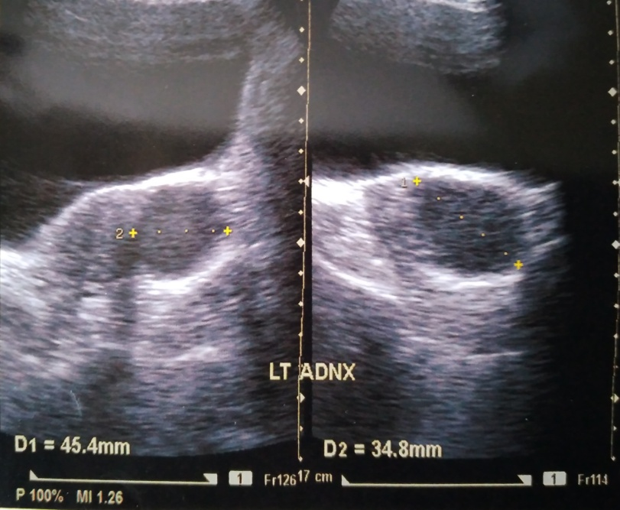
Fig. 1: Hemorrhagic ovarian cyst (left) at the baseline

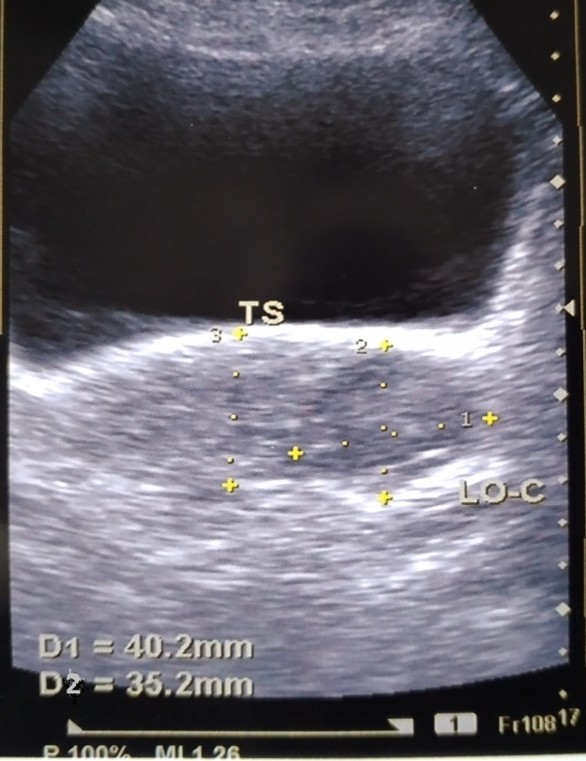
Fig. 2: Same patient having persistent hemorrhagic ovarian cyst (left) after 12 weeks of watchful expectancy

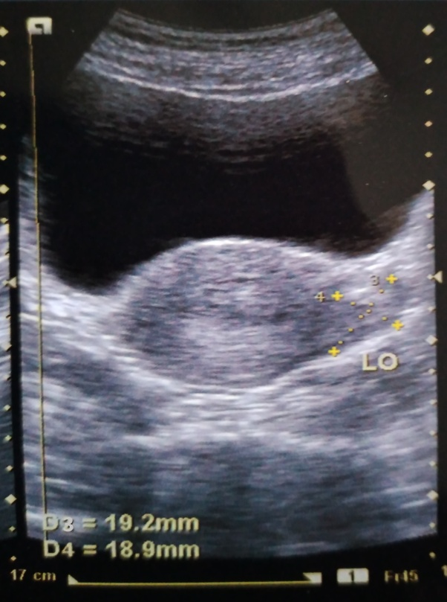
Fig.3: Same patient after 3 months of therapy –left ovarian cyst resolved

DISCUSSION
Hemorrhagic ovarian cyst is not a rare entity in gynaecological practice. It is the after-effect of ovulation. Stromal cells around the maturing Graafian follicle becomes very vascular secondary to hormonal response. Corpus luteum, aftermath of Graafian follicle, have a highly vascular and fragile granulosa layer which easily gets ruptured and formed hemorrhagic ovarian cyst.³Clinically they present in different ways – may be asymptomatic, may be having features of acute abdomen.⁴A twisted/ruptured/hemorrhagic ovarian cyst is the commonest gynaecological cause of acute abdomen in afebrile, premenopausal woman.⁵In present study most of the patients (58%) were having pain lower abdomen during menstruation with or without backache.
Ultrasound is the first-line imaging modality. Correlation of clinical features along with the findings of the transvaginalsonograpgy can accurately diagnose HOC.³In cases of doubt CT scan and MRI can help us to reach the diagnosis.⁶HOC was diagnosed during luteal phase in 56.2% cases, follicular phase 9.4% cases, and in pregnancy 34.4% cases.¹In our study 80.6% cases were diagnosed during luteal phase. Watchful expectancy usually resolved it by 8-12 weeks (2-3 menstrual cycles). However, a follow-up imaging with ultrasound or MRI is better after 6-12 weeks.^{1,7,8}The cyst usually resolved spontaneously in 87.5% cases within 2-6 weeks.¹ The persistent cyst need some kind of therapy. Though surgical excision is mainstay of treatment² but in some cases medical management had to be offered e.g. not willing for surgery.

Bromelain is an anti-inflammatory, antiedematous, antithrombotic, fibrinolytic enzyme results in faster wound healing and improve the circulation. In addition to these it is also have anticancer and immunomodulatory activity.^{9,10}It is absorbed without losing its proteolytic activity and without major side effects. Its wide range of therapeutic application includes treatment of angina pectoris, bronchitis, sinusitis, thrombophlebitis, wound debridement, surgical trauma, osteoarthritis, diarrhoea, certain cancers etc.¹⁰

Trypsin is alsoan proteolytic enzyme. It affects protease activated receptor 2 activation resulting in reduction of inflammatory response.^{11,12}It breaks down the proteins of dead tissue which helps in healing of wounds. This causes improvement of blood supply of the respective area and reduction of inflammation.¹³
Rutosidetrihydrateis an antioxidant and antiedematous. It can inhibit pro-inflammatory genes transcription in human macrophages.^{12,14} It has been used for the treatment of osteoarthritis, post-operative edema, varicose vein, haemorrhoids etc.¹⁵
Continuous low dose OCP prevented further ovulation. So, there was no chance of formation of Graafian follicle and subsequent hemorrhage in corpus luteum.
In present study bromelain, trypsins, rutosidetrihydratealongwith low dose OCP have been found to be effective in resolvingthe persistent hemorrhagic ovarian cyst. Limitation of the study is the small sample size, no control arm and single centre study. By observing the result of the study, we wished to conduct further research as multicentre RCT.

CONCLUSION
Bromelain, trypsin, rutosidetrihydrate combination therapy for 3 months in persistent benign hemorrhagic ovarian cyst appears to be a promising therapy. Final comments can be made only after further research.
ABBREVIATION
CT scan - Computed tomography scan
hCG – Human chorionic gonadotrophin
HOC - Hemorrhagic ovarian cyst
MRI - Magnetic resonance imaging
RCT- Randomized controlled trial
REFFRENCES
- Abbas AM, Amin MT, Tolba SM, Ali MK. Hemorrhagic ovarian cysts: clinical and sonographic correlation with the management options. Middle East Fertil Soc J. 2016;21:41-45. Doi: 10.1016/j.mefs.2015.08.001
- Amesse LS, Hernandez-Rey AE, Pfaff-Amesse T, Rivlin ME. Ovarian cystectomy. https://emedicine.medscape.com/article/1848505-overview Updated on 15.10.2019; accessed on 02.01.2021
- Jain KA. Sonographic spectrum of hemorrhagic ovarian cysts. J Ultrasound Med. 2002 Aug;21(8):879-86. doi: 10.7863/jum.2002.21.8.879.
- Nemoto Y, Ishihara K, Sekiya T, Konishi H, Araki T. Ultrasonographic and clinical appearance of hemorrhagic ovarian cyst diagnosed by transvaginal scan. J Nippon Med Sch 2003;70(3):243–9.
- Cicchiello LA, Hamper UM, Scoutt LM. Ultrasound evaluation of gynecologic causes of pelvic pain. ObstetGynecolClin North Am. 2011 Mar;38(1):85-114, viii. doi: 10.1016/j.ogc.2011.02.005.
- Iraha Y, Okada M, Iraha R, Azama K, Yamashiro T, Tsubakimoto M, Aoki Y, Murayama S. CT and MR Imaging of Gynecologic Emergencies. Radiographics. 2017 Sep-Oct;37(5):1569-1586. doi: 10.1148/rg.2017160170
- Iqbal S. Hemorrhagic ovarian cyst. https://radiopaedia.org/articles/haemorrhagic-ovarian-cyst accessed on 24.12.2020
- Green-top guideline no. 62. Management of suspected ovarian masses in premenopausal women. RCOG/BSGE joint guideline 2011 https://www.rcog.org.uk/globalassets/documents/guidelines/gtg_62.pdf accessed on 29.12.2020
- Rathnavelu V, Alitheen NB, Sohila S, Kanagesan S, Ramesh R. Potential role of bromelain in clinical and therapeutic applications. Biomed Rep. 2016 Sep;5(3):283-288. doi: 10.3892/br.2016.720.
- Pavan R, Jain S, Shraddha, Kumar A. Properties and therapeutic application of bromelain: a review. Biotechnol Res Int. 2012;2012:976203. doi: 10.1155/2012/976203.
- Grabs V, Nieman DC, Haller B, Halle M, Scherr J. The effects of oral hydrolytic enzymes and flavonoids on inflammatory markers and coagulation after marathon running: study protocol for a randomized, double-blind, placebo-controlled trial. BMC Sports Sci Med Rehabil. 2014 Feb 22;6(1):8. doi: 10.1186/2052-1847-6-8.
- Jayachandran S, Khobre P. Efficacy of Bromelain along with Trypsin, RutosideTrihydrate Enzymes and Diclofenac Sodium Combination Therapy for the treatment of TMJ Osteoarthritis - A Randomised Clinical Trial. J ClinDiagn Res. 2017 Jun;11(6):ZC09-ZC11. doi: 10.7860/JCDR/2017/25771.9964
- Therapeutic Research Faculty. Natural Medicines Comprehensive Database. Trypsin. Updated January 22, 2014. http://www.naturaldatabase.com accessed on 02.01.2021
- Kauss T, Moynet D, Rambert J, Al-Kharrat A, Brajot S, Thiolat D, et al. Rutoside decreases human macrophage-derived inflammatory mediators and improves clinical signs in adjuvant-induced arthritis. Arthritis Res Ther. 2008;10:R19.
https://drugs.ncats.io/drug/RF4N03853G accessed on 01.01.2021

Received: 04.01.2021
Accepted: 07.01.2021
Published online: 15.01.2021
Citation: Bandypadhyay S. Medical management of persistent hemorrhagic ovarian cyst – a pilot study. J Indian Acad Obstet Gynecol. 2021;2(2):13-17.

Journal of Indian Academy of Obstetrics and Gynaecology January 2021
Vol. 2, Issue 2

Original Article

A study on the trend of vaginal delivery versus caesarean section- An institutional record based retrospective observational study

Rahul Chaudhury, Gairik Bera, Ranita Roy Chowdhury, Manidip Pal

ABSTRACT
Background: Even though the caesarean section is an essential component of comprehensive obstetric and new born care for reducing maternal and neonatal mortality. But this increasing trend of Caesarean section has not always resulted to a guaranteed quality improvement in perinatal outcome.
Objective: The aim of this study is to estimate and compare rates of delivery modes, indications and outcomes of caesarean section.
Method: A retrospective record based observational study of last 7 years (January 2013 to December 2020) in our institute, College of Medicine and JNM Hospital.
Results: The caesarean section rate increased 16.74% in last 7 years. Age of the mother, parity, previous caesarean and delayed referral were some of the important determinants of caesarean section rates. The most common indications of caesarean section were previous caesarean section (22.36%), PIH (14.38%), foetal distress (12.75%), breech (8.22%) and prolonged labour (3.0%)
Conclusion: Encouraging vaginal delivery improves foetal and maternal health and changes the existing beliefs and attitude towards safe mode of delivery.
Key words: fetal health, maternal health, safe delivery

INTRODUCTION
“The art of surgery has not replaced the older art of obstetrics; it has only softened it, for it is of gentler kind.” Marshall 1955
Caesarean section (CS) is being a part of the standard care in modern obstetrics. During the last 50 years, institutionalization of delivery has made childbirth a safer event. Goal of Caesarean section is better maternal and neonatal outcome in certain clinical situations where vaginal delivery is not a safe option. The indications for a caesarean section have changed over the time. Today, Caesarean Section is an active part of obstetrical practice with aims to improve clinical performance and perinatal outcome.
The rate of Caesarean Section has been used in many healthcare settings as an indicator of obstetrical performance. In 1985, the World Health Organization (WHO) proposed that, of all births, the percentage of caesarean sections should be between 5 and 15%; a percentage lower than 5% would suggest a limitation in the performance of caesarean sections, while a higher percentage of caesarean sections would not represent additional benefits¹. Over the last decades, obstetrics has evidenced a notorious increase in the rate of caesarean sections. The increasing number of institutional births has resulted improvements in foetal and neonatal care and also in a growing number of caesarean sections. Significant factors are responsible for increasing trend of Caesarean Section in first-and third-world countries as health models, the standard of obstetrical care and cultural influences, other factors related are limited training in instrumented vaginal delivery among the younger generations of obstetricians, optimization of time, minimizing possible legal medical complications, and evident improvements in surgical and anaesthetic safety². Finally, new phenomena like acceptance of Caesarean Section upon maternal request without any medical indications as a valid indication in the modern practice of obstetrics also contributors to changes in Caesarean Section rates.
Unfortunately, this increasing trend of Caesarean section has not always resulted to a guaranteed quality improvement in perinatal outcome. This worldwide concerning trend of an increasing caesarean rate has been reported and analysed not only from the perspective of reproductive medicine but also as a neonatal, financial, public health, legal, and ethical issue.
Materials and methods

A retrospective observational study conducted at the College of Medicine and JNM Hospital, WBUHS, Kalyani, Nadia, West Bengal, India. The study period was from January 2013 to December 2020. The data was obtained from the computerized data entry register of the hospital. Yearly data (January- December) of 2013 and 2020 were collected from the HMIS (Health Management Information System) sheet for annual performance comparison. Data relevant to delivery were collected, rest of the details regarding indications and type of caesarean sections were noted down from the OT register.

Inclusion Criteria: All deliveries that took place during the study period.
Perinatal outcome was determined in terms of number of live births per total deliveries conducted in the institute.

Statistical Analysis

All data are registered on Microsoft Excel 2019, Version 16.0 spread sheet. Data analysis was done, table created after data compilation and interpretation is made.

RESULTS

In our study all mothers were divided according to their mode of delivery (i.e. vaginal or C-section) according to their age. Table1 is showing that vaginal delivery rate is high in-between 20-24 years age group, whereas C-section is mostly (41.32 %) among 25-30 years age group mothers. There is very high number of un-booked cases in our hospital; most of them are referred from peripheral hospitals. Primipara mothers have delivered maximum vaginal birth (61.05%) successfully; C- Section rate is very high among multigravida mothers (55.47%). Most of the mothers delivered vaginally are term gestation (84.66 %), about (23.56 %) C-section mothers are in pre-term gestation. Mothers delivered vaginally have maximum percentage (83.68%) of babies with birth weight >2.5kg, significant number of C-Section mothers (21.67 %) have low birth weight baby.

Category | Mode of Delivery
 | Vaginal Delivery |  |  | LSCS
 | Percentage (%) |  | No of subjects | Percentage (%) | No of Subjects
AGE
<20yrs | 12.94 |  | 4450 | 05.51 | 1353
20-24yrs | 44.36 |  | 15255 | 34.87 | 8561
25-30yrs | 30.54 |  | 10502 | 41.32 | 10145
>30yrs | 12.16 |  | 4182 | 18.30 | 4493
BOOKING STATUS
Booked | 23.64 | 8129 |  | 31.58 | 7753
Un-booked | 76.36 | 26260 |  | 68.42 | 16299
PARITY
Primi | 61.05 | 20994 |  | 44.53 | 10933
Multi | 38.95 | 13395 |  | 55.47 | 13619
GESTATIONAL AGE
Pre-term | 15.34 | 5275 |  | 23.56 | 5784
Term | 84.66 | 29114 |  | 76.44 | 18768
BIRTH WEIGHT
<2.5kg | 16.32 | 5612 |  | 21.67 | 5320
>2.5kg | 83.68 | 28777 |  | 78.33 | 19232
Table 1: Demographic distribution of mode of delivery

As shown in Table 2and Figure1 total no of vaginal delivery from Jan’2013 to Dec’2020 is about 34389 (58.34 %) where no of C-section are 24552 (41.66 %)
Mode of Delivery | Percentage (%) | No of Subjects
Vaginal Delivery | 58.34 | 34389
C-Section | 41.66 | 24552
Table 2: Institutional Delivery mode for last 7years

Figure 1: Institutional rate of delivery mode

In our hospital there is a very high number of emergency C-section (79.24 %), most of the emergency cases are referred cases from peripheral centres (Table 3).

Type of C-Section
 | Percentage (%) | No of Subjects
Emergency | 79.24 | 19457
Elective | 20.76 | 5095
Table 3: Institutional rate of different types of C-section

Figure 2 showing a very high number of C-section is for previous caesarean section (22.36 %) followed by pregnancy induced hypertension (14.38 %), foetal distress (12.75 %), oligohydramnios (12.04 %) etc.

Figure 2: Indications of C-Section

Table 4 reflects the annual trend of delivery in the institute, with maximum number of deliveries in 2017. Maximum number of C-section was done in 2019 (3984), about 52.48% of total delivery. In the year 2013 maximum number of vaginal deliveries was performed (4919) about 69.99% of total delivery.

 | Vaginal Delivery |  | C-Section |  | Total Delivery
Year | Percentage (%) | No of Subjects | Percentage (%) | No of Subjects
2013 | 69.99 | 4919 | 30.01 | 2110 | 7029
2014 | 63.83 | 4828 | 36.17 | 2736 | 7564
2015 | 60.45 | 4475 | 39.55 | 2929 | 7404
2016 | 61.81 | 4531 | 38.19 | 2800 | 7331
2017 | 59.57 | 4829 | 40.43 | 3278 | 8107
2018 | 50.43 | 3738 | 49.57 | 3675 | 7413
2019 | 47.52 | 3607 | 52.48 | 3984 | 7591
2020 | 53.25 | 3462 | 46.75 | 3040 | 6502
Table 4: Number and Rate of Vaginal and C-Section Delivery Data Annually
Figure 3 showing institutional trend of vaginal and C-Section trend over the years from 2013 to 2020. There is progressive decline in vaginal delivery rate and increase in C- section rate. In the year 2019 there was more C- section than vaginal delivery.

Figure 3: Institutional trend of Vaginal and C-Section( 2013 – 2020)

Table 5 shows total 1625 number of still births (2.75%) among 58941 total births from 2013 to 2020.

 | No of Subjects | Percentage (%)
Live Birth | 57316 | 97.25
Still Birth | 1625 | 2.75
Table 5: Perinatal Outcome

Diagram 04: Perinatal Outcome

DISCUSSION
In the days of modern obstetrics, focus of obstetrics thinking has changed increasingly towards the perinatal survival and prevention of birth trauma to the baby. The awareness of perinatal mortality and morbidity associated with safety of caesarean, expert anaesthesia, potent antibiotics, blood transfusion facilities and better neonatal care have increased incidence of caesarean section very fast³.
Over the last years, the unprecedented and steady rise in the rates of C-Section have led to increased research, debate and concern among healthcare professionals, governments, policy-makers, scientists and clinicians all over the world. It also raises the possibility of negative impact on maternal and neonatal health ⁴ which has received support from a number of studies^{5, 6, 7}.
In Table 01, there is increased number of C-Section between 25-30years of age. This may be due to most of 2ndgravidae mothers who had previous C-Section fall into this age group.
We also found higher C-Section among Un-booked (68.42 %) cases rather booked (31.58 %) cases. In our institute there is very high number of un-booked referred cases from peripheral hospitals who underwent emergency C-Section. Adequate antenatal visits, timely referral can significantly reduce emergency C-Section number in our hospital. A study done by Jaspinder Kaur in Punjab, India shown similar result, about 55.38% un-booked case went through C-section⁸.
C-Section among multigravida (55.47%) is much higher rather primi gravida (44.53%). However, a study done in Brazil by D’Orsireports an association between primiparity and Caesarean Section⁹. This increased no of C-Section among multigravida may be due to over-estimation of risk among previous C-section patients.
Our study has shown that higher number of preterm babies (23.56%) were associated with C-Sections. Though the occurrence of birth asphyxia, trauma and meconium aspiration is reduced by Caesarean deliveries but the risk of respiratory distress, surfactant deficiency and pulmonary hypertension is increased. There occurs a physiological event in last few weeks of pregnancy coupled with onset of spontaneous labour which is accompanied by hormonal changes in foetus & its mother resulting in preparation of foetus for neonatal transition¹⁰. It also leads to increase in workload and costs in neonatal unit because a significantly higher transfer rate to Neonatal Intensive Care Unit (NICU) is observed among this group¹¹.
The Caesarean Section rate in our institute increased 16.74% in last 7 years: 2013: 30.01 %, 2020: 46.75 %, in the United States caesarean section rate has also increased dramatically during the last 50 years 1970: 5%, 1990: 23.5% and 2016: 31.9%.^{12, 13.}
The rising caesarean section rate in the United Kingdom continues to generate many debates in Scotland. The caesarean rate rose from 8.5% in 1975 to 16% in 1994. In 1985, the WHO stated that the CS should not exceed 15% in any population group.¹ In last decades, an invariable upward trend has been evident mainly in low- and middle-income countries, China (64.1%), Columbia (46.4%), Dominican Republic (56.4%), Egypt (51.8%), Iran (47.9%) and Brazil (55.6%), 80% for second deliveries when the first was by caesarean, are some examples.^{14,15}
At all India level, the rate has increased from 2.9% of the child birth in 1992-93 to 7% in 1988-99 and further to 10.2% in 2005-06, according to NFHS data sets.¹⁶
In our study we have found 41.66 % of total deliveries are by C-section for last 7years. Which is significantly high compared to WHO recommendation.¹ This may be due to our institute is tertiary care hospital receiving high risk cases from 3 districts Nadia, North24Pgs and Hooghly. This also explains very high rate of emergency C-Section (79.24 %) in our hospital (Table 3).
We have seen high number of C-Section is indicated for Previous C-Section, Pregnancy induced hypertension, Foetal distress, oligohydromnioscases (Diagram 02).
In our institute most, common indication is previous C-Section. Though the rate of uterine rupture is very low, the over estimation of risk decreases no of TOLAC (Trial of Labour After Caesarean) in our hospital. McMahon et al¹⁷has noted that higher rate of maternal and foetal morbidity exists with VBAC as compared to Elective Caesarean Section which has been also supported by Crowtheret al.¹⁸
Pregnancy Induced Hypertension is 2nd most frequent cause of C-Section in our hospital. Due to lack of awareness in the population regarding regular antenatal check-up leads to delayed diagnosis of PIH, fatal complications, last moment referral are rising emergency C-section requirement for termination of pregnancy. Careful antenatal check-up can also decrease incidence by early detection and intervention of Oligohydromnios, Intrauterine growth restriction cases.
Foetal Distress was 3rd most common cause in our institute, foetal distress is diagnosed by Foetal Heart Rate and presence of meconium stained amniotic liquor. However, accurate method of diagnosis foetal distress is to perform foetal scalp blood pH estimation which is considered a gold standard for assessingfoetalwellbeing but is not done at our set up. Cardiotocography monitoring is known to overestimate foetal distress.¹⁹
In the study we have found an alarming rising trend of C-Section over the years which is mostly due to-

- Delayed diagnosis and referral of high-risk cases
- Decreased tolerance for foetal risk(Routine C-Section for breech pregnancy)
- Avoiding perianal trauma (Preferring C-Section over Forceps Delivery)
- Decreased VBAC rate(Over estimation of risk)
- Lack of obstetrical skills among obstetricians (vaginal breech, Operative vaginal delivery, vaginal twin delivery etc.)
- Maternal Obesity

Fear of litigation, health insurance system, Caesarean Section by maternal choice are influencing Caesarean delivery rate.
Limitations of the study were due to its inappropriate record of follow up of both mothers and the neonate. This being a data based retrospective study the same was not possible.

CONCLUSION

Encouraging vaginal delivery improves foetal and maternal health and changes the existing beliefs and attitude towards safe mode of delivery. Potential complications of caesarean section should be explained in case of caesarean section simply on maternal request and may even incur several risks for the child.
It is essential to bring down the unnecessary caesarean section rates. According to the WHO, 15% of deliveries have precise indication for caesarean section where it is mandatory for the preservation of maternal and/or foetal health. Increasing rates of Lower Segment Caesarean Sections puts forward various question that, whether a LSCS need to be reflected as a normal delivery in this twenty first century.

References

- World Health Organization. Appropriate technology for birth. Lancet. 1985; 2: 436-7.
- Trends in Cesarean Section by Andres Sarmiento, Universidad de los Andes, Bogota, Columbia, 2018. Available at: https://dx.doi.org/10.5772/ intechopen.77309. Accessed on 4 th January 2020. J. Thomas, S. Paranjothy, London: RCOG Press, 2001.
- Changing trends in cesarean section: from 1950 to 2020 Babulal S. Patel, NoopurKedia, Sushma R. Shah, Saumya P. Agrawal, Vismay B. Patel, Adwait B. Patel DOI: http://dx.doi.org/10.18203/2320-1770.ijrcog20201842
- M. Wagner, Lancet, 2000, 356,1677.
- J. Thomas, S. Paranjothy, London: RCOG Press, 2001.
- J. Villar, E. Valladares, D. Wojdyla, N. Zavaleta, G. Carroli, A. Velazco, Lancet 2006,367,1819.
- M.H. Hall, S. Bewley, Lancet, 1999,354,776.
- Current trend of caesarean sections and vaginal births, JaspinderKaur, Sargun Singh and KawaljitKaurPelagia Research LibraryAdvances in Applied Science Research, 2013, 4(4):196-202 ISSN: 0976-8610
- E. D’Orsi, D. Chor, K. Giffin, A. Angulo-Tuesta, G.P. Barbosa, A.S. Gama, A.C. Reis, Cad. Saúde Pública.,2006,22,2067
- A. Ramachandrappa, L. Jain, ClinPerinatol., 2008,35,373.
- T. Kolas, O.D. Saugstad, A.K. Daltveit, S.T. Nilsen, P. Øian, American Journal of Obstetrics and Gynecology,2006,195,1538.
- Kerr JMM. The technique of cesarean section, with special reference to the lower uterine segment incision. Am J ObstetGynecol 1926;12:729–34
- Recent trends in cesarean delivery in the United States. Factsheet: NCHS Data Brief, September 2017. Available at: https://www.cdc.gov/nchs/products/databriefs/db287. htm. Accessed on 2 nd December 2019.
- Chalmers. Appropriate technology for birth. Lancet. 1985;2(8452):436-7.
- Betran AP. The increasing trend in cesarean section rates: Global, regional and national estimates: 1990 - 2014. Plos One. 2016;11(2):e0148343.
- Beogo I. Determinants and materno-fetal outcomes related to cesarean section delivery in private and public hospitals in low-and middle-income countries: A systematic review and meta-analysis protocol. BMC Syst Rev. 2017;6(1):5.
- M.J. McMahon, E.R. Luther, W.A. Bowes, A.F. Olshan, N Engl J Med., 1996,335,689.
- C.A. Crowther, J.M. Dodd, J.E. Hiller, R.R. Haslam, J.S. Robinson, PLoS Med., 2012,9, e1001192
- M. Dabbas, A. Al-Sumadi, ClinExpObstet Gynecol., 2007,34,146.
Received: 05.01.2021
Accepted: 12.01.2021
Published online: 15.01.2021
Citation: Chaudhury R, Bera G, Roy Chowdhury R, Pal M. A study on the trend of vaginal delivery versus caesarean section- An institutional record based retrospective observational study. J Indian Acad Obstet gynecol. 2021;2(2):18-25.
Dept of Obs. & Gyn, College of Medicine & JNM Hospital, Kalyani, West Bengal
 Email: gairikbera10@gmail.com

Journal of Indian Academy of Obstetrics and Gynaecology January 2021
Vol. 2, Issue 2

Original Article

CAMP STERILIZATION VS HOSPITAL STERILIZATION –A LONG TERM FOLLOWS UP

Dilip Kumar Dutta¹, Indranil Dutta², Ranita Roy Chowdhury^{3 }

ABSTRACT

Introduction: As a part of national family planning programme hospital and camp sterilization has been popularized in last few years.
Methodology: A study was undertaken at GICE Hospital, Kalyani since December, 2009 to March, 2018 on 500 sterilization cases who presented with various gynecological problems, at the clinic. The demographic profile, clinical presentations and operative findings were noted and a comparative study was done between the outcomes of camp and hospital cases.
Results: Three hundred sterilization cases ware performed at hospital and 200 were in camp. Mini laparotomy was done in 59.4%, (160/300) cases in hospital and 70% (140/200) cases of laparoscopic sterilization were per formed in camp sterilization cases. All 200 camp sterilization cases (100%) were performed during interval period, whereas in hospital sterilization cases were mostly puerperal 180/300 (60%). Complications following camp sterilization were found to be higher than that of hospital sterilization cases. Laparotomy revealed that tubo-ovarian mass was found in 33.3% (10/30) of camp sterilization (3 cases diagnosed pre-operatively) as compared to 11.4% (8/70) hospital sterilization cases.
Conclusion: Proper selection of cases and appropriate technique will improve the outcome of sterilization.
Key words: interval, laparoscopic sterilization, mini laparotomy, puerperal

INTRODUCTION
Voluntary sterilization is now increasingly performed at various hospitals and camp as a national family planning programmes. As the number of women who were sterilized continues to increase, complication arising from these operations was also increasing in number especially in unselected cases. After reviewing various literatures, it appeared that long term complications following sterilization operation (both in Camps and hospitals) were rarely reported, Therefore, it was decided to carry out a study to focus the long-term complications following sterilization operations.

MATERIALS AND METHODS
This study was undertaken at GICE Hospital, Kalyani since December, 2009 to March, 2018. During this period 500 sterilization cases, all patients who underwent sterilization procedure at any time now presented with various gynecological problem, were included in the study.
Complete history regarding age, parity, socio-economic status, menstrual history, obstetric history, place of sterilization, route sterilization, time of sterilization, during of sterilization and lastly any complications were reviewed very thoroughly. Clinical examinations were performed to find out any pelvic tenderness, T.O.mass, or any other pelvic pathology. During laparotomy, which were done for various gynecological conditions, (with the history of sterilization operations) condition of both tubes regarding any adhesion with the surrounding structures, tubo ovarian mass or hydrosalpinx were evaluated. A comparative study was done in between camp and hospital sterilization in a tabulated form.

RESULTS
Total 300 sterilization cases ware performed at hospital and 200 were in camp. Out of 300 hospital sterilization cases, Mini laparotomy were done in 59.4%, (160/300) cases, laparoscopic sterilization was in 43.3% (130/300) cases and vaginal sterilization were in 3.3% (10/300) cases, whereas 30% (60/200) cases of minilap and 70% (140/200) cases of laparoscopic sterilization were per formed in camp sterilization cases (Table - 1).

TABLE – 1

TYPES OF STERILISATION
Place | Minilap | Laparoscopic sterilization | Vaginal sterilization
Hospital (n=300) | 160 (59.4%) | 130 (43.3%) | 10 (3.3%)
Camp (n=200) | 60 (30%) | 140 (70%)

Regarding parity distribution, it appeared from the Table-2 that, 70 % (210/300) in hospital sterilization and 80% (160/200) in camp sterilization cases were having 4-5 living children.

TABLE – 2

Parity wise sterilization
Place of sterilization | Parity
 | 2-3 | 4-5 | 6-7 | 8 & above
Hospital (n=300) | 75 (25%) | 210 (70%) | 15 (5%) | Nil
Camp (n=200) | 160 (80%) | 19 (9.5%) | 10 (5%) | 1 (0.5%)

TABLE- 3

TIME OF OPERATION
Time of operation | Hospital sterilization (n=300) | Camp sterilization (n=200)
Puerperal | 180 (60%) | -
Interval | 60 (20%) | 200 (100%)
During cesarean section | 35 (11.7%) | -
During hysterectomy | 20 (6.6%) | -
Along with D&E | 5 (1.7%) | -

From Table-3, it revealed that all the camp sterilization cases were performed during interval period, whereas in hospital sterilization cases, 60% (180/300) were done during post-partum period, 78.4% (235/300) hospital and 85% (170/200) camp sterilization cases had the history of tubectomy within last 6 years. (Table 4)

TABLE – 4

Duration since sterilization
Place | Duration since sterilization (years)
 | 1-2 | 3-4 | 5-6 | 7-8 | 9-10 | 11 & above
Hospital (n=300) | 70 (23.4%) | 75 (25%) | 90 (30%) | 25 (8.3%) | 25 (8.3%) | 15 (5%)
Camp (n=200) | 60 (30%) | 70 (35%) | 40 (20%) | 20 (10%) | 8 (4%) | 2 (1%)

Complications following camp sterilization were found to be higher than that of hospital sterilization cases (Table-5). Persistent pain at pelvic region due to low grade infection were found to be 10% (20/300) in camp cases as compared to 4% (12/300) in hospital cases, 9% (18/200) camp cases have been suffering from menorrhagia as compared to 6% (19/300) hospital sterilization cases. Clinically tubo-ovarian mass was found to be ex (16/200) in camp sterilization and 5% (15/300) in hospital sterilization cases respectively, probably due to improper selection of cases.

TABLE - 5
LATE COMPLICATIONS
Types of complications | Hospital Sterilization | Camp Sterilization
Persistent pain at pelvic region | 12(4%) | 20 (10%)
Irregular bleeding | 10(3.3%) | 7(3.5%)
Menorrhagia | 18 (6%) | 18 (9%)
Keloid | 5(1.7%) | 4 (2%)
Pregnancy | 1(.33%) | 11 (.5%)
Tubo-ovarian mass (clinically) | 15(5%) | 16 (8%)

Irregular bleeding per vagina was found to be almost same in both groups probably due to pre-existing pathology involved.

TABLE- 6

LAPAROTOMY FINDINGS
Findings | Hospital sterilization (n=70) | Camp sterilization (n=30)
Adhesion | 4 (5.7%) | 5 (16.7%)
Hydrosalpinx | 3 (4.2%) | 4 (13.3%)
Tubo-ovarian mass | 8 (11.4%) | 10 (33.3%)

Out of 100 laparotomy cases, (70 from Hospital sterilization and 30 from camp sterilization) which were performed for other gynecological reasons, tubal adhesion to the surrounding structures were found in 5.7% (4/10) in the former and 16.7% (5/30) in camp cases respectively. It was interesting to note that T.O. mass was found in 33.3% (10/30) of camp sterilization (3 cases diagnosed pre-operatively) as compared to 11.4% (8/70) hospital sterilization cases (6 cases diagnosed pre-operatively). Hydrosalpinx 13.3 % (4/30) were found to be higher in camp sterilization cases as compared to 4.2% (3/10) in hospital sterilization cases respectively. (Table 6)

DISCUSSION

Voluntary sterilization is increasingly performed at various hospitals and camps as a part of national family planning programme, since the number of sterilization operations are continuing to increase, complications arising from this operation are increasing in number especially in an unselected case. Long term complications following camp and-hospital sterilization cases are very rarely reported.
Out of five hundred cases, 300 had hospital sterilization and 200 had camp sterilization. Mini laparotomy was found to be higher 53.4%, (160/300) in hospital sterilization as compared to camp sterilization 30% (60/200) cases. On the other hand, laparoscopic sterilization was reported to be more 70% (140/100) In camp sterilization compared to hospital cases 43.3% (130/300), only 3.3% (10/300) hospital cases had vaginal approach.
All the camp sterilization cases reported to have operated during interval period, whereas in hospital sterilization cases 70% (210/300) were reported to have operated during puerperal period, 76.4% (235/300) hospital and 85% (170/200) camp cases were reported to have operated 1 years back. 74% (370/500) women were having 4 to 5 children.
Proper selection of cases, the type, procedure and morbidity rate after operations have definite effect on the pelvic pathology Including effect in menstrual cycle, In the present series persistent pelvic pain were found to be more 10% (20/200) in camp cases than that of 4% (12/300) in hospital cases as specially in an unselected case. Most of the women reported to have told this author that they have suffered from this problem even before these operations. In a similar study the risk of menstrual disorder was found to be more in post tubal sterilization cases, however increased associations with laparoscopy was not established.
Neil et. al (1975) reported a significant increase in menstrual loss and dysmenorrhoea in women sterilized by tubal diathermy and division of tubes by Pomeroy's procedure.¹ This is probably due to interruption of the vascular pattern of anastomosis between the uterine and ovarian arteries (Lieberman et, al 1974).² According to Fortney et. al (1983) women defined as having abnormal pattern of menstrual cycles were three times more likely to experience changes than women with normal cycles.³ In the present series, out of 200 camp cases 9% (18/200) had menorrhagia and 3.5% (7/200) had irregular bleeding whereas out of 300, hospital cases 6% (18/300) had menorrhagia and 3.3% (10/300) had irregular bleedings. It appeared that menorrhagia was found to be common complications in both groups probably due to interruption of vascular pattern of anastomosis between the ovarian and uteri arteries, but in 70% and 40% menorrhagia cases in camp and hospital respectively had the history of excessive flow in menstruation before operation.⁸
To avoid Interruption of vascular pattern of anastomosis, Hawkins and Stall-Worthy (1974), and Kasonde (1976) have suggested that to include a small portion of the medial half of the tube by Oxford technique which does not occlude the artery, therefore no significance difference to menstrual loss, but this technique is not probably possible in camp sterilization except in hospital cases.^{4,5} As regards irregular menstrual cycle - all the patients in both groups were reported to have suffered from these problem before operation, therefore proper screening is essential.
Clinically T.O mass were found to be higher 8% (16/100) in camp cases as compared to 5% (15/300) hospital sterilization cases. On laparotomy (which were advocated for other gynecological reasons) out of 30 camp sterilization case 16.7% (5/30) tubal adhesion from mild to severe degree, 13.3% (4/30) hydrosalpinx and 33, 3% (10/30) T.O. mass was seen as compared to 5.7% (4/70) tubal adhesion, 4.2% (3/70) hydrosalpinx and 1.4% (8/70) mass were detected out of 70 hospital sterilization cases. 3 case (Camp) and 6 cases (hosp) of T.O. mass was diagnosed pre-operatively. There was a reported increase in hydrosalpinx after surgical sterilization.⁵ Case reports of adnexal torsion and fallopian tube torsions have been reported after 10years of sterilization were available after reviewing literature of last few years.^{9,10}
Pregnancy rate were reported one from each group following failure of camp laparoscopic sterilization and other following failure of hospital vaginal ligation. Complications in camp sterilization were due to improper quality control which can be attributed to infrastructure, burden of cases to be completed in short span of time, sterility rather than improper training.⁷
During hysterectomy in 1st group fallopes ring is not seen on right tube and but on left side it embedded in mesosalpinx, whereas in vaginal sterilization cases both round ligaments were found to be cut and ligated with surrounding adhesions.
Drawback of the study is paucity of data and improper documentation due to which intraoperative findings were the result of the current pathology or as a consequence of sterilization were not clear.

CONCLUSION

It appeared from this study that the success of sterilization operations depends particularly (1) proper selection of cases (2) pre-sterilization screening to find out pre-existing pelvic pathology (3) Any menstrual abnormality is to be treated first (4) proper maintenance of hygiene specially in camp sterilization cases (5) proper applications of sterilization and expertise in technique and (6) and lastly post sterilization follow up. All the above-mentioned suggestions are to be advocated properly to reduce long term complications. It is not the number but the quality and efficacy of operation which is most essential for successful sterilization operations.

REFERENCE

1. Neil JR, Hammond GT, Noble AD, Rushton L, Letchworth AT. Late complications of sterilisation by laparoscopy and tubal ligation. A controlled study. Lancet. 1975 Oct 11;2(7937):699-700. doi: 10.1016/s0140-6736(75)90789-8.
2. Lieberman BA, Bostock JF, Anderson MC. Evaluation of laparoscopic sterilization using a spring-loaded clip. J Obstet Gynaecol Br Commonw. 1974 Dec;81(12):921-32. doi: 10.1111/j.1471-0528.1974.tb00409.x.
3. Fortney JA, Cole LP, Kennedy KI. A new approach to measuring menstrual pattern change after sterilization. Am J Obstet Gynecol. 1983 Dec 1;147(7):830-6. doi: 10.1016/0002-9378(83)90049-2.
4. Howkins J, Stallworthy J. Bonney's Gynecological Surgery. 8th edn, London: Bailliere Tindall, 1974: P645.
5. Kasonde JM, Bonnar J. Effect of sterilization on menstrual blood loss. Br J Obstet Gynaecol. 1976 Jul;83(7):572-5. doi: 10.1111/j.1471-0528.1976.tb00888.x.
6. Gregory MG. Post tubal ligation syndrome or iatrogenic hydrosalpinx. J Tenn Med Assoc. 1981 Oct;74(10):712-4.
7. Pulla P. Why are women dying in India's sterilisation camps? BMJ. 2014 Dec 8;349:g7509. doi: 10.1136/bmj.g7509.
8. Shy KK, Stergachis A, Grothaus LG, Wagner EH, Hecht J, Anderson G. Tubal sterilization and risk of subsequent hospital admission for menstrual disorders. Am J Obstet Gynecol. 1992 Jun;166(6 Pt 1):1698-705; discussion 1705-6. doi: 10.1016/0002-9378(92)91559-s.
9. LaCombe J, Ginsburg F. Adnexal torsion in a patient with hydrosalpinx who underwent tubal occlusion before in vitro fertilization. Fertil Steril. 2003 Feb;79(2):437-8. doi: 10.1016/s0015-0282(02)04672-1.
10. Ikeda S, Sumiyoshi M, Oki C. Torsion of the fallopian tube following sterilization. Gynecol Obstet Invest. 1998;46(4):271-3. doi: 10.1159/000010049.

Received: 07.01.2021
Accepted: 11.01.2021
Published online: 15.01.2021
Citation: Dutta D, Dutta I, Roy Chowdhury R. Demographic evaluation of sterilization operation at Naihati state general hospital. J Indian Acad Obstet Gynecol. 2021;2(2):26-30.

1. GICE, Kalyani
2. Dept of Obs & Gyn, IQ City Hospital, Durgapur
3. Dept of Obs & Gyn, COMJNMH, Kalyani, West Bengal
 Email: ranitasinha@gmail.com

Journal of Indian Academy of Obstetrics and Gynaecology January 2021
Vol. 2, Issue 2

Original Article

Feto-maternal outcome among Covid-19 positive women delivered in a Level III Covid hospital at Moradabad, Western UP

Nupur Nandi^{1}, Amita Azad², Garima Bajpai³

ABSTRACT
Background: The ongoing pandemic situation by a highly infective Covid-19 virus is a global health threat. Pregnancy related physiological changes of cardio- respiratory system and relative immunosuppression might cause more infectivity and worsening complications of this novel respiratory virus infection. Limited data availability on feto -maternal outcome of Covid 19 positive pregnant women necessitates the current study.
Methodology: A prospective cohort study was conducted in a government designated level III Covid care hospital at Teerthankar Mahaveer Medical College & Research Centre to assess the feto-maternal outcome in Covid 19 RT- PCR test positive pregnant women delivered between April 2020 to September 2020. Mothers were evaluated in terms of asymptomatic status or predominant symptoms (fever, cough, sore throat, and breathlessness), complication if any including need for ventilatory support for extensive pneumonia, or mortality. Neonates were tested for presence of infection by RT-PCR test on day 2 & 5 of delivery, and also looked for any symptoms of the disease or it’s complication.
Results: Total 33 women with Covid19 positivity delivered at term pregnancy in the said period of 6 months. The most frequent (45.45%) age group was 26 to 30 years. Asymptomatic Covid 19 positive cases were more (57.58%) prevailing over symptomatic patients. Fever was most frequent (33.33%) physical symptom. Emotional quotient was significantly affected by presence of anxiety amongst 36.36%. Caesarean delivery conducted maintaining all protocol in 60.6% women, but all were indicated for other obstetric reason. None of the mother had developed significant pneumonia or other complication. One case of maternal mortality noted, but was not related to Covid 19 infection. Vertical transmission was nil in our study and no neonate was affected by any complication.
Conclusion: Course of disease was not different in pregnant women infected by Covid 19 virus in late pregnancy in comparison to non-pregnant adults. No case of vertical transmission noted, neither any neonatal morbidity nor mortality in present study, shows the importance of following optimum protocol. All pregnant women should be screened for Covid 19 infection in current scenario.
Key words: Fetal, Maternal, SARS CoV-2.

Introduction

The current corona virus disease (COVID-19) pneumonia pandemic, caused by the Severe Acute Respiratory Syndrome Corona Virus 2 (SARS-CoV-2) has become a major global health threat. Viral pneumonia is thought to be the most common non-obstetric infectious disease during pregnancy, and is associated with high maternal and neonatal morbidity and mortality.¹
Since its first identification in Wuhan, China, in December 2019, COVID-19 is highly infectious and has spread globally at an accelerated rate with rapid increase in cases and mortality ¹. Physiological changes during pregnancy, such as reduced functional residual volume, diaphragm elevation, and oedema of respiratory tract mucosa, as well as changes in immunity can lead to increased susceptibility to viral infections and infected women can have worsened outcomes.¹ Pregnancy-related immunological and physiological changes can lead to worsening of respiratory infections due to systemic effects on the body. Increased heart rate, oxygen consumption, stroke volume, and decreased pulmonary capacity and functional residual capacity are the main physiological changes in the cardiovascular and respiratory systems during pregnancy that increase the chance of complications of COVID-19 in pregnant women compared to the non-pregnant population.² On the other hand, pregnancy is associated with immunosuppression. This situation makes pregnant women more susceptible to infectious diseases.²
There is a possibility of vertical transmission of SARS-CoV-2 from mother to fetus and creating significant infections in fetuses and neonates.²
Studies have so far shown that the clinical, radiological, and laboratory characteristics of COVID-19 pneumonia in pregnant women are similar to those reported for non-pregnant patients. [³⁻⁶]
Health policy changes in countries affected by the pandemic. As Covid-19 is a novel infection continuously evolving clinical management guidelines and uncertainty about the reliability of the results make the findings of these reports difficult to interpret.⁷
Data on the maternal and perinatal outcomes of pregnant women infected with the SARS-CoV-2 are limited to a handful of case reports and series. The sample sizes were small and the findings were diverse in those studies.
This necessitates us to conduct the present study to assess the feto-maternal outcome among COVID-19 positive women delivered in a Level III covid hospital at Moradabad, Western UP.

OBJECTIVE

The objective of the study is to determine the feto-maternal outcome among Covid-19 RT-PCR positive women delivered in a Level III covid hospital.

METHODOLOGY

Study Design
This is a prospective cohort study done from April 2020 to September 2020 over a period of 6 months.
All Covid 19 RT- PCR test positive pregnant women presented either at labour or with other obstetric causes for termination of pregnancy at Teerthanker Mahaveer Medical college and Research Centre (Government designated level III Covid Hospital) were taken as study subject. The study was conducted in the Department of obstetrics and gynecology. The study population was selected after taking informed written consent. All the study subjects received standard care discharged by Covid care team as defined by government protocol.
Various parameters which were taken into consideration to assess maternal outcome were- psychological stress, fever, cough, sore throat, breathlessness , ICU admissions, need for ventilator/BI-PAP support and mortality. Neonatal outcomes were assessed by knowing Covid status of baby tested on 2nd and 5th day of life, development of fever and pneumonia, need for ventilatory/C-PAP support.
All patients were followed up till their discharge from hospital which varied from time to time as per constantly evolving guidelines by the designated health committee of the government.

RESULTS & ANALYSIS

Iniatially pregnant patients with Covid-19 were scanty as per lower chance of exposure amongst pregnant women due to restricted outdoor activity. Total number of samples was 33 till 30th September 2020. All 33 diagnosed Covid 19 positive mothers came with term pregnancy either in labour or for other obstetric condition for need of immediate delivery. As our institution was working as government designated Covid-Care hospital from the very beginning, positive pregnant patients were referred from nearby government as well as private set-ups for deliveries. Out of 33, four patients had hypothyroidism (on medication), two were GDM (on diabetic diet only), and one reported with antenatal eclampsia.

Table 1: Age wise distribution of the study population

Age groups | Number | Percentage
20-25 years | 13 | 39.40%
26-30 years | 15 | 45.45%
More than 30 years | 5 | 15.15%
Total | 33 | 100.0%

Age distribution pattern shows maximum numbers of study population (45.45%) were in 26 to 30 years group. Numbers of pregnancy cases are more in 20 to 30 years of age group in general, so also reflected in our study population (85%).

Table 2: Showing History of exposure and COVID symptoms

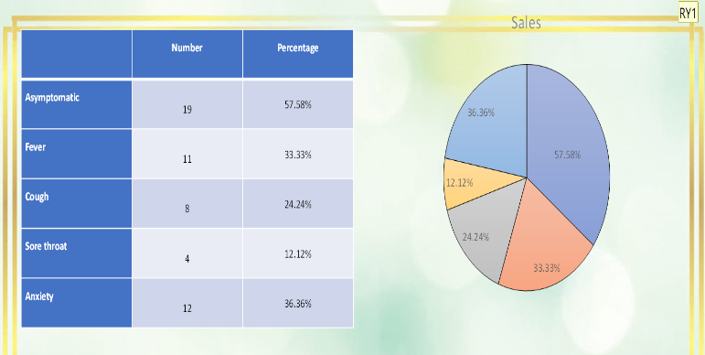
All mothers had history of exposure to Covid positive individuals either in the family or in close contact.
Asyptomatic cases dominated (57.58%) over symptomatic (considering physical symptoms only) cases. Asymptomatic cases were diagnosed by following contact tracing protocol. Fever was most common (33.33%) presenting symptom. Many patients had multiple symptoms.

Table 3: Showing the distribution of Mode of Delivery

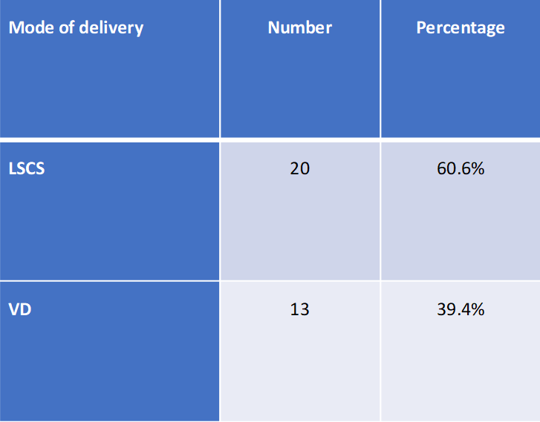

Table 4: Distribution of complications among study population

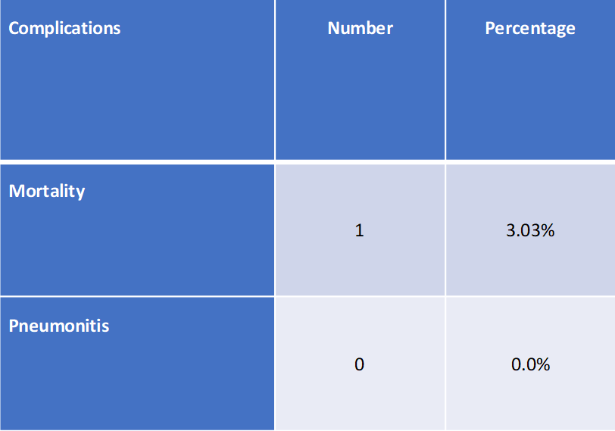

Table 3 showing 60.6% mothers were delivered by C section (but all were due to other obstetric indication).
Table 4 shows none of our study population had developed significant pneumonia. One case of mortality noted although not related to SARS CoV2 complication.
None of the neonates tested for SARS-CoV-2 viral nucleic acid on nasopharyngeal and oropharyngeal samples were resulted positive on day 2 and 5 evaluation as per government protocol. None of the babies had developed any sign of fever, pneumonia or any other morbid condition. No mortality noted.

Discussion

World Health Organisation (WHO) has reported that there is no apparent difference in the risk of developing clinical symptoms between non-pregnant and pregnant women of reproductive age.⁸
Patients most commonly present with mild symptoms of the infection including fever, cough, fatigue, and shortness of breath; however, many of them may be asymptomatic.^{3, 8}
In a retrospective review by Liu et al, a comparison of 59 patients, which included both pregnant and non-pregnant adults, was carried out. That review reported no significant difference between two groups regarding the development of the clinical features of SARS-CoV-2.⁴
According to one study, pregnancy itself does not worsen the symptoms experienced, or the findings on a CT scan of COVID-19 related pneumonia.¹

In our study, the most common symptom at presentation was fever among 33.33%, cough among 24.24% and sore throat among 12.1% women. None had developed breathlessness. The majority of the studies have supported the evidence of fever and cough as the most common presenting symptoms.^{3, 8}
Data from China found severe complications among 8% pregnant women with coronavirus disease (COVID-19).¹
A prospective cohort study using the UK Obstetric Surveillance System (UKOSS) found fever and cough as common symptoms in pregnant women having COVID-19 and less common symptoms include shortness of breath, diarrhoea, and myalgia.⁹
We have found 57.58% women were asymptomatic Covid positive diagnosed by contact tracing. Lesser morbidity and mortality amongst Covid 19 positive were observed in all categories of patients in India. Study by Smith V et al found the majority of women being asymptomatic and afebrile at presentation.⁵
As reported by Shah et al, most common symptoms at presentation were cough (61.6%) and fever (46.4%). They noted 38.4% of pregnant patients did not present with symptoms, but most of these patients were diagnosed as having COVID-19 infection by intensive field testing and contact tracing during the initial phase of outbreak in India.⁶
Other reported symptom was distressing anxiety among 36.36% of study population. Isolation, lack of knowledge regarding a comparatively new disease with high infectivity, bizarre look of heath care professionals (wearing PPE) are some of the explanations for unusual development of significant anxiety.
In our study, among 33 deliveries, LSCS was performed among 60.6% and vaginal delivery among 39.39% women following all protocols. C. sections were done not for Covid positive status in our study , but for other obstetric reason (mainly post- caesarean pregnancy). Study by Muhidin et al reported that the preferred mode of delivery in Covid 19 infected mothers was caesarean section to reduce neonatal infection. ¹⁰
Since there is limited evidence about vertical transmission and vaginal shedding of virus, vaginal delivery in stable patients may be considered.
Favre et al. suggested that for every individual patient, vaginal delivery even by induction should be considered. Using instrumental delivery also is preferred to caesarean section to avoid unnecessary surgical complications and maternal exhaustion.¹¹
With regard to the mode of delivery, caesarean section was performed in the majority of cases and several authors cited fetal distress as the reason behind the decision.^{12, 13}
Regarding the perinatal outcomes, most authors did not report any adverse events. ^{14, 15} In our study there was no evidence of vertical transmission. All our study subjects were infected in the later part of pregnancy, might be the explanation for the same. None of the babies had any other morbidity or mortality as evaluated by designated protocol of our study. In contrast, Zhu et al reported one neonatal death and a total of 6 admissions to the neonatal intensive care unit (ICU). The first symptom in the newborns was shortness of breath, observed in six neonates. Other initial symptoms were fever, thrombocytopenia accompanied by abnormal liver function, tachycardia, vomiting and pneumothorax in his study. ¹²
However, the severity of postnatally acquired disease in the newborn is unknown. A case series of 10 COVID-19 negative neonates born to COVID-19 positive mothers reported fetal distress, premature labor, respiratory distress, thrombocytopenia accompanied by abnormal liver function, and even death among neonates.⁶ This may indicate a possible association, but not necessarily a causal effect.

CONCLUSION

The available data revealed that clinical manifestations of pregnant women infected by SARS-CoV-2 in late pregnancy are similar to those of non-pregnant adults.
At present, there is no evidence regarding the greater risk of pregnant women to succumb to COVID-19 infection and experience severe pneumonia.
Maternal morbidity was evident as cough, fever, sorethroat and anxiety. No evidence of maternal mortality noted due to Covid complication in present study.
There was no evidence of vertical transmission and no fetal morbidity and mortality seen in our study. Following strict protocol at every stage of management of Covid 19 positive mother reduces chances of neonatal infection.
Overall, due to the lack of information on COVID-19 pneumonia in pregnancy, all suspected pregnant women should be systematically screened, monitored and followed up in current scenario.
Limitations
As novel corona virus infection is a new challenging situation, our study was limited to assess the obvious presentation and immediate outcome. All our samples contacted infection by SARS CoV2 in late pregnancy period, so evaluation of vertical transmission may not be the actual reflection. Long term studies are required to evaluate the all-out effect of Covid-19 infection on maternal as well as fetal health.

REFERENCES
1. Huang C, Wang Y, Li X, Ren L, Zhao J, Hu Y, et al. Clinical features of patients infected with 2019 novel coronavirus in Wuhan, China. Lancet. 2020; 395:497-506.
2. Fan C, Lei D, Fang C, Li C, Wang M, Liu Y, et al. Perinatal Transmission of COVID-19 Associated SARS-CoV-2: Should We Worry? Clinical Infectious Diseases. 2020.
3. Yu N, Li W, Kang Q, Xiong Z, Wang S, Lin X, et al. Clinical features and obstetric and neonatal outcomes of pregnant patients with COVID-19 in Wuhan, China: a retrospective, single-centre, descriptive study. Lancet Infect Dis. 2020; 20(5):559-64.
4. Liu H, Liu F, Li J, Zhang T, Wang D, Lan W. Clinical and CT imaging features of the COVID-19 pneumonia: focus on pregnant women and children. J Infect. 2020; 80(5):e7-13.
5. Smith V, Seo D, Warty R, Payne O, Salih M, Chin KL, et al. (2020) Maternal and neonatal outcomes associated with COVID-19 infection: A systematic review. PLoS ONE 15(6): e0234187.
6. Shah PT, Shah SR, Shah SR, Yadav PA, Patel BS, Chudasama TJ. Fetomaternal outcome in COVID-19 infected pregnant women: a preliminary clinical study. Int J Reprod Contracept Obstet Gynecol 2020; 9:3704-16.
7. Zaigham M, Andersson O. Maternal and perinatal outcomes with COVID-19: A systematic review of 108 pregnancies. Acta Obstet Gynecol Scand. 2020; 99(7):823-9.
8.Liu D, Li L, Wu X, Zheng D, Wang J, Yang L, et al. Pregnancy and perinatal outcomes of women with coronavirus disease (COVID-19) pneumonia: a preliminary analysis. Am J Roentgenol. 2020; 215: 1–6.
9. Chen H, Guo J, Wang C, et al. Clinical characteristics and intrauterine vertical transmission potential of COVID-19 infection in nine pregnant women: a retrospective review of medical records. Lancet 2020; 395:809-15.
10. Muhidin S, Behboodi Moghadam Z, Vizheh M. Analysis of Maternal Coronavirus Infections and Neonates Born to Mothers with 2019-nCoV; a Systematic Review. Arch Acad Emerg Med. 2020; 8(1):e49.
11. Favre G, Pomar L, Qi X, Nielsen-Saines K,Musso D, Baud D. Guidelines for pregnant women with suspected SARSCoV-2 infection. The Lancet Infectious Diseases. 2020.
12. Zhu H, Wang L, Fang C, Peng S, Zhang L, Chang G, et al. Clinical analysis of 10 neonates born to mothers with 2019-nCov pneumonia. Transl Pediatr. 2020; 9:51-60.
13.Liu Y, Chen H, Tang K, Guo Y. Clinical manifestations and outcome of SARS-CoV-2 infection during pregnancy. J Infect. 2020.
14. Liu Y, Zhao R, Zheng S. Lack of vertical transmission of severe acute respiratory syndrome coronavirus 2, China. Emerg Infect Dis. 2020; 26(6).
15. Wang S, Guo L, Chen L.A case report of neonatal COVID 19 infection in China. Clin Infect Dis. 2020. pii: ciaa225.

Received: 10.01.2021
Accepted: 12.01.2021
Published online: 15.01.2021
Citation: Nandi N, Azad A, Bajoai G. Feto-maternal outcome among Covid-19 positive women delivered in a Level III Covid hospital at Moradabad, Western UP. J Indian Acad Obstet Gynecol. 2021;2(2):31-36.

Department of Obstetrics & Gynaecology, Teerthankar Mahaveer Medical College & Research Centre, Morabad, UP
 Email: nupurnandi2002@gmail.com

Journal of Indian Academy of Obstetrics and Gynaecology January 2021
Vol. 2, Issue 2

Original Article

An analysis of maternal mortality – 3 years study in a tertiary care hospital

Suvobrata Sarkar, N Lavanya, Ranita Roy Chowdhury

ABSTRACT
Introduction: Pregnancy is considered to be a physiological state but can develop severe morbidities or even death during any period. Maternal mortality rate (MMR) is a sensitive index that reflects the quality of reproductive care provided to pregnant women. A maternal death is defined as death of a woman while pregnant or within 42 days of termination of pregnancy, irrespective of the duration and site of pregnancy, from any cause related to or aggravated by pregnancy or its management but not from accidental or incidental causes” (ICD-10)
Methodology: A retrospective observational hospital-based study was carried out in the department of Obstetrics and Gynecology, College of Medicine and JNM hospital which is a tertiary level health care referral center, situated in kalyani West Bengal, over a period of 3 years from January 2018 to December 2020. Distribution of maternal deaths in relation to age, parity index, gestational period, mode of delivery and admission to death interval causes of deaths and MMR was calculated.
Results: In this three-year study the total maternal mortality of 60. In 2018 maternal deaths were 24, in 2019 - 12 and 2020 -24. Maternal mortality due to direct causes was 45 (75%) and indirect causes were 15 (25%) altogether. The most common direct cause was hemorrhage (26.6%) considering ante partum, intra partum and postpartum deaths in all three years. The MMR as pr live birth during the study period was 277.
Conclusion: Maternal mortality can be prevented with better antenatal care and early referral as more deaths are due to direct cause.
Keywords: hospital-based, maternal, mortality

INTRODUCTION
Pregnancy is not a disease and childbirth are a universally celebrated event. Yet for thousands of women the outcome is not favorable and may end up even losing their lives. The tragedy is that a large number of these deaths are preventable. MMR is a sensitive index that reflects the quality of reproductive care provided to pregnant women.
According to the World Health Organization (WHO), “A maternal death is defined as death of a woman while pregnant or within 42 days of termination of pregnancy, irrespective of the duration and site of pregnancy, from any cause related to or aggravated by pregnancy or its management but not from accidental or incidental causes” (ICD-10).¹ Maternal mortality ratio (MMR) is defined as the number of maternal deaths per 100,000 live births. Almost half a million women die every year from complications during pregnancy and childbirth. About 99% of these women are from developing world with over 90% concentrated in Africa and Asia.²
About 295 000 women died during and following pregnancy and childbirth in 2017. The vast majority of these deaths (94%) occurred in low-resource settings, and most could have been prevented. Between 2000 and 2017, MMR dropped by about 38% worldwide. Between 1990 and 2015, the global maternal mortality ratio (MMR) decreased by 44%, from 385 to 216 maternal deaths per 100,000 live births.^{3]}In India, Maternal Mortality Ratio has declined to 113 in 2016-18 from 122 in 2015-17 and 130 in 2014-2016.⁴
Hence, this present study was conducted to review the existing maternal mortality ratio and the causes of maternal death at a tertiary care teaching hospital of rural India, so that corrective steps can be taken to reach the goal within the stipulated time frame as most of the deaths are preventable.

METHODOLGY
A retrospective analytical hospital-based study was carried out in the department of Obstetrics and Gynecology, College of Medicine and JNM hospital which is a tertiary level health care referral center, situated in Kalyani, Nadia, West Bengal, over a period of 3 years. Data regarding maternal mortality was collected from maternal mortality register of our hospital after obtaining permission. The details of maternal deaths from January 2018 to December 2020 were collected and analyzed with respect to following epidemiological parameters: - Distribution of maternal deaths in relation to age, parity index, gestational period, mode of delivery and admission to death interval and causes of deaths. Results were analyzed by using percentage. Maternal mortality rate (MMR) was calculated after obtaining the live births of these 3 years from hospital Data base.
Maternal mortality is classified by WHO Application of ICD -10 to deaths during Pregnancy, Childbirth and the puerperium ICD – MM into two major groups - Direct causes and indirect causes. The DIRECT causes are 1. Pregnancy with abortive outcome including ectopic pregnancy and gestational trophoblastic disease. 2. Hypertensive disorders in Pregnancy birth and puerperium including HELLP syndrome.3. Obstetric hemorrhage (except Haemorrhage) excluding abortive hemorrhage 4. Pregnancy related infection excluding abortion outcome 5. Others obstetric complications like Amniotic fluid Embolism, uterine inversion, hepatorenal failure due to vomiting during pregnancy and unexplained. 6. Unanticipated complications of management. The Maternal Death due to INDIRECT causes is due to 7. Non-obstetric complications like a. Anemia b. Cardiac disorders like cardiomyopathy myocardial infarctions c. Liver Disorders like acute fatty liver of pregnancy, infective hepatitis d. Respiratory disorders like ARDS Pulmonary embolism e. Renal disorders like acute renal failure e. endocrinal disorders like diabetes f. neurological disorders like cerebral embolism g. infection/infestations like malaria Dengue HIV etc. Maternal deaths UNSPECIFIED are due to unknown causes. The last category is COINCIDENTAL causes due to external causes.

RESULTS
In this three-year study the total maternal mortality of 60. In 2018 maternal deaths were 24, in 2019 - 12 and 2020 -24. Maternal mortality due to direct causes was 45 (75%) and indirect causes were 15(25%) altogether. The most common direct cause was hemorrhage (26.6%) considering ante partum, intra partum and postpartum deaths in all three years. Other important causes contributing to the mortality were pregnancy induced hypertension, (18.3%) abortion (20%) and sepsis (10%) in pregnancy. Among the indirect cause’s death due to hepatic reasons and renal reasons were more frequent. The direct and indirect causes of death are summarized in Table 1 and 2. Another outcome observed in this study was maximum maternal mortality took place during immediate peurperium. 14 maternal mortalities were seen within 20 weeks of gestation among which 9 was related to abortion, 3 dues to ectopic pregnancy 1 anemia and 1 indirect infective cause (Dengue). One was during ante natal period when patient came with antepatrum eclampsia and succumbed within minutes. Other 45 mortalities were after delivery, though in most cases pathology leading to death raised in antenatal period. Considering the total live births in these 3 years were 21584 the maternal mortality was 277 in our institution.
Maternal mortality was mostly seen among multi gravida patients. Considering the age groups maximum deaths were among 30 to 34 years. Maternal deaths were increased with maternal age.

DISCUSSION
Pregnancy, though a physiological state if not kept under constant vigil, can develop severe morbidities or even death during any period. The death carries with it a huge grief and pain for the family, and also an immeasurable loss to the new born or young ones left behind.
From 2000 to 2017, the global maternal mortality ratio declined by 38 per cent – from 342 deaths to 211 deaths per 100,000 live births, according to UN inter-agency estimates. This translates into an average annual rate of reduction of 2.9 per cent. While substantive, this is less than half the 6.4 per cent annual rate needed to achieve the Sustainable Development global goal of 70 maternal deaths per 100,000 live births. There has been significant progress since 2000. Between 2000 and 2017, South Asia achieved the greatest overall percentage reduction in MMR, with a reduction of 59 per cent (from 395 to 163 maternal deaths per 100,000 live births). Sub-Saharan Africa achieved a substantial reduction of 39 per cent of maternal mortality during this.⁵ In our institution the maternal mortality was 277 which is higher than national average. This is because referred cases are higher in this institution.
A study conducted in Safdarjang Hospital in New Delhi revealed that 120 maternal deaths occurred during the year beginning 1 July 2003 to 30 June 2004 with post-partum hemorrhage (26%) as the leading direct cause of death; 89% of cases were un-booked.⁶ In our study obstetrical hemorrhage was the leading cause of maternal mortality.
In a study conducted in a tertiary care hospital in a neighboring country, Pakistan, Begum, et al. showed the maternal mortality rate as 12.7/1000 live births. In the similar study from a tertiary care hospital, the leading cause of death was obstetric hemorrhage followed by other causes.⁷

Study conducted in West Bengal the majority of the deaths occurred in the 20-24 years’ age group, those with Hindu religion, and the postpartum period. One third of mothers had cesarean sections. The majority (78.2%) of deaths were among referred cases. Eclampsia was the leading cause of maternal death (29.1%). The study found that the eclampsia accounted 29.1%, which made it the leading cause of maternal mortality, followed by hemorrhage (22.7%) and infections/sepsis (10.9% Approximately half of the deceased women sought care after 10 hours of developing complications. More than one-third of maternal deaths were registered with type 1 delays.⁸ In the current study also most deaths were in postnatal period though the second leading cause was eclampsia.

A total of 120 maternal deaths occurred in a tertiary care centre in southern most part of west Maharastha. Most maternal deaths occurred in the age group of 20-24 years, multiparous women (56.66%), women from rural areas (69.16%), illiterate women (65%), unbooked patients (83.33%), and patients of low socioeconomic status (83.33%). Direct causes accounted for 72.5% of maternal deaths where as 27.5% of maternal deaths were due to indirect causes.⁹ In this study direct cause of death was 75% and indirect cause was 25% which was at per with the afore said study.

The Maternal mortality ratio in the study period from December 13 to December 16 in a tertiary care in new Delhi was 361.71/100,000 live births. The number of maternal deaths was 364. Unbooked cases accounted for the majority, i.e., 322, booked being 29 and registered 13. Two hundred and eleven cases were referred from other centers. Maximum deaths occurred between 21 and 30 years (73.07%). Anemia was widely prevalent. Most maternal deaths were due to direct causes like hypertensive disorders (28.02%), pregnancy-related infections (20.87%), and hemorrhage (12.36%). Among indirect causes, anemia, hepatitis, heart disease and respiratory illness accounted for 15.93, 11.53, 3.29 and 5.49%, respectively. Type I delay was most common (64.28%).¹⁰

A retrospective study of maternal deaths from January 2015 to December 2015 there was a total of 56 maternal deaths out of 6976 live births giving the MMR of 802/1,00,000 live births. The MMR is high as it is an institution MMR and this is tertiary care institution which caters to 3 districts. Late referrals were 64.28%. The majority of deaths were in the 21-25 age groups and around term 33 (58.92%). Hypertensive disorders were the commonest cause of death 15 (26.78%) followed by hemorrhage 10 (17.8%) and sepsis 7 (12.5%) and CVT 7 (12.5%).¹¹ The current study institution also cater 3 nearby district and the maternal mortality is more compared to national standard.

This is an institution-based, retrospective study in Minia Maternity and Children University Hospital, Minia governorate, Egypt. Data collection was done between January 2008 and December 2017.From 2008 to 2017 MMR in this hospital was 186/100.000 live births. Most frequent causes of maternal mortality were postpartum hemorrhage, hypertensive disorders of pregnancy and sepsis.¹²
CONCLUSIONS
Maternal mortality reflects the quality of obstetric services given to pregnant women in the community. MMR is still high in India and appropriate steps need to be taken at grassroot level. As most causes of maternal mortality are direct causes scope for improvement is large. Early detection of high-risk cases and early referral can reduce deaths.

BIBLIOGRAPHY
1. International Classification of Diseases and Related Health Problems. Geneva: World Health Organization,1992
2. Badrinath M, Karekal SA. Maternal mortality: A retrospective study. IOSR J Nurs Health Sci 2015; 4:10‐3.
3. Trends in maternal mortality: 2000 to 2017: estimates by WHO, UNICEF, UNFPA, World Bank Group and the United Nations Population Division. Geneva: World Health Organization; 2019.
4. https://censusindia.gov.in/vital_statistics/SRS_Bulletins/MMR%20Bulletin%202016-18.pdf
5. https://data.unicef.org/topic/maternal-health/maternal-mortality/ last accessed on 06/01/2021.
6. Salhan S. Process documentation of the initiative to “improve the quality of Maternal Health through implementation of facility-based review of maternal deaths” Regional Health Forum. 2005;9(1):19–26. [Google Scholar]
7. Begum S, Aziz-un-Nisa, Begum I. Analysis of maternal mortality in a tertiary care hospital to determine causes and preventable factors. J Ayub Med Coll Abottabad. 2003; 15:49–52. [PubMed] [Google Scholar]
8. Sk MIK, Chattopadhyay A, Anand A, Naskar TK, Chakraborty S. Analyzing the etiology behind mortality associated with antepartum, intrapartum, and post-partum cases in a tertiary care teaching hospital of West Bengal. J Turk Ger Gynecol Assoc. 2018 Jun 4;19(2):65-71. doi: 10.4274/jtgga.2017.0136. Epub 2018 Mar 28. PMID: 29588262; PMCID: PMC5994816.
9. Murthy BK, Murthy MB, Prabhu PM. Maternal Mortality in a Tertiary Care Hospital: A 10-year Review. Int J Prev Med. 2013 Jan;4(1):105-9. PMID: 23411635; PMCID: PMC3570901.
10. Mittal P, Kapoor G, Kumari N, Bajaj B. Review of Maternal Mortality at a Tertiary Care Hospital: What Have we Achieved? J Obstet Gynaecol India. 2019 Apr;69(2):149-154. doi: 10.1007/s13224-018-1129-1. Epub 2018 May 21. PMID: 30956469; PMCID: PMC6430275.
11. K. P. Mohana Sundari, R. Padma Priya, Subathra. Maternal mortality: analysis of causes and preventable factors. https://dx.doi.org/10.18203/2320-1770.ijrcog20161478
12. Mohammed, M.M., El Gelany, S., Eladwy, A.R. et al. A ten-year analysis of maternal deaths in a tertiary hospital using the three delays model. BMC Pregnancy Childbirth 20, 585 (2020). https://doi.org/10.1186/s12884-020-03262-7

Table 1 Direct Obstetric causes of mortality
Year | Total | Hemorrhage  APH+IPH+ PPH | Pregnancy induced Hypertension | Sepsis excluding abortive | Abortive + Ectopic
2018 | 20 | 4+2+0=6 | 6 | 2 | 5+1
2019 | 7 | 1+2+1=4 | 2 | 0 | 0+1
2020 | 18 | 2+0+4=6 | 3 | 4 | 4+1
Total (percentage of total deaths) | 45(75%) | 16(26.6%) | 11(18.3%) | 6(10%) | 12(20%)

Table 2 – Indirect obstetrics causes of mortality
Year | Total | Anemia | CVS | Liver | Resp | Renal | CNS | Infective
2018 | 4 | 0 | 2 | 1 | 0 | 0 | 0 | 1
2019 | 5 | 0 | 1 | 1 | 1 | 2 | 0 | 0
2020 | 6 | 1 | 0 | 2 | 1 | 1 | 1 | 0
Total | 15(25%) | 1 | 3 | 4 | 2 | 3 | 1 | 1

Table 3 Demographic factors Age, Parity
Age of mother | Gestational age
 | <20 weeks |  | 20wks to delivery | Post-partum |  | Total
<20years | 1 |  | 1 | 3 |  | 5(8.3)
20-24 years | 2 |  | 0 | 6 |  | 8(13.3)
25-29 years | 3 |  | 0 | 12 |  | 15(25%)
30-34 years | 6 |  | 0 | 14 |  | 20(33.3)
>35 Years | 2 |  | 0 | 10 |  | 12(20%)
Total | 14(23.3%) |  | 1 | 45(75%)
 | Pariety
Primi | 4 | 1 |  | 19 | 24(40%)
Multi | 9 | 0 |  | 27 | 36(60%)
 | Mode of delivery
Live births | Vaginal (11) instrumental (4) operative (13) |  |  |  | 28
Still born/IUFD | Vaginal (12) Instrumental (3) Operative (2) PMCS*(1) |  |  |  | 18
 | Referred or in patient
Referred cases | 26(43.3%)
In patient | 34(56.6%)

PMCS – postmortem Caeseraen

Received: 11.01.2021
Accepted: 14.01.2021
Published online: 15.01.2021
Citation: Sarkar S, Lavanya N, Roy Chowdhury R. An analysis of maternal mortality – 3 years study in a tertiary care hospital. J Indian Acad Obstet Gynecol. 2021;2(2):37-41.

Dept.Obs & Gyn,
College of Medicine and JNM Hospital, Kalyani, West Bengal
 Email: suvobratas@gmail.com

Journal of Indian Academy of Obstetrics and Gynaecology January 2021
Vol. 2, Issue 2

Case Report

A case of massive hematometra and hematocolpos with imperforate hymen

Shraddha Kiran Swami, Oby Nagar, Suwaram Saini, Manish Bhardwaj

ABSTRACT
Introduction: Imperforate hymen is the most common obstructive congenital anomaly of female genital tract which prevents passage of menstrual bloodcausing hematometra and hematocolpos but its diagnosis is delayed and usually missed in emergency settings.
Case report: Here presenting a case of 14 year old girl who presented to emergency department with complaints of cyclical lower abdominal pain and primary amenorrhoea since 2 years and lower abdominal mass since 6 months.Secondary sexual characteristics were normal for her age.A bulging vaginal membrane with bluish hue noted on perineal examination was suggestive of imperforate hymen.The transabdominal ultrasound revealed hematometra,hematocolpos, right sided hydrosalpinx and left renal hydronephrosis. She underwent virginity preserving hymenotomy with drainage of approximately 1000cc menstrual blood.
Conclusion: Early diagnosis and treatment can prevent serious complication of imperforate hymen.Imperforate hymen can be diagnosed easily with detailed history and gynaecological examination.Virginity preserving hymenotomy is surgery of choice.
Keywords: Hematocolpos, hematometra, hymenotomy, imperforate hymen

INTRODUCTION
Imperforate hymen, although rare, is the most common obstructive congenital anomaly of the female genital tract, with an incidence of approximately 1 in 2000 females.¹ It occurs when the sinovaginal bulb fails to canalize with rest of vagina. Imperforate hymen prevents passage of blood causing accumulation of menstrual products in the vagina (hematocolpos), uterus (hematometra) and/or fallopian tubes (hematosalpinx).² Mostly imperforate hymen is sporadic in nature.³ The most common age of presentation is around puberty.⁴ It typically presents with delayed menarche, cyclic lower abdominal pain, per abdomen mass and bulging vaginal membrane at the vaginal introitus. Complications of untreated imperforate hymen include pelvic infection with tubo-ovarian abscess, obstructive acute renal failure, non-urological urine retention, peritonitis, endometriosis, mucometrocolpos, constipation, and recurrent urinary tract infection.^{5,6} Here we present the case of a young female with delayed menarche with a large palpable abdominal mass as a result of imperforate hymen.

CASE REPORT

A 14-year-old girl referred to OBGY department of SMS Medical College, Jaipur with history of delayed menarche, cyclical lower abdominal pain for 2 years and lower abdominal mass for 6 months. She had a complaint of increased frequency of micturition since last three months. There was no history of nausea, vomiting, constipation or urinary retention. There was no previous history of trauma or surgery. Her secondary sexual characteristics were normal for her age (Tanner stage III). There was no family history of primary amenorrhea.
Fig 1: Lower abdominal mass secondary to imperforate hymen

On general examination patient was stable, oriented and secondary sexual characteristics were normal for the age. On Per abdominal examination atendor, cystic, dull on percussion lower abdominal mass approximately 22 -24 weeks in size was palpable (Fig.1). On perineal examination, normal external genitalia with a bulging vaginal membrane with bluish hue seen suggestive of imperforate hymen. Her haemoglobin was 9.5, renal function test and all other routine investigations were normal. The transabdominal USG revealed bulky uterus with grossly dilated endometrial and cervical canal with echogenic fluid and maximum width measuring 82 mm. Right sided hydrosalpinx with left kidney moderate hydronephrosis also noted.

The diagnosis of hematometra and hematocolpos secondary to imperforate hymen made and decision of hymenotomy with drainage of hematometra was taken.

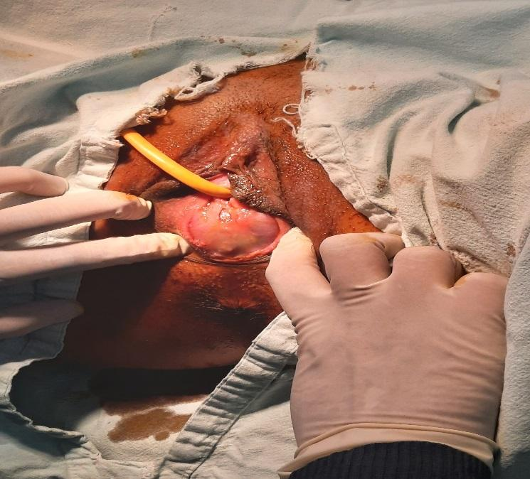
Fig 2: vaginal membrane with bluish hue suggestive of imperforate hymen

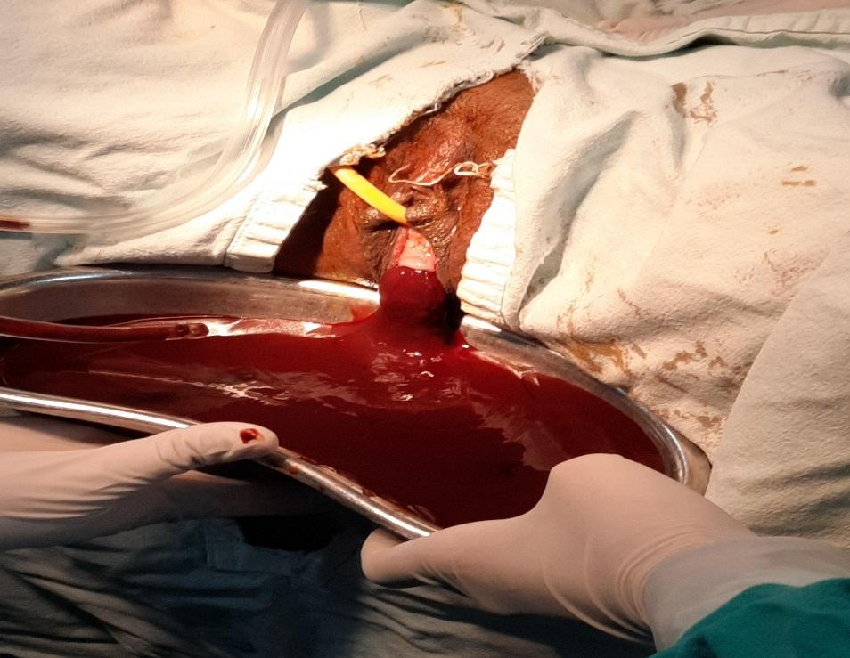

Fig 3: Dark coffee colored menstrual blood coming out after applying incision

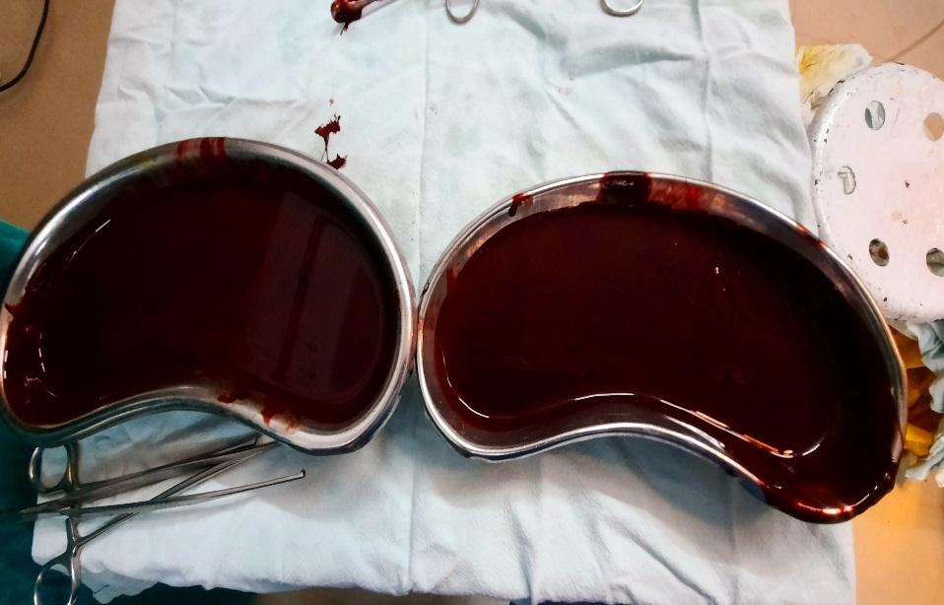

Fig 4: Approximately 1000 cc drained menstrual blood

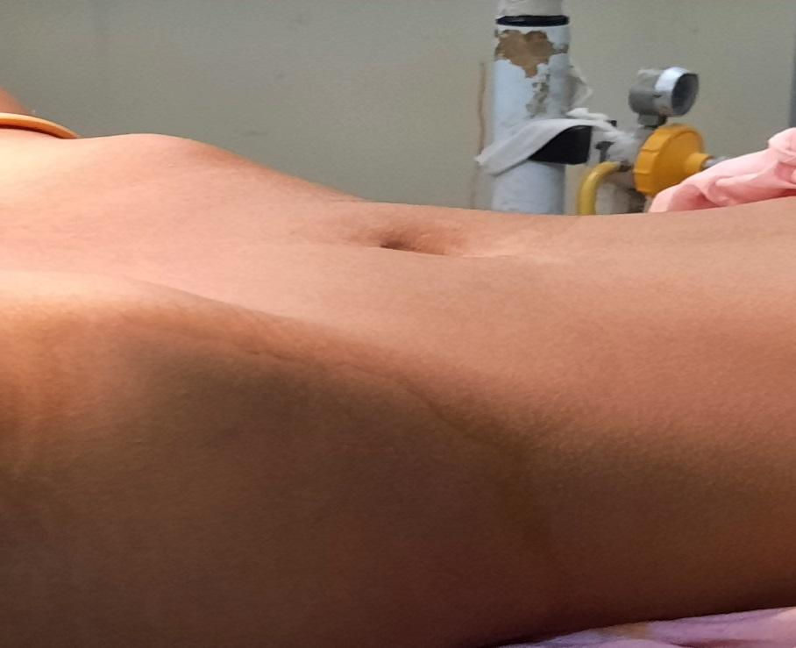

Fig 5: Postoperative picture showing disappearance of abdominal mass

IV Antibiotics were given for 2 days and patient was instructed to maintain the perineal hygiene. Postoperative period was uneventful and she was discharged in satisfactory condition after 2 days with oral antibiotics. Follow up after two month revealed patent outflow tract with normal menses.

DISCUSSION
The hymen is a vestigial membrane at the junction between sinovaginal bulb and urogenital sinus. Normally it ruptures partially at the inferior portion at 8th week of gestation to establish connection between the vaginal lumen and exterior. Complete failure of the inferior end of the vaginal plate to canalize leads to imperforate hymen.⁷ It is an isolated anomaly but rarely can be associated with other female genitourinary tract anomalies or genetic disorders.⁴ So we need to rule out other associated mullerian anomalies.
The diagnosis is easy with detailed history and gynaecological examination. Typically, imperforate hymen presents with primary amenorrhea and a cyclic pattern of lower abdominal pain⁸, with or without associated symptoms such as back pain(38%–40%), urine retention (37%–60%)^{7,9}, or constipation (27%). It may present as acute abdomen in emergency. So sometimes misdiagnosed as acute appendicitis, peritonitis, urinary tract infection, ovarian torsion etc. This is why thorough genitourinary examination in girls of all ages from birth through the onset of menarche should be performed. If patient or parents refuse for genital examination, imaging studies can greatly help with diagnosis. Ultrasound will show an echogenic fluid accumulation in the vagina that can extend to uterus. In low-resources settings, imaging modalities may not be available.
In a newborn, uterovaginal secretions under influence of maternal estrogen collect in blind vaginal cavity result in hydrocolpos and hydrometra.⁴ But, usually, the diagnosis of cases like this is delayed and is discovered near puberty. According to Lui et al mean age of presentation is 12 years.¹⁰ Differential diagnosis of imperforate hymen includes other obstructive reproductive tract anomalies like transverse vaginal septum, vaginal atresia, phimosis of cervix and mucocolpos.¹¹
Once diagnosed, the treatment of imperforate hymen is either hymen sparing hymenotomy or non-sparing hymenectomy (excision of the hymenal tissue). The standard surgical procedure is hymenotomy using cruciate, T, plus, or X shaped (at 2-, 4-, 8-, and 10-o’clockpositions) incisions and removal of excess hymenal tissue. The outcome of the surgery is excellent and recurrence is rare. Needle aspiration of hematocolpos is discouraged due to the risk of infection and pyocolpos formation. Acar et al. advocated incision and insertion of Foleys catheter as a drain for 14 days for better preservation of the hymen and virginity, but the risk of ascending infection and the discomfort of having in-situ Foleys catheter in the young girls made the procedure unpopular.¹² Preservation of virginity should be taken into serious account, as virginity is cherished by many religions and families. Most girls who want to conceive after surgery usually achieve pregnancy.

CONCLUSION
Imperforate hymen is although the most common congenital anomaly of female genital outflow tract, but it is rare. The diagnosis is usually missed in emergency settings. History taking and careful gynecological examination should be recommended in premenarchal girls presenting with abdominal pain.Young girls presenting with amenorrhoea and cyclical abdominal pain should be suspected of this condition. Early diagnosis and treatment can prevent serious complications. Virginity-preserving hymenotomy is standard care of choice.

REFERENCES

- Parazzini F, Cecchetti G. The frequency of imperforate hymen in Northern Italy. Int J Epidemiol. 1990;19(3):763–4.
- Ipyana HM, Baraka AM. Imperforate hymen presenting with massive haematocolpos and acute urinary retention in a teenage girl: A case report. Tanzan J Health Res. 2012;14(4):293-6.
- Sakalkale R, Samarakkody U. Familial occurrence of imperforate hymen. J Pediatr Adolesc Gynecol. 2005;18(6):427-9.
- Nagai K, Murakami Y, Nagatani K, et al. Life threatening acute renal failure due to imperforate hymen in an infant. Pediatr Int. 2012;54(2):280-2.
- Ho JW, Angstetra D, Loong R, Fleming T. Tuboovarian abscess as primary presentation for imperforate hymen. Case Rep Obstet Gynecol. 2014:1420396.
- Gueye M, Seck SM, Ndiaye-Guèye MD, et al. Imperforate hymen complicated by obstructive acute renal failure. Niger J Paed. 2013;40:79-81.
- Basaran M, Usal D, Aydemir C. Hymen sparing surgery for imperforate hymen: case reports and review of the literature. J Pediatr Adolesc Gynecol. 2009;22(4):61-4.
- Lardenoije C, Aardenburg R, Mertens H. Imperforate hymen: a cause of abdominal pain in female adolescents. BMJ Case Rep. 2009: (2009):bcr0820080722.
- Salhan B, Omisore OT, Kumar P, Potter J. A rare presentation of imperforate hymen: a case report. J Case Rep Urol. 2013;2013:731019.
- Lui CT, Chan TWT, Fung HT, Tang SYH. A retrospective study on imperforate hymen and hematocolpos in a regional hospital. Hong Kong J Emerg Med. 2010;17(5):435-40.
- Bakos O, Berrghind L. Imperforate hymen and ruptured haemosalphinx: a case report with a review of literature. J Adolesc Health. 1999;24(3):226-8.
Acar A, Balci O, Karatayli R, Capar M, Colakoglu MC. The treatment of 65 women with imperforate hymen by a central incision and application of Foley catheter. BJOG. 2007;114(11):1376-9.

Received: 24.12.2020
Accepted: 09.01.2021
Published online: 15.01.2021
Citation: Swami SK, Nagar O, Saini S, Bhardwaj M. A case of massive hematometra and hematocolpos with imperforate hymen: A Case Report. J Indian Acad Obstet Gynecol. 2021;2(2):42-45.

Department of Obstetrics and Gynecology, SMS Medical College Jaipur, Rajasthan, India
 Email: sshraddhakiranswami@gmail.com

Journal of Indian Academy of Obstetrics and Gynaecology January 2021
Vol. 2, Issue 2

Case Report

A case of Placenta Percreta in a Post-caesarean patient with Scar Rupture at 30 weeks of pregnancy – Management

Anindita Jana, Abhijit Halder, Nupur Nandi, Pijush Bepari, Sagar R. Gaikwad

ABSTRACT
Placenta percreta is the most dreadful form of placental accreta syndrome. It is a variant of placenta accreta in which chorionic villi penetrates the entire thickness of the myometrium through the uterine serosa and may involve the adjacent structures. A 31 years old second gravida with previous one LUCS came to GOPD at 30 weeks POG with C/O mild lower abdominal pain. She was already diagnosed with placenta percreta at USG FPP of 12 weeks 6days. Despite all the risks and possibilities counselled during first diagnosis, she wanted to continue the pregnancy. At 30 weeks of POG with mild lower abdominal pain, she was admitted with a plan to continue the pregnancy till 34weeks under strict monitoring. But on the third day of admission, the intensity of lower abdominal pain increased with increased supra-pubic tenderness with clinical signs of impending scar rupture. Patient was taken for immediate intervention. During OT, it was diagnosed as a case of scar rupture with placental tissue popping out. Baby delivered by classical section, followed by bilateral internal iliac artery ligation and peripartum hysterectomy. Internal iliac ligation prior to hysterectomy reduced intra-operative blood loss, improving the maternal outcome and decreasing the maternal morbidity.
Keywords: obstetric hysterectomy, poft CS, placenta previa

CASE REPORT
A 31years old gravida two, para one with prior one cesarean section presented with complain of lower abdominal pain. She was a booked case of our hospital followed up for Ante-natal check-up. Her USG FPP of 12 weeks 6 days of gestation showed placental location at lower segment anteriorly and completely covering the internal os suggesting central placenta previa. There was also evidence of invasion of placenta into anterior myometrium with loss of retro-placental hypo-echoic halo with impact on urinary bladder wall, sign of placenta percreta. Patient had been counselled about risks of continuing the pregnancy and emerging need of hysterectomy at any point of period of gestation. Still she wanted to continue with the pregnancy. Then, at 30 weeks patient presented at GOPD with mild lower abdominal pain. USG FPP shows AGA of fetus around 29weeks 4days and placenta in anterior wall with grade II maturity with almost absence of myometrium at lower segment, suggestive of placenta percreta. Patient admitted with a plan of continuation of pregnancy until 34weeks under strict in-patient supervision. Twice weekly USG FPP and daily CTG planned for the patient and she was kept under strict monitoring of vitals (pulse, BP, U/O, Hb- 8.4 gm/dL) and antenatal steroid dosage for fetal lung maturity started. But, on the third dayof admission, the lower abdominal pain increased; on palpation, there was intense supra-pubic tenderness and the uterus found to be irritable. Patient had pulse around 124/min, BP – 100/70 mm Hg suggesting clinical signs of impending scar rupture. Patient shifted to OT immediately with 4 units pRBC in hand and operative procedure started under General Anesthesia. Abdomen opened with supra-umbilical vertical incision and 700 mL hemoperitoneum found mainly confined in front of previous lower segment caesarean scar. Upon removing the blood clots,scar dehiscence noted on lower uterine segment with placental mass popping out and invading the bladder seen.Girl baby of 1165 gms was delivered by breech extraction through midline vertical incision in upper segment of uterus. Baby handed over to neonatologist for further care and management. Maternal end of umbilical cord with placental mass kept in situ and the fundal incision repaired in single layer with vicryl 1-0 suture to reduce the blood loss. Trial for hysterectomy taken but torrential hemorrhage from the placental site obscured the field of surgery. Then,bilateralinternal iliac artery ligationdone andbilateral uterine cornu clamped, excised and ligated followed by obstetric hysterectomy is performed. Placental mass separated from bladder base as much as possible with fine dissection. Then, vault repaired in two layers.Drain placed in peritoneal cavity and abdomen closed in layers. Patient shifted to HDU for strict hemodynamic monitoring. 2 units pRBC transfused intra-operatively and 2 units pRBC transfused on post-operative day 1 and 2. Post-operative period was otherwise uneventful and patient was discharged on post-operative day 6. Baby discharged from neonatal unit after 15days of hospital stay attaining body weight of 1.5 kgs. HPE revealed that the placental tissue had invaded the entire uterine wall, confirming the diagnosis of placenta percreta.
DISCUSSION
Adherent placenta is one of the concerning situations which has a great potential to affect the health and life of the patient, if not managed well.
Its incidence is increasing day by day probably due to rise in the rate of caesarean section. ACOG estimated in 2002 that placenta accreta complicates around 1 in 2500 pregnancy, a tenfold rise in last 50 years.¹

As per ACOG recommendation, there are several management options for placenta percreta ranging from immediate salvage surgeries to expectant conservative managements discussed below;¹

- When placenta accreta syndrome diagnosed first time intra-operatively, and the removal of placenta not possible in usual manuavers; uterine incision should be closed immediately and decision for obstetric hysterectomy to be taken as early as possible.

- Expectant management -Methotrexate, can be used for placental resorption.² Serial beta HCG monitoring,serial USG to look for placental volume and MRI may be used for monitoring the regression of placental mass.The biologic plausibility of this method is questionable as methotrexate targets rapidly dividing cells and division of 3rd trimester placental cells are limited. Also, methotrexate has the potential for maternal hematologic and nephrologic toxicities and is contraindicated in breast-feeding because of neonatal morbidity.^{3,4}
Some authors have left the placenta in situ without giving any agent for resorption, and the results are good. But there are high risks of associated complications like maternal sepsis,peritonitis, uterine necrosis, fistula, DVT/ PE, AKI etc. Nevertheless, in case of major haemorrhage, as in our case, there is no role of expectant management, and hysterectomy should be considered without delay to prevent major maternal complications or even maternal death.⁴

- For expectantly managed patients with persistent placental tissue with or without substantial bleeding, hysteroscopic resection of the placental remnants has been proposed as an adjunctive treatment.⁵ High-intensity focused ultrasonography has also been used in conjunction with hysteroscopic resection.⁶ The frequency of adverse events, and the proportion of patients who needed a repeat procedure, routine hysteroscopic resection with or without antecedent high-intensity focused ultrasonography is not recommended.

- Delayed interval hysterectomy – it is another procedure for the expectant management of placenta accreta syndrome, specifically where future fertility is not a concern, and there is need for minimizing blood loss and tissue damage intra-operatively.^{7,8} But, here is also risks of adverse outcomes including DIC and septic shock, causing major concerns of maternal morbidity. Moreover, where there is torrential hemorrhage with slight handling of uterine tissue intra-operatively, there is no role of delayed hysterectomy.

e. Future Fertility - Expectant management of placenta accreta spectrum appears to have minimal effect on subsequent fertility but does carry a high recurrence risk of placenta accreta spectrum.⁹

CONCLUSION

The case of placenta increta in a post caesarean pregnancy diagnosed at first trimester continued till third trimester and then termination with good maternal and neonatal outcome is an interesting case. Though the placenta accreta syndrome has perspective of expectant management specially to avoid bladder and bowel injury, it has many drawbacks. Intra-operatively, ligating the bilateral internal iliac artery to secure hemostasis before proceeding for obstetric hysterectomy is an novel step for reducing intra-operative maternal blood loss and preventing morbidity. Hence, if future fertility is not a concern, concurrent hysterectomy with internal iliac ligation is the best option for decreasing maternal mortality and morbidity.

REFERRENCES

- American College of Obstetricians and Gynecologists Placenta Accreta Committee opinion, No. 266, January 2002 accessed on 25.12.2020.
- Ramoni A, Strobl EM, Tiechl J, Ritter M, Marth C. Conservative management of abnormally invasive placenta: four case reports. Acta Obstet Gynecol Scand. 2013;92:468–71.
- Fox KA, Shamshirsaz AA, Carusi D, et al. Conservative management of morbidly adherent placenta: expert review. Am J Obstet Gynecol. 2015;213:755–60.
- Sentilhes L, Ambroselli C, Kayem G, et al. Maternal outcome after conservative treatment of placenta accreta. Obstet Gynecol. 2010;115:526–34.
- Legendre G, Zoulovits FJ, Kinn J, Senthiles L, Fernandez H. Conservative management of placenta accreta: hysteroscopic resection of retained tissues. J Minim Invasive Gynecol. 2014;21:910–3.
- Ye M, Yin Z, Xue M, Deng X. High-intensity focused ultrasound combined with hysteroscopic resection for the treatment of placenta accreta. BJOG 2017;124(suppl 3):71–7.
- Clausen C, Lonn L, Langhoff-Roos J. Management of placenta percreta: a review of published cases. Acta Obstet Gynecol Scand. 2014;93:138–43.
- Lee PS, Kempner S, Miller M, et al. Multidisciplinary approach to manage antenatally suspected placenta percreta: updated algorithm and patient outcomes. Gynecol Oncol Res Pract. 2017;4:11.
Sentilhes L, Kayem G, Ambroselli C, et al. Fertility and pregnancy outcomes following conservative treatment for placenta accreta. Hum Reprod. 2010;25:2803–10.

FIGURES

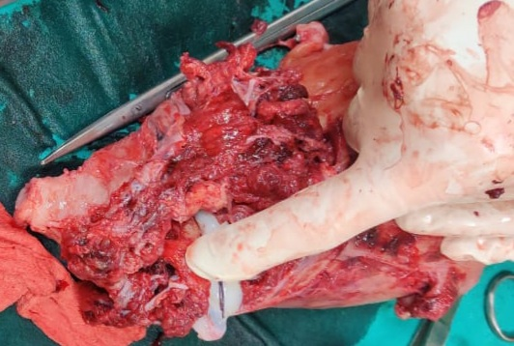

Figure 1: Specimen of uterus with placenta percreta after obstetric hysterectomy

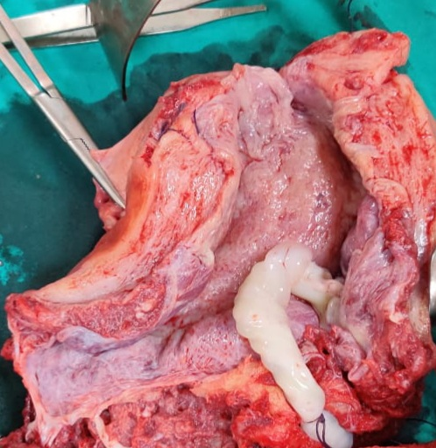
Figure 2: Cut open specimen of uterus after obstetric hysterectomy
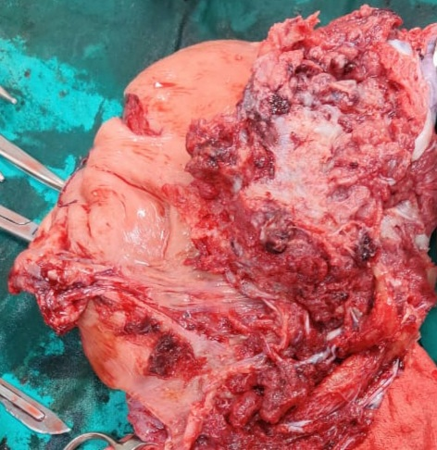
Figure 3: Specimen of uterus with placenta percreta invading the uterine wall all over

Received: 10.01.2021
Accepted: 12.01.2021
Published online: 15.01.2021
Citation: Jana A, Halder A, Nandi N, Bepari P, Gaikwad SR. A case of Placenta Percreta in a Post-caesarean patient with Scar Rupture at 30 weeks of pregnancy – Management. J Indian Acad Obstet Gynecol. 2021;2(2):46-49.
Department of Obstetrics and Gynecology, COM&JNMH, Kalyani, West Bengal
 email: draninditajana@gmail.com

Journal of Indian Academy of Obstetrics and Gynaecology January 2021
Vol. 2, Issue 2
Book Review

D C Dutta’s Textbook Gynecology

Soma Bandyopadhyay

D C Dutta’s Textbook of Gynecology, 8th edition, edited by Hiralal Konar, has been published in January 2020 by Jaypee Brothers Medical Publishers (P) Ltd. This book is very much student friendly. The main appealing characteristic of this book is its lucidity. Each topic is described vividly but to the point. Instead of linguistic jugglery, language of the book is kept very simple for easy understanding. All the important information of a topic is presented in such a manner that it becomes very easy to memorise. Presence of boxes with salient features and key point summary are very useful during quick revision. Flowcharts are excellent to make a difficult topic into an easy one.
Updated information has been provided regarding all the subspeciality of gynecology viz. infertility, reproductive endocrinology, oncology, adolescent gynecology, endoscopic surgery, urogynecology etc. Informative and perfectly drawn illustrations as well as photographs, increases the potentiality of the book very much. Questions along with their answers and explanations help the trainees to prepare better for the viva-voce and other examinations.
This book is a worthy textbook not only for MBBS, MS (O&G) students but also for the practicing clinicians, faculties, nursing and AYUSH.

Received: 25.12.2020
Accepted: 25.12.2020
Published online: 15.01.2021
Citation: Bandyopadhyay S. D C Dutta’s Textbook of Gynecology. J Indian Acad Obstet Gynecol. 2021;2(2):50
Dept of Obs & Gyn, Katihar Medical College, Katihar, Bihar
 Email: somapb@gmail.com

Journal of Indian Academy of Obstetrics and Gynaecology January 2021
Vol. 2, Issue 2

Author’s Guidelines

Original quality works only deserves the acceptance. All manuscripts will be reviewed by two anonymous peer reviewers and Editorial members, unless otherwise specified. If the quality is not maintained and subject of work is beyond the scope of this journal, then the Editorial board will not consider the article for publication. Editorial Board’s decision is final.
COVERING LETTER
Covering letter should clearly mentioned that this article is not been submitted elsewhere for publication. If more than one author, then each author’s contribution should be quantified properly. All authors must approve the content of the article. Research work should have approval of the Ethics Committee of the respective institution, and within the provisions of the Declaration of Helsinki (current version). Everything should be done after obtaining informed consent and identity of the patient & human subject should not be disclosed – these have to be mentioned in the covering letter. All animal experiments should be within the respective country’s National Guidelines. Any conflict of interest, which may arise due to financial assistance or any other kind of help taken, should be informed.

MANUSCRIPTS PREPARATION
Manuscript is to be written in English. Use 12 font size for heading and 11 font size for others, in Times New Roman. Maximum word limit for an ORIGINAL ARTICLE AND REVIEW ARTICLE is 5000, inclusive of everything. The article has to be submitted in A4 paper format with double spaced lining and 30 mm margin all around. Numbering of the pages should be done in Arabic numerals using the ‘Footer’ at right corner; start from the title page. All the new paragraphs are to be indented. Don’t use hyphenation except where the word itself is hyphenated.

caSe rePortS
Interesting and rare cases are to be submitted and these should provide valuable information to the readers. The Case reports, without any significant carry forward message to the readers, will not be considered. Patient’s identification must not be disclosed. Maximum word limit for a case report is 2000.

LETTER TO THE EDITOR
Two types of Letter to the Editor will be accepted –

1) Referencing any article published in the recent past 3 consecutive issues of the Journal of Indian Academy of Obstetrics & Gynaecology.
2) Discourse that illuminates us on the various works on Obstetrics & Gynaecology, and other related arena.
Brief and precise communications are welcomed; maximum word limit is 400 with 1-4 references. Maximum three authors together can send a Letter to the Editor.

STYLE
1) Vancouver system is solicited. For guidance author can look at the International Committee of Medical Journal Editors’ revised ‘Uniform Requirements for Manuscripts Submitted to Biomedical Journals: Writing and Editing for Biomedical Publication’.
2) Only universally accepted standard abbreviation, acronyms and symbols are accepted. For other abbreviations, write the full form at least once at first use.
3) SI units are to be used for measurements.
4) Only generic names of the drugs are to be written.
5) Variables should be written in italics.

PARTS OF MANUSCRIPTS
The manuscripts should contain the following headings and arranged in this order –
1) Title page
2) Abstract and Key words
3) Text
4) Acknowledgments
5) References
6) Appendices
7) Tables
8) Figures

TITLE PAGE
It should contain –
1) Title of the article which should be precise and contain the major key words
2) Full name of author(s) with surname underlined
3) Designation of author(s)
4) Full address of corresponding author which should include e-mail ID, phone no.
5) Concise title (maximum 40 characters including spaces)

This information, except the title of the article, should not appear in any other part of the manuscript.
ABSTRACT AND KEY WORDS
A structured abstract of 250 words or less is needed for all original articles. The headings are Background/Objectives, Methods, Results and Conclusion. An unstructured abstract of 200 words or less for review article and 150 words or less for Case reports is to be submitted. No abbreviation and references should appear in this stage.
Title of the article should be written on the top and 3-5 key words are to be supplied at the end, in alphabetical order. If any doubt occurs regarding key words, then the help of US National Library of Medicine’s Medical Subject Headings (MeSH) browser list can be taken.

TEXT
It should be written under following subheadings –
1) Introduction
2) Materials & Methods
3) Results
4) Discussion (mention the limitation of the study, if any)
5) Conclusion

Use 12 font size for headings and 11 font size for others, in Times New Roman. Limit the conclusion within few sentences.
ACKNOWLEDGMENTS
Contribution of colleague(s), institution(s), financial and other helps, if any, are to be acknowledged.

REFERENCES
1. Vancouver system is to be followed
2. Number them according to their first appearance in the text by superscripting with Arabic numerals. Tables and figures referencing also should be numbered according to their appearance in the text.
3. Write all the name of the author’s up to six (6) authors.
4. In case of more than six (6) authors, write first three (3) author’s name and followed by et al.
5. Journal’s abbreviation is according to Index Medicus
6. Personal communication and unpublished data should be cited in the text (e.g. Manglem Ch, 2007, unpublished data); not in the references.

Journal
- Frederick J, Fletcher H, Simeon D, Mullings A, Hardie M. Intramyometrial vasopressin as a haemostatic agent during myomectomy. Br J Obstet Gynaecol 1994; 101(5):435-7.

booK
- Shaw RW, Soutter WP, Stanton SL (eds) Gynaecology, 3rd edn. Philadelphia: Churchill Livingstone, 2003.

chaPter in a booK
- Menefeee SA, Wall LL. Incontinence, prolapse, and disorders of the pelvic floor. In: Berek JS (eds) Novak’s Gynecology, 13th edn. Philadelphia: Lippincott Williams & Wilkins, 2002; p 645-710.

WebSite linK
http://www.pfizer.com/files/products/uspi_ gelfoam_plus.pdf. accessed on 25-05-19
aPPendiceS
Abbreviation’s full form is to be written here. If any other kind of appendices are used, those are also to be mentioned here. The consequences should be their appearance in the text.
tableS
- Table should have a small, precise heading.
- Column headings may be supplemented by units, if applicable, in parentheses.
- Full form of the abbreviations should be supplied in the footnote and refer to the table by superscripting a,b,c……
- *, **, *** symbols are reserved for ‘p’ values
Consequences of the tables are according to their appearance in the text and number them in Roman numerals.

FIGURES
Figure means all illustrations (600 d.p.i.) – line drawing as well as photograph. Line drawing should be sharp and well defined. It can be professionally drawn and scanned or drawn on computer graphics. Proper labeling should be done. Photograph can be sent as jpeg file. All illustrations should bear heading at footnote and they should be numbered by Arabic numerals (e.g. Fig.1) according to their appearance in the text. Photograph is, preferably, to be associated with a linear scale or magnification mentioned.

PEER REVIEW
Double blind peer review. All the manuscripts will be peer reviewed by 2 independent peer reviewers. Decision of the manuscript will be communicated to the corresponding authors within 4-6 weeks.
PROOF CORRECTION
After checking, proof will be sent back to the corresponding author by e-mail for resubmission, if any correction needed. In case he/she is not available, then an alternative e-mail ID should be provided.

PUBLICATION
There will be online and print version of the journal. Online version is freely accessible and downloadable to the authors. The corresponding author will receive one hard copy of the journal.

REPRINT REQUEST
Reprints and additional copies are available on request after payment of requisite fees.

Subscription Form

I want to subscribe to Journal of Indian Academy of Obstetrics and Gynaecology.


- Name –
- Qualification –
- Occupation –
- Postal address –
5. -----------------------------------------------------------------------------------------------
-----------------------------------------------------------------------------------------------
-----------------------------------------------------------------------------------------------

Ph No - Whattsapp No - Email ID -

6. Cheque No / DD No Cheque in favor of Indian Academy of
Obstetrics & Gynaecology, payable at Kalyani

Subscription Rate
Journal of Indian  Academy of Obstetrics & Gynaecology | Periodicity | 1 issue | 1 year | 3 years
 | Half yearly | Rs. 200 | Rs. 400 | Rs. 1000
Subscription may increase if the periodicity of the journal increases.


Indian Academy of Obstetrics & Gynaecology
A – 9/7, Kalyani, Nadia, West Bengal 741235 India
Email: jiaog@iaog.in
website: www.iaog.in

