Email: jiaog2017@gmail.com Website: www.iaog.in

Official Journal of
Indian Academy of Obstetrics & Gynaecology
ISSN(s) prints: 2583-0589
JIAOG
Vol. 5 | Issue 1
July 2023
RNI- WBENG/2019/78475

Journal of
Indian Academy of Obstetrics and Gynaecology

Email: jiaog@iaog.in
Website: www.iaog.in

Journal of Indian Academy of Obstetrics and Gynaecology
Vol. 5 | Issue 1 | July 2023
Official Journal of
Indian Academy of Obstetrics & Gynaecology

About of Journal: | Journal of Indian Academy of Obstetrics and Gynaecology (JIAOG) is the official journal of Indian Academy of Obstetrics & Gynaecology. It covers all the areas of Obstetrics and Gynaecology including Family Planning & Contraception with special focus on reduction of maternal mortality and morbidity.  Original articles, Review articles, Case reports, Letter –to-Editor etc. within the purview of the journal are accepted. This is a double-blind peer reviewed journal. The journal is available in print version. At present the journal is published in 2 issues a year i.e. half-yearly publication.
Frequency: | Biannual
ISSN(s) prints: | 2583-0589 Journal of Indian Academy of Obstetrics and Gynaecology
Publisher: | IAOG
Chief Editor: | Dilip Kumar Dutta
Copyright: | CC BY license: Allows anyone to copy, distribute and transmit work; adapt work; make commercial use of the work under the condition that the user must attribute the work in the manner specified by the author or licensor (but not in any way that suggests they endorse the user or their use of the work)
Starting year: | Starting year July 2019
Subject: | Obstetrics & Gynecology
Language: | English
Format: | Print
Phone no: | +91 93309 25898
Email: | jiaog@iaog.in
Website: | www.iaog.in
Address: | A – 9/7, Kalyani, Nadia, West Bengal 741235 India

Printed, Published and Owned by Dilip Kumar Dutta on behalf of Indian Academy of Obstetrics & Gynaecology and printed at Bishnupriya Printers, Market # 2, Shop # 70, Kalyani, Nadia, West Bengal and published at A-9/7, Kalyani, Nadia, West Bengal. Editor Dilip Kumar Dutta.

Indian Academy of Obstetrics & Gynaecology
A – 9/7, Kalyani, Nadia
West Bengal, India
PIN – 741235
Email: jiaog@iaog.in
website: www.iaog.in

CC BY license: Allows anyone to copy, distribute and transmit work; adapt work; make commercial use of the work under the condition that the user must attribute the work in the manner specified by the author or licensor (but not in any way that suggests they endorse the user or their use of the work)

Disclaimer:
The opinions and information expressed in this Journal reflect the views of the authors and not of the Journal or its Editorial board or the Publisher. Publication does not constitute endorsement by the Journal. Journal of Indian Academy of Obstetrics and Gynaecology is not responsible for the authenticity or reliability of any product, gadget, equipment or any claim by the medical establishments/manufacturers/ institutions or any training programme in the form of advertisements appearing in Journal of Indian Academy of Obstetrics and Gynaecology and also does not endorse or give any guarantee to such products or training programme or promote any such thing or claims made so after.

Printed at:
Bishnupriya Printers
Market # 2, Shop # 70
Kalyani, Nadia, West Bengal
bishnupriyaprinters@gmail.com

JOURNAL OF INDIAN
ACADEMY OF
OBSTETRICS AND GYNAECOLOGY
Official journal of Indian Academy of Obstetrics & Gynaecology

Chief Editor
Dilip Kumar Dutta Senior Consultant, Obs & Gyn, Gice Hospital, Kalyani, West Bengal email: editor.jiaog@iaog.in
Executive Editor
Ranita Roy Chowdhury Associate Professor, Obs & Gyn, College of Medicine & JNM Hospital, WBUHS, Kalyani, West Bengal
email: executive.editor.jiaog@iaog.in

Associate Editor
Soma Bandyopadhyay
Professor, Obs & Gyn, Katihar Medical College, Al-Karim University, Katihar, Bihar
Email: soma.bandyopadhyay@alkarimuniversity.edu.in

Saubhagya Kumar Jena
Professor, Obs & Gyn, AIIMS, Bhubaneswar, Odisha
Email: obgyn_saubhagya@aiimsbhubaneswar.edu.in

Assistant Editor
Indranil Dutta
Professor, Obs & Gyn, IQ City Medical College, Durgapur, West Bengal
Email: indranil.dutta@iqct.in
Shyam Piyari Jaiswar
Professor, Obs & Gyn, King George Medical University, Lucknow, Uttar Pradesh email: spjaiswar@kgmcindia.edu

Epidemiologist cum Statistician
Ritesh Singh
Associate Professor, Community & Family Medicine, AIIMS, Kalyani, West Bengal
Email: ritesh.cmfm@aiimskalyani.edu.in

Advisory Board

International
Ranadeb Acharyya
Consultant Obstetrician and Gynaecologist at Calderdale and Huddersfield NHS Foundation Trust, Yorkshire, UK.
Email: ranadeb.acharyya@cht.nhs.uk
Subhayu Bandyopadhyay
Consultant Obstetrician and Fetal Medicine Specialist at Aberdeen Maternity Hospital, Cornhill Road, Aberdeen.UK.AB25 2ZL
Email-subhayu.bandyopadhyay@nhs.scot
S N Roy
Consultant lead Gynaecologist. North Tees and Hartlepool NHS Trust and NTH Endometriosis Centre. Department of OBGYN, Univ. Hospital of Hartlepool. Holdforth Road. Hartlepool.UK. TS24 9AH
Email - s.roy5@nhs.net
Ranee Thakar
Consultant Urogynaecologist, Croydon University Hospital, Croydon.
Email - ranee.thakar@nhs.net
National
Shakuntala Chhabra
Emeritus Professor, Obs & Gyn, Mahatma Gandhi Institute of Medical Sciences, Wardha, India
Email: schhabra@mgims.ac.in
J B Sharma
Professor, Obs & Gyn, AIIMS, New Delhi, India Email: jbsharma2000@aiims.ac.in

Editorial office
A – 9/7, Kalyani, Nadia, West Bengal, India, PIN - 741235
E-mail – jiaog@iaog.in, Website: www.iaog.in

Journal of Indian Academy of Obstetrics and Gynaecology July 2023
Vol. 5, Issue 1

As a chief editor of JIAOG, I am glad to inform you that volume – 5, Issue – I of JIAOG, will be released in July 2023, the birth month Dr. Bidhan Chandra Roy.
In this issue we are mainly focusing on M.M.R. and Non-communicable diseases. I am very much grateful to all contributors for submission of their own original research papers.
I am happy to inform you that we received one scientific paper from Bangladesh.
We are trying for online version for last 1 year and also waiting to get indexing as well as pub med journal in farther.

With regards,

Thanking you,

Prof. Dilip Kumar Dutta
Chief Editor
Journal of Indian Academy of Obstetrics and Gynaecology

Journal of Indian Academy of Obstetrics and Gynaecology July 2023
Vol. 5, Issue 1

Contents

Original Article:

ADMISSION CARDIOTOCOGRAPHY VERSUS INTERMITTENT AUSCULTATION OF FOETAL HEART RATE AS A PREDICTOR OF FOETAL OUTCOME IN HIGH-RISK CASES: A RANDOMISED CONTROLLED TRIAL
Pranoy Nath, Veena N Hosamani

................................................................................................1-13

Asymptomatic bacteriuria in pregnancy and adverse maternal & preinatal outcome: A prospective study
Naima S Hoque, Farzana Shabnam, Nasreen Akhtar, Tanzina Islam

................................................................................................14-21

Surgical Site Infection Following Caesarean Section: Frequency, Etiological Factors and Management
Apurba Kumar Dutta, R. C. Purohit, Monideepa Mondal

................................................................................................22-28
SCARRED UTERUS-A RISK FACTOR FOR PLACENTA PREVIA
S. Manikya Rao, A. Sudha Rani, P. Mounika

................................................................................................29-35
Prevalance of NON-COMMUNICABLE disease among women in the town of Kalyani

Dilip Kumar Dutta, Gairik Bera, Ranita Roy Chowdhury
................................................................................................36-41
Case Report:
PERIPARTUM CARDIOMYOPATHY IN A CASE OF POST OPERATIVE ECTOPIC PREGNANCY
Unbe Hany, Prithu Bandopadhyay, Arijit Debnath, Suvasmita Saha
................................................................................................42-45

A MISTAKEN CASE OF HYDATIDIFORM MOLE
Nilakshi Phukan Kumar, Subhendu Buzarbaruah
................................................................................................46-47

Author’s Guidelines
.................................................................................................48-50
Subscription Form
.................................................................................................49

Journal of Indian Academy of Obstetrics and Gynaecology July 2023
Vol. 5, Issue 1

Original Article

ADMISSION CARDIOTOCOGRAPHY VERSUS INTERMITTENT AUSCULTATION OF FOETAL HEART RATE AS A PREDICTOR OF FOETAL OUTCOME IN HIGH-RISK CASES: A RANDOMISED CONTROLLED TRIAL

Pranoy Nath^{1✉}, Veena N Hosamani²

ABSTRACT
Background: Admission cardiotocography (CTG) and intermittent auscultation (IA) of the foetal heart rate might help to identify those foetuses that could not withstand the stress of labour and also predict neonatal outcome. Admission CTG is a test done to trace foetal heart rate immediately after admission in labour ward which is usually carried out for 20-30min. FHR monitoring plays the most important role in management of labouring patient [ patient in labour may be a better term] when incidence of foetal hypoxia and progressive asphyxia increases. Now a day’s cardiotocography (CTG) become a popular method for monitoring of foetal wellbeing and it is assisting the obstetrician in making the decision on the mode of delivery to improve perinatal outcome.

Aims and objectives: The aim was to compare the associations of admission CTG and Intermittent [intermittent] auscultation of the foetal heart rate with labour and perinatal outcomes in high-risk obstetric population.

Materials and Methods: A hospital-based interventional study [interventional is not a study design] was conducted in Silchar Medical College and Hospital, Silchar (Assam), for 1 year from 1st June 2021 to 31st May 2022 after approval from ethical committee. A total of 200 patients attending Obstetrics and Gynaecology Department were examined during the study period.

Results: The present study included 200 patients belonging to high-risk group. Out of the 100 ACTG subjects, 76 (76%) had reactive ACTG, 14 (14%) cases had suspicious ACTG, 10 (10%) cases had pathological ACTG. Out of 100 IA subjects, 89/ (89%) belongs to category 1, remaining 11(11%) belongs to category 2. All 10 patients with pathological ACTG had foetal distress i.e., 100%. It is evident that foetal distress significantly increased with worsening of ACTG (p<0.001). 22(28.9%), 4(28.6%) and 9(90%) neonates in reactive, suspicious and pathological ACTG group had Apgar score at 1 min <7 respectively. 11(12.4%), 9(81.8%) neonates in Category I and Category II in IA group had Apgar score at 1 min <7 respectively. Compared with Intermittent auscultation, admission CTG was statistically more significant in predicting the labour, neonatal outcomes, caesarean section rates, 1 min Apgar score less than 7, 5 min Apgar score less than 7 and admission to SNCU.

Conclusion: Admission CTG was a better predictor of labour and neonatal outcome than admission IA. CTG was therefore highly recommended as an integral tool in the management of labour.
Keywords: Admission cardiotocography (ACTG), Intermittent auscultation (IA), Foetal heart rate (FHR). Emergency

Introduction

Admission CTG is a test done to trace foetal heart rate immediately after admission in labour ward which is usually carried out for 20-30min.¹ Among various new techniques of antepartum foetal surveillance, admission CTG is being used extensively in the management of high-risk pregnancy which have contributed in significant reduction in perinatal mortality and morbidity.
Abnormal CTG may represent a foetus suffering from chronic hypoxia and thus having little reserve to withstand the stress of labour, or it may be the result of significant uterine contractions. The findings would allow for timely intervention.^{2,3} Approximately 140 million birth occurs globally every year.⁴ Majority of these births are normal vaginal delivery among pregnant women with no antenatal risk factors complicating either themselves or their babies at the time of labour.^{5,6} Approximately half the stillbirths and ¼ of the neonatal deaths results from complications at the time of labour and delivery.⁷ Therefore, it is better to monitor the foetus adequately during labour and also on admission to the labour ward. The WHO however doesn’t recommend routine CTG in healthy pregnant women, presenting with spontaneous labour on labour room admission for foetal wellbeing, but auscultation using doppler ultrasound device, pinard stethoscope is recommended after admission in labour room for assessing foetal wellbeing.⁸ The admission cardiotocogram is a brief (20-minute) recording of the FHR immediately following admission to the labour ward.⁹ The key reason for an admission cardiotocogram is that labour uterine contractions stress the placental circulation; an abnormal tracing implies a deficiency and thus helps to identify foetal compromise at an earlier than usual enough stage to allow intervention.¹⁰ The test was introduced as a risk screening in early labour in order to detect the compromised foetus on admission and to identify the women who would require continuous electronic foetal monitoring during labour. ^{9,11}
British guidelines from 2001¹² do not recommend admission CTG for low-risk women, whereas Swedish guidelines from the same year¹³ propose the test for all women.

Material and Method

A hospital-based intervention study was conducted in Silchar Medical College and Hospital, Silchar (Assam), for 1 year from 1st June 2021 to 31st May 2022 after approval from ethical committee. A total of 200 patients attending Obstetrics and Gynaecology Department were examined during the study period.

Inclusion criteria

Women who had gestational age > 36 weeks in first stage of labour with high risk factors like anaemia, PIH, diabetes mellitus [GDM or PGDM or BOTH], Rh negative, PROM, IUGR (Intrauterine growth restriction), post-dated pregnancy, bad obstetrics history, oligohydramnios and decrease foetal movements.

Exclusion criteria

1.Patients who are not willing to participate in the study [ this is an implied exclusion criteria for all studies, non-specific].
2. Patient excluded in this study group were gestational age < 36 weeks and all antenatal patient without mentioned obstetric high-risk factors in inclusion criteria. [ implied]

Details of the study protocol was explained to the study participants. Informed consent was obtained. Demographic data of the participants were recorded in the designed questionnaire. Detailed history was taken. General Physical, Systemic and obstetrics Examination was done. Routine blood investigations were done. Ultrasonography of gravid uterus was also done.
Randomization- The women were randomly allocated into 2 groups of 100 each. Group A includes those monitored with admission CTG and Group B includes those monitored with Intermittent Auscultation (IA). The randomization sequence was computer generated, using block randomization, with random block sizes of two or four, and stratification by study site. Due to the nature of the intervention, blinding was not possible at participant and clinician level; however, the biostatistician performing the analysis was blinded to group allocation during the analysis process.
Patients were first given a description of the procedure they would have to undergo after a preliminary history taking, thorough general examination & obstetric examination. Informed consent was taken. Later 100 patients in group A were subjected to admission test using Sonicaid fetal monitor at speed of 3cm/min for 20 minutes after initial assessment to document vital signs, obstetric examination to confirm the foetal lie, presentation, station, cervical dilatation and status of membranes. After ensuring maternal hydration and food intake.
Admission test is recording of foetal heart rate and uterine contraction in labour for a period of 20 minutes. The trace thus obtained was classified as Normal, Suspicious, and Pathological according to National Institute for Health and Care Excellence (NICE) guidelines (2007)¹⁴and managed according to NICE guideline¹⁵

NATIONAL INSTITUTE FOR HEALTH AND CARE EXCELLENCE (NICE) GUIDELINES

TABLE 1: Categorization of fetal heart rate features¹⁴

Feature | Baseline (bpm) | Variability (bpm) | Decelerations | Accelerations
Reassuring | 110-160 | ≥ 5 | None | Present
Non-reassuring | 100-109  161-180 | < 5 for 40-90 minutes | Typical variable decelerations with over 50% of contractions, occurring for over 90 minutes  Single prolonged deceleration for up to 3 minutes | The absence of accelerations with otherwise normal trace is of uncertain significance
Abnormal | <100  >180  Sinusoidal pattern  ≥ 10 minutes | < 5 for 90 minutes | Either atypical variable decelerations with over 50% of contractions or late decelerations, both for over 30 minutes  Single prolonged deceleration for more than 3 minutes

Table 2: CARDIOTOCOGRAPH CLASSIFICATION¹⁴

Category | Definition
Normal | A CTG where all four features fall into the 'reassuring' category
Suspicious | A CTG where one of the features fall into 'non-reassuring category' and the remainder of the features are reassuring
Pathological | A CTG whose features fall into two or more non-reassuring categories or one or more abnormal categories

Later 100 people in group B were monitored with only intermittent auscultation (IA) either with stethoscope or with hand held doppler, after performing Leopold’s manoeuvres to identify the foetal presentation and position, assist the labouring woman into a position that maximizes audibility and preserves comfort and also after assessing the uterine contractions by palpation. Subsequently count the foetal heart rate after a uterine contraction for 30 to 60 seconds every 15 to 30 minutes in active labour and every 5 minutes in the second stage of labor. Findings are interpreted into two categories. These two categories are consistent with the NICHD/American Congress of Obstetricians and Gynecologists (ACOG) three-tier system of three categories and have been adapted to reflect the FHR characteristics obtainable via IA.¹⁶
Category I FHR characteristics by auscultation include all of the following:
Normal FHR baseline between 110 and 160 bpm
Regular rhythm
Presence of FHR increases or accelerations from the baseline.
Absence of FHR decreases or decelerations from the baseline
Category II FHR characteristics by auscultation include any of the following:
Irregular rhythm
Presence of FHR decreases or decelerations from the baseline
Tachycardia (baseline >160 bpm, >10 minutes in duration)
Bradycardia (baseline 10 minutes in duration)

Statistical analysis

Categorical variables are expressed as number of patients and percentage of patients and compared across the groups using Pearson’s Chi square test for independence of attributes/Fisher’s exact test as appropriate. Relative risk was used for risk association in few circumstances. The statistical software SPSS version 22 has been used for the analysis. An alpha level 5% has been taken, i.e., if any p value is less than 0.05 it has been considered as significant.

Results

A total number of 200 (two hundred) patients with high-risk pregnancy who were admitted in the Department of Obstetrics and Gynecology, Silchar Medical College were allocated randomly into 2 groups of 100 each i.e., admission CTG and IA group during the period of 1 year (JUNE 2021 to MAY 2022) as per the inclusion and exclusion criteria.
Out of 100 subjects who were randomly received admission CTG only for foetal monitoring as an intervention method,76(76%) subjects had reactive ACTG, 14(14%) subjects had suspicious ACTG, 10(10%) subjects had pathological CTG.

Admission CTG | ACTG group
 | Number of subjects
Reactive | 76(76%)
Suspicious | 14(14%)
Pathological | 10(10%)
Total | 100(100%)

TABLE 3. PATTERN OF ADMISSION CTG ONLY

Among 100 subjects who randomly received IA only as an intervention method for foetal monitoring, 89(89%) subjects fall under category 1 and 11(11%) subjects fall under category 2

 | Number of subjects in IA group
Intermittent auscultation
Category I | 89(89%)
Category II | 11(11%)
Total | 100(100%)

TABLE 4. PATTERNS OF INTERMITTENT AUSCULTATION ONLY

Among 100 ACTG subjects total 76(76%) subjects were showing reactive trace in which 32(42.1%) subjects were post-dated pregnancy, 22(28.9%) were having PIH, 9(11.8%) subjects had pre mature rupture of membrane (PROM). 4(5,3%) of subjects had oligohydramnios. 4(5.3%) of subjects had bad obstetrics history (BOH). 1(1.3%) subject was anaemic. 2(2.6%) subjects had GDM. 2(2.6%) subjects had Rh negative pregnancy. Remaining 14(14%) subjects showed suspicious pattern of ACTG in which 3(21.4%) subjects were post-dated pregnancy, 8(57.1%) were having PIH, 1(7.1%) subject had premature rupture of membrane (PROM) .1(7.1%) subject had oligohydramnios. 1(7.1%) subject had bad obstetrics history (BOH). Rest subjects showed pathological trace of ACTG which includes 10(10%) subjects in which 5(50%) subjects were post-dated pregnancy, 2(20%) were having PIH, 1(10%) subject had premature rupture of membrane (PROM). 1(10%) subject had oligohydramnios. 1(10%) subject had bad obstetrics history (BOH).

 |  | Admission CTG
Risk factor | Reactive |  | Suspicious | Pathological | Total | p value
AN | 1(1.3%) |  | 0(0%) | 0(0%) | 1(1%) | 0.912
BOH | 4(5.3%) |  | 1(7.1%) | 1(10%) | 6(6%)
GDM | 2(2.6%) |  | 0(0%) | 0(0%) | 2(2%)
O | 4(5.3%) |  | 1(7.1%) | 1(10%) | 6(6%)
PD | 32(42.1%) |  | 3(21.4%) | 5(50%) | 40(40%)
PIH | 22(28.9%) |  | 8(57.1%) | 2(20%) | 32(32%)
PROM | 9(11.8%) |  | 1(7.1%) | 1(10%) | 11(11%)
RH | 2(2.6%) |  | 0(0%) | 0(0%) | 2(2%)
Total | 76(100%) |  | 14(100%) | 10(100%) | 100(100%)

TABLE 5. REACTIVITY OF CTG ACCORDING TO HIGH RISK FACTOR
[short forms of risk factors preferably be avoided]

Among 100 subjects of IA group 89(89%) subjects fall under category 1, in which 37(41.6%) subjects were having post-dated pregnancy followed by 28(31.5%) subjects were diagnosed PIH cases. 10(11.2%) subjects had pre mature rupture of membrane (PROM) .5(5.6%) subjects had oligohydramnios. 5(5.6%) subjects had bad obstetrics history (BOH). 1(1.1%) subject in were anaemic. 2(2.2%) subjects had GDM. 1(1.1%) subject had Rh negative pregnancy. Remaining 11(11%) subjects fall under category 2, in which 3(27.3%) subjects were having post-dated pregnancy followed by 4(36.4%) subjects were diagnosed PIH cases. 1(9.1%) subject had pre mature rupture of membrane (PROM).1(9.1%) subject had oligohydramnios. 1(9.1%) subject had bad obstetrics history (BOH). 1(9.1%) subject had Rh negative pregnancy.

 | Intermittent auscultation
Risk factor | CI | CII | Total | p value
AN | 1(1.1%) | 0(0%) | 1(1%) | 0.722
BOH | 5(5.6%) | 1(9.1%) | 6(6%)
GDM | 2(2.2%) | 0(0%) | 2(2%)
O | 5(5.6%) | 1(9.1%) | 6(6%)
PD | 37(41.6) | 3(27.3%) | 40(40%)
PIH | 28(31.5) | 4(36.4%) | 32(32%)
PROM | 10(11.2) | 1(9.1%) | 11(11%)
RH | 1(1.1%) | 1(9.1%) | 2(2%)
Total | 89(100%) | 11(100%) | 100(100%)

TABLE 6. CATEGORIZATION OF IA GROUP ACCORDING TO HIGH RISK FACTOR.

In ACTG reactive cases, 11(14.5%) cases had foetal distress and 65(85.5%) cases had no foetal distress. In ACTG suspicious cases, 5(35.7%) cases had foetal distress and 9(64.3%) cases had no foetal distress. In pathological traces of ACTG, 10(100%) cases had foetal distress. [the diagnostic parameter of foetal distress should be specified]

 |  |  | Admission CTG
Fetal distress | Reactive | Suspicious |  | Pathological | Total | p value
No | 65(85.5%) | 9(64.3%) |  | 0(0%) | 74(74%) | <0.001
Yes | 11(14.5%) | 5(35.7%) |  | 10(100%) | 26(26%)
Total | 76(100%) | 14(100%) |  | 10(100%) | 100(100%)

TABLE 7. CORRELATION OF ACTG FINDINGS WITH FOETAL DISTRESS.

In ACTG reactive cases, 3(3.9%) cases had meconium-stained liquor and 73(96.1%) cases had no signs of meconium stain. In ACTG suspicious cases, 2(14.3%) cases had meconium-stained liquor and 12(85.7%) cases had no meconium stain. In pathological traces of ACTG, 7(70%) cases had meconium-stained liquor while the rest didn’t have.
 |  | Admission CTG
Meconium staining | Reactive |  | Suspicious | Pathological | Total | p value
NO | 73(96.1%) |  | 12(85.7%) | 3(30%) | 88(88%) | <0.001
YES | 3(3.9%) |  | 2(14.3%) | 7(70%) | 12(12%)
Total | 76(100%) |  | 14(100%) | 10(100%) | 100(100%)

TABLE 8: CORRELATION OF ACTG FINDINGS WITH MECONIUM-STAINED LIQUOR.
Out of 11(11%) cases of category II, 11(100%) had foetal distress. Remaining cases didn’t show any signs of foetal distress in both the groups.

 | Intermittent auscultation
Fetal distress | Category I | Category II | Total | p value
No | 89(100%) | 0(0%) | 89(89%) | <0.001
Yes | 0(0%) | 11(100%) | 11(11%)
Total | 89(100%) | 11(100%) | 100(100%)

TABLE 9: CORRELATION OF IA FINDINGS WITH FOETAL DISTRESS.

Out of 11(11%) cases of category II, 6(54.5%) cases had meconium-stained liquor and remaining cases didn’t show any meconium-stained liquor in both the groups

 | Intermittent auscultation
Meconium staining | Category I | Category II | Total | p value
NO | 89(100%) | 5(45.5%) | 94(94%) | <0.001
YES | 0(0%) | 6(54.5%) | 6(6%)
Total | 89(100%) | 11(100%) | 100(100%)

TABLE 10: CORRELATION OF IA FINDINGS WITH MECONIUM-STAINED LIQUOR.

Incidence of spontaneous vaginal delivery in reactive ACTG group with fetal distress was 4 (9.8%) and without fetal distress was 37(90.2%). Whereas in suspicious ACTG group 4(57.1%) cases had SVD without fetal distress, and 3(42.9%) cases had SVD with FD. In pathological ACTG group 1(100%) cases had SVD with fetal distress. Incidence of LSCS delivery in reactive ACTG group with fetal distress was 4 (14.8%) and without fetal distress was 23(85.2%). Whereas in suspicious ACTG group 5(83.3%) cases had LSCS without fetal distress, and 1(16.7%) case had LSCS with FD. In pathological ACTG group 8(100%) cases had LSCS with fetal distress. Incidence of instrumental delivery in reactive ACTG group with fetal distress was 3 (37.5%) and without fetal distress was 5(62.5%). Where as in suspicious ACTG group 1(100%) case had instrumental delivery with fetal distress. And in pathological ACTG group 1(100%) case had instrumental delivery with fetal distress. [rewrite the paragraph with proper sentence construction]
Out of 89(89%) cases of Category I, 63(70.8%) cases had spontaneous vaginal delivery without fetal distress, 17(19.1%) cases underwent LSCS without foetal distress, 9(10.1%) cases underwent instrumental delivery without foetal distress. Out of 11(11%) cases of Category II, 1(9.1%) case had spontaneous vaginal delivery with foetal distress, 9 (81.8%) cases underwent LSCS with foetal distress, 1(9.1%) case underwent instrumental delivery with foetal distress.

In our study, 55(27.5%) babies born had a APGAR score at 1 min of <7 and 145(72.5%) had score >7. Out of babies with score <7, 35(35%) of their mothers were monitored by ACTG and 20(20%) were monitored by IA. Out of babies with score >7, 65(65%) of their mothers were monitored by ACTG and 80(80%) were monitored by IA. These results were significant with p value 0.018.

 | Group
APGAR score at 1 min | ACTG | IA | Total | p value | Relative Risk | 95% CI
<7 | 35 (35%) | 20 (20%) | 55 (27.5%) | 0.018 | Ref (<7)
>7 | 65 (65%) | 80 (80%) | 145 (72.5%) |  | 1.42 | 1.084-1.858
Total | 100 (100%) | 100 (100%) | 200 (100%)

TABLE 11: CORRELATION OF APGAR SCORE AT 1 MIN IN BOTH ACTG AND IA GROUPS

In our study, 22(11%) babies born had APGAR score at 5 min as <7 and 178(89%) had score >7. Out of babies with score <7, 13(13%) of their mothers were monitored by ACTG and 9(9%) were monitored by IA. Out of babies with score >7, 87(87%) of their mothers were monitored by ACTG and 91(91%) were monitored by IA.

 | Group
APGAR score at 5 min | ACTG | IA | Total | p value | Relative Risk | 95% CI
<7 | 13 (13%) | 9 (9%) | 22 (11%) | 0.366 | Ref (<7)
>7 | 87 (87%) | 91 (91%) | 178 (89%) |  | 1.209 | 0.828-1.766
Total | 100 (100%) | 100 (100%) | 200 (100%)

Table 12: Correlation of APGAR score at 1 min in both ACTG and IA groups

In this study out of 76(76%) reactive CTG cases 2(2.6%) babies had died. Out of 14(14%) suspicious ACTG cases, 1(7.1%) baby died. Out of 10(10%) pathological cases, 2(20%) babies had died.

 | Admission CTG
Perinatal outcome | Reactive | Suspicious | Pathological | Total | p value
AL | 74 (97.4%) | 13 (92.9%) | 8 (80%) | 95 (95%) | 0.025
ND | 2 (2.6%) | 1 (7.1%) | 2 (20%) | 5 (5%)
Total | 76 (100%) | 14 (100%) | 10 (100%) | 100 (100%)

TABLE 13: CORRELATION BETWEEN CTG REACTIVITY AND PERINATAL MORTALITY

In our study, out of 89(89%) category I cases 1(1.1%) baby died. Out of 11(11%) category II cases, 2(18.2%) babies died.

 | Intermittent auscultation
Perinatal outcome | CI | CII | Total | p value
Alive | 88(98.9%) | 9(81.8%) | 97(97%) | 0.002
Neonatal death | 1(1.1%) | 2(18.2%) | 3(3%)
Total | 89(100%) | 11(100%) | 100(100%)

TABLE 14: CORRELATION BETWEEN IA FINDINGS AND PERINATAL MORTALITY

Discussion

- PATTERN OF ADMISSION CARDIOTOCOGRAPHY: Out of 100 subjects who were randomly received admission CTG only for foetal monitoring in our study as an intervention method,76(76%) subjects had reactive ACTG, 14(%) subjects had suspicious ACTG, 10(10%) subjects had pathological CTG. Similar findings were seen in study by Rahman et al¹⁷, where 76.9% cases had reactive CTG, 14.4% had suspicious CTG and 8.7% had pathological CTG. Abbey Met al¹⁸ found 71.43% reactive ACTG, 3.17 % had suspicious ACTG and 25.4% had pathological ACTG.
- PATTERN OF INTERMITTENT AUSCULTATION: Among 100 subjects who randomly received IA only as a [an] intervention method for fetal monitoring, 89(89%) subjects fall [tense of the verb should be corrected] under category 1 and 11(11%) subjects fall under category 2. The results were similar to study done by Abbey et al¹⁸, where 84.92% were in category I and 15.08% were in category II.
- FOETAL DISTRESS: According to our study, in ACTG reactive cases, 11(14.5%) cases had foetal distress and 65(85.5%) cases had no foetal distress. In ACTG suspicious cases, 5(35.7%) cases had foetal distress and 9(64.3%) cases had no foetal distress. In pathological traces of ACTG, 10(100%) cases had foetal distress. It is evident that foetal distress significantly increased with worsening of admission CTG (p<0.001)
Similar findings were found by Rahman et al ¹⁷, 11.3% had foetal distress in reactive group, 39.1% had foetal distress in suspicious group and 85.7% had foetal distress in pathological group. Abbey M et al¹⁸ had found similar results of 10% foetal distress in reactive CTG, 25% foetal distress in suspicious CTG and 39.1% had foetal distress in pathological CTG. Aparna Hedge et al¹⁹ had found 3.6% foetal distress in reactive group, 15% in suspicious group and 75% in pathological group. In our study, out of 11(11%) cases of category II of IA group, 11(100%) had foetal distress (P<0.001). There is no distress in category I. It is evident from our results that Admission CTG is better than IA in predicting foetal distress.
- MECONIUM STAINING: According to our study, in ACTG reactive cases, 3(3.9%) cases had meconium-stained liquor and 73(96.1%) cases had no signs of meconium stain. In ACTG suspicious cases, 2(14.3%) cases had meconium-stained liquor and 12(85.7%) cases had no meconium stain. In pathological traces of ACTG, 7(70%) cases had meconium-stained liquor rest didn’t have. It is evident that meconium staining associated foetal distress significantly increased with worsening of admission CTG (p<0.001) Out of 11(11%) cases of category II in IA group, 6(54.5%) cases had meconium-stained liquor (p<0.001) Similar results were seen in study done by Rahman et al¹⁷, where 8.9% had meconium stain in reactive group, 39.1% in suspicious group and 71.4% in pathological group. It is evident from our results that Admission CTG is better than IA in predicting meconium staining associated foetal distress.
- MODE OF DELIVERY:
In our study, incidence of spontaneous vaginal delivery in reactive ACTG group with foetal distress was 4 (9.8%) and without foetal distress was 37(90.2%). Where as in suspicious ACTG group 4(57.1%) cases had SVD without foetal distress, and 3(42.9%) cases had SVD with FD. In pathological ACTG group 1(100%) cases had SVD with foetal distress. Incidence of LSCS delivery in reactive ACTG group with foetal distress was 4 (14.8%) and without foetal distress was 23(85.2%). Whereas in suspicious ACTG group 5(83.3%) cases had LSCS without foetal distress, and 1(16.7%) case had LSCS with FD. In pathological ACTG group 8(100%) cases had LSCS with foetal distress. Incidence of instrumental delivery in reactive ACTG group with foetal distress was 3 (37.5%) and without foetal distress was 5(62.5%). Where as in suspicious ACTG group 1(100%) case had instrumental delivery with foetal distress. And in pathological ACTG group 1(100%) case had instrumental delivery with foetal distress. The results were statistically significant with higher rate of LSCS in pathological group (p< 0.001). Similar statistically significant results were found in study done by Rahman et al¹⁷ , where 49.37% had spontaneous vaginal delivery, 10% had instrumental delivery and 40.62% had LSCS. In IA group, out of 89(89%) cases of Category I, 63(70.8%) cases had spontaneous vaginal delivery without foetal distress, 17(19.1%) cases underwent LSCS without foetal distress, 9(10.1%) cases underwent instrumental delivery without foetal distress. Out of 11(11%) cases of Category II, 1(9.1%) case had spontaneous vaginal delivery with foetal distress, 9 (81.8%) cases underwent LSCS with foetal distress, 1(9.1%) case underwent instrumental delivery with foetal distress. It is evident from our results that statistically significant (p<0.001) higher rates of LSCS (41%) were seen in Admission CTG group when compared to IA group (26%). Similar statistically significant results were seen in Abbey M et al¹⁸ with 70.59% LSCS in Admission CTG group and 41.18% LSCS in IA group.
- APGAR SCORE AT 1 MIN: In our study, 55(27.5%) babies born had a APGAR score at 1 min of <7 and 145(72.5%) had score >7. Out of babies with score <7, 35(35%) of their mothers were monitored by ACTG and 20(20%) were monitored by IA. Out of babies with score >7, 65(65%) of their mothers were monitored by ACTG and 80(80%) were monitored by IA. These results were significant with p value 0.018. ACTG group has slightly higher detection rate of APGAR score of <7 at 1 minute compared to IA group. Similar results were seen in study by Abbey M et al¹⁸, where 89.66% had <7 score at 1minute in ACTG group and 41.18% had <7 score at 1 minute in IA group.

- APGAR SCORE AT 5 MIN: In our study, 22(11%) babies born had APGAR score at 5 min as 7. Out of babies with score 7, 87(87%) of their mothers were monitored by ACTG and 91(91%) were monitored by IA. There is no significant difference in two groups (p value 0.366).
- ADMISSION TO SNCU: In our study, 35% of babies born were admitted to SNCU in ACTG monitoring group whereas 19% were admitted in IA group. Abbey M et al ¹⁸found similar results with 51% and 30% admission rates in ACTG group and IA group. ACTG group has more admission rate compared to IA group.
- PERINATAL MORTALITY: In our study, 5(5%) neonatal deaths were seen in ACTG group and 3(3%) neonatal deaths were seen in IA group. There is no statistical difference in two groups. Similarly Abbey M et al¹⁸ found no statistical difference in determining perinatal mortality in two groups.

Conclusion

Compared with Intermittent auscultation, admission CTG was statistically more significant in predicting the labour, neonatal outcomes, caesarean section rates, 1 min Apgar score less than 7, 5 min Apgar score less than 7 and admission to SNCU. The differences were not statistically significant in the following circumstances, that is 5 min Apgar score >7.

REFERENCES

- Ingemarsson I. Electronic foetal monitoring as a screening test. In: Spencer JAD, Ward RHT, eds. Intrapartum foetal surveillance. London: Royal College of Obstetricians and Gynaecologists; 1993: 45-52
- Impey L, Reynolds M, MacQuillan K, Gates S, Murphy J, Sheil O Admission cardiotocography: a randomised controlled trial. Lancet. 2003;361(9356):465-70.
- Penning S, Thomas JG. Management of fetal distress. Obset J Obset gynecol Clin North Am. 1999;26(2):259-74
- UNICEF. Fact sheet: The state of the world’s children 2016: a fair chance for every child. New York (NY), 2016. Available at:https://www.unicef.org/publications/files/UNICEF_SOWC _2016.pdf. Accessed on 19 June 2021
- Danilack VA, Nunes AP, Phipps MG. Unexpected complications of low-risk pregnancies in the United States. American journal of obstetrics and gynecology. 2015 Jun 1;212(6):809-e1.
- National Institute for Health and Care Excellence. Fact sheet: Intrapartum care for healthy women and babies. NICE clinical guideline,2014.Availableat:http://www.geburtshaus.ch/docum ents/upload/NICE_clinical_guideline190dec2014.pdf.
- Lawn JE, Blencowe H, Waiswa P, Amouzou A, Mathers C, Hogan D, Flenady V, Frøen JF, Qureshi ZU, Calderwood C, Shiekh S. Stillbirths: rates, risk factors, and acceleration towards 2030. The Lancet. 2016 Feb 6;387(10018):587-603.
- WHO recommendation on routine assessment of foetal well-being on labour admission. 15 February 2018.
- Ingemarsson I, Arulkumaran S, Ingemarsson E, Tambyraja RL, Ratnam SS. Admission test:A screening test for fetal distress in labor. ObstetGynecol 1986 Dec;68(6):800-6.
- Prentice A, Lind T. Fetal heart rate monitoring in labour–too frequent intervention, too little benefit?. Lancet 1997 Dec;2:1375-7.
- Robinson B, Nelson L. A review of the proceedings from the 2008 NICHD workshop on standardized nomenclature for cardiotocography: update on definitions, interpretative systems with management strategies, and research priorities in relation to intrapartum electronic fetal monitoring. Reviews in Obstetrics and Gynecology. 2008;1(4):186.
- Royal College of Obstetricians and Gynaecologists. The use of electronic foetal monitoring. London: RCOG Press, 2001.
- Nordström L, Waldenström U. Handläggning av normal födsel (Management of normal labour). Stockholm:Socialstyrelsen, 2001.
- Sri Sabartnam Arulkumaran, Rohan D’ Souza, Intrapartum fetal monitoring: the management of labour, 3rd edition, Pg. 85-111.
- Delgado Nunes V, Gholitabar M, Sims J, Bewley S. Intrapartum care of healthy women and their babies: summary of updated NICE guidance. BMJ. 2014;349(dec03 6):g6886- g6886.
- Lyndon A, Ali LU. Fetal heart monitoring principles and practices, 4th ed. Dubuque, IA: Kendall-Hunt Publishing, 2009.
- Rahman H, Renjhen P, Dutta S, Kar S. Admission cardiotocography: Its role in predicting foetal outcome in highrisk obstetric patients. Australasian Medical Journal (Online). 2012 Oct 1;5(10):522.
- Abbey M, Green KI. Admission cardiotocography versus Doppler auscultation of fetal heart in high-risk pregnancy in a tertiary health facility in Nigeria. International Journal of Reproduction, Contraception, Obstetrics and Gynecology. 2021 Sep 1;10(9):3268-77.
- Hegde Aparna, Kore Shailesha, Srikrishna Sushma, et al. Admission test:screening test for prediction of fetal outcome in labour. J Obstet & Gynaec of India 2001; 51(2): 40-43.

Received on 24.5.23
Revised on 10.06.23
Accepted on 26.6.23
Published 15.7.23
Citation: Nath P, Hosamani V. Admission cardiotocography versus intermittent auscultation of foetal heart rate as a predictor of foetal outcome in high-risk cases: a randomized controlled trial. J Indian Acad Obstet Gynecol. 2023;5(1): 1-13.

1. Professor and Head, OB-GYN,
Department of Obstetrics and Gynaecology, Silchar
Medical College and Hospital, Assam.
2. Junior Resident, OB-GYN,
Department of Obstetrics and Gynaecology, Silchar
Medical College and Hospital, Assam.

 Mail: drnathdas@gmail.com

CC BY license: Allows anyone to copy, distribute and transmit work; adapt work; make commercial use of the work under the condition that the user must attribute the work in the manner specified by the author or licensor (but not in any way that suggests they endorse the user or their use of the work)
Journal of Indian Academy of Obstetrics and Gynaecology July 2023
Vol. 5, Issue 1

Original Article

Asymptomatic bacteriuria in pregnancy and adverse maternal & preinatal outcome: A prospective study

Naima S Hoque^{1✉}, Farzana Shabnam², Nasreen Akhtar³, Tanzina Islam⁴

ABSTRACT
Background: Asymptomatic bacteriuria (ASB) is associated with adverse maternal and perinatal outcome. Physiological changes in pregnancy increase the potentiality for the ASB. Undiagnosed and untreated ASB is a causative factor of abortion as well as preterm labour and premature rupture of membrane.
Methods: Every pregnant patient is routinely screened for asymptomatic bacteriuria to prevent adverse effect on pregnancy at early trimester.
Results: This study was conducted on total 250 outdoor patients from January, 2023 to July, 2023. Among them 25.2% were primi gravid patient, 47.2% cases were presented in 3rd trimester of pregnancy, 26% were pregestational diebetic patient and GDM was found in 33.6% cases. Anaemia was found in 54% cases. 35.2% cases presented with premature uterine contractions and among them 28.40% proceed to preterm labour.
Conclusion: Routine screening for asymptomatic bacteriuria is very much helpful to reduce adverse feto-maternal outcome.
Keywords: ASB, Pyelonephritis, Preterm Labour, Premature rupture of membrane (PROM), premature uterine contractions

Introduction

Asymptomatic bacteriuria (ASB) is the persistent bacterial colonization of the urinary tract without symptoms¹. Though it’s a benign condition, it puts the pregnant women at increased risk for infections such as pyelonephritis². Asymptomatic bacteriuria is routinely screened in all women during pregnancy to reduce the risk of progression of two pyelonephritis¹. ASB also increase the risk of preterm labour and other complications². Incidence of asymptomatic bacteriuria during pregnancy has been reported to be 2–10% in the United States ^{[1]} and 2–5% in the United Kingdom ^{[3]}. In Australia, available estimates suggest that asymptomatic bacteriuria during pregnancy may be more common among Aboriginal and Torres Strait Islander women ^{[4]}. The prevalence of infection is most closely related to socioeconomic status and is similar in pregnant and non-pregnant women ^{[5,6]}. Other factors associated with an increased risk of bacteriuria include a history of recurrent urinary tract infections, diabetes and anatomical abnormalities of the urinary tract ^{[7]}.
Asymptomatic bacteriuria in non-pregnant women is usually benign. But in pregnancy it increases the renal involvement (pyelonephritis), with an incidence of around 30% in affected women ^{[6]}. There is association between untreated asymptomatic bacteriuria and low birth weight and preterm birth ^{[8]} if the infection progresses to pyelonephritis ^{[9]}. Routinely offer and recommend testing for asymptomatic bacteriuria early in pregnancy as treatment is effective and reduces the risk of pyelonephritis.
Midstream urine culture and sensitivitity is considered the standard for diagnosis of asymptomatic bacteriuria in pregnancy. Dipstick urinalysis of nitrites may be useful for excluding asymptomatic bacteriuria but is not accurate for diagnosis [10]. A meta-analysis (Deville et al 2004) and a small number of RCTs Teppa & Roberts 2005, Karabulut 2007, Eigbefoh et al 2008, Mignini et al 2009 have shown high specificity (89–100%) but low sensitivity (33–98%), with a mid-range around 50%. There is no consensus in the literature about the optimal timing and testing frequency for asymptomatic bacteriuria. However, in a prospective study, a single urine specimen obtained between 12- and 16-weeks’ gestation identified 80% of women who ultimately had asymptomatic bacteriuria ^{[11]}.
Materials and method

A prospective study was conducted in outpatient group at private hospital in Dhaka, Bangladesh during the period from January, 2023 to July, 2023. Total 250 patients of any age of reproductive age group were considered as study participants. There was a predesigned questionnaire for data collection from the respondents. In this study, the sociodemographic status and presence of diabetes in pregestational period was also taken into consideration. Diagnosis of asymptomatic bacteriuria was made under clinical testing of mid-stream urine routine examination under microscope and doing culture and sensitivity testing. Data was collected through direct interview of the pregnant patients of different age group.

Result

It was a prospective study and was conducted in private sector OPD patients in Dhaka, Bangladesh during the period from January, 2023 to July, 2023. In total 250 patients were recruited for this study who were presented with ASB in pregnancy. Out of 250 patients 35(14%) were within age group 15-20 years, 45(18%) were 21-25 years, 82(32.8%) were 26-30 years, 40(16%) were 31-35 years and 48(19.2%) were >35 years. Maximum 70(28%) patients had educational status of primary school level, 68(27.2%) patients were in higher secondary school passed people, 52(20.8%) patients were graduate and 30(12%) were postgraduate and 30(12%) belongs to illiterate group. Majority 95(38%) patients have family income <15000/month and only 40(16%) patients could earn >30000/month. Regarding occupational status 135(54%) patients were housewives, 58(23.2%) were day labourers, 33(13.2%) were service holder and only 24(9.6%) belongs to another occupational group (Table-1). Almost all 248(99.2%) patients were presented with increased frequency of micturition, 210(84%) had lower abdominal pain, 137(54.8%) had foul smelled micturition and only 38(15.2%) complaints of lower abdominal discomfort (Table-2). 57(22.8%), 75(30%) and 118(47.2%) pregnant patients presented at 1st, 2nd and 3rd trimester of pregnancy respectively (Table-3). 67(26.8%) cases suffered from ASB for a single episode in whole pregnancy, 88(35.2%) suffered from twice and 95(38%) from more than three times (Table-4). Among the pregnancy outcome in different age group and trimester we found abortion in 1st and 2nd trimester in 25(10%) and 32(12.8%) respectively. 63(25.2%) cases were primi gravid and 187(74.8%) were multigravid (Table 5). Among the predisposing factors anaemia 135(54%) was the most common factor than history of previous UTI in 105(42%), pregestational DM in 65(26%) and GDM in 84(33.6%) cases (Table 6). Most common causative organism is E. coli (34%), S. aureus (26.8%), Enterococcus (17.2%), Klebsiella (15.6%) (Table 7). 88(35.2%) patients developed premature contractions among them 25(28.40%) progresses to preterm labour. 105(42%) pregnant patients developed premature rupture of membrane (PROM) (Table 8). 45.59% (88) cases delivered out average sized baby and 24.35% (47), 16.58% (32), 13.47% (26) delivered out SGA fetus, LBW baby and IUGR baby respectively (Table 9).

Table 1: Scociodemographic characterestics of patients (n=250):

Sociodemographic characterestics | Frequency (n) | Percentage (%)
Age in years

15-20 years | 35 | 14%
21-25 years | 45 | 18%
26-30 years | 82 | 32.8%
31-35 years | 40 | 16%
>35 years | 48 | 19.2%
Educational status

Illiterate | 30 | 12%
Primary | 70 | 28%
Secondary | 68 | 27.2%
Graduate | 52 | 20.8%
Postgraduate | 30 | 12%
Monthly income in taka

<15000tk/month | 95 | 38%
15000-20000tk/month | 48 | 19.2%
>20000tk/month | 67 | 26.8%
>30000/month | 40 | 16%
Occupational status

Housewife | 135 | 54%
Day labourers | 58 | 23.2%
Service holder | 33 | 13.2%
Others | 24 | 9.6%

Table 2: Distribution of presenting symptoms of the patients:

Symptoms | Frequency (n=250) | Percentage (%)
Increased Frequency of micturition | 248 | 99.2%
Lower abdominal discomfort | 38 | 15.2%
Lower abdominal pain | 210 | 84%
Foul smelling of urine | 137 | 54.8%

Table 3: Duration of pregnancy:

Trimester | Frequency (n=250) | Percentage (%)
1st trimester (upto 12 weeks) | 57 | 22.8%
2nd trimester (13weeks to 28weeks) | 75 | 30%
3rd trimester (29 weeks to 40weeks) | 118 | 47.2%

Table 4: Occurance of ASB in pregnancy:

Total episodes of ASB in pregnancy | Frequency (n=250) | Percentage (%)
Single episode | 67 | 26.8%
2 times | 88 | 35.2%
>3 times | 95 | 38%

Table 5: Number of pregnancies:

Number of pregnancy | Frequency (n=250) | Percentage (%)
Primi | 63 | 25.2%
Multipara | 187 | 74.8%

Table 6: Predisposing factors:

Predisposing factors | Frequency (n=250) | Percentage (%)
Anaemia | 135 | 54%
History of previous UTI | 105 | 42%
Pregestational DM | 65 | 26%
GDM | 84 | 33.6%

Table 7: Causative organism:

Causative organism | Frequency (n=250) | Percentage (%)
E. coli | 85 | 34%
S. areus | 67 | 26.8%
Enterococcus | 43 | 17.2%
Klebsiella | 39 | 15.6%
Others | 16 | 6.4%

Table 8: Pregnancy outcome:

Pregnancy outcome | Frequency | Percentage (%)
Abortion in 1st trimester | 25 (n=250) | 10%
Abortion in 2nd trimester | 32 (n=250) | 12.8%
Premature contraction | 88 (n=250) | 35.2%
Premature rupture of membrane | 105 (n=250) | 42%
Preterm labour | 25 (n=88) | 28.40%

Table 9: Fetal outcome:

Fetal outcome | Frequency (n=193) | Percentage (%)
Average baby weight (2.5kg) | 88 | 45.59%
LBW baby (<2.5kg) | 32 | 16.58%
IUGR | 26 | 13.47%
SGA fetus | 47 | 24.35%

Pie chart 1: Pregnancy outcome (n=250)

Discussion:

UTI is a globally prevalent disease with higher incidence in pregnant females, owing to decreased immunity and various physiological effects of increased progesterone levels [19]. This study was conducted in private hospital sectors among 250 pregnant patients who visited the hospital with the features of ASB in pregnancy. Some of them visited for several episodes of attack. This study was conducted from January, 2023 to July, 2023 with the aim to treat ASB in pregnancy at different age group and to identify and prevent the adverse maternal and perinatal outcome. During this study we found pregnant patients of any trimester can be affected by ASB in pregnancy for several times. The rate of ASB was found 2.1%, 2.1% and 3.2% in the first, second and third trimesters respectively in a study [12] and in our study we find ASB affects the pregnancy more in 3rd trimester 118(47.2%) rather than in 1st 57(22.8%) and 2nd trimester respectively 75(30%).
In our study we found mostly 187(74.8%) multigravid patients were prone to suffer from ASB in pregnancy rather than primi gravida patients, 63(25.2%). In other study it’s also reflected that multigravida patients suffer from ASB in pregnancy more than primi patients [13], Among the predisposing factors anaemia 135(54%) was the most common factor than history of previous UTI in 105(42%), pregestational DM in 65(26%) and GDM in 84(33.6%) cases. Similarly, was found in a study conducted on ASB in pregnancy where there was a significant finding of previous history of UTI (22.9%) and anemia (58.3%) associated with ASB in pregnant females [13]. In this study most common causative organism was found Escherichia coli (85%), S. Aureus (67%), Enterococcus (39), Klebsiella (16%) cases respectively. Similarly other study also found Escherichia coli (39.2%) was the most common microorganism isolated followed by Staphylococcus aureus (34.3%), Enterococcus faecalis (14.7%), Klebsiella (4.9%), coagulasenegative Staphylococcus spp. (2.9%), and Citrobacter and Acinetobacter (1.9%) [13]. The most common microorganism causing ASB is Escherichia coli (80%–85%). [14-18]. Other microorganisms causing ASB are Klebsiella, Proteus, Staphylococcus aureus, coagulase-negative Staphylococcus (CoNS), and Pseudomonas spp.
Urine culture is considered the gold standard test identification of ASB in pregnant females. [15.18] It should be done early in pregnancy since ASB can occur as early as the 6th week of gestation and peaks around 22nd –24th weeks. [21,22,23]. ASB occurs without any apparent symptoms of UTI, so it becomes important to detect any undiagnosed bacterial infection present in the urinary tract during pregnancy as it can progress to symptomatic bacteriuria, which further leads to maternal and fetal complications such as pyelonephritis, spontaneous abortion, anemia, preeclamptic toxemia, postpartum endometritis, maternal and neonatal sepsis, low birth weight (LBW), intrauterine growth retardation, premature preterm rupture of membrane, preterm labor, and higher fetal mortality rates.[14,21,16, 18,20]. In our study 57(22.8%), 75(30%) and 118(47.2%) pregnant patients presented in 1st, 2nd and 3rd trimester of pregnancy respectively. Among them 54% (135) had varying degrees of anaemia, 42% (105) cases had history of recurrent UTI. 33.6% (84) cases had GDM and 26% (65) patients were suffering from pregestational DM. 10% (25) and 12.8% (32) presented cases were aborted in 1st trimester and 2nd trimester respectively. 42% (105) pregnancies were complicated with premature rupture of membrane and 35.2% (88) cases developed premature contractions. Among the premature contraction group 28.40% (25) had developed preterm labour. Except the abortion group 45.59% (88) patients had delivered baby with average body weight, 24.35% (47) were small for gestational age (SGA) babies, LBW was found in 16.58% (32) cases and IUGR was associated with 13.47% (26) cases. Among the presented cases 26.8% (67) patients reported with single episode of UTI attack and max 38% (95) cases presented with recurrent attack of UTI. Al the cases were treated as OPD basis and Nitrofurantoin was the drug of choice for most of the patients.
According to a study by the WHO for global burden of disease, LBW and perinatal causes are the leading causes of death and disability. Therefore, it is always better to screen and treat ASB during antenatal period to avoid further complications [17] It will be the cost-effective interventions at primary healthcare for safe motherhood and newborn care in developing countries.[20]
Limitations of the study

This study was conducted in private sector. So, the result might not reflect the scenario of the whole country.

Conclusion
It was emphasized that urine culture should be done in early antenatal visit as routine screening to identify ASB in pregnant females as it can prevent fetal and maternal complications. The clinicians should play a pivotal role to improve ANC follow up.

Reference
- Andrews WW & Gilstrap LC (1992) Urinary tract infections. In: Gleicher N editor(s). Principles and Practice of Medical Therapies in Pregnancy. Appleton and Lange, pp913–7.
- Bookallil M, Chalmers E, Bell A (2005) Challenges in preventing pyelonephritis in pregnant women in Indigenous communities. Rural Remote Health 5: 395
- Campbell-Brown M, McFadyen IR, Seal DV et al (1987) Is screening for bacteriuria in pregnancy worthwhile? Brit Med J 294: 1579–82.
- Hunt J (2004) Pregnancy Care and Problems for Women Giving Birth at Royal Darwin Hospital. Carlton: Centre for the Study of Mothers’ and Children’s Health.
- Turck M, Goff BS, Petersdorf RG (1962) Bacteriuria in pregnancy; relationship to socioeconomic factors. New Engl J Med 266: 857–60.
- Whalley P (1967) Bacteriuria of pregnancy. Am J Obstet Gynecol 97: 723–38.
- Golan A, Wexler S, Amit A et al (1989) Asymptomatic bacteriuria in normal and high-risk pregnancy. Eur J Obstet Gynecol Reprod Biol 33: 101–8.
- LeBlanc AL & McGanity WJ (1964) The impact of bacteriuria in pregnancy: a survey of 1300 pregnant patients. Biologie Medicale 22: 336–47.
- Meis PJ, Michielutte R, Peters TJ et al (1995) Factors associated with preterm birth in Cardiff, Wales. II. Indicated and spontaneous preterm birth. Am J Obstet Gynecol 173: 597–602.
- Deville WL, Yzermans JC, van Duijn NP et al (2004) The urine dipstick test useful to rule out infections: a meta-analysis of the accuracy. BMC Urology 4: 4.
- Stenqvist K, Dahlen-Nilsson I, Lidin-Janson G et al (1989) Bacteriuria in pregnancy. Frequency and risk of acquisition. Am J Epidemiol 129: 372–79.
- Aust N Z J Obstet Gynaecol. 2023 May 8. doi: 10.1111/ajo.13693.
- Prevalence of Asymptomatic Bacteriuria and Antimicrobial Resistance Profile among Pregnant Females in a Tertiary Care Hospital Anjali Agarwal, Shreya Pandey, Ujjwal Maheshwari, M. P. Singh, Jyoti Srivastava, and Seema Bose. Indian J Community Med.2021 Jul-Sep; 46(3): 469–473
- Verma A, Vyas A, Shrimali L, Sharma M. Asymptomatic bacteriuria and antibacterial susceptibility during pregnancy. Int J Reprod Contracept Obstet Gynecol. 2016;5:407–10.
- Kasinathan A, Thirumal P. Prevalence of asymptomatic bacteriuria in antenatal women attending a tertiary care hospital. Int J Reprod Contracept Obstet Gynecol. 2014;3:437–41.
- Prasanna B, Naimisha M, Swathi K, Shaik MV. Prevalence of asymptomatic bacteriuria in pregnant women, isolates and their culture sensitivity pattern. Int J Curr Microbiol App Sci. 2015;4:28–35.
- Chandel LR, Kanga A, Thakur K, Mokta Kiran K, Sood A, Chauhan S. Prevalence of pregnancy associates asymptomatic bacteriuria: A study done in a tertiary care hospital. J Obstet Gynecol India. 2012;62:511–4.
- Girishbabu RJ, Srikrishna R, Ramesh ST. Asymptomatic bacteriuria in pregnancy. Int J Biol Med Res. 2011;2:740–2.
- Jennifer P, Cyril R, Piyumi P, Nimesha G, Renuka J. Aymptomatic bacteriuria in pregnancy: Prevalence, risk factors and causative organisms. Sri Lankan J Infect Dis. 2012;1:42–6.
- Jain V, Das V, Agarwal A, Pandey A. Asymptomatic bacteriuria and obstetric outcome following treatment in North Indian women. Indian J Med Res. 2013;137:753–8.
- Prabhavathi V, Krishnamma B, Krishna GM, Prasad DK. Prevalence of asymptomatic bacteriuria among antenatal women and its effects on maternal and perinatal outcome in northern Andhra Pradesh population. Int J Adv Med. 2018;5:179–85.
- Parveen K, Momen A, Ara Begum A, Begum M. Prevalence of urinary tract infection during pregnancy. J Dhaka Natl Med Coll Hosp. 2011;17:8–12.
- Sujatha R, Nawani M. Prevalence of asymptomatic bacteriuria and its antibacterial susceptibility pattern among pregnant women attending the antenatal clinic at Kanpur, India. J Clin Diagn Res. 2014;8:DC01–3

Received on 14.5.23
Revised 01.06.23
Accepted on 18.6.23
Published 15.7.23
Citation: Hoque NS, Shabnam F, Akhtar N, Islam T. Asymptomatic bacteuria in pregnancy and adverse maternal & perinatal outcome: a prospective study. J Indian Acad Obstet Gynecol. 2023;5(1): 14-21.12.

1. Associate Professor, OB-GYN, ZHSWMCH
2. Graded Specialist, Pathology, CMH, Dhaka
3. Assistant registrar, OB-GYN, ZHSWMCH
4. Medical Officer, OB-GYN, ZHSWMCH

 Mail: drsharminhoque@gmail.com

CC BY license: Allows anyone to copy, distribute and transmit work; adapt work; make commercial use of the work under the condition that the user must attribute the work in the manner specified by the author or licensor (but not in any way that suggests they endorse the user or their use of the work)
Journal of Indian Academy of Obstetrics and Gynaecology July 2023
Vol. 5, Issue 1
Original Article

Surgical Site Infection Following Caesarean Section: Frequency, Etiological Factors and Management

Apurba Kumar Dutta ^{1✉}, R. C. Purohit², Monideepa Mondal³

ABSTRACT
Objectives: The aim of the study was to determine the frequency of surgical site infection (SSI), the etiological factors and its management in elective and emergency cesarean sections.
Methods: This prospective study was conducted on women who underwent caesarean section at GMC, Haldwani from 1 st August 2012 to 31st July2013. Two groups were made. Group –I comprised of 128(15.50%) cases that underwent elective caesarean sections while group – II comprised of 698(84.50%) cases that were unbooked and presented in emergency. The surgical aseptic technique was same in both the groups including antibiotic prophylaxis. All the patients were admitted for at least 5 days postoperatively and abdominal dressings changed on 3rd postoperative day and on 5th day before being discharged, follow-up was done on 8-10th day including assessment for surgical site infections. Infections that met standard case definitions were identified during hospital stay and follow up within 30 days of operation.
Results: A total 826 patients underwent elective/emergency caesarean section for various indications, out of which, 74 patients had surgical site infections. The frequency of surgical site infection in group – I was 2.34% (n=3) and in group – II 10.17% (n=71). Of the total 74 cases of SSI in both the groups, 61 (82.43%) were superficial in nature, 13(17.57%) deep. 86% of the infections occurred after hospital discharge. 20 of these women were rehospitalised and 11 were reoperated. The commonest isolate was E. coli (28%) followed by Staphylococcus aureus (20%) and coagulase negative Staphylococcus (17%). 23.8% of Staphylococcus aureus strains were MRSA.
Conclusion: A proper assessment of risk factors that predispose to SSI and their modification may help in reduction of SSI rates. Frequent antimicrobial audit and qualitative research could give an insight into the current antibiotic prescription practices and the factors affecting these practices.
Key Words – Surgical site infection, Caesarean section, Wound infection

INTRODUCTION:

Surgical site infection causes more than 20% of all healthcare-associated infections. Cesarean section is one of the most common surgical procedures performed worldwide.¹ Postoperative SSI delays recovery and leads to increase morbidity. Some of these infections can leads to severe health problems or even death.² Measures should be taken that can help to prevent this type of infection.³ Cesarean sections are performed either as emergency or elective procedures depending upon the indications. Elective operation is defined as a cesarean section that was planned at least 24 hours before the intervention.⁴SSI is defined as infection occurring in surgical wound within 30 days of operation. It can be superficial, deep or organ/ space related. Host susceptibility, degree of microbial contamination of a surgical site, pre-existing risk factor and duration of operation are predictors of surgical site infection risk.⁵⁻⁷

Approximately 5% of patients undergoing surgery develop SSI.⁸ SSI results in delays in wound healing with subsequent increased treatment costs, prolonged hospital stays, a greater likelihood of admission to the intensive care unit and higher postoperative mortality.⁹ The goal of this study was to find out the frequency of surgical site infection in elective and emergency cesarean sections, etiological factors and its management.

MATERIALS AND METHODS

After approval of hospital ethics committee, this observational study was carried out on women who underwent caesarean section at Government medical college and associated Susheela Tiwari Government hospital, Halwani, Nainital from 1st August 2012 to 31st July2013. In the study, eight hundred twenty-six patients undergoing elective/emergency caesarean section were included.

The patients’ age group was between 18-41 year and belonged to American Society of Anesthesiologists (ASA) physical status class 1-3
as well as medically optimized ASA-class 4 patients. Two groups were made. Group – I comprised of 128(15.50%) cases who underwent elective caesarean sections while group – II comprised of 698(84.50%) cases who were unbooked and presented in emergency with or without having the antenatal clinic visits. The standard preoperative assessment was done in both the groups including blood complete examination, urine analysis, blood sugar and obstetric ultrasound. The regional and general anesthesia was given under standard protocols. The surgical aseptic technique was same in both the groups including antibiotic prophylaxis. All the patients were admitted for at least 5 days postoperatively and abdominal dressings changed on 3rd postoperative day and on 5th day before being discharged. The follow-up was done on 8-10th day including assessment for surgical site infections. Infections that met standard case definitions were identified during hospital stay and follow up within 30 days of operation.

Patients who presented with signs and symptoms of SSI were managed according to the severity and samples of pus were sent for culture and sensitivity. In superficial incisional SSI, only skin or subcutaneous tissues were involved. In deep incisional SSI, there was purulent discharge from the deep incision, but not from organ or space
compartment.¹⁰

Data was compared and analyzed by SPSS version 17. Chi-square test was used to check interdependence between the two groups elective/emergency variables.

RESULTS

A total 826 patients underwent elective/emergency caesarean section for various indications, out of which, 74 patients had surgical site infections. The frequency of surgical site infection in group – I was 2.34% (n=3) and in group – II 10.17% (n=71). The general demographic data of both the groups are shown in table-I. Of the total 74 cases of SSI in both the groups, 61 (82.43 %) were superficial in nature, 13(17.57 %) deep. 86% of the infections occurred after hospital discharge.

Risk factors like personal hygiene and nutritional status, anemia and handling by Dai/ local health worker and duration of surgery played a significant role in causing surgical site infection. Our study revealed a surgical site infection rate of 2.34% in cases of elective caesarean section while it was 10.17% in emergency cases.

In all the cases of superficial and some of deep SSIs, patients were managed by repeated dressings and broad-spectrum oral antibiotics on outpatient basis. 20 of these women were re-hospitalised and 11 were reoperated. There was no peritonitis or mortality.

Single microbial infection was noted in 48 (64.86%) cases and polymicrobial infection in 26 (35.14%). The commonest isolate was E. coli (28%) followed by Staphylococcus aureus (20%) and coagulase negative Staphylococcus (17%) .23.8% of Staphylococcus aureus strains were MRSA.

FIGURE No.1. TOTAL NUMBER OF CASES

Table No. 1. ELECTIVE Vs EMERGENCY CESARIAN SECTION
 | SSI | No SSI
ELECTIVE CESARIAN SECTION | 3 | 125
EMERGENCY CESARIAN SECTION | 71 | 627
P value = 0.003

FIGURE No. 2. TOTAL NUMER OF SUPERFICIAL AND DEEP WOUND

Ta

TABLE No.2. CORRELATION WITH ANEMIA
 | SSI | No SSI
MILD (Hb = 9-10 gm%) n= 183 | 22 | 161
MODERATE (Hb = 7-9gm%)n=27 | 7 | 20
SEVER (Hb <7 gm%) n=17 | 16 | 01
P value= 0.001

TABLE No. 3 CORRELATION WITH DAI HANDLING
DAI HANDLING | SSI | No SSI
PRESENT(n=163) | 61 | 102
ABSENT (n =663) | 13 | 650
P value = 0.003
TABLE No. 4. CORRELATION WITH OBESITY
OBESITY(BMI) | SSI | NO SSI
25-29.99(n =70) | 12 | 58
30-34.99(n=63) | 14 | 49
35-39.99(12) | 5 | 7
>40(4) | 2 | 2
P value= 0.001

TABLE No. 4. CORRELATION WITH DURATION OF SURGERY
DURATION | SSI | NO SSI
<60 MIN(n=710) | 52 | 658
60-90MIN(n=107) | 19 | 88
>90 MIN(n=9) | 3 | 6
P value = 0.004

TABLE No.5 CORRELATION WITH NUMBER OF PREVIOUS SECTION
 | SSI | NO SSI
PRIMIGRAVIDA | 24 | 252
PREV- 1- LSCS | 21 | 309
> PREV- 1- LSCS | 29 | 191
P value =0.002
TABLE No.6.CORRELATION WITH DIABETIS
DIABETIS | SSI | NO SSI
CONTROLLED | 4 | 20
UNCONTROLLED | 6 | 2
P value = 0.001

DISCUSSION

Hospital infection control programs are important component to improve quality of healthcare services, duration of hospital stay, decrease morbidity and mortality. Surgical site infections are one of the most common types of nosocomial infections.¹¹In this study cesarean section procedure was addressed as it is the most commonly performed surgery.

In the present study the frequency of surgical site infection was affected by duration of surgery.¹²The frequency was higher with duration of cesarean sections lasting for more than 90 minutes. Similar results were found in a study by Anvikar et al which reported 2.6% SSI in surgeries of duration less than 1 hour, 4.8% SSI in surgeries lasting between 1-2 hours and 5.4% SSI in surgeries of more than 2 hours duration. ¹³
Poor nutritional status, personal hygiene, anemia and handling of cases by the untrained health workers/Dai were important factors for SSI. These factors were present mainly in patients of group II. Frequency of SSI in repeated surgeries i.e., cesarean in patients with previous scar is more in present study. SSI leads to longer postoperative hospital stay which results in prolonged exposure to the potentially infective hospital environment.¹⁴ Length of hospitalization and duration of stay was not significant in our study. Jido TA et al reported 9.1% SSI from Nigeria¹⁵ while Wanger MB et al reported 8.7%¹⁶ SSI in Brazil. The importance of the study lies in the fact that it is from a developing country in a rural set up, where maternal morbidity and mortality is high.

CONCLUSIONS

The frequency of surgical site infection was 2.34% in elective cesarean section while it is 10.17% in emergency cesarean section. Poor nutritional status, personal hygiene, anemia, previous scar and handling by the untrained health workers/Dai were important factor leads to SSI. Length of hospital stay and duration of surgery were found to be minor risk factors responsible for causing surgical site infection. E. coli was the most common organism isolated followed by Staphylococcus aureus.

REFERENCES

1. Shakeel S, Batool A, Mustafa N. Peritoneal non-closure at caesarean section-a study of shortterm post operative morbidity. Pak Armed Forces Med J. 2008;53:267-70

2. Rosenberg K. Preprocedure antibiotics reduce infection after cesarean delivery. Am J of Nursing. 2012;112:14.
3. Mitchell DH, Swift G, Gilbert GL. Surgical wound infection surveillance: the importance of infections that develop after hospital discharge. Aust N Z J Surg. 1999;69:117-20.
4. Johnson A, Young D, Reilly J. Caesarean section surgical site infection surveillance. J Hosp Infect. 2006;64:30-5.

5. Couto RC, Pedrosa TM, Nogueira JM, Gomes DL, Neto MF, Rezende NA. Postdischarge surveillance and infection rates in obstetric patients. Int J Gynaecol Obstet. 1998;61:227-31.

6. Ward VP, Charlett A, Fagan J, Crawshaw SC. Enhanced surgical site infection surveillance following caesarean section: experience of a multicentre collaborative post-discharge system. J Hosp Infect. 2008;70:166-73.

7. Reilly J, Allardice G, Bruce J, Hill R, McCoubrey J. Procedure-specific surgical site infection rates and post discharge surveillance in Scotland. Infect Control Hosp Epidemiol. 2006;27:1318 - 23.

8. Geubbels EL, Nagelkerke NJ, Mintjes-De Groot AJ, broucke-Grauls CM, Grobbee DE, De Boer AS. Reduced risk of surgical site infections through surveillance in a network. Int J Qual Health Care. 2006;18:127-33.

9. Olsen MA, Butler AM, Willers DM, Devkota P, Gross GA, Fraser VJ. Risk factors for surgical site infection after low transverse caesarean section. Infect Control Hosp Epidemiol 2008; 29: 477 - 84.

10. de Lissovoy G, Fraeman K, Hutchins V, Murphy D, Song D, Vaughn BB. Surgical site infection: incidence and impact on hospital utilization and treatment costs. Am J Infect Control 2009;37:387-97.

11. Humphreys H. Preventing surgical site infection. Where now? J Hosp Infect. 2009; 73:316-22.

12. Lipsky BA, Hoey C. Topical antimicrobial therapy for treating chronic wounds. Clin Infect Dis. 2009;49:1541-9.

13. Anvikar AR, Deshmukh AB, Karyakarte RP, Dample AS, Patwardhan NS, Malik AK. A one year prospective study of 3,280
surgical wounds. Indian J Med Microbiol. 1999;17:129-32.

14. Lilani SP, Jangale N, Chowdhary A, Daver GB. Surgical infection in clean and clean contaminated cases. Indian J Med Microbiol. 2005;23:249-52.

15. Jido TA, Garba ID. Surgical-site infection following cesarean section in Kano, Nigeria. Ann Med Health Sci Res. 2012;2:33-6.

16. Wanger MB, da Silva NB, Vinciprova AR, Becker AB, Burtet LM, Hall AJ. Hospital acquired infection among surgical patients in a Brazilian hospital. J Hosp Infect. 1997; 35:277-85.
1. Assistant Professor, OB-GYN, IQ city Medical college and Hospital, Durgapur, West Bengal.
2. Professor, OB-GYN, GMC, Halwani, Nainital, Uttarakhand.
3. Consultant, OB-GYN, Regional Hospital, Kustor, Dhanbad.
 Mail: drapurbakdutta@gmail.com

Received on 25.06.2023
Revised on 30.06.23
Accepted on 02.07.2023
Published.15.7.2023
Citation: Dutta A, Purohit R, Mondal M. Surgical site infection following cesarean section: frequency, etiological factors and management. J Indian Acad Obstet Gynecol. 2023;5(1):22-28.
CC BY license: Allows anyone to copy, distribute and transmit work; adapt work; make commercial use of the work under the condition that the user must attribute the work in the manner specified by the author or licensor (but not in any way that suggests they endorse the user or their use of the work)
Journal of Indian Academy of Obstetrics and Gynaecology July 2023
Vol. 5, Issue 1

Original Article

SCARRED UTERUS-A RISK FACTOR FOR PLACENTA PREVIA

S. Manikya Rao¹, A. Sudha Rani², P. Mounika^{3✉}

ABSTRACT
Objective: To compare the incidence of placenta previa in pregnant women with previously scarred and unscarred uterus.
Methodology: Prospective cohort study conducted at GGH, Department of OBG, Kurnool from December 2020 to December 2022. 1000 patients (500 PVD depicts previous vaginal delivery and 500 PSU depicts previous scarred uterus). All patients were admitted through emergency or OPD.
Results: There is an increased risk of placenta previa and related complications in scarred uterus when compared to vaginal deliveries.
In our study age is mostly found to be between 26 to30 years, gestational age between 33 to 36 weeks, placenta previa is 6 to 8% in PSU according to placenta localization by USG. Maternal complications are more in PSU group like PPH, interventions required in PSU are 35.3%, 29.4% respectively. Risk of Placenta previa is 69.2%, 27.6%, 1.2% and 2% in 1,2,3 c-sections and D&C respectively.
Conclusion: Increase in the incidence of placenta previa is in rising trends with increase in number of c- section and surgeries on uterus.
Key words: PSU, PVD, PLACENTA PRAEVIA

INTRODUCTION

Placenta previa is the medical term when placental tissue covers the internal cervical os. Consequences may include the necessity for a cesarean delivery, significant bleeding, and preterm birth. Any lady who is over 20 weeks pregnant and has painless vaginal bleeding should have placenta previa suspected.¹ Antepartum bleeding after 20 weeks of pregnancy should prompt sonographic determination of placental location in women who have not had a second trimester ultrasound examination because palpating the placenta can result in serious hemorrhage.
This should be done before performing a digital vaginal examination. One of the well-known "triad" causes of maternal fatalities in both industrialized and developing nations remains to be obstetrical bleeding, along with hypertension and infections. The frequency of emergency hysterectomy has grown in cases where there has been increases in the cesarean section rate, abnormal placentation rate, and cesarean section rate.² As a result, pregnancy morbidity and death rates are rising.³ As of the third trimester, P.previa is an obstetric problem caused by an aberrant placentation close to the internal cervical region os, typically manifested as painless of the vaginal bleeding. However, because of technological advancements in ultrasonography, placenta previa is now frequently diagnosed before the pregnancy. The three forms of a placenta previa that have been recognised historically are total, partial and a marginal. These concepts have recently been combined into the two terms full and a slight previa.⁴ Full previa is when the placenta completely covers cervical os.To be classified marginal previa, the placenta's leading edge must be less than 2 cm from the internal os, but it need not entirely cover.
The P.previa may results in substantial mortality and the mortality for both the mother and the foetus due to the inherent risk of haemorrhage.³ Because prompt care will have a better impact on maternal and perinatal health, the primary need of a study is to understand the association or relationship between the placenta previa is more common in prior cesarean section. As a result, this study primarily evaluates P. previa in a prior section along with other risk factors such abortions, D&C, and myomectomy.

MATERIALS AND METHODS

❖ Sample size is 1000 with 500in each group
❖ This study conducted in Department of OBG Kurnool which include study group with history of previous scar in uterus after crossing 28 weeks of gestation.
❖ Includes previous dilatation and curettage.
❖ Previous myomectomy
❖ Control Group includes all pregnant women with no history of previous scar in uterus after 28 weeks of gestation.
❖ Primi gravida are excluded.
❖ Patients with bleeding prevaginum before 28 weeks were excluded.
❖ APH due to abruption were excluded
❖ All data of the patients collected in a systematically designed proforma.
Results were analyzed by descriptive statistics.

RESULTS
Table 1: Distribution of study subjects by age
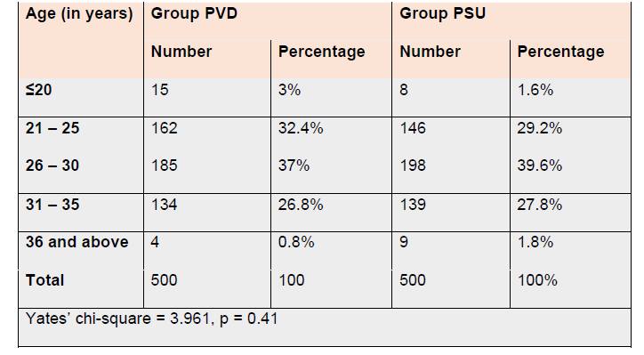
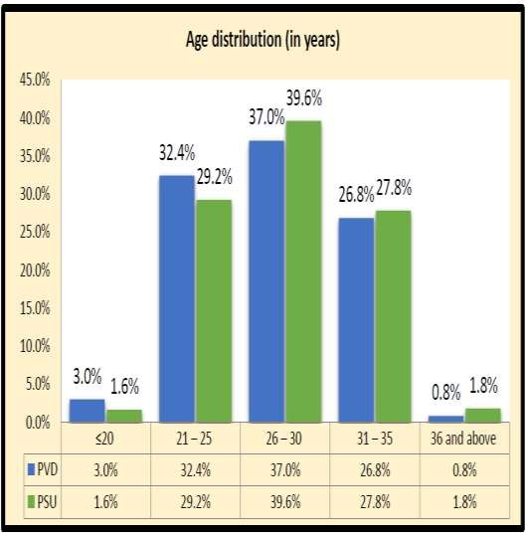

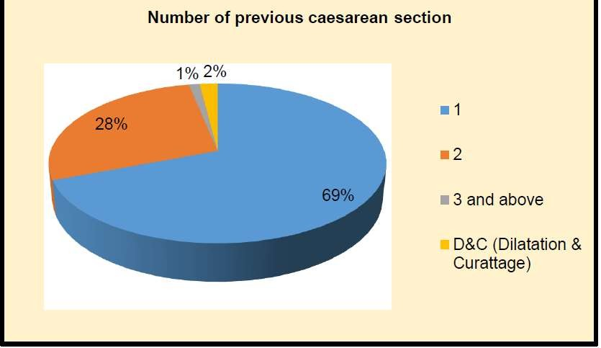
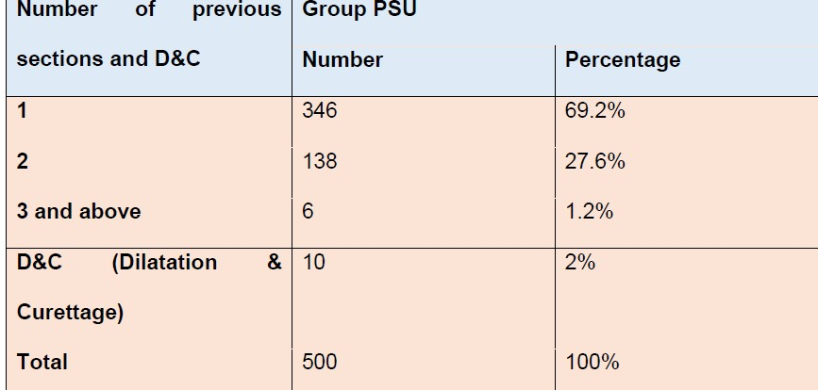
Table 2: Distribution of study subjects in Group PSU by history of number of previous caesarean Section and D&C

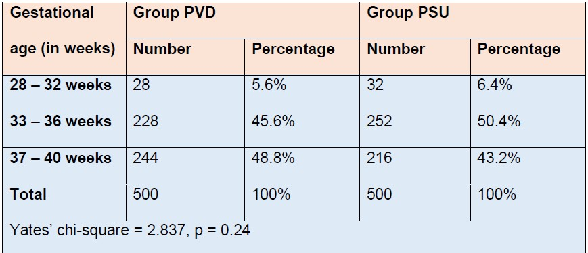
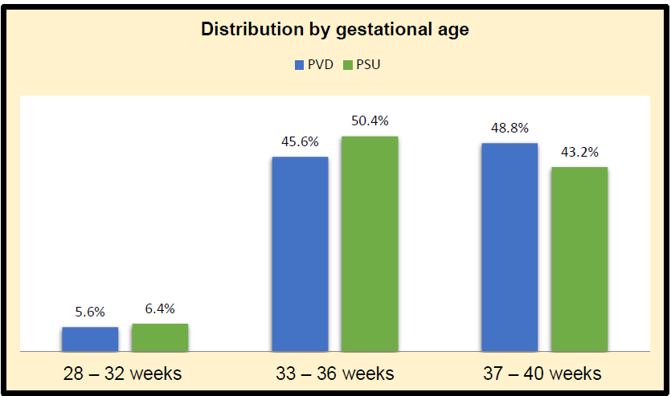
Table 3: Distributions with study subjects by gestational age

Table 4: Distributions with study subjects according to Placental location in USG

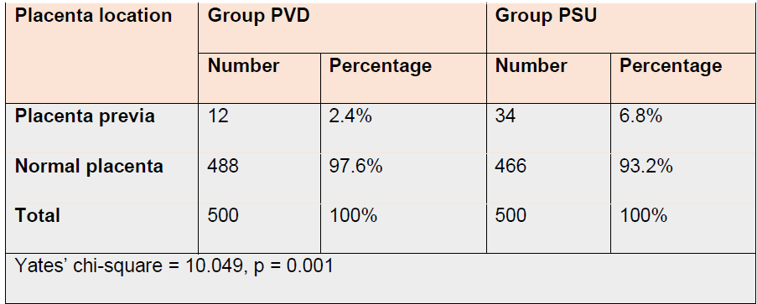
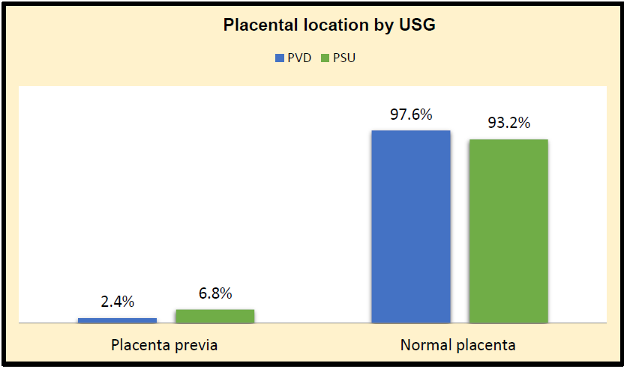

Table 5: Distribution by history of ante- partum hemorrhage (APH)

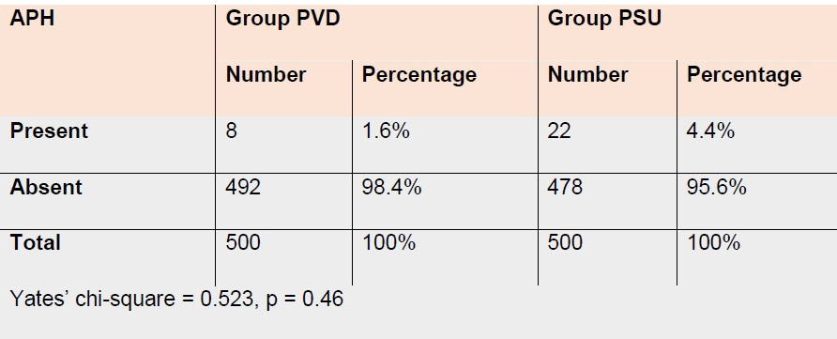
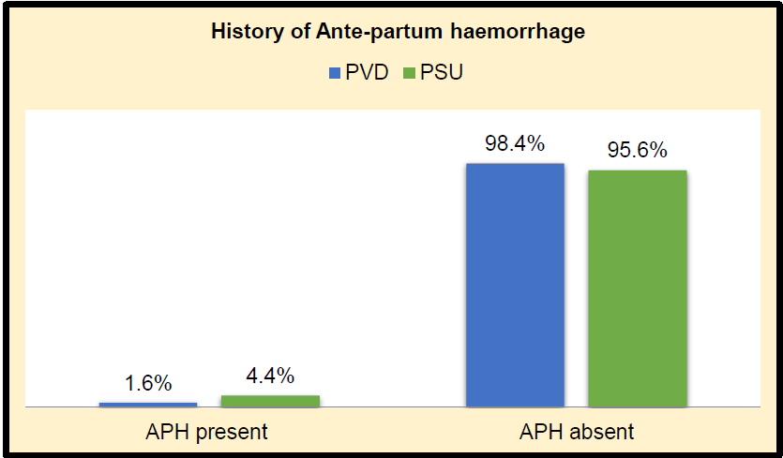

Table 9: Maternal complications with normal and abnormal placentation in group PVD and group PSU
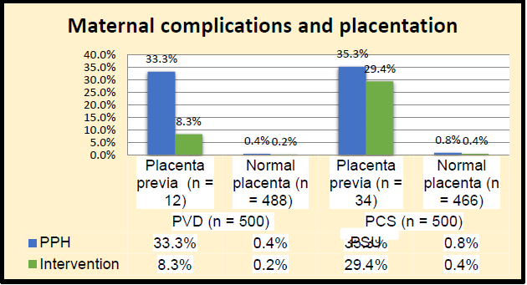
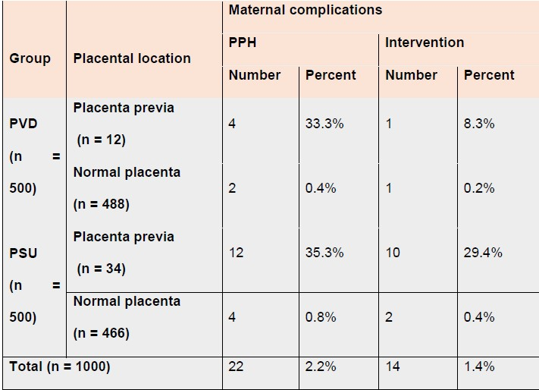

Table 10: Foetal complications with normal and abnormal placentation in group PVD and group PSU
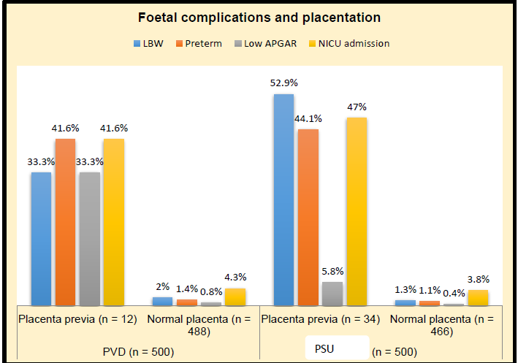
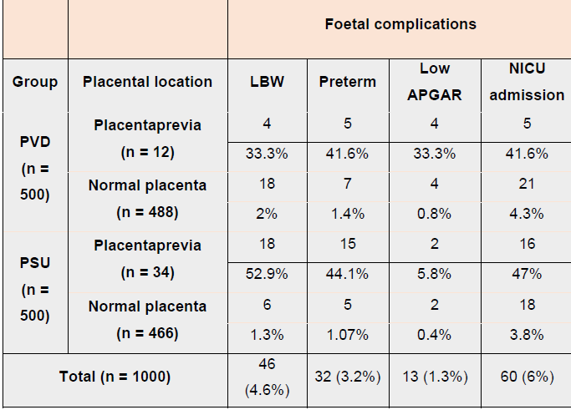
1

DISCUSSION

Placenta previa, a serious pregnancy issue where the placenta is developing partially or absolutely attached to the interior cervical ostium(os), can have adverse effects on both the maternal and the foetus beyond 20 weeks of gestation. About 0.3- 0.5% of pregnancies experience it, with senior age being the main risk factor. Conditions that may cause endometrial tissue damage include mother age, male foetus during pregnancy foetuses, smoking, multiparity, previous history of cesarian procedures (C- sections), along with ongoing abortion.

The reason is likely that the placenta moves to more vascularized regions of the uterus. The fundus, which has the capacity to supply more blood, is often where the placenta develops. Defective vascularization of the endometrium as a result of scarring or atrophy brought on by earlier surgeries or infections may be the cause of reduced differential growth of a portion of the lower uterine segment, less of an upward shift in placental positioning. A prospective cohort study was carried out at The Department of Obs and Gynae, Kurnool Medical College and associated hospital, Kurnool from March 2021 to March. The result and analysis can be discussed under the following subheadings.

Demographic Data

In the current study, 32.4%, 26.8%, 3%, and 0.8% of the women in this age group of 21-25 years, 31-35 years, < 20 years, and 36 and above years respectively, were PVD. In the group PVD, 37% of the women with PVD 25 in this age group of 26- 30 years. In the PSU group, 39.6% of the women PVD in this age range of 26–30, followed by 29.2%, 27.8%, 1.6%, and 1.8% of the women in the 21–25, 31–35, 20, and 36–and-above age ranges, respectively. In another study the age distribution revealed that 26 women (34.0%) were between the ages of 26-30, 23 (30.0%) were between the ages of 36-40, 17 (22.4%) were between the ages of 31-35, and 10 (13.0%) instances were between the ages of 21-25.^{4,5}

History of Previous Scarring

Placentaprevia was observed in 25 cases of this current study in 3.1%, 12.3%, 33.3%, and 10% of the cases, respectively, with histories of one, two, three, or more cesarean sections and histories of DC. The differences were determined to be statistically significant. There were 59 patients of previous cesarean section in research of a comparable nature conducted by Sasindra Kumar Das et al. was 2100.⁶ There were 66 of these patients who had placenta previa. 3.14% of pregnancies end with placenta previa. According to the study, there were 60, 5, and 1 patients with P.previa with prior one,two,and three prior cesarean deliveries. This is consistent with a study by Chen X et al.⁷

Ante-Partum Haemorrhage

1.6% of the women in group PVD and 4.4% of the women in group PSU in the current study had ante-partum hemorrhage, although the difference was found to be statistically insignificant. Study by Saima Aziz et al. lends support to our investigation.⁸ In our study, 18.2% of cases were asymptomatic, while 81.8% of cases had bleeding when they were admitted. Our research is consistent with those of Kavitha and colleagues.⁹ 80.3% of patients in the current study had cephalic presentations, 15.2% had breech presentations, and 4.5% had transverse lie.

Maternal Complications

In the current study, the postpartum hemorrhage and intervention rates (35.3% and 29.4%, respectively) were higher in the placenta previa group of women with prior uterine scarring than in the vaginal birth group (33.3% and 8.3%). The study by Matalliotakis M et al., which found that 54.0% of women with two or more prior C-sections had had at least one, supports our research.¹⁰ Six (8.0%) of these patients experienced placenta percreta, seven (9.0%) were moved to the intensives care unit (ICU), 14 (18.0%) of the females. So, this can be summarized as below:
- In order to examine the prevalence of placenta previa and its effects during the
current pregnancy women with previously scarred uteruses and those who had not, a prospective cohort research with a total 1000 participants in the trial, of which 500 had a history of vaginal delivery in the past (Control Group PVD) and 500 had a history of uterine scarring in the past (Study Group PSU)
- In this current study, there were no significant differences in these patients
- distribution between the two groups based on presenting complaints like APH,
and mean age, parity, GA, and foetal appearance were comparable in two groups.
Previous cesarean sections were performed on 69.2% of the women in group PSU, followed by two and more on 27.6% and 1.2% of the women, respectively, while 2% of the women who had a history of D&C. With their history of one, two, three, or more cesarean sections or history of DC, placenta previa was observed in 3.1%, 12.3%, 33.3%, and 10% of instances, and the difference was determined to be statistically significant, indicating that scarring is a substantial risk factor for previa.Placenta prevalence was 2.4% in the PVD group and 6.8% in the PSU group, indicating a higher prevalence in the PSU group.
- The Placenta Previa group of PSU had more postpartum hemorrhage cases and interventions than the PVD group.
- Low birth weight (LBW), preterm, low APGAR scores, and NICU admissions were comparable in both groups.
CONCLUSION
According to the results of the current study, uterine scarring in the past significantly increased the likelihood of placenta previa in a subsequent pregnancy. Therefore, it is important to promote vaginal delivery as much as possible. The key to better maternal care is regular antenatal checkups, early diagnosis, and competent management of previa.

REFERENCES

1. Faiz AS, Ananth CV. Etiology and risk factors for placenta previa: an overview and meta-analysis of observational studies. J Matern Fetal Neonatal Med 2003; 13:175.
2. Ananth CV, Smulian JC, Vintzileos AM. The association of placenta previa with history of cesarean delivery and abortion: a metaanalysis. Am J Obstet Gynecol 1997; 177:1071.
3. National Institutes of Health Consensus Development Conference Statement. NIH Consensus Development Conference: Vaginal Birth
After Cesarean: New Insights. March 8–10, 2010.
4. Lavery JP. Placenta previa. Clin Obstet Gynecol 1990; 33:414.
5. Ananth CV, Demissie K, Smulian JC, Vintzileos AM. Placenta previa in singleton and twin births in the United States, 1989 through 1998: a comparison of risk factor profiles and associated conditions. Am J Obstet Gynecol 2003; 188:275.
- https://www.worldwidejournals.com/indian-journal-of-applied-research-(IJAR)/recent_issues_pdf/2019/November/incidence-of-placenta-previa-in-post-caesarean-pregnancy-and-maternal-outcome_November_2019_1572595873_9801480.pdf
- Chen X, Gao J, Liu J, et al. Previous mode of delivery affects subsequent pregnancy outcomes: a Chinese birth register study. Ann Transl Med. 2021 Jul;9(14):1135.
- Siddiqui SA, Soomro N, Shabih-ul-Hasnain F. Severe obstetric morbidity and its outcome in patients presenting in a tertiary care hospital of Karachi. J Pak Med Assoc. 2012 Mar;62(3):226-31. PMID: 22764453.
- https://doi.org/10.18203/2320-1770.ijrcog20203293
- M M, A V, Gn G, E N, Ae P, I M. Association of Placenta Previa with a History of Previous Cesarian Deliveries and Indications for a Possible Role of a Genetic Component. Balkan J Med Genet. 2017 Dec 29;20(2):5-10.

Received: 23.5.2023
Revised: 29.06.23
Accepted: 09.07.2023
Published: 15.7.2023
Citation: Rao SN, Rani AS. Mounika P. Scarred uterus: a risk factor for placenta previa. J Indian Acad Obstet Gynecol. 2023;5(1):29-35.
1. Professor and HOD, OB-GYN,
2. Associate Professor, OB-GYN,
3. Post Graduate Student, OB-GYN, GGH Kurnool.

 Email: mounikapothuraj@gmail.com

CC BY license: Allows anyone to copy, distribute and transmit work; adapt work; make commercial use of the work under the condition that the user must attribute the work in the manner specified by the author or licensor (but not in any way that suggests they endorse the user or their use of the work)
Journal of Indian Academy of Obstetrics and Gynaecology July 2023
Vol. 5, Issue 1

Original Article

Prevalance of NON-COMMUNICABLE disease among women in the town of Kalyani

Dilip Kumar Dutta¹, Gairik Bera^{2}, Ranita Roy Chowdhury³

ABSTRACT
Introduction: Non-communicable diseases (NCDs) may experience a quick epidemiological shift with a change in disease burden, particularly in India, where the burden of NCDs is rising at an alarming rate.1 One in four Indians is at danger of passing away from an NCD before becoming 70 years old.
Methods: An observational study of women who live at or close to Kalyani is being conducted to ascertain the prevalence of non-communicable diseases.
Results: In our study, (Table 1)1723 women participated. There were 53 women from semi-urban areas, 880 women from rural areas, and 880 women from metropolitan areas. The most prevalent NCD in our study was diabetes (N= 256, 27%), followed by obesity (N = 235, 24%). Occurrence of chronic renal disease and hypertension were 19% (N = 182) and 16% (N = 153) respectively.
Conclusion: The two most prevalent risk factors that we identified were unhealthy eating and physical inactivity. In 95% of the women, either of these two or both was present. This is primarily the result of urban lifestyle.
Key Words: Non communicable disease, Multimorbidity

INTRODUCTION

Non-communicable diseases (NCDs) may experience a quick epidemiological shift with a change in disease burden, particularly in India, where the burden of NCDs is rising at an alarming rate.¹ One in four Indians is at danger of passing away from an NCD (such as a heart attack, stroke, cancer, diabetes, etc.) before becoming 70 years old.² According to disease epidemiology, NCDs spread via common pathophysiological behaviours, environmental risk factors, and behavioural transmission pathways.³ Multimorbidity, often known as simultaneous illness incidence, has grown due to the associative nature of NCDs.⁴
The time has come for programmes and policies in women's health care that go beyond outcomes of pregnancies and births.
MATERIALS AND METHODS

An observational study of women who live at or close to Kalyani is being conducted to ascertain the prevalence of non-communicable diseases and common risk factors for their development.

Inclusion Criteria:

- All the patients who came to Out-patient Department of Obstetrics and Gynaecology, COM & JNM Hospital, Kalyani, Nadia, West Bengal from February 2023 to July 2023 (6 months period) were included in the study.
- Patient with age more than 18years.
- Patient who are willing to participate in the study.

Exclusion Criteria:

- Patient age less than 18 years
- Patient denial to participate.

Study area: The Department of Obstetrics & Gynaecology, College of Medicine & JNM Hospital, Kalyani, Nadia, West Bengal.
Study population: All the women with age more than 18 years who came to Out-patient Department of Obstetrics and Gynaecology, COM & JNM Hospital, Kalyani, Nadia, West Bengal from February 2023 to July 2023 (6 months period) were included in the study.

RESULT

In our study, (Table 1)1723 women participated. There were 53 women from semi-urban areas, 880 women from rural areas, and 880 women from metropolitan areas.

Area | Number | Percentage
Urban | 880 | 51%
Rural | 790 | 46%
Semi-urban | 53 | 3%
Total | 1723 | 100%

Table 1: Distribution of Participants according to Residence

Table 2 shows demographic distribution among study population. The majority of the women were Hindus (N = 1426, 83%) and the 10% (N = 182) was Muslims. Total 99% of the women (N = 1707) were married. About 26% women were nulliparous, 744 women was primipara and 515 women were multipara.
Demographic Distribution
 |  | Number | Percentage
Religion | Hindu | 1426 | 83%
 | Muslim | 182 | 10%
 | Christmas | 15 | 1%
 | Others | 100 | 6%
Marital Status | Married | 1707 | 99%
 | Unmarried | 16 | 1%
Parity | 0 | 448 | 26%
 | 1 | 744 | 43%
 | ≥2 | 515 | 30%

Table 2: Demographic Distribution among Study Population

In our study, (Table 3) we discovered that the most frequent risk factor for NCD was the combination of unhealthy diet and physical inactivity (N = 930, 54%), which was followed by unhealthy food (N= 482, 28%) then physical inactivity (N = 223, 13%). In our study population, substance addiction was relatively less prevalent (Fig 1).

Risk Factors of NCD | No | Percentage
Tobacco | 37 | 2%
Alcohol | 51 | 3%
Physical Inactivity | 223 | 13%
Unhealthy Food | 482 | 28%
Unhealthy Food and Physical Inactivity | 930 | 54%
Total | 1693 | 100%

Table 3: Risk Factors for Non-communicable diseases

Figure 1: Pie Diagram Showing Risk factors for NCDs
The most prevalent NCD in our study was diabetes (N= 256, 27%), followed by obesity (N = 235, 24%). Occurrence of chronic renal disease and hypertension were 19% (N = 182) and 16% (N = 153) respectively. Eighty-Six (9%), and 30 (3%) of patients had cardiovascular disease and chronic respiratory disease conditions respectively. Less than 1% of cases had neurological disorders and cervical cancer (Fig 2).

Prevalance of Non communicable Disease | Number | Prevalance
Diabetes | 256 (27%) | 14.85
Hypertension | 182 (19%) | 10.56
Chronic Kidney Disease | 153 (16%) | 08.87
Cardiovascular Disease | 86 (9%) | 04.99
Chronic Respiratory Disease | 30 (3%) | 01.74
Neurological Disease | 11 (1%) | 00.01
Obesity | 235 (24%) | 13.64
Cervical Cancer | 8 (1%) | 00.01
Total | 961 (100%) | 55.77

Table 4: Prevalance of NCDs

Figure 2 Bar Diagram showing Prevalance of NCDs

DISCUSSION

We included 1723 women from Kalyani and the surrounding areas in our study, the majority of whom were married Hindu women. The World Health Organization (WHO) reports that coexisting NCDs, often known as multimorbidity, are more prevalent in low- and middle-income countries.⁵ Multimorbidity affects about 18% of people who are 45 years of age or older, according to recent research from the Longitudinal Ageing Study in India (LASI).⁶
The two most prevalent risk factors that we identified were unhealthy eating and physical inactivity. In 95% of the women, either of these two or both was present. This is primarily the result of urban lifestyle. Similar to our study, Peters R Et al¹⁰ observed that poor diet and inactivity are to blame for the majority of NCDs. An individual's age, gender, educational level, marital status, employment position, and behavioral characteristics like smoking, drinking, and using tobacco can all be used to determine the likelihood of numerous chronic diseases.⁸ Given that women are more likely than males to have many medical conditions. Gender can be an essential confounding factor for underreporting of NCDs in women.⁹
In our analysis, the two NCDs with the highest prevalence rates were diabetes and obesity. On the contrary cardiovascular disease is the most prevalent NCD, followed by chronic respiratory diseases and diabetes, according to the Ministry of Health and Family Welfare's Status of Non-Communicable Diseases (NCDs) in India report issued on February 8th, 2022.¹¹ Women typically outlive males, however, reporting a modest increase in life expectancy every ten years does not always imply a better health situation for women.⁷ At UN summit in September 2011 WHO member nations have agreed to a worldwide objective, to reduce preventable NCD mortality 25% by 2025.
There are several regulation and programmes in existence in India that are primarily focused on the health of women, especially during pregnancy. However, very few policies and programmes concentrate on managing chronic diseases in women.

CONCLUSION

NCDs are a major public health concern in the twenty-first century due to the human misery they inflict as well as the harm they do to a country's socioeconomic development. Due to the combination of medical expenses, travel expenses to and from healthcare institutions, time spent providing informal care, and lost productivity, NCDs financially impact individuals and families.

The good news is that, despite an overall rise in NCD fatalities among women, there has been a decline in CVD deaths as a result of government or non-governmental organization-mounted awareness and preventive efforts on salt restriction and tobacco control.

The outlook for women and the management of NCDs is positive. The significance of a life course approach to NCD prevention, starting with the health of girls and young women, is becoming more widely acknowledged. Given that women, girls, and other vulnerable groups who are afflicted by NCDs typically have limited access to medical services, the integration of NCD prevention initiatives within maternal and women-centric health programs has significant promise.

REFERENCES

- Puri P, Kothavale A, Singh SK, Pati S. Burden and determinants of multimorbidity among women in reproductive age group: a cross-sectional study based in India. Wellcome Open Res. 2021;5:275. Published 2021 Feb 18.
- Non-communicable Diseases | National Health Portal of India [cited 7 March 2022]. https://www.nhp.gov.in/healthlyliving/ncd2019
- Pati S, Swain S, Metsemakers J, Knottnerus JA, van den Akker M. Pattern and severity of multimorbidity among patients attending primary care settings in Odisha, India. PLoS One. 2017;12(9):e0183966. Published 2017 Sep 14.
- Alimohammadian M, Majidi A, Yaseri M, et al. Multimorbidity as an important issue among women: results of a gender difference investigation in a large population-based cross-sectional study in West Asia. BMJ Open. 2017;7(5):e013548. Published 2017 May 9.
- World report on ageing and HeAltH. 2015 [cited 7 March 2022]. www.who.int
- NPHCE. Longitudinal Ageing Study in India (LASI). Int Inst Popul Sci. 2020;1–632. Available from: http://iipsindia.org/research_lasi.htm
- World Population Prospects - Population Division - United Nations [cited 7 March 2022]. https://population.un.org/wpp/
- Singh, S.K., Chauhan, K. & Puri, P. Chronic non-communicable disease burden among reproductive-age women in India: evidence from recent demographic and health survey. BMC Women's Health 23, 20 (2023).
- Violan C, Foguet-Boreu Q, Flores-Mateo G, et al. Prevalence, determinants and patterns of multimorbidity in primary care: a systematic review of observational studies. PLoS One. 2014;9(7):e102149. Published 2014 Jul 21.
- Peters R, Ee N, Peters J, et al. Common risk factors for major noncommunicable disease, a systematic overview of reviews and commentary: the implied potential for targeted risk reduction. Ther Adv Chronic Dis. 2019;10:2040622319880392. Published 2019 Oct 15.
- Status of Non-Communicable Diseases (NCDs) in India | Ministry of Health and Family Welfare [ cited 8 Feb 2022]. https://pib.gov.in/PressReleaseIframePage.aspx?PRID=1796435

Received: 11.05.2023
Revised: 01.06.2023
Accepted: 14.06.2023
Published: 15.07.2023
Citation: Dutta DK, Bera G, Chowdhury RR. Prevalence of non-communicable disease among women in the town of kalyani. J Indian acad obstet Gynecol. 2023;5(1):36-41.
1. Consultant, OB-GYN, GICE Hospital, Kalyani.
2. Senior Resident, OB-GYN, COMJNM & Hospital, Kalyani
3. Associate professor, OB-GYN, COMJNM & Hospital, Kalyani

 Email: gairikbera10@gmail.com

CC BY license: Allows anyone to copy, distribute and transmit work; adapt work; make commercial use of the work under the condition that the user must attribute the work in the manner specified by the author or licensor (but not in any way that suggests they endorse the user or their use of the work)
Journal of Indian Academy of Obstetrics and Gynaecology July 2023
Vol. 5, Issue 1

Case Report

PERIPARTUM CARDIOMYOPATHY IN A CASE OF POST OPERATIVE ECTOPIC PREGNANCY

Unbe Hany^{1✉}, Prithu Bandopadhyay², Arijit Debnath², Suvasmita Saha³

ABSTRACT
Peripartum cardiomyopathy (PPCM) is a rare, poorly understood form of congestive heart failure that can be life-threatening for mothers. It typically occurs in the last month of pregnancy or in the months following delivery, with reduced heart pumping function (ejection fraction <45%). It has an estimated mortality rate of 6-10% in the United States. This case describes a 27-year-old female with a suspected ectopic pregnancy, which was successfully treated with surgery. However, she later developed cardiac symptoms and was diagnosed with PPCM. Treatment involves a multidisciplinary approach, medication, and sometimes bromocriptine. Proper management is crucial to prevent adverse outcomes, including maternal mortality.
Key Words: Peripartum, Cardiomyopathy, Ejection fraction

INTRODUCTION
Peripartum cardiomyopathy is a rare form of congestive heart failure of unknown etiology but one of the major causes of maternal death. The estimated mortality rate associated with peripartum cardiomyopathy in the United States is 6% to 10%.¹ AHA criteria for diagnosis peripartum cardiomyopathy - Heart failure develops in the last month of pregnancy or within months following delivery, heart pumping is reduced, with a left ventricular ejection fraction less than 45% (typically measured by an echocardiogram), no other cause for heart failure can be found. The incidence of peripartum cardiomyopathy was 1 case per 1374 live births². Clinical presentation of peripartum cardiomyopathy resembles DCM with systolic HF including fatigue, dyspnea, orthopnea, paroxysmal nocturnal dyspnea, leg edema, neck vein engorgement, pulmonary crackles, hepatic congestion, and third heart sound.³
CASE
A 27-year-old athlete female, resident achalasia, West Bengal, primi-gravida, having a non-consanguineous marriage, belonging to middle socio-economic class, presented to emergency department on11^{th June},2023 with the chief complain flower abdominal pain and per vaginal bleeding for last 2 days after amenorrhea of 6 weeks 5 days. There was no history of abortifacient intake. She attended menarche at 14 years age and used to have regular menstrual cycle at a interval of 30 days for 5-6 days with moderate flow.
Her last menstrual period (LMP) was on 26th April, 2023 and expected date of delivery was on 2ndFebruary, 2024. Her estimated gestational age by LMP was 6 weeks 5 days. There was no Ultrasound report available. No history of contraception in her last 2 years of marriage.
There was no significant medical history of cardiac diseases, respiratory diseases, tuberculosis, diabetes mellitus, hypertension, thyroid disorders in patient or in her Family.
She did not give any history of surgery performed previously. There was no history of blood transfusion or drug allergies.
GENERAL EXAMINATION
Patient was examined on admission after obtaining proper informed consent. She was conscious, alert, cooperative, cold and clammy extremities, moderately built and nourished. She had severe pallor but no icterus/ edema/ clubbing / cyanosis. She was afebrile with axillary temperature 97F, Pulse rate 110 bpm, regular, high volume, no radio-radial or radio- femoral delay. Blood pressure 90/60 mmHg in supine position.
SYSTEMIC EXAMINATION
No abnormalities detected in Respiratory, Cardiovascular or central nervous system on admission.
OBSTETRICAL EXAMINATION
Abdominal examination revealed guarding rigidity along with diffuse tenderness over hypogastric region. Fresh blood was found in peritoneal cavity by paracentesis, which does not get clotted even after 10 min.
On per vaginal examination, uterus was found to be of 6-8 weeks size approximately, ante-verted, cervical motion tenderness noted, cervical Os closed, mild bleeding was found to be present.
In ER urine pregnancy test was done which was found to be positive.
So, she was suspected as rupture ectopic pregnancy and planned for exploratory laparotomy.
Exploratory laparotomy followed by left salpingectomy successfully done after identifying left sided tubal rupture ectopic pregnancy and about 1- 1.5 L of blood was suctioned from peritoneal cavity. She was then transferred to the Intensive Care Unit. The patient received two units of red blood cells. The post transfusion hemoglobin level was 11 g/dL.
Post operative period was initially favourable, then, after 11 hours, the patient developed shortness of breath. Physical examination showed tachypnoea (33/min) and tachycardia(106/min), blood pressure 82/50 mmhg, Cardiac auscultation was normal but pulmonary auscultation revealed bilaterally crackles. Her Trop T was negative. Moist oxygen and nebulization given; inotropic support was initiated.
The ECG revealed sinus tachycardia. Transthoracic echocardiography (TTE) revealed left ventricular (LV) systolic dysfunction with regional wall motion abnormality, mid global hypokinesia and mild concentric left ventricular hypertrophy. Ejection fraction of the LV was 46%.
Proper intensive monitoring and diuretics (Torsemide and Spironolactone tablets) was given once daily after consulting with medicine specialist. After stabilization patient was referred to cardiologist for further follow up.
DISCUSSION
Peripartum cardiomyopathy is uncommon, but serious medical condition. The ethology is not fully understood, but both genetic susceptibility and hormonal influences play major role. For assessment of decreased cardiac systolic function an elevated NT-pro-BNP level, an echocardiogram is essential with clinical symptoms. Multidisciplinary collaboration with a cardio-obstetrics team is necessary for prompt treatment and to prevent adverse outcome⁴. Management of peripartum cardiomyocyte path include e a low sodium diet, fluid restriction, bed rest along with medication for heart failure which is the mainstay of treatment. Bromocriptine, a dopamine D2 agonist, can be used as an adjunctive treatment which has controversial benefits. The addition of bromocriptine to standard HF treatment is associated with significantly higher survival and higher LVEF improvement.⁵ Variable outcomes of peripartum cardiomyopathy include complete recovery, persistent heart failure, arrhythmias, thromboembolic events, and even death. Also risk of relapse and death in subsequent pregnancy, if there is incomplete myocardial recovery.⁶
CONCLUSION
Peripartum cardiomyopathy following 1st trimester pregnancy loss is rare but potentially life-threatening disease. Clinical diagnosis can be confirmed by echo-cardiography. Early diagnosis, prompt and specific treatment, cardiac consultation is need. If it is not diagnosed and managed properly on time, can lead to maternal mortality and morbidity.
REFERENCES
1. Felker GM, Jaeger CJ, Klodas E, Thiemann DR, Hare JM, Hruban RH, et al. Myocarditis and long-term survival in peripartum cardiomyopathy. Am Heart J 2000;140(5):785–91.
2. Pandit V, Shetty S, Kumar A, Sagir A. Incidence and outcome of peripartum cardiomyopathy from a tertiary hospital in South India. Trop Doct. 2009;39(3):168-9.
3. Sliwa K, Hilfiker-Kleiner D, Petrie MC, et al. Current state of knowledge on aetiology, diagnosis, management, and therapy of peripartum cardiomyopathy: a position statement from the Heart Failure Association of the European Society of Cardiology Working Group on peripartum cardiomyopathy. Eur J Heart Fail. 2010;12:767–778.

4. Carlson S, Schultz J, Ramu B, Davis MB. Peripartum Cardiomyopathy: Risks Diagnosis and Management. J Multidiscip Healthc. 2023;16:1249-1258.
5. Trongtorsak A, Kittipibul V, Mahabir S, Ibrahim M, Saint Croix GR, Hernandez GA, Chaparro S. Effects of bromocriptine in peripartum cardiomyopathy: a systematic review and meta-analysis. Heart Fail Rev. 2022;27(2):533-543.
6. Davis MB, Arany Z, McNamara DM, Goland S, Elkayam U. Peripartum Cardiomyopathy: JACC State-of-the-Art Review. J Am CollCardiol. 2020;75(2):207-221.

- Post Graduate Trainee, OB-GYN, COMJNM & Hospital, Kalyani
- Assistant Professor, OB-GYN, COMJNM & Hospital, Kalyani
- Resident Medical Officer cum Clinical Tutor OB-GYN, COMJNM & Hospital, Kalyani

 Mail: hanycnmc20@gmail.com

Received: 23.05.2023
Revised: 30.05.23
Accepted: 14.06.2023
Published: 15.07.2023
Citation: Hany U, Bandopadhyay P, Debnath A, Saha S. Peripartum cardiomyopathy in a case of post operative ectopic pregnancy. J Indian Acad Obstet Gynecol. 2023;5(1):42-45.

CC BY license: Allows anyone to copy, distribute and transmit work; adapt work; make commercial use of the work under the condition that the user must attribute the work in the manner specified by the author or licensor (but not in any way that suggests they endorse the user or their use of the work)
Journal of Indian Academy of Obstetrics and Gynaecology July 2023
Vol. 5, Issue 1

Case Report

A Mistaken Case of Hydatidiform Mole

Nilakshi Phukan Kumar^{1✉}, Subhendu Buzarbaruah¹

ABSTRACT
This is a case of recurrent hydatidiform mole in 30-year-old women. Initially diagnosed with a molar pregnancy in September 2020, underwent D&E and received methotrexate treatment, resulting in a decline of beta hCG levels to 0.8mIU/ml by December 2020. Subsequent ultrasound in March 2021 indicated a hydatidiform mole like picture despite of low beta hCG (<2.0mIU/ml). An MRI suggested similar findings without myometrial invasion, without enlarged lymph nodes or ascites. Histopathology of D&E sample showed endometrial hyperplasia rather than hydatidiform mole. Upon detailed history review, it was found the patient had been self-administering mifepristone at 25mg/day for over five months post the initial procedure. Literature search links extended high dose mifepristone usage to an unopposed estrogen environment, causes endometrial hyperplasia, alerting us to monitor prolonged mifepristone use meticulously.
Key words: Hydatidiform mole, Molar pregnancy, prolonged mifepristone
INTRODUCTION
A 30-year-old female patient was referred to down town hospital in March 2021 with a diagnosis of recurrent hydatidiform mole. In January 2019 she had a failed IVF following blastocyst transfer. Subsequently she had a spontaneous pregnancy in September 2020 later diagnosed to be a molar pregnancy with a beta human chorionic gonadotrophin (hcg) of about 85,000 mIU/ml. A dilatation and evacuation were performed and she received a full course of methotrexate and folinic acid in September 2020. Following this, her beta hcg dropped to 16.8 mIU/ml in October 2020. Beta hgc further decreased to 0.8 mIU/ml in December 2020. A histopathology revealed hypersecretory endometrium with extensive decidualization of stroma with focal areas of areas Stella reaction. No chorionic villi were identified. There was no evidence of hydatidiform mole.

Fig 1 & Fig 2: Ultrasonography and MRI reveal features suggestive of hydatidiform mole in March 2021

Diagnosis and Management
The same patient came to down town hospital with a hydatidiform mole like picture shown in ultrasound done in March 2021 with a beta hcg level of <2.0 mIU/ml. An MRI done in March 2021 revealed features suggestive of hydatidiform mole without invasion of inner myometrium, without enlarged lymph nodes or ascites.
A dilatation and evacuation were done in April 2021 at our hospital under ultrasound guidance. The endometrial tissue was evacuated but no typical grape like tissues identified. The material retrieved was sent for hystopathological (HPE) examination. The HPE revealed secretory hyperplasia of endometrium with no evidence of hydatidiform mole. Subsequently the patient recovered with no clinical or laboratory findings of hydatidiform mole.

Fig 3: HPE revealed secretory endometrium without atypia in April 2021 Fig 4: Ultrasonography showing normal endometrium in May 2021

Discussion

On obtaining detailed history, it was revealed that the patient was advised mifepristone 25 mg/day following the dilatation and evacuation performed in September 2020 for an unspecified indication. The patient didn't follow-up with the treating gynaecologist and continued taking mifepristone 25 mg/day for a period of more than 5 months. A literature search revealed case reports that showed high doses of the antiprogestogen mifepristone over a prolonged period of time may promote an unopposed oestrogen milieu leading to endometrial hyperplasia.¹

Conclusion

Diagnosis of hydatidiform mole should not be based only on ultrasound findings and needs to be correlated with the level of hcg level as well as histopathological findings. Prolonged use of mifepristone should be monitored as an unopposed oestrogen milieu may lead to endometrial hyperplasia. Further studies are required to rule out the role of prolonged use of mifepristone in endometrial hyperplasia.

Reference

1. Newfield RS, Spitz IM, Isacson C, New MI. Long-term mifepristone (RU486) therapy resulting in massive benign endometrial hyperplasia. Clin Endocrinol (Oxf). 2001;54(3):399-404.
Received: 25.05.2023
Revised: 11.06.2023
Accepted: 14.06.2023
Published: 15.07.2023
Citation: Kumar NP, Buzarbaruah S. A mistaken case of Hydatidiform mole. J Indian Acad Obstet Gynaecol. 2023;5(1): page no.
1. Consultant, OB-GYN, Down Town Hospital, Guwahati, Assam

 Email: nilakshi.phukhan@yahoo.co.in

CC BY license: Allows anyone to copy, distribute and transmit work; adapt work; make commercial use of the work under the condition that the user must attribute the work in the manner specified by the author or licensor (but not in any way that suggests they endorse the user or their use of the work)
Journal of Indian Academy of Obstetrics and Gynaecology July 2023
Vol. 5, Issue 1

Author’s Guidelines

Original quality works only deserves the acceptance. All manuscripts will be reviewed by two anonymous peer reviewers and Editorial members, unless otherwise specified. If the quality is not maintained and subject of work is beyond the scope of this journal, then the Editorial board will not consider the article for publication. Editorial Board’s decision is final.
COVERING LETTER
Covering letter should clearly mentioned that this article is not been submitted elsewhere for publication. If more than one author, then each author’s contribution should be quantified properly. All authors must approve the content of the article. Research work should have approval of the Ethics Committee of the respective institution, and within the provisions of the Declaration of Helsinki (current version). Everything should be done after obtaining informed consent and identity of the patient & human subject should not be disclosed – these have to be mentioned in the covering letter. All animal experiments should be within the respective country’s National Guidelines. Any conflict of interest, which may arise due to financial assistance or any other kind of help taken, should be informed.

MANUSCRIPTS PREPARATION
Manuscript is to be written in English. Use 12 font size for heading and 11 font size for others, in Times New Roman. Maximum word limit for an ORIGINAL ARTICLE AND REVIEW ARTICLE is 5000, inclusive of everything. The article has to be submitted in A4 paper format with double spaced lining and 30 mm margin all around. Numbering of the pages should be done in Arabic numerals using the ‘Footer’ at right corner; start from the title page. All the new paragraphs are to be indented. Don’t use hyphenation except where the word itself is hyphenated.

caSe rePortS
Interesting and rare cases are to be submitted and these should provide valuable information to the readers. The Case reports, without any significant carry forward message to the readers, will not be considered. Patient’s identification must not be disclosed. Maximum word limit for a case report is 2000.

LETTER TO THE EDITOR
Two types of Letters to the Editor will be accepted –

1) Referencing any article published in the recent past 3 consecutive issues of the Journal of Indian Academy of Obstetrics & Gynaecology.
2) Discourse that illuminates us on the various works on Obstetrics & Gynaecology, and another related arena.
Brief and precise communications are welcomed; maximum word limit is 400 with 1-4 references. Maximum three authors together can send a Letter to the Editor.

STYLE
1) Vancouver system is solicited. For guidance author can look at the International Committee of Medical Journal Editors revised ‘Uniform Requirements for Manuscripts Submitted to Biomedical Journals: Writing and Editing for Biomedical Publication’.
2) Only universally accepted standard abbreviation, acronyms and symbols are accepted. For other abbreviations, write the full form at least once at first use.
3) SI units are to be used for measurements.
4) Only generic names of the drugs are to be written.
5) Variables should be written in italics.

PARTS OF MANUSCRIPTS
The manuscripts should contain the following headings and arranged in this order –
1) Title page
2) Abstract and Key words
3) Text
4) Acknowledgments
5) References
6) Appendices
7) Tables
8) Figures

TITLE PAGE
It should contain –
1) Title of the article which should be precise and contain the major key words
2) Full name of author(s) with surname underlined
3) Designation of author(s)
4) Full address of corresponding author which should include e-mail ID, phone no.
5) Concise title (maximum 40 characters including spaces)

This information, except the title of the article, should not appear in any other part of the manuscript.
ABSTRACT AND KEY WORDS
A structured abstract of 250 words or less is needed for all original articles. The headings are Background/Objectives, Methods, Results and Conclusion. An unstructured abstract of 200 words or less for review article and 150 words or less for Case reports is to be submitted. No abbreviation and references should appear in this stage.
Title of the article should be written on the top and 3-5 key words are to be supplied at the end, in alphabetical order. If any doubt occurs regarding key words, then the help of US National Library of Medicine’s Medical Subject Headings (MeSH) browser list can be taken.

TEXT
It should be written under following subheadings –
1) Introduction
2) Materials & Methods
3) Results
4) Discussion (mention the limitation of the study, if any)
5) Conclusion

Use 12 font size for headings and 11 font size for others, in Times New Roman. Limit the conclusion within few sentences.
ACKNOWLEDGMENTS
Contribution of colleague(s), institution(s), financial and other helps, if any, are to be acknowledged.

REFERENCES
1. Vancouver system is to be followed
2. Number them according to their first appearance in the text by superscripting with Arabic numerals. Tables and figures referencing also should be numbered according to their appearance in the text.
3. Write all the name of the author’s up to six (6) authors.
4. In case of more than six (6) authors, write first three (3) author’s name and followed by et al.
5. Journal’s abbreviation is according to Index Medicus
6. Personal communication and unpublished data should be cited in the text (e.g. Manglem Ch, 2007, unpublished data); not in the references.

Journal
- Frederick J, Fletcher H, Simeon D, Mullings A, Hardie M. Intramyometrial vasopressin as a haemostatic agent during myomectomy. Br J Obstet Gynaecol 1994; 101(5):435-7.

booK
- Shaw RW, Soutter WP, Stanton SL (eds) Gynaecology, 3rd edn. Philadelphia: Churchill Livingstone, 2003.

chaPter in a booK
- Menefeee SA, Wall LL. Incontinence, prolapse, and disorders of the pelvic floor. In: Berek JS (eds) Novak’s Gynecology, 13th edn. Philadelphia: Lippincott Williams & Wilkins, 2002; p 645-710.

WebSite linK
http://www.pfizer.com/files/products/uspi_ gelfoam_plus.pdf. accessed on 25-05-19
aPPendiceS
Abbreviation’s full form is to be written here. If any other kind of appendices are used, those are also to be mentioned here. The consequences should be their appearance in the text.
tableS
- Table should have a small, precise heading.
- Column headings may be supplemented by units, if applicable, in parentheses.
- Full form of the abbreviations should be supplied in the footnote and refer to the table by superscripting a,b,c……
- *, **, *** symbols are reserved for ‘p’ values
Consequences of the tables are according to their appearance in the text and number them in Roman numerals.

FIGURES
Figure means all illustrations (600 d.p.i.) – line drawing as well as photograph. Line drawing should be sharp and well defined. It can be professionally drawn and scanned or drawn on computer graphics. Proper labeling should be done. Photograph can be sent as jpeg file. All illustrations should bear heading at footnote and they should be numbered by Arabic numerals (e.g., Fig.1) according to their appearance in the text. Photograph is, preferably, to be associated with a linear scale or magnification mentioned.

PEER REVIEW
Double blind peer review. All the manuscripts will be peer reviewed by 2 independent peer reviewers. Decision of the manuscript will be communicated to the corresponding authors within 4-6 weeks.

PROOF CORRECTION
After checking, proof will be sent back to the corresponding author by e-mail for resubmission, if any correction needed. In case he/she is not available, then an alternative e-mail ID should be provided.

PUBLICATION
There will be online and print version of the journal. Online version is freely accessible and downloadable. The corresponding author will receive one hard copy of the journal.

Indian Academy of Obstetrics & Gynaecology
A – 9/7, Kalyani, Nadia, West Bengal 741235 India
Email: jiaog@iaog.in
website: www.iaog.in

