Email: jiaog2017@gmail.com Website: www.iaog.in

Official Journal of
Indian Academy of Obstetrics & Gynaecology
ISSN(s) prints: 2583-0589
JIAOG
Vol. 4 | Issue 1
July 2022
RNI- WBENG/2019/78475

Journal of
Indian Academy of Obstetrics and Gynaecology

Email: jiaog@iaog.in
Website: www.iaog.in

Journal of Indian Academy of Obstetrics and Gynaecology
Vol. 4 | Issue 1 | July 2022
Official Journal of
Indian Academy of Obstetrics & Gynaecology

About of Journal: | Journal of Indian Academy of Obstetrics and Gynaecology (JIAOG) is the official journal of Indian Academy of Obstetrics & Gynaecology. It covers all the areas of Obstetrics and Gynaecology including Family Planning & Contraception with special focus on reduction of maternal mortality and morbidity.  Original articles, Review articles, Case reports, Letter –to-Editor etc. within the purview of the journal are accepted. This is a double-blind peer reviewed journal. The journal is available in print version. At present the journal is published in 2 issues a year i.e. half-yearly publication.
Frequency: | Biannual
ISSN(s) prints: | 2583-0589 Journal of Indian Academy of Obstetrics and Gynaecology
Publisher: | IAOG
Chief Editor: | Dilip Kumar Dutta
Copyright: | Copyright is reserved by Indian Academy of Obstetrics & Gynaecology. All rights are reserved. No part of this publication may be reproduced, stored in a retrieval system or transmitted in any form or by any means, electronic, mechanical, photocopying, recording or otherwise, without written permission of the publisher. Individual subscriber may copy & distribute among colleagues and friends for noncommercial purpose. Institutional subscriber may copy & distribute within the institution for noncommercial purpose.
Starting year: | Starting year July 2019
Subject: | Obstetrics & Gynecology
Language: | English
Format: | Print
Phone no: | +91 93309 25898
Email: | jiaog@iaog.in
Website: | www.iaog.in
Address: | A – 9/7, Kalyani, Nadia, West Bengal 741235 India

Printed, Published and Owned by Dilip Kumar Dutta on behalf of Indian Academy of Obstetrics & Gynaecology and printed at Bishnupriya Printers, Market # 2, Shop # 70, Kalyani, Nadia, West Bengal and published at A-9/7, Kalyani, Nadia, West Bengal. Editor Dilip Kumar Dutta.

Indian Academy of Obstetrics & Gynaecology
A – 9/7, Kalyani, Nadia
West Bengal, India
PIN – 741235
Email: jiaog@iaog.in
website: www.iaog.in

© All rights reserved.
No part of this publication can be reproduced, stored in a retrieval system, or transmitted in any form or by any means, electronic or mechanical, without written permission from the publisher.

Disclaimer:
The opinions and information expressed in this Journal reflect the views of the authors and not of the Journal or its Editorial board or the Publisher. Publication does not constitute endorsement by the Journal. Journal of Indian Academy of Obstetrics and Gynaecology is not responsible for the authenticity or reliability of any product, gadget, equipment or any claim by the medical establishments/manufacturers/ institutions or any training programme in the form of advertisements appearing in Journal of Indian Academy of Obstetrics and Gynaecology and also does not endorse or give any guarantee to such products or training programme or promote any such thing or claims made so after.

Printed at:
Bishnupriya Printers
Market # 2, Shop # 70
Kalyani, Nadia, West Bengal
bishnupriyaprinters@gmail.com

JOURNAL OF INDIAN
ACADEMY OF
OBSTETRICS AND GYNAECOLOGY
Official journal of Indian Academy of Obstetrics & Gynaecology

Chief Editor
Dilip Kumar Dutta Senior Consultant, Obs & Gyn, Gice Hospital, Kalyani, West Bengal email: editor.jiaog@iaog.in
Executive Editor
Ranita Roy Chowdhury Associate Professor, Obs & Gyn, College of Medicine & JNM Hospital, WBUHS, Kalyani, West Bengal
email: executive.editor.jiaog@iaog.in

Associate Editor
Soma Bandyopadhyay
Professor, Obs & Gyn, Katihar Medical College, Al-Karim University, Katihar, Bihar
Email: soma.bandyopadhyay@alkarimuniversity.edu.in

Saubhagya Kumar Jena
Professor, Obs & Gyn, AIIMS, Bhubaneswar, Odisha
Email: obgyn_saubhagya@aiimsbhubaneswar.edu.in

Assistant Editor
Indranil Dutta
Professor, Obs & Gyn, IQ City Medical College, Durgapur, West Bengal
Email: indranil.dutta@iqct.in
Shyam Piyari Jaiswar
Professor, Obs & Gyn, King George Medical University, Lucknow, Uttar Pradesh email: spjaiswar@kgmcindia.edu

Epidemiologist cum Statistician
Ritesh Singh
Associate Professor, Community & Family Medicine, AIIMS, Kalyani, West Bengal
Email: ritesh.cmfm@aiimskalyani.edu.in

Advisory Board

International
Ranadeb Acharyya
Consultant Obstetrician and Gynaecologist at Calderdale and Huddersfield NHS Foundation Trust, Yorkshire, UK.
Email: ranadeb.acharyya@cht.nhs.uk
Subhayu Bandyopadhyay
Consultant Obstetrician and Fetal Medicine Specialist at Aberdeen Maternity Hospital, Cornhill Road, Aberdeen.UK.AB25 2ZL
Email-subhayu.bandyopadhyay@nhs.scot
S N Roy
Consultant lead Gynaecologist. North Tees and Hartlepool NHS Trust and NTH Endometriosis Centre. Department of OBGYN, Univ. Hospital of Hartlepool. Holdforth Road. Hartlepool.UK. TS24 9AH
Email - s.roy5@nhs.net
Ranee Thakar
Consultant Urogynaecologist, Croydon University Hospital, Croydon.
Email - ranee.thakar@nhs.net
National
Shakuntala Chhabra
Emeritus Professor, Obs & Gyn, Mahatma Gandhi Institute of Medical Sciences, Wardha, India
Email: schhabra@mgims.ac.in
J B Sharma
Professor, Obs & Gyn, AIIMS, New Delhi, India Email: jbsharma2000@aiims.ac.in

Editorial office
A – 9/7, Kalyani, Nadia, West Bengal, India, PIN - 741235
E-mail – jiaog@iaog.in, Website: www.iaog.in

Journal of Indian Academy of Obstetrics and Gynaecology July 2022
Vol. 4, Issue 1

My sincere thanks to our team of JIAOG for their active co-operation and valuable advice & suggestions to improve our journal in better way in future.

As an editor of JIAOG, I am glad to inform that VOL-4, ISSUE- 1, which will be released on 15th July 2022.

We have received the print ISSN (2583-0589, Date – 01/12/2021) permission and applied for the electronic version. Hope we will get online permission as early as possible; we are also trying to index our journal in national and international agencies. Our main focused will be on research-oriented papers which will not only cover review & original articles but also videos and case reports.

I hope, through this issue we will be able to highlight many topics which will not only focus on various aspects of scientific research but also future innovative work.

In future, we are planning to organize a PICSEP (Programme for Inculcating the Culture of Scientific Enquiry and Pursuit) this year which will impart principles of modern research methodology concepts to academicians and clinicians.

Thanking you,

Dilip Kumar Dutta
Chief Editor
Journal of Indian Academy of Obstetrics and Gynaecology

Journal of Indian Academy of Obstetrics and Gynaecology July 2022
Vol. 4, Issue 1

Contents

Original Article:

Study on indications of primary caesarean sections in a tertiary care centre of West Bengal
Anindita Jana, Arijit Debnath

................................................................................................1-6

MATERNAL DEATH DUE TO HYPERTENSIVE DISORDERS IN PREGNANCY: A RETROSPECTIVE STUDY
Swarna Nandi, Vasundhara Singh, Chaitali Sarkar, Ranita Roy Chowdhury, Manidip Pal

................................................................................................7-11

A Comparative Study of IDA In Rural, Industrial & Urban Area >50 years of age
Dilip Kumar Dutta, Indranil Dutta

................................................................................................12-14
SURGICAL TERMINATION OF PREGNANCY: A RETROSPECTIVE STUDY IN A TERTIARY CARE HOSPITAL OF WEST BENGAL
Mousumi Maji, Jayeeta Mukherjee, Ranita Roy Chowdhury, Gairik Bera

................................................................................................15-20
STUDY OF ENDOMETRIAL TUBERCULOSIS FROM RURAL, INDUSTRIAL & ADIVASI AREAS – A COMPARATIVE ANALYSIS

Dilip Kumar Dutta, Narayan Halder, Indranil Dutta, Gairik Bera

................................................................................................21-24
Case Report:
SUCCESSFUL PREGNANCY OUTCOME IN A SEPTATE UTERUS: A CASE REPORT
Sourav Das, Suvobrata Sarkar, Arpita Mondal
................................................................................................25-28

A CASE OF SEIZURE DISORDER (NEUROCYSTICERCOSIS) IN PREGNANCY
Sanjyot Patil, Vasundhara Singh, Chaitali Sarkar, Ranita Roy Chowdhury, Manidip Pal
................................................................................................29-32

Book Review:

“Essentials in Gynecology for Undergraduate Medical Students” is a textbook of Gynecology for MBBS course
Manidip Pal

.................................................................................................33
Author’s Guidelines
.................................................................................................34-36
Subscription Form
.................................................................................................37

Journal of Indian Academy of Obstetrics and Gynaecology July 2022
Vol. 4, Issue 1

Original Article

Study on indications of primary caesarean sections in a tertiary care centre of West Bengal

Anindita Jana^{1*}, Arijit Debnath², Prithu Bandopadhyay³, Nupur Nandi⁴

ABSTRACT
BACKGROUND: Caesarean section is the major obstetric surgery performed to save the mother and child for reducing the maternal and perinatal mortality. The rapid increase of global caesarean rate has become the most debated topic in modern obstetric care. The World Health Organization (WHO) recommended that the population-based c-section rate should be 5% to 15%. Unnecessary c-section may impose detrimental effect on maternal and perinatal outcome with inadvertent increase in maternal and neonatal mortality and morbidity.
AIMS AND OBJECTIVE: a) To find out the indications of c-section along with their obstetric determinants.
b) To identify factors needed to be addressed for strategies for improved MCH care.
Materials and METHODS: This observational study conducted at College of Medicine and JNM Hospital, Kalyani upon all patients undergoing caesarean section at this facility from June 2021 to April 2022. Patients with previous caesarean sections and C-sections on maternal requests were excluded from the study.
RESULTS: A total of 1716 caesarean sections were studied among which 505 cases were elective and 1211 cases were emergency. The percentage of primigravida women was significantly higher in emergency group (82%) than elective ones (64%). The most common indication of all caesarean sections being presumed fetal distress (28.61%) followed by failed induction (22.78%).
CONCLUSION: Caesarean section is considered as a process indicator in maternal health. There is a tremendous increase of population causing increasing caesarean rate globally. This causes burden to the general health system and may complicate maternal and child health. Obstetricians should cautiously take decision regarding c-section delivery. The government should also develop better health-care infrastructure and caesarean audit strategies to decrease preventable maternal as well as perinatal mortality.

KEY WORDS: Caesarean section, Indications, Elective, Emergency

INTRODUCTION
Caesarean section is the major obstetric surgery performed to save the mother and child for reducing the maternal and perinatal mortality. The rapid increase of global caesarean rate has become the most debated topic in modern obstetric care.^{1,2} The World Health Organization (WHO) recommended that the population-based c-section rate should be 5% to 15%³, to have an optimal impact^{4,5}. Unnecessary c-section may impose detrimental effect on maternal and perinatal outcome with inadvertent increase in maternal and neonatal mortality and morbidity.

AIMS AND OBJECTIVE

a) To find out the indications of c-section along with their obstetric determinants.
b) To identify factors needed to be addressed for strategies for improved MCH care.

Materials and METHODS

This observational study was conducted at College of Medicine and JNM Hospital, Kalyani upon all patients undergoing caesarean section at this facility. Patients with previous caesarean sections were excluded from the study. A total of 1716 women with primary caesarean sections were included in this study from June 2021 to May 2022.

Last 12 months CS Audit excel sheets collected

Sample size calculated taking account all C-sections done with exclusion of

- cases with previous C-sections
- Caesarean section on maternal request

Cases studied thoroughly to extract following data;
- Obstetric History
- Interval between decision for caesarean and delivery time
- Interval between admission and delivery time
- Indications of C-section

Monthly data put on a new excel sheet and annual data calculated from it

Data analysed and outcome measured with statistical diagrams

A detailed proforma was completed regarding the relevant information about registered or unregistered, elective or emergency caesarean section. Elective caesarean section was defined as those performed without emergencies, and the decision was made before the onset of labour.

 | Patient 1 | Patient 2 | Patient 3
Name of the mother
Institution booked/ Outside booked/ Private booked/ Unbooked
Number of antenatal visits
Gravida
Parity
Number of abortions
Gestational age of ongoing pregnancy
Date of admission in hospital
Time of admission in hospital
Whether patient is in labour on admission in labour
Dilatation (in cms) of cervical os on admission in LR
Interval between admission and CS (will calculate automatically in excel sheet)
Whether post CS (yes/no)
Whether repeat CS (yes/no)
Emergency CS (yes/no)
Interval between decision of C-section and delivery time
Indications
Whether oxytocin used for induction of labour? (yes/no)
Whether oxytocin used for augmentation of labour? (yes/no)
Was partograph used prior to make decision for CS? (yes/no)
Whether CTG finding was used to take decision for CS? (yes/no)

RESULTS
In our study, among 1716 cases more than half of the women (1211) undergone emergency caesarean sections (70%), while (505) patients undergone elective caesarean sections (29%).
The most commonly found indications for elective caesarean sections were induction failure (38%), pre-eclampsia (30%), IUGR (6.7%).
Among all patients undergone elective caesarean sections, 64% patients were primigravida and 20% patients had history of previous abortions.
Among the patients undergone emergency caesarean sections, 82% patients were primigravida and most common indications being presumed foetal distress (45%), induction failure (16.5%), abnormal CTG (7.3%). This was because that most of unbooked women directly came in labour and showed abnormal foetal tracing.
Patients with multiple gestation undergone elective caesarean sections in 15% cases. All cases of multiple gestation were twin pregnancies except a single case of primigravid triplet pregnancy which undergone emergency caesarean section. 80% patients with twin pregnancies were primigravida.
Most of the women had 99% and 96% caesarean section in singleton pregnancy in the elective and emergency groups, respectively, whereas 1% and 4% caesarean for multiple pregnancies in the elective and emergency groups, respectively. Reason for the difference of caesarean in multiple pregnancies was that most of the women came directly in labour in emergency.
Malpresentation was the indication in caesarean section in 1.4% of cases in elective and 0.6% in emergency group.
There is no available evidence that elective c-section is safer than vaginal delivery. Most studies suggest that c-section has a much higher risk than labour. Obstetricians should promote vaginal delivery as the optimum mode of delivery¹².

Total (n=1716) | Primigravida | Multigravida
Elective C-section (505) | 323 | 182
Emergency C-section (1211) | 997 | 214

TABLE I. TOTAL NUMBER OF CAESAREAN SECTIONS AND OBSTETRIC STATUS OF PATIENTS UNDERGOING CAESAREAN SECTIONS

Indications | Number and Percentage of C-sections (including both primi and multi gravida)
Severe pre-eclampsia/ impending eclampsia | 183 (10.66%)
Presumed fetal distress | 545 (28.61%)
Breech | 70 (4.08%)
Induction failure | 391 (22.78%)
IUGR | 61 (3.55%)
Multifetal pregnancy | 45 (2.62%)
Placenta previa | 41 (2.39%)
abruption | 20 (1.16%)
Post-dated pregnancy | 45 (2.62%)
oligohydramnios | 44 (2.56%)
CPD | 68 (3.96%)
Unstable/transverse/oblique lie | 16 (0.93%)
malpresentation | 14 (0.81%)
Meconium-stained liqour | 15 (0.87%)
Premature rupture of membrane | 33 (1.92%)
Abnormal CTG | 89 (5.19%)
Cord prolapse | 6 (0.35%)
Non-progress of labour/ Deep Transverse Arrest/ Obstructed labour | 30 (1.75%)

TABLE III. CAUSES OF PRIMARY CAESAREAN SECTIONS IN COM & JNMH, KALYANI (INCLUDING BOTH ELECTIVE AND EMERGENCY CAESAREAN SECTIONS)

Indications | Primigravida | Multigravida
Pre-eclampsia | 100 | 53
Breech | 20 | 10
Induction Failure | 100 | 91
IUGR | 30 | 4
Multifetal pregnancy | 5 | 2
Placenta previa | 1 | 1
Abruption | 1 | 1
Post-dated pregnancy | 34 | 3
Oligohydramnios | 19 | 11
CPD | 4 | 1
Unstable lie/ transverse lie | 3 | 3
Malpresentation | 5 | 2

TABLE IV. CAUSES OF ELECTIVE CAESAREAN SECTIONS AMONG PRIMIGRAVIDA AND MULTIGRAVIDA

Indications | Primigravida | Multigravida
Severe pre-eclampsia/ impending eclampsia | 18 | 12
Presumed foetal distress | 425 | 120
Breech | 32 | 8
Induction failure | 194 | 6
IUGR | 25 | 2
Multiple pregnancy | 30 | 8
Placenta previa | 36 | 3
Abruption | 12 | 6
Post-dated pregnancy | 6 | 2
Oligohydramnios | 11 | 3
CPD | 50 | 13
Unstable lie/transverse lie | 6 | 4
malpresentation | 6 | 1
MSL | 9 | 6
PROM | 30 | 3
Abnormal CTG | 83 | 6
Cord prolapse | 4 | 2
NPoL/DTA/Obstructed labour | 21 | 9

TABLE V. CAUSES OF EMERGENCY CAESAREAN SECTIONS AMONG PRIMIGRAVIDA AND MULTIGRAVIDA

DISCUSSION

In our study among 1716 cases 1211 (70%) undergone emergency c-section while 505 (29%) cases undergone elective c-section. Among all cases undergone elective c-section 64% cases were primigravida and 20% cases had history of previous abortions while among those who undergone emergency c-section, 82% cases were primigravida. The most commonly found indications for elective c-section were induction failure (38%), pre-eclampsia (30%) IUGR (6.7%), malpresentation (1.4%) while for emergency c-section most common indications were fetal distress (45%), induction failure (16.5%), abnormal CTG (7.3%), malpresentation (0.6%). In our study Most of the women had 99% and 96% caesarean section in singleton pregnancy in the elective and emergency groups, respectively, whereas 1% and 4% caesarean for multiple pregnancies in the elective and emergency groups, respectively. 80% patients with twin pregnancies were primigravida. And among all cases of multiple gestation 15% were undergone elective c-section.
Saraya Y S. et. al.⁶ in their study showed that among 506 cases of c-sections, 190 (95%) were singleton, 9 were twins and one was triplets. The most common primary indication was fetal distress (27.5%), NPoL (22.5%), breech (18%), failed induction (4.5%).
Panna LK, Mirza TT, Rahim R. et. al.⁷ showed in their study among 100 cases, more than 60% patients were primigravidae. The most common indications found to be fetal distress (31%), failed induction (13%), severe pre-eclampsia (7%), eclampsia (4%), CPD (9%), APH (8%), breech presentation (7%), obstructed labour (5%) etc. 79% cases were emergency c-sections and 31% elective c-sections.
Singh N., Pradeep Y., Jauhari S. et. al.⁸ showed in their study, among 150 women with c-section, 88 were elective c-sections and 62 were emergency c-sections. The percentage of primigravida was higher (77%) in emergency C-sections and percentage of multigravida was higher (60%) in elective c-sections. 94% in elective and 81% in emergency c-sections had singleton pregnancies. The most common indications for elective c-sections (except previous caesarean) being fetal distress (17%), malpresentations (13%). The main indications for emergency c-sections were fetal distress (62%). Females presented with fetal distress had 1.5 times more chances of elective c-sections. Induction failure cases had 3.2 times more chances of elective c-sections. Women with other indications like malpresentation, BOH, macrosomia, abnormal colour doppler had more chances of elective c-sections.
Dorji T., Dorji P., Gyamtsho S. et. al.⁹ in their study among 10,919 c-sections showed the rate of elective and emergency c-sections were 41% and 58.8%. The most common indications (excluding post-cs cases) were fetal distress and non-reassuring CTG (14.3%), NPoL (13.2%), CPD (12%), oligohydramnios (9%), malpresentation (including breech) (8.8%), induction failure (8.7%), FGR (5.7%), pre-eclampsia/eclampsia/hypertension (4.6%).
Pravina P., Ranjana R, Goel N.¹⁰ showed in their study showed among 812 c-sections, the major indications (excluding post-cs and on request cases) were fetal distress 31.15%, malpresentation 7.88%, induction failure 6.77%, NPoL 5.66%, decompensated heart disease 3.45%, severe pre-eclampsia/eclampsia 3%, CPD 1.72%, multiple pregnancies 1.47%.

LIMITATIONS OF THE STUDY

- Being a tertiary care centre, most of the patients undergoing caesarean sections in our institute were referred in cases. Hence, the result obtained could not be generalised to the overall population of West Bengal.
- Because of retrospective study design using existing records, some relevant information may be missing, resulting in information bias.

CONCLUSION

Caesarean section is considered as a process indicator in maternal health. There is a tremendous increase of population causing increasing caesarean rate globally. This causes burden to the general health system and may complicate maternal and child health. Obstetricians should cautiously take decision regarding c-section delivery. The government should also develop better health-care infrastructure and caesarean audit strategies to decrease preventable maternal as well as perinatal mortality.

references

- Lee SI, Khang YH, Lee MS. Women’s attitudes toward mode of delivery in South Korea – A society with high cesarean section rates. Birth 2004;31:108-16.
- Hamilton BE, Martin JA, Ventura SJ, Sutton PD, Menacker F. Births: Preliminary data for 2004. Natl Vital Stat Rep 2005;54:1-7.
- Betrán AP, Merialdi M, Lauer JA, Bing-Shun W, Thomas J, Van Look P, et al. Rates of caesarean section: Analysis of global, regional and national estimates. Paediatr Perinat Epidemiol 2007;21:98-113.
- Dumont A, de Bernis L, Bouvier-Colle MH, Bréart G; MOMA study group. Caesarean section rate for maternal indication in sub-Saharan Africa: A systematic review. Lancet 2001;358:1328-33.
- Althabe F, Sosa C, Belizán JM, Gibbons L, Jacquerioz F, Bergel E. Cesarean section rates and maternal and neonatal mortality in low-, medium-, and high-income countries: An ecological study. Birth 2006;33:270-7.
- Saraya Y S., Alashkar A H., Ali M A. et. al. Indications and rate of first caesarean delivery in central region’s maternity and children hospital. Saudi Med J 2019; 40(12): 1251-5.
- Panna LK, Mirza TT, Rahim R, Gush AK, Shikha SS, Sharmin T. Indications of Primary Caesarean Section: In A Medical College Hospital, Bangladesh. Mymensingh Med J. 2019 Apr;28(2):286-290.
- Singh N., Pradeep Y., Jauhari S. Indications and Determinants of Cesarean Section: A Cross-Sectional Study. Int. J of Applied and Basic Medical Research 2020; 10(4): 280-5.
- Dorji T., Dorji P., Gyamtsho S. et. al. Rates and indications of caesarean section deliveries in Bhutan 2015-2019: a national review. BMC Pregnancy Childbirth 2021; 21(698): 1-11.
10. Pravina P., Ranjana R., Goel N. Cesarean Audit Using Robson Classification at a Tertiary Care Centre in Bihar: A Retrospective Study. Cureus 2022; 14(3): 1-13.

Received on 24.5.22
Accepted on 26.6.22
Published 15.7.22
Citation: Jana A, Debnath A. Study on indications of primary caesarean sections in a tertiary care centre of West Bengal. J Indian Acad Obstet Gynecol. 2022;4(1):1-6.

1.Postgradiate Trainee
2. Assistant Professor
3. Assistant Professor
4. Professor
Dept of obstetrics and gynecology, COMJNM &H,WBUHS, Kalyani, Nadia.
 Mail: draninditajana@gmail.com

Journal of Indian Academy of Obstetrics and Gynaecology July 2022
Vol. 4, Issue 1

Original Article

MATERNAL DEATH DUE TO HYPERTENSIVE DISORDERS IN PREGNANCY: A RETROSPECTIVE STUDY

Swarna Nandi¹, Vasundhara Singh², Chaitali Sarkar³, Ranita Roy Chowdhury^{4 *}, Prof Manidip Pal⁵

ABSTRACT
Introduction: Hypertensive disorders of pregnancy specifically eclampsia contributes greatly to maternal mortality as well as morbidity in developing nations like India. It is observed that of all pregnancies, 5-10% are complicated by hypertensive disorders. Maternal mortality due to hypertensive disorders of pregnancy in developing country is shockingly high, almost 50 per 10,000 deliveries, whereas it is only 1.6 per 10,000 deliveries in developed nations. Naturally in a developing country like India, to decrease MMR, decreasing PIH and a timely intervention is much needed. PIH is further categorised into, pre-eclampsia, eclampsia, pre-eclampsia superimposed on chronic hypertension.
Materials and methods: Our study is a hospital based retrospective study on maternal deaths due to PIH.
Results: In this study we found that MMR for the study period was much higher than the national average. 22% deaths were due to PIH. Most of them had history of ominous signs and symptoms which were neglected. Deaths were mostly found in unbooked, illiterate, aged less than 25 years, primigravid, referred in cases. Most deaths occurred within 48 hours of hospital admission and most common cause of death being pulmonary oedema.
Conclusion: Maternal mortality is a serious issue and strong actions to be taken in order to decrease it. This study analysis will help us to detect pre-existing conditions leading to death due to pre-eclampsia and eclampsia and give us an insight on how to decrease the death toll.
Keywords: PIH, Pre-eclampsia, Eclampsia, MMR.

INTRODUCTION
Hypertensive disorders complicate 5% to 10% of all pregnancies. ⁽¹⁾ With haemorrhage and infection, pregnancy induced hypertension (PIH) forms a lethal trio and contributes significantly in maternal death.
Maternal mortality is defined as the death of any woman while pregnant or within 42 completed days of termination of pregnancy, irrespective of the duration or site of pregnancy, from any cause related to or aggravated by pregnancy, but not from accidental or incidental causes ⁽²⁾.
In spite of several global and regional interventions and initiatives from governments and concerned agencies, in Sub-Saharan Africa and India, maternal mortality continues to be very high with eclampsia as a major cause. Preeclampsia is one of the four categories associated with hypertensive disorders of pregnancy. The other three categories include chronic hypertension, gestational hypertension, and preeclampsia superimposed on chronic hypertension.
Preeclampsia, the precursor to eclampsia, has had an evolving definition over recent years. The definition for preeclampsia initially included proteinuria as a diagnostic requirement, but this is no longer the case as some patients had advanced disease before proteinuria detection.
Preeclampsia is defined as a new-onset of hypertension with systolic blood pressure greater than or equal to 140 mmHg and/or diastolic blood pressure greater than or equal to 90 mmHg after 20 weeks of gestation with proteinuria and/or end-organ dysfunction (renal dysfunction, liver dysfunction, central nervous system disturbances, pulmonary oedema, and thrombocytopenia).
Eclampsia is defined as the new onset of generalized tonic-clonic seizures in a woman with preeclampsia. Eclamptic seizures can occur antepartum, 20 weeks after gestation, intrapartum, and postpartum. Seizures before 20 weeks are rare but have been documented in gestational trophoblastic disease. ⁽³⁾
MMR i.e., maternal mortality ratio is an index which gives an overall idea about quality of healthcare provided to the women in the country during pregnancy. In India during 2014 to 2016 MMR was 130. During 2015-2017 was 126 and maternal mortality ratio between 2016- 2018 is 113. This decrease in maternal mortality ratio reflects an overall progress in terms of good maternity care in India. ⁽⁴⁾ According to the special bulletin on MMR released by the Registrar General of India March 14, 2022 current MMR is 103.
Reported incidence of eclampsia is 1.6 to 10 per 10,000 deliveries in developed countries, but in developing countries, the figure goes to 50 per 10,000 deliveries. This huge difference in the numbers might be due to poor access to healthcare, late detection of pre-eclampsia and unpreparedness of the maternity units for prompt care and referrals to tertiary units^{. (5)}
Given these indices, it is important to find out the maternal deaths occurring due to PIH and possible ways to combat them.
Our main objective will be to find out relationship between PIH and maternal mortality. factors which predispose PIH and the warning signs which healthcare workers should be aware of, in order to prevent PIH and maternal deaths due to PIH and eclampsia.

MATERIALS AND METHODS

This is a retrospective hospital-based study carried out in a tertiary care referral centre of West Bengal Nadia district. This study is conducted for a period of one year from June 2021 to May 2022. Data were retrieved from records section of the institute and closely evaluated. There was total 6287 live births during this period and there were 22 maternal deaths and out of them 5 were having pregnancy induced hypertension as an antecedent cause. Pregnant women with known seizure disorders and women with pre-existing hypertension were excluded from the study. The study was approved by the institutional ethics committee.
RESULTS
In this present study out of total 22 deaths, 22% is due to PIH as an antecedent cause.
3 cases out of 5 mortalities were unbooked to this institute. 2 of the unbooked cases had no antenatal visits at all.

Age wise distribution  (years) | Number of mortalities
<19 | 1
19-24 | 1
25-30 | 0
30-35 | 2
>35 | 1
TABLE 1: AGE WISE DISTRIBUTION OF MATERNAL DEATH
Majority of deaths occurred beyond the age of 30 and strikingly there were no deaths in the age group of 25-30 years.
MMR or maternal mortality ratio is defined as maternal death per 100000 live births. There were 6287 live births in this 1-year duration of study period, and total 22 maternal deaths; giving an MMR of 349.
80% of the study population were residents of rural area and 60% of study population were illiterate. Most of the mothers who lost their lives were primigravida (60%). All deaths were unbooked cases of the institute with only one case booked elsewhere. 3 out of 5 cases were referred in from other institutes.
They all had convulsive episodes in pre operative antenatal period after 20 weeks of gestation. They all were delivered by caesarean section with 100% live births; out of them only one was non-viable as the pregnancy was of 27 weeks.

Pre monitoring signs | No of deceased mothers having it as chief complaint
Headache | 4
Blurring of vision | 3
Epigastric pain | 2
Nausea vomiting | 2
Shortness of breath | 3
TABLE 2: DISTRIBUTION OF PREMONITORY SIGNS IN THE DECEASED MOTHERS
Most of them had headache and blurring of vision as their premonitory signs. They also complained of shortness of breath which was later corroborative with the severe pulmonary oedema that those patients developed.

Urine protein | No of cases
+/- | 0
1+ | 1
2+ | 0
3+ | 4
TABLE 3: CASES AND THEIR URINE DIPSTICK RESULTS
Out of 5, 4 of them had a urine protein dipstick result of 3+ corroborating to more than 300mg/dl protein excretion.
Out of these 5 diseased mothers; 3 were further complicated with hepatic derangements with 3 folds elevated liver enzymes and increased LDH. 1 was also having severe anaemia with haemoglobin <7gm%.
Most of them (80%) conceived naturally and only one elderly primigravida had an history of ART for conception.
Most of the deaths (60%) occurred in late of third trimester with period of gestation >37 completed weeks, one in early third trimester and one death in late second trimester.

FIGURE 1: PIE CHART SHOWING NUMBER OF DEATHS IN TRIMESTERS

Cases | Duration of hospital admission to death
Case 1 | 36 hours
Case 2 | 28 hours
Case 3 | 10 hours
Case 4 | 7 days and 12 hours
Case 5 | 24 hours

TABLE 3: CASE WISE DISTRIBUTION OF DURATION OF HOSPITAL STAY BEFORE THEY SUCCUMB TO DEATH

It is seen that 40% death occurred within 24hours of hospital stay; 40% within 48 hours of hospital admission.

Case | Mode of Death
Case 1 | Respiratory failure with cardiac asystole with pulmonary oedema
Case 2 | Pulmonary embolism with severe PET
Case 3 | Cardiac asystole due to Eclampsia
Case 4 | Acute congestive heart failure in a post operative Eclampsia with heart disease
Case 5 | Type II respiratory failure with pulmonary oedema with PIH
TABLE 4: CASE WISE MODE OF DEATHS
While reviewing modes of death it is seen pulmonary oedema is the leading cause in these eclamptic mothers, which ultimately led to acute congestive heart failure.

DISCUSSION

As per the current study, a good antenatal care could have saved lives as majority (60%) of the cases were unbooked to the institute.
As per our study the MMR during the study period was calculated to be 349. This MMR is way beyond the Indian average MMR of 103. ⁽⁴⁾
Not only that, a timely referral also plays a major role in preventing mortality as we can see that the majority deaths occurring within 48 hours of hospital admission as the patient condition were already deteriorated when they were admitted to this institute. In our study 3 out of 5 cases were referred in from other institution when the disease had already taken an ugly turn. In an article by Berhan a high maternal and perinatal mortality was shown in Ethiopia due to 3 delays model; delay in healthcare seeking behavior, delay in getting access to health facility and delay in getting proper treatment. ⁽⁶⁾ In our study to a similar picture is evident where there is significant delay is seen in healthcare seeking and getting a delayed access to proper healthcare facility is observed.
All these patients had to undergo HDU admission for better monitoring and support of these patients. 2 of them required intubation for respiratory support. In a 4-year population based retrospective study in Reunion Islands, it has been seen that out of 482 preeclampsia cases, 94 women needed an ICU transfer. ⁽⁷⁾
Also, the age of the mothers playing a vital role as the deaths are mainly in the age group of <25 years or in >30 years. This picture also supported by a study conducted in Wuhan; China which showed relative to mothers aged between 25-29 years, maternal age >30 years carried more risk of GDM, PIH and caesarean delivery. ⁽⁸⁾ So, we need to educate the society on decreasing the trends of teenage pregnancy. Illiteracy, ignorance and cultural beliefs are major road blocks in our society.
Majority of the cases in our study had various premonitory signs of eclampsia like headache, blurring of vision, epigastric pain which they failed to understand and convey in order to get a timely intervention. In a study done by Shamil D cooray et. All in Tanzania; 80% of their study population had headache and 45% had visual disturbances as neurological symptoms. ⁽⁹⁾
Hence in India the Auxiliary Nurse Midwifery (ANM) and Accredited Social Health Activist (ASHA) workers have a major role to educate mothers about these warning signs so that timely interventions can be done and the deaths are prevented.
From the investigation point of view, majority had a urine protein >300mg/dl corroborating to a 3+ urine dipstick result. In a study by James Airoldi et. All it was seen acute onset of proteinuria and worsening of hypertension in women with chronic hypertension is suggestive of superimposed preeclampsia which increases adverse outcome. ⁽¹⁰⁾
In another study with 407 pre-eclampsia patients, a statistically low 5 min APGAR score of neonates was found in patients with proteinuria. ⁽¹¹⁾
Only good outcome was out of 5 cases 4 had a live neonate due to timely caesarean delivery, of which 2 required SNCU admission due to Poor APGAR at 0 and 5 minutes. In a study done by Lal AK et. All; low birthweights and low mean gestational age was reported in eclampsia group. Also, low 5 min APGAR, Respiratory distress syndrome, neonatal seizures were significantly higher in eclampsia cohort. ⁽¹²⁾
The main drawback of this study is the duration of the study, which is only of one year. By increasing study duration, the number of study population would have increased, which would have given us a clearer view in this topic.
As all retrospective studies, this also carries a risk of recall bias, which we have tried to decrease by collecting details from written documents on the case sheets as retrieved from the records section.

CONCLUSION

Maternal mortality is very disturbing to the treating doctors and also distressing to the family of the diseased. Hence utmost care to be taken to reduce the maternal mortality due to any cause.
The picture is quite pitiful and gloomy as majority of cases could have been prevented by increasing their socioeconomic status, literacy rate, nutrition and early detection of danger signs.
This study analysis will help us in future to detect pre-eclampsia, and thereby preventing eclampsia at an early stage. It will also help us understand the pathophysiology and the nature of the disease better. Early and timely interventions will reduce maternal mortality as well as morbidity and help us achieve a decrease in MMR.

REFERENCES

- Cunningham FG, Leveno KJ, Bloom SL. Williams Obstetrics. New York: McGraw-Hill; 2018. Hypertensive disorders; pp. 710–754.
- Ministry of Health and Family Welfare; https://www.pib.gov.in/PressReleasePage.aspx?PRID=1697441
- Trends in maternal mortality: 1990-2010— estimates developed by WHO, UNICEF, UNFPA and the World Bank. 2012
- Wilkerson RG, Ogunbodede AC. Hypertensive Disorders of Pregnancy. Emerg Med Clin North Am. 2019 sDisorders in Pregnancy. Obstet Gynecol Clin North Am. 2018 Jun;45(2):333-347.
- Fishel Bartal M, Sibai BM. Eclampsia in the 21st century. Am J Obstet Gynecol. 2022 Feb;226(2S).
- Berhan Y, Berhan A. Commentary: Reasons for persistently high maternal and perinatal mortalities in Ethiopia: Part III-Perspective of the "three delays" model. Ethiop J Health Sci. 2014 Sep;24 Suppl(0 Suppl):137-48.
- Tran PL, Randria JM, Ratsiatosika AT, Winer A, Schweizer C, Omarjee A, Peretti V, Dumont C, Dennis T, Lazaro G, Robillard PY, Boukerrou M. Admission into intensive care unit in preeclampsia: a four-year population-based study in Reunion Island. J Matern Fetal Neonatal Med. 2020 Nov 18:1-6.
- Cao J, Xu W, Liu Y, Zhang B, Zhang Y, Yu T, Huang T, Zou Y, Zhang B. Trends in maternal age and the relationship between advanced age and adverse pregnancy outcomes: a population-based register study in Wuhan, China, 2010-2017. Public Health. 2022 May;206:8-14.
- Cooray SD, Edmonds SM, Tong S, Samarasekera SP, Whitehead CL. Characterization of symptoms immediately preceding eclampsia. Obstet Gynecol. 2011 Nov;118(5):995-999.
- Airoldi J, Weinstein L. Clinical significance of proteinuria in pregnancy. Obstet Gynecol Surv. 2007 Feb;62(2):117-24.
- Xu X, Wang Y, Xu H, Kang Y, Zhu Q. Association between proteinuria and maternal and neonatal outcomes in pre-eclampsia pregnancy: a retrospective observational study. J Int Med Res. 2020 Apr;48(4)
- Lal AK, Gao W, Hibbard JU. Eclampsia: Maternal and neonatal outcomes. Pregnancy Hypertens. 2013 Jul;3(3):186-90.
Received on 14.5.22
Accepted on 18.6.22
Published 15.7.22
Citation: Nandi S, Singh V, Sarkar C, Chowdhury RR, Pal M.
Maternal death due to hypertensive disorders in pregnancy: a retrospective study. . J Indian Acad Obstet Gynecol. 2022;4(1):7-12.

- Post graduate trainee
- Resident medical officer
- Assistant professor
- Associate professor
- Professor
Dept of obstetrics and gynecology, COMJNM &H,WBUHS, Kalyani, Nadia.
 Mail: ranitasinha@gmail.com

Journal of Indian Academy of Obstetrics and Gynaecology July 2022
Vol. 4, Issue 1
Original Article

A Comparative Study of IDA In Rural, Industrial & Urban Area >50 years of age

Dilip Kumar Dutta^{1*}, Indranil Dutta²

ABSTRACT
Background – Iron deficiency anaemia is not only one of the leading causes of maternal mortality and morbidity but also important health hazards of women above 50 years of age.
Aims & Objective - To find out the incidence iron deficiency anaemia (IDA) in above 50 years of age from rural, industrial & urban area.
Material & methods – This study was conducted at Gice clinic Kalyani from January 2015 to December 2021 from different areas in and around Kalyani, Nadia, W.B.
Observation- It was observed from study that anaemia <8gm Hb% were found to be more in industrial & rural areas as compare to urban area. Main reason was due to poor socio-economic status, lack of balanced diet, P.I.D. along with excessive menstruation.
Conclusion – Hence good nutrition, supplement of iron in food, prevention of pelvic infection and early diagnosis and treatment of gynaecological diseases were found to be very much important to prevent maternal mortality and mortality due to anaemia.
Key Words – Anaemia, Comparative Study, >50 years’ age group, Rural, Industrial & Urban area.

INTRODUCTION
IDA above 50 years’ age is among the most common medical problem in India. Women are at higher risk because of factors like menstrual blood loss, high parity, lack of iron in diet in additional to gastrointestinal problem. Hence early detection of IDA was found to be paramount important to prevent maternal morbidity and mortality too.

Materials & Methods

This is a prospective comparative study was conducted at Gice Clinic Kalyani, Nadia, West Bengal from January 2015 to December 2021. Every woman who attended Gice Clinic Gynaecology OPD or Emergency with age more than 50 years and willing to participate in the study was included,
Area: Rural, Industrial (Chemical, Pharmaceutical), Urban.
Total Number Cases: Rural -500, Industrial-500, Urban – 500 (1500 Cases).
Blood Sample: Peripheral Blood
Method: Sls Method.
OBSERVATIONS

It is interested to note that IDA (<8 gm%) were found to be more in industrial 22.2% (111) and rural areas – 21.2% (106) as compare to urban areas 3.2% (16) (Table 1).

Areas | Haemoglobin Level
 | < 8.0 gm% | 8.1-10 gm% | 10.1-12 gm% | 12.1-14 gm% | > 14gm%
Rural | 106 (21.2 %) | 295 (59%) | 60 (12%) | 39 (7.4%) | 0 (0%)
Industrial | 111 (22.2%) | 335 (67%) | 32 (6.4%) | 22 (4.4%) | 0 (0%)
Urban | 16 (3.2%) | 206 (41.2%) | 182 (36.4%) | 96 (19.2%) | 0 (0%)

Table 1: Hemoglobin level distribution according to areas among patients with age > 50years (N = 500 each group)

On further analysis it was also observed that 67% (335) from industrial and 59 % (295) from rural area were below <10 gm as compare to urban 41.2% (206) areas, indicating that even in urban area incidence of IDA is high due to lack of iron in food & nutrition etc.

- Socio-economic Status |  | Number | Percentage
 | Poor | 645 | 43.0 %
 | Average | 700 | 46.7 %
 | Good | 155 | 10.3 %
- Nutrition | Poor | 803 | 53.5 %
 | Average | 400 | 26.7 %
 | Good | 297 | 19.8 %
- Infection | Pelvic Infection | 1295 | 86.3 %
 | UTI | 205 | 13.7 %
- Menopause | Yes | 1429 | 95.3 %
 | No | 71 | 4.7 %
- Gynaecological Pathology | Fibroid | 21 | 1.4 %
 | DUB | 19 | 1.3 %
 | Ovarian Tumour | 30 | 2.0 %

Table 2: Causative factors for anemia (N = 1500)

It appeared from (Table- 2) that most of the Patient were from Poor 43% (645) & average 40.7% (700) socio-economic background with a history of poor nutrition 53.5% (803), indicating that lack of iron in food or negligence to proper treatment for gynaecological diseases which were most visibly seen Industrial & Rural areas.
Most of women were suffering from Pelvic Infection 86.3% (1295) & U.T.I. – 13.7% (205) in addition to lack of nutrition, which may be the additional causative factors for anaemia. 95.3% had history of menopause 95.3% (1429) before <50 years of age. Only 4.7% had history of Bleeding per vagina of which fibroid (1.4%), DUB (1.3%) & ovarian tumours (2%) indicating that due to blood loss during menstruation may cause IDA in addition of improper diet, lack of iron absorption.

DISCUSSION

Anaemia after 50 years of age is one of the important causes of maternal morbidity and mortality if not diagnose & treated early especially in women who had the history of pre-existing anaemia.
This study shows that out of 500 cases 22.2% (n-111) from in industrial, 21.2% (n-106) from rural areas have been suffering from anaemia < 8 gm as compare to urban area – 3.2% (n-16). Whereas Tesfaye TS et al found anemia prevalence was 20.1% among urban and 46.6% among rural area. At, Ethiopia 31% for rural and 16% for urban area women was found to have anemia in there 2011 health survey. (1-5)
It was interesting to note that anaemia in between 8.1 – 10 gm % was found to be more in Industrial area (67%) rural area (61%) as compare to urban area 41.2% (206) indicated that proper care to be taken to prevent anaemia in these areas.
It is also significant to observe that anaemia in between 10 – 12 gm% was found to be better in urban area – 36.4% (182) as compare rural 12% (60) and industrial area 6.4% (32) possible reasons might be due to low socioeconomic status, low serving of iron-rich foods, lack of adequate nutrition information and a high number of illiterates in rural areas. (6-7)
As per the causes of anaemia, <10gm, it was observed from this study that poor socio-economic status with a history of poor nutrition were very much related with anemia. Afaf A Tawfik did a study at Egypt concluded similar results. (8)
Pelvic inflammatory disease and history of irregular bleeding or excessing bleeding (4.7%) caused by fibroid (1.4%), DUB (1.3%) ovarian tumor (2%) were found to be more important to cause anaemia. (9-10)

CONCLUSION

Hence it was concluded from the study that, poor socio-economic status, poor nutrition, P.I.D. & gynecological pathology was found to be more significant causes of anaemia at this age group.
Prevention of infection, good nutrition, supplement of iron, early diagnosis of cervical cancer and prompt surgical and medical intervention were found to be very much significant to prevent maternal morbidity and mortality.

REFERENCES

1. International Institute for Population Services and ICF. 2017. National Family Health Survey (NFHS-4), 2015-2016: India. Mumbai: IIPS. Available at http:// rchiips. org/NFHS/NFHS-4 Reports/India.pdf.
2. Nutritional anemias.Tools for effective prevention and control, Geneva:World Health Organization.2017. Available at http://apps.who.int/iris/bitstream/handle / 10665 /259425/ 9782541513067_eng.pdf.
3. Tesfaye TS, Tessema F, Jarso H. Prevalence of Anemia and Associated Factors Among "Apparently Healthy" Urban and Rural Residents in Ethiopia: A Comparative Cross-Sectional Study. J Blood Med. 2020;11:89-96.
4. Berger, J., & Dillon, J. C. (2002). Stratégies de contrôle de la carence en fer dans les pays en développement [Control of iron deficiency in developing countries]. Sante (Montrouge, France), 12(1), 22–30.
5. Central Statistical Agency. Ethiopia Demographic and Health Survey. The Democratic Republic of Ethiopia. Central Statistical Agency; 2012.
6. National Institutes of Health (NIH) (2010) Dietary Supplement Fact Sheet: Iron. Bethesda, MD: Office of Dietary Supplements. National Institutes of Health. http://ods.od.nih.gov/factsheets/iron/
7. Alleyne, M., Horne, M. K., & Miller, J. L. (2008). Individualized treatment for iron-deficiency anemia in adults. The American journal of medicine, 121(11), 943–948.
8. Tawfik AS, Hanna ET, Abdel-maksoud AM. Anemia and iron deficiency anemia in Egypt. IOSR J Pharm. 2015;5(4):30–34.
9. Lynch S. R. (2011). Why nutritional iron deficiency persists as a worldwide problem. The Journal of nutrition, 141(4), 763S–768S. https://doi.org/10.3945/jn.110.130609
10. Sazawal, S., Black, R. E., Ramsan, M., Chwaya, H. M., Stoltzfus, R. J., Dutta, A., Dhingra, U., Kabole, I., Deb, S., Othman, M. K., & Kabole, F. M. (2006). Effects of routine prophylactic supplementation with iron and folic acid on admission to hospital and mortality in preschool children in a high malaria transmission setting: community-based, randomised, placebo-controlled trial. Lancet (London, England), 367(9505), 133–143.

Received on 25.06.2022
Accepted on 02.07.2022
Published.15.7.2022
Citation: Dutta D K, Dutta I. A Comparative Study of IDA In Rural, Industrial & Urban Area >50 years of age. J Indian Acad Obstet Gynecol 2022;4(1):8-15.
1. Consultant GICE Hospital
2. Professor, IQ City Medical College, Durgapur
 Mail: drdilipdutta@yahoo.com

Journal of Indian Academy of Obstetrics and Gynaecology July 2022
Vol. 4, Issue 1

Original Article

SURGICAL TERMINATION OF PREGNANCY: A RETROSPECTIVE STUDY IN A TERTIARY CARE HOSPITAL OF WEST BENGAL

Mousumi Maji¹, Jayeeta Mukherjee², Ranita Roy Chowdhury³, Gairik Bera^{4*}

ABSTRACT
BACKGROUND: Placenta previa is defined as complete or partial covering of cervical internal os with the placenta. Placenta previa is a major risk factor for obstetric haemorrhage. Uterine artery embolization (UAE) reduces blood flow to the lower uterine segment which helps to reduce blood loss during placental separation.
OBJECTIVE: The study aims to evaluate the incidence, indications, age groups, parity distribution, rates of acceptance of contraception after surgical termination of pregnancy. It also enumerates the percentage of patients undergoing surgical abortion and their causes, which are mainly failure of contraception, ignorance, illiteracy, cultural beliefs etc.

METHODS: A retrospective data analysis of one year was undertaken. Data was retrieved from the MTP register of C.O.M.J.N.M. Hospital, in Kalyani, Nadia, West Bengal.

RESULTS: The main reason for surgical termination was failure of contraception which highlights the unmet need of contraception and counselling. Majority of the age group availing the procedures belonged to 25-35 years which is 240 (69.7%) out of total 344 study population. Dilatation and evacuation were the commonest procedure undertaken (201 or 58.4%). Most pregnancy termination-seekers were parous, 288 (83%) patients underwent termination in the first trimester. Mostly OCP (56.3%) was the contraception choice after the intervention.
KEY WORDS: Surgical termination of pregnancy, Dilatation and evacuation, contraception.

INTRODUCTION
The Medical Termination of Pregnancy Act, 1971 (“MTP Act”) was passed due to the progress made in the field of medical science for safer abortions. In a historic move to provide universal access reproductive health services, India amended the MTP Act 1971 to further empower women by providing comprehensive abortion care to all. The new Medical Termination of Pregnancy (Amendment) Act 2021 expands the access to safe and legal abortion services on therapeutic, eugenic, humanitarian and social grounds to ensure universal access to comprehensive abortion care [Table1].

Indication | Medical Termination of Pregnancy Act, 1971 | The MTP Amendment Act 2021
Contraceptive failure | Only applies to married women | Unmarried women also covered
Gestational age limit | 20 weeks for all indications | 24 weeks for rape survivors and beyond 24 weeks for substantial fetal abnormalities
Medical practitioner opinions required before termination | One RMP till 12 weeks  Two RMP till 20 weeks | One RMP till 20 weeks,  Two RMPs 20-24 weeks  Medical board approval after 24 weeks
Breach the women confidentiality | Fine up to Rs.1000/- | Fine and/or imprisonment of 1 year

Table 1: Showing difference between MTP Act, 1971 & The MTP Amendment Act 2021

Complications arising from spontaneous and unsafe induced abortions are recognized worldwide as a major public health concern and are one of the important attributes of maternal morbidity and mortality (ACOG 2009).[1] Medical termination of pregnancy (MTP) has been legalized in India since 1971 considering burden of unsafe abortions. Indian women continued to have unsafe abortions and face adverse and fatal consequences.
At this point, only legislative amendments may not be sufficient but along with that, many other aspects need to be considered like awareness, availability, and accessibility, affordability of quality MTP services, and post abortion follow up and contraceptives. People should know the adverse effects of taking un-prescribed medical termination pills. Comprehensive abortion care (CAC) should be provided at every level of health care to ensure the good reproductive health of the women.
MATERIALS AND METHODS
This is a retrospective, observational study of women undergoing surgical medical termination of pregnancy under MTP Act. All the patients who had undergone surgical procedures for pregnancy termination in the Department of Obstetrics and Gynaecology, COM &JNM Hospital, Kalyani, Nadia, West Bengal from January 2021 to December 2021 (1 year period) were included in the study. The data was taken and compiled from the MTP register and was analysed in terms of incidence, indications, causes, parity, age groups and obstetric profile among the patients undergoing surgical termination of pregnancy and the methods of contraception following MTP.

Study area: The Department of Obstetrics & Gynaecology, College of Medicine & J.N.M. Hospital, Kalyani, Nadia, West Bengal.

Target population: All the young women (18-45 years) attending the Obstetrics & Gynaecology outdoor clinic, admitted in the Maternity ward, College of Medicine & J.N.M. Hospital, Kalyani, Nadia, West Bengal.

Study population: All women aged between 18 to 45 years, requiring surgical abortio in 1st and 2nd trimesters of pregnancy.

RESULTS
In our study, total 344 candidates availed the service for surgical termination of pregnancy over 1 year (January – December 2021). Out of total 344 studied patients, majority (240 i.e., 69.7%) were in age distribution of 25-35 years. Among the rest, 72 (20.9%) belonged to 18-25 years, and 32 (9.3%) to 35 to 45 years of age groups [Table 2].

Age group | Number | percentage
18-25 years | 72 | 20.9%
25-35 years | 240 | 69.7%
35-45 years | 32 | 9.3%

Table2: Age distribution of patients undergoing surgical termination of pregnancy.

In terms of education, 142 (41.3%) completed secondary education whereas 68 (19.76%) were illiterate and 134 (38.9%) completed primary education. [Figure1].

Figure 1: Educational background of patients undergoing surgical termination of pregnancy.

Out of the total 344 patients, 288 (83%) underwent surgical evacuation in the first trimester while 56 (16%) cases of termination were performed in the second trimester [Figure 2].

Figure2: Diagram showing trimester-wise distribution of surgical termination of pregnancy.

In our institute mostly we performed manual vacuum aspirator (MVA), suction evacuation (S&E) and dilatation evacuation (D&E) as methods surgical abortion. Among 344, MVA done in 57 (16.5%) patients, S&E required in 86 patients (25%), and rest 201 patients D&E done (58.4%) [Figure 3].

Figure 3: Distribution according to methods of surgical abortion

The primary anteceden cause in majority, (302 or 87.8%) was failure of contraception. 24 (6.9%) patients required pregnancy termination for foetal congenital anomalies, 16 (4.6%) for maternal life-threatening conditions and 2 (0.58%) patients came with ligation failure [Figure 4].

Figure 4: Distribution of underlying causes of surgical termination of pregnancy.

Among the total study population, history of previous one episode of Dilatation and Evacuation (D&E) was present in 89 (25.8%) patients, ≥2 episodes in 47 (13.6%). The rest (208 or 60.4%) experienced D&E for the first time [Table 3].

Number of previous Dilatation and evacuation | Number of people | Percentage
nil | 208 | 60.4%
1 | 89 | 25.8%
≥2 | 47 | 13.6%

Table 3: Number of previous Dilatation and evacuation.

Out of 344 patients, 235 had a previous history of vaginal delivery, 92 had previous history of caesarean section and there was no previous viable pregnancy in 17 cases [Figure 5].

Figure 5: Mode of delivery in previous pregnancy
In the study population, 15 (4.36%) were primi-gravida, 329 (95.64%) were multi-gravida and 46 of them were multipara.

Gravida | Number of people | percentage
Primi gravida | 15 | 4.36%
Multigravida | 329 | 95.64%

Table 4: Distribution of study population on the basis of gravida and parity

After the procedure, maximum patients opted for oral contraceptive pills (194 or 56.3%) as a post-abortal contraception. 26 (7.5 %) consented for permanent sterilization, 42 (12.2%) for IUCD, 19 (5.5%) for DMPA, 32 (9.3%) for barrier method and there were 31 (9%) patients who were unwilling for any measure of birth control [Figure 6].

Figure 6: Distribution of post-abortal contraception.

DISCUSSION

Till 2017, there was a dichotomous classification of abortions safe and unsafe. However, with abortion technology now becoming safer, this has been replaced by a three‑tier classification, which is as follows:[2]
• Safe abortion: Provided by healthcare workers and with methods recommended by the WHO.
• Less safe abortion: Done by trained providers using non‑recommended methods or using a safe method (e.g., misoprostol) but without adequate information or support from a trained individual
• Least safe abortion: Done by a trained provider using dangerous, invasive methods.
Young population opting for MTP indicates the unmet need of contraception and counselling suggesting that implementation and integration of MTP services should be at the root level. D&E made second trimester surgical abortion safer, faster and more cost-effective than the available medical alternative.[3]

Among total 344 cases 288(84%) were done in 1st trimester and 56(16%) were in 2nd trimester, which is comparable to the study of Ramesh et al where also 82% cases were done in 1st trimester.[4] The prime indication to undergo MTP in the present study was failure of contraception (87.8%) which is comparable to the study of Katke RD et al where also the failure of contraception was the most common indication .[5] This highlights the unmet need of contraception in the society also the need of proper counselling and uninterrupted use of method of contraception.[6] The barriers which impede women from reaching the required safe abortion services include illiteracy especially female illiteracy, lack of awareness, lack of access to health facilities, distance, lack of confidentiality, anonymity, privacy and respect towards women.
The present study finding indicates that majority (69.7%) of the study population belonged to the age group of 25-35 years with mean age was 30.7±8.3 years which was more than a study conducted by Adera et al at Ethiopia 6 among Women of Reproductive age group (37.8%), Bamnia et al at Mewar, Issue2, July-2020 Rajasthan (56%).[7]
In our study 19% were illiterate which was almost similar to Ethiopia (16%) [8], but lower than Rajasthan (40%). This study revealed that 66% had no abortion history, whereas in Bihar and Jharkhand 85.7% had no spontaneous abortion and 95.4% had no induced abortion.[9] About 14% of women reported at least one spontaneous abortion, while induced abortions were reported by only 5% of women in Bihar and Jharkhand.
The main reason for undergoing abortion was failed contraception (87. 8%) in Mewar [10] and Indore (38.1% and 32.38%).[11]
Not all providers use ultrasound during dilatation and evacuation (D&E) or have this technology available in the procedure room. Completion of the D&E therefore relies on a clinician’s sensation. [12] Under-estimation of gestational age is also associated with perforation, so accurate determination of gestational age is essential.[13] But in our study we have done TAS before and after D&E in every case.

LIMITATIONS

Like other studies, our study also has some limitations. Self-reported information may be subjected to reporting errors, missed values, wrong gestational age may affect study results of this hospital. The findings of this study are based on only attending, obstetrics & gynaecology outdoor clinic, admitted in the maternity ward, thereby missing a bulk of the population who attended private clinics and nursing homes.

CONCLUSION

Information, education, and communication could be an effective tool regarding the generation of awareness about the medical termination of pregnancy (MTP) Act. Distribution of contraceptives and detailed information of surgical abortion, abortification pills, and follow‑up care after abortion can be achieved effectively and efficiently through grass root level health care workers. Thus, along with Government legislation, several other factors need to be re‑considered for achieving comprehensive abortion care (CAC) for women in this country.

REFERENCES

- ACOG. Misoprostol for Postabortion Care: ACOG Committee Opinion. The American College of Obstetricians and Gynaecologists. Report No:
- 427 November, 2009.Ganatra B, Gerdts C, Rossier C, Johnson BR Jr., Tunçalp Ö, Assifi A, et al. Global, regional, and subregional classification of abortions by safety, 2010‑14: Estimates from a Bayesian hierarchical model. Lancet 2017;390:2372‑81.
- Cates W, Jr., Schulz KF, Grimes DA, et al. Dilatation and evacuation procedures and second-trimester abortions. The role of physician skill and hospital setting. Journal of American Medical Association 1982;248(5):559–63.
- Ramesh AS, Sadashivaiah K, Simha JS. Medical termination of pregnancy: a study of acceptor characteristics. Bull Eugen Soc. 1981;13(3):85-90
- Katke RD, Prabhudesai AA. Socio-epidemiological factors of medical termination of pregnancy: an overview in a tertiary care institute. Int J Reprod Contracept Obstet Gynecol. 2016;5(4):1061-4.
- Banerjee NE, Sinha AL, Kriplani AL, Roy KK, Takkar DE. Factors determining the occurrence of unwanted pregnancies. Nat Med J Ind. 2001;14(4):211-4.
- Bamniya A, Verma S. The study of knowledge, attitude and practice about abortion and technology at the tertiary centre in the region of Mewar, Rajasthan, India. Int J Reprod Contracept Obstet Gynecol 2018;7(8):3320-4.
- Adera A, Wudu M, Yimam Y, Abera H, Dessie G, Tinsae F. Assessment of Knowledge, Attitude and Practice Women of Reproductive Age Group towards Abortion Care at Debre Markos Referral Hospital, Debre MarkosEthiopia. Science Journal of Public Health 2015; 3(5): 618-624.
- Banerjee SK, Andersen KL, Buchanan RM, et al. Womancentered research on access to safe abortion services and implications for behavioral change communication interventions: a cross-sectional study of women in Bihar
and Jharkhand, India. BMC Public Health 2012;12:175.
- Bamniya A, Verma S. The study of knowledge, attitude and practice about abortion and technology at the tertiary centre in the region of Mewar, Rajasthan, India. Int J Reprod Contracept Obstet Gynecol 2018;7(8):3320-4.
- Shrivastava N. Yadav S. The study of knowledge, attitude and practice of medical abortion in women at a tertiary centre. IOSR Journal of Dental and Medical Sciences. 2015;14(12):2279-0861.
- Darney PD, Atkinson E, Hirabayashi K. Uterine perforation during second-trimester abortion by cervical dilation and instrumental extraction: a review of 15 cases. Obstetrics & Gynecology 1990;73(3):441–44.
12.Baird TL, Castleman LD, Alyson G, et al. Clinician’s Guide for Second-Trimester Abortion. 2nd ed. Chapel Hill NC7 Ipas, 2007.

Received: 23.5.2022
Accepted: 31.16.22
Published: 15.7.2022
Citation: Maji M, Mukherjee J, Chowdhury R R, Bera G. Surgical termination of pregnancy: A retrospective study in a tertiary care hospital of West Bengal. J Indian Acad Obstet Gynecol. 2022;3(2):16-21
- Postgraduate Trainee
- Assistant professor
- Associate professor
- Senior resident
Dept of Gynecology & Obstetrics, COMJNM & Hospital, Kalyani, Nadia.
 Email: gairikbera10@gmail.com

Journal of Indian Academy of Obstetrics and Gynaecology July 2022
Vol. 4, Issue 1

Original Article

STUDY OF ENDOMETRIAL TUBERCULOSIS FROM RURAL, INDUSTRIAL & ADIVASI AREAS – A COMPARATIVE ANALYSIS

Dilip Kumar Dutta¹, Narayan Halder², Indranil Dutta³, Gairik Bera^{4*}

ABSTRACT
BACKGROUND: Endometrial tuberculosis is found to be very important cause of subfertility due to damage to endometrium & fallopian tube as well as pelvic organs.
MATERIALS & METHODS: This study was conducted at Gice Clinic Kalyani, from 2015 April to 2021 December. 300 cases were selected for study from different areas in and around Kalyani, West Bengal. The participants were subjected to menstrual blood TB-RTPCR on Day 2 of menstruation and endometrial biopsy on Day 19-21 respectively.
OBSERVATION: It is significant to note that, out of 300 cases, 52 cases were found to be TB-PCR positive which included adivasi (26%), industrial (18%), & rural (8%) areas, whereas endometrial granuloma were seen in adivasi 6 (23%), industrial 4 (22.2%), & rural 2 (25%) – which may be important causative factors for subfertility.
CONCLUSION: Hence TB-PCR test as well as endometrial biopsy was found to be very important procedures for diagnosis & treatment of subfertility, chronic pelvic diseases & ill health, especially in low resources areas.
KEY WORDS: Menstrual blood, TB PCR test, Endometrial Biopsy, Endometrial tuberculosis.

INTRODUCTION
Genitourinary TB is a common form of extra-pulmonary TB (EPTB) worldwide (27%) with genital TB alone accounting for 9 percent of all EPTB cases.¹ Genital tuberculosis is one of the major causes for severe tubal disease which leads to subfertility. Unlike pulmonary tuberculosis (TB), the clinical diagnosis of genital tuberculosis is difficult because in most of the cases the disease is either asymptomatic or has varied clinical presentations.² In addition to the subtle presentation of the disease, there is low sensitivity and specificity of the routine diagnostic methods and the insufficiency of the organism in clinical samples accounting for the lower detection of genital tuberculosis. Early detection of endometrial tuberculosis is not only necessary to diagnose subfertility but also prevent socio-economic problems, particularly from low resource areas.
TB-PCR test is usually performed to confirm the presence of non-viable AFB & or viable AFB especially in a patient with history chronic ill health, or history of non-genital tuberculosis, whereas endometrial biopsy can be done to identify any involvement of deep endometrium or basal endometrium.

Materials & methods

This study was conducted at Gice Clinic, Kalyani, Nadia, West Bengal from 2015 April to 2021 December.
Area: Rural, Industrial and Adivasi area
Total Cases: We studied 300 cases, 100 each from rural, industrial, & adivasi areas who had history of primary subfertility.
Test: TB-PCR tests of menstrual blood were done in 2nd day of menstruation & endometrial biopsies were done in between D₁₉ – D₂₁ of menstrual in all positive cases of TB-PCR, for Histopathology Examination.
Collected data was recorded in Microsoft Excel Sheet and data analysis was done by mean, median, percentage calculation.

RESULTS

In our study most of the patients who had the history of subfertility > 5 years were seen in rural (70%), industrial (60%), adivasi (71%) areas (Table 1).

Areas | 1-2 years | 1-5 years | >5 years
RURAL (N=100) | 6 (6%) | 24 (24%) | 70(70%)
INDUSTRIAL (N=100) | 12 (12%) | 28 (28%) | 60 (60%)
ADIVASI (N=100) | 9 (9%) | 20 (20%) | 71(71%)

Table 1: Distribution according to Period of Subfertility (N =300)

On further enquiry (Table 2) it was seen that adivasi women had maximum positive family history of tuberculosis, about 10% cases husband, 9% cases other family members & in 7% cases relatives was previously diagnosed with tuberculosis. Among women staying at industrial area 7% women’s husband was diagnosed with tuberculosis before, 5% and 6% positive history found among family members & relatives respectively. In rural areas positive cases was minimum, only 3% husband, 2% family members & 1% relatives had history of tuberculosis.

Areas | Husband | Own Family | Relatives
RURAL (N=100) | 3 (3%) | 2 (2%) | 1 (1%)
INDUSTRIAL (N=100) | 7 (7%) | 5 (5%) | 6 (6%)
ADIVASI (N=100) | 10 (10%) | 9 (9%) | 7(7%)

Table -2: Distribution according to Family history of Tuberculosis (N-300)

It was also observed that - 3 (3%) rural, 5(5%)- industrial & 2(2%) adivasi women had the past history of tuberculosis in lung as compared to 1(1%), 2 (2%) & 4(4%) women having history of tuberculosis in intestine. All cases were treated as per Government of India guidelines.

Areas | Lung | Intestine | Others
RURAL (N=100) | 3 (3%) | 1 (1%) | ----
INDUSTRIAL (N=100) | 5 (5%) | 2 (2%) | 1(1%) (lymph node)
ADIVASI (N=100) | 2 (2%) | 4 (4%) | 1(1%) (Skin)

Table -3: Distribution according to past history of Tuberculosis (N=300)

In (Table 4) it appeared that TB-PCR test, done on 2nd day of menstruation, were found to be positive in 52 cases & were seen more in adivasi 26 (26%) areas as compared to industrial 18(18%) & rural 8(8%) areas which significantly indicate that proper awareness, improvement of socio-economic conditions & proper hygiene may prevent endometrial or genital tuberculosis in these areas.

Areas | Positive | Negative
RURAL (N=100) | 8 (8%) | 92 (92%)
INDUSTRIAL (N=100) | 18 (18%) | 82 (82%)
ADIVASI (N=100) | 26 (26%) | 74 (74%)

Table -4: Distribution according to TB-PCR Test Results (N=300)

Endometrial biopsy was done in between D -19 and D -22 of menstrual circle to all 52 TB-PCR positive cases from different areas which showed that endometrial granuloma was almost found to be same in rural 2 (25%), industrial 4 (22.2%) & adivasi 6(23%) areas. On further investigations many of them had tubal block, tubo-ovarian mass, adhesions etc.

Areas | Positive | Negative
RURAL (N=8) | 2 (25%) | 6 (75%)
INDUSTRIAL (N=18) | 4 (22.2%) | 12 (77.8%)
ADIVASI (N=26) | 6 (23.1%) | 20 (76.9%)

Table -5: Distribution according to Endometrial Biopsy Findings (N=52)

DISCUSSION

Endometrial tuberculosis is caused by mycobacterium tuberculosis (rarely mycobacterium bovis and / or atypical mycobacteria). It is mostly secondary to TB of the lung or others organs with infection reaching through haematogenous, lymphatic route or direct spread from abdominal cavity TB.³A study on FGTB among patients with subfertility from India has shown an incidence of 3-16 percent.⁴ A survey by the Indian Council of Medical Research (ICMR) reported that the prevalence of FGTB in India has increased from 19 percent in 2011 to 30 percent in 2015.⁵
All of the patients (n-300) who had past history of tuberculosis (lung, intestine) or chronic pelvic pain, menstrual irregularities & ill health or history of tuberculosis either in family members or relatives - were undergone TB-PCR test on the 2nd day of menstruation. It was interesting to observe that out of 300 cases 52 cases were found to be positive which includes adivasi 26(26%) (n-100), industrial 18 (18%) (n=100) & rural 8 (8%) (n=100) areas. This finding was of great significance as higher incidence of Tuberculosis was found in adivasi & industrial areas as compare to rural area. S.N.Tripathi found ⁶ that the incidence of genital tuberculosis in subfertility and tubal factor subfertility were 3 and 41%, respectively. A study done by A.G Radhika and others⁷ at Delhi found 44.4% positive cases among infertile women. In another study done by L.Chaubey and others⁸ found 65% cases of subfertility was positive for tuberculosis among 126 patients.
On further investigations (endometrial biopsy) and analysis, it was observed that endometrial granuloma was seen in - adivasi 6 (23.1%) (n=26), industrial 4 (22.2%) (n=18) & rural 2 (25%) (n=8), which may the important causative factors to destroy endometrial lining or tubal damage/and or block or adhesion in the pelvic organs - leading to subfertility. J.B.Sharma and others⁹ found endometrial granuloma at 28.6% of genital tuberculosis patients.

CONCLUSION

Most of the patients of genital tuberculosis are diagnosed in advanced stage with scarring, severe fibrosis and adhesions. This may be a significant reason that treatment outcomes of genital tuberculosis, especially for subfertility are very poor. Rapid diagnosis and treatment are essential to decrease morbidity and mortality of genital TB. It is eagerly required to have a good sensitive and specific diagnostic test of genital TB to diagnose the disease easily and in an earlier stage. Screening for genital TB should be a part of subfertility and menstrual abnormality evaluation protocol in endemic regions.
Hence, proper counselling, awareness programs, TB-PCR test (D₂ of menstruation), endometrial biopsy (D19-D20) were not only found to be very important steps to prevent subfertility caused by tuberculosis but also helped to implement immediate treatment to prevent further damage to the pelvic organs.

REFFRENCES

- Pesut, D., & Stojsić, J. (2007). Female genital tuberculosis--a disease seen again in Europe. Vojnosanitetski pregled, 64(12), 855–858. https://doi.org/10.2298/vsp0712855p
- Grace, G. A., Devaleenal, D. B., & Natrajan, M. (2017). Genital tuberculosis in females. The Indian journal of medical research, 145(4), 425–436. https://doi.org/10.4103/ijmr.IJMR_1550_15
- Kumar S, Sharma JB. Female genital Tuberculosis. In: Sharma SK, Mohan A, editors. Tuberculosis.3rd ed. Delhi : Jaipur ; 2015.pp.362-71.
- Sharma J. B. (2015). Current Diagnosis and Management of Female Genital Tuberculosis. Journal of obstetrics and gynaecology of India, 65(6), 362–371. https://doi.org/10.1007/s13224-015-0780-z
- Khan Sm. Incidence of genital tuberculosis in infertility women. Jpakmed Assoc 1985;35:280-I.
- Tripathy, S. N., & Tripathy, S. N. (2002). Infertility and pregnancy outcome in female genital tuberculosis. International journal of gynaecology and obstetrics: the official organ of the International Federation of Gynaecology and Obstetrics, 76(2), 159–163. https://doi.org/10.1016/s0020-7292(01)00525-2
- Radhika, A. G., Bhaskaran, S., Saran, N., Gupta, S., & Radhakrishnan, G. (2016). Comparison of diagnostic accuracy of PCR and BACTEC with Lowenstein-Jensen culture and histopathology in the diagnosis of female genital tuberculosis in three subsets of gynaecological conditions. Journal of obstetrics and gynaecology : the journal of the Institute of Obstetrics and Gynaecology, 36(7), 940–945. https://doi.org/10.1080/01443615.2016.1174829
- Chaubey L, Kumar D, Prakash V, Nath G. Menstrual Blood versus Endometrial Biopsy in Detection of Genital Tuberculosis by Using Nested Polymerase Chain Reaction in an Endemic Region. J Hum Reprod Sci. 2019;12(1):35-39. doi:10.4103/jhrs.JHRS_149_17
- Sharma, J. B., Roy, K. K., Pushparaj, M., Gupta, N., Jain, S. K., Malhotra, N., & Mittal, S. (2008). Genital tuberculosis: an important cause of Asherman's syndrome in India. Archives of gynecology and obstetrics, 277(1), 37–41. https://doi.org/10.1007/s00404-007-0419-0.

Received: 11.05.2022
Accepted: 14.06.2022
Published online: 15.07.2022
Citation: Dutta D K, Halder N,Dutta I, Bera G. Study of endometrial tuberculosis from rural, industrial & adivasi areas – A comparative analysis. Indian Acad Obstet Gynecol. 2022;3(2):22-25
1. Consultant , GICE Hospital, Kalyani.
2. Professor, Department of Obstetrics & Gynecology, IQ City Medical College, Durgapur
3. Postgraduate trainee ,Dept of Obstetrics & Gynecology, COMJNM & Hospital, WBUHS,Kalyani, Nadia.
 Email: gairikbera10@gmail.com

Journal of Indian Academy of Obstetrics and Gynaecology July 2022
Vol. 4, Issue 1

Case Report

SUCCESSFUL PREGNANCY OUTCOME IN A SEPTATE UTERUS: A CASE REPORT

Sourav Das^{1*}, Suvobrata Sarkar², Arpita Mondal³

ABSTRACT
The septate uterus is the most common müllerian anomaly. The present paper reports a case of a successful live birth of a healthy baby at term of a mother with undiagnosed uterine septum prenatally diagnosed by USG at 20 weeks gestation. Pregnancy in septate uterus can occasionally continue upto term without complications but most cases diagnosed earlier requires surgical treatment for fertility.
Key words: Septate Uterus, Mullerian Abnormality, Transvaginal Ultrasonography, Septoplasty

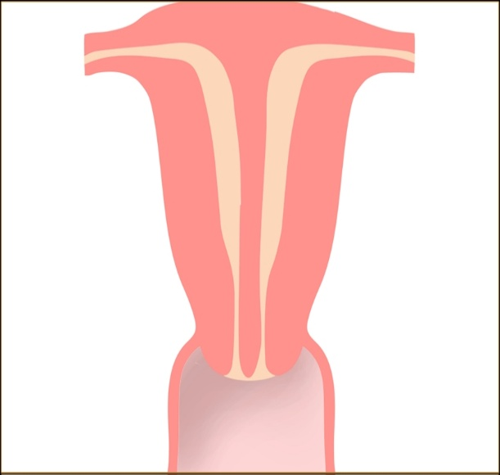

INTRODUCTION
Fusion anomalies of the uterus result in variety of uterine shapes and increased incidence of miscarriages, poor fetal growth, malpresentations, abnormal placental adherence. The prevalence of mullerian anomalies in general population is 1 – 3 %¹. Because of better availability of diagnostic modalities that is transvaginal sonography, hysterosalpingography, 3D,4D USG, MRI and hystero-laparoscopy, better detection of such anomalies is possible. Reproductive outcomes can be improved with better treatment modalities, but generally poor reproductive performance prevails. The abnormality consists of a single uterus divided by a largely fibrous midline septum¹. Although there is some evidence of a weak genetic factor at work, researchers still do not know the exact cause of the failure of a septum to resorb¹.

Figure 1- SEPTATE UTERUS

PRESENT CASE

HISTORY
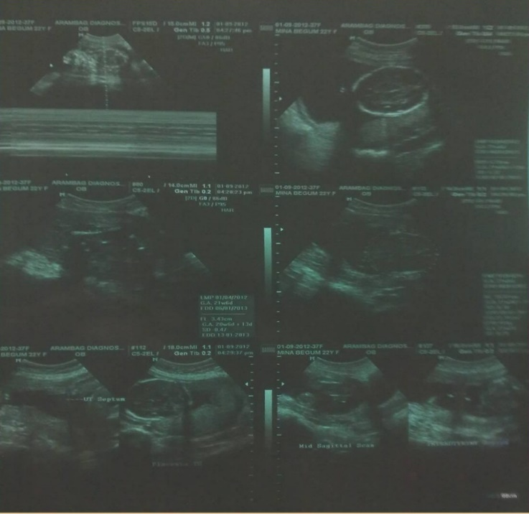
Mrs. MK, 22 years, primi, married for 3 years, treated for infertility by homeopath, term by LMP and early USG, antenatal investigations within normal limits showed an abnormality in USG, ultrasonographic finding being single live fetus, placenta- grade iii maturity left lateral wall, BPD- 5.19 cm, AC- 16.61 cm, FL- 3.43 cm, AGA- 21 W 2 D, EFW- 218 G with an intrauterine septum found.

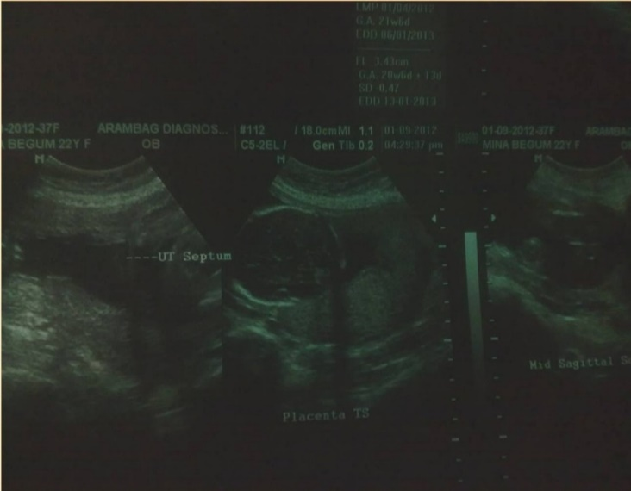
Figure 2- USG at 22 weeks gestation

Figure 3- Intrauterine septum found.

MANAGEMENT
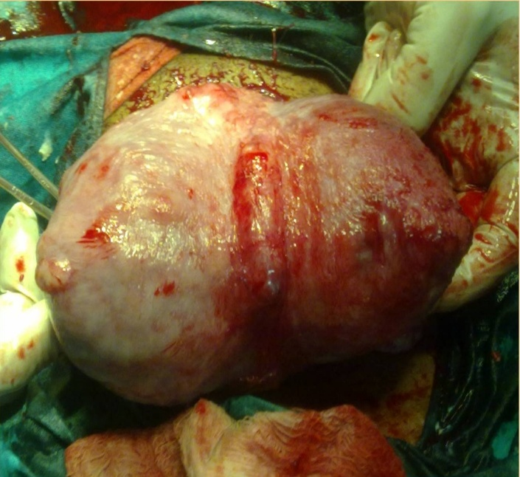
Pregnancy was followed up to term by monthly USGs. Elective LUCS was done. Baby was in breech presentation, placenta removed, an intrauterine septum was found extending from fundus to internal os and baby was in left compartment of the septum. A healthy 2.6 kg male baby was born.
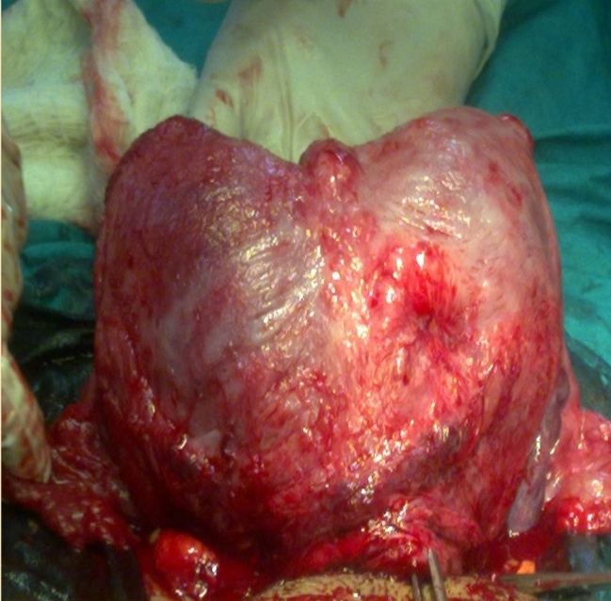

Figure 4 and 5 – Intraoperative finding of septate uterus- external surface.

DISCUSSION
This case is a rare case where pregnancy continued up to term without any complications, without prenatal diagnosis of the uterine septum and therefore without any specific management. But most pregnancies with septate uterus end up dishearteningly with miscarriages. Promising treatments of septate uterus and successful pregnancies are on rise now.
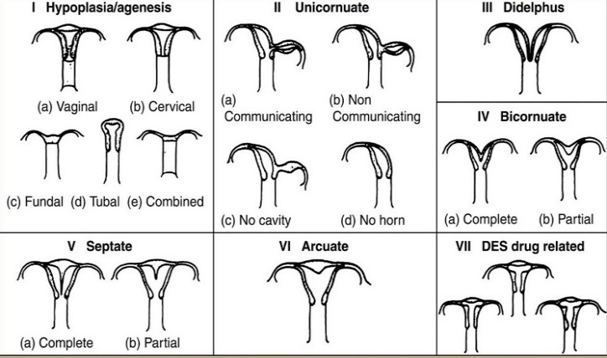
ABNORMALITY
A septate uterus is a type of congenital uterine anomaly. It is classified as a class V Mullerian duct anomaly2. It is considered the commonest uterine anomaly (accounts for up to ~ 55% of such anomalies) and is the most common anomaly associated with reproductive failure (in 67%)3. It is considered a type of uterine duplicational anomaly and results from partial or complete failure of resorption of the uterovaginal septum after fusion of the para-mesonephric ducts.
Figure 6- AFS Classification of Mullerian anomalies⁴.

The septum is usually fibrous but can also have varying muscular components. The external uterine contour may be convex, flat, or mildly (< 1cm) concave3. The sub types are: complete septum extends to internal os : septate uterus, partial septum involves endometrial canal but not cervix : sub-septate uterus ,septum extends into the vagina : septate uterus and vagina5. Early miscarriage is common within the septate uterus, because the blood-starved median septum is covered by a poorer grade of endometrium than that of the blood-rich sidewalls. An embryo implanting in the septum frequently fails to thrive because of lack of nourishment, and an early miscarriage is the result. Late miscarriage is also common, where the pregnancy outgrows available space and the cervix may give way, typically midway in the pregnancy, before the fetus is mature enough to survive.

RADIOLOGICAL DIAGNOSIS

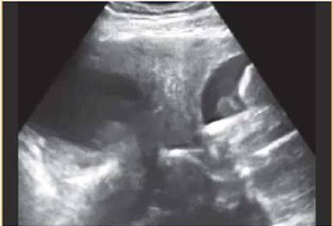
On ultrasound, the echogenic endometrial cavities are separated at the fundus by the intermediate echogenicity of the myometrium in all cases of complete septa and within the fundal part only in partial septa6.

Figure 7- USG showing thick intrauterine septum.

The external uterine contour must demonstrate a convex, flat, or mildly concave (ideally no more than 1cm) configuration and may best be appreciated on transverse images of the uterus. Colour Doppler may show vascularity in the septum in 70% of cases: and if present may be associated with a higher rate of obstetric complications. Fluoroscopy – Hysterosalpingogram -accuracy of alone is only 55 % for differentiation of septate from bicornuate uteri. An angle of less than 75° between the uterine horns is suggestive of a septate uterus, and an angle of more than 105° is more consistent with bicornuate uteri. MRI is considered the imaging modality choice in modern radiological practice. On MR images, the septate uterus is generally normal in size and each endometrial cavity appears smaller than the configuration of a normal cavity. The septum may be composed of fibrous tissue (low T2 signal intensity), myometrium (intermediate signal) or both.
DEFINITIVE TREATMENT
The distinction between septate uterus and bicornuate uterus has important management implications. In septate uterus, but not in bicornuate uterus, the septum can be shaved off during hysteroscopy (metroplasty) to form a single uterine cavity without perforating the uterus. Reproductive outcome has been shown to improve after resection of the septum, with reported decreases in the spontaneous abortion rate from 88 to 5.9% after hysteroscopic metroplasty7. One of the heartening aspects of having a septate uterus is that it can be repaired through a relatively simple surgery, giving the woman near-normal odds of carrying a subsequent pregnancy to term. Until the mid-1980s, surgery to reduce a septum, called a metroplasty, was done through an abdominal incision. Recent development of the hysteroscopic metroplasty (also known as "septoplasty") has rendered the former technique almost obsolete8. Removal of the septum during caesarian section- to do or not to do is a question that still needs to be answered. Some authors believe that during caesarian section septum should be kept intact in view of the excess bleeding that can occur during this procedure.
CONCLUSION
This report represented a case of a live birth baby delivered from a completely septate uterus without any prior intervention. Though this is possible in a few cases(miracle), most cases of septate uterus need treatment prenatally which will successfully enhance their reproductive outcome. Better diagnostic and treatment facilities have accomplished this purpose.
REFERENCES
1. Heinonen PK. Complete septate uterus with longitudinal vaginal septum. Fertil Steril. 2006 Mar;85 (3): 700–5.
2. Propst AM, Hill JA 3rd. Anatomic factors associated with recurrent pregnancy loss. Semin. Reprod. Med. 2000;18 (4): 341–50.
3. Creasy RK, Resnik R. Maternal-Fetal Medicine: Principles and Practice. Philadelphia: W.B.Saunders. 1994; 447. ISBN 0-7216-6590-X.
4. Rackow B.W. and Arici, A. Reproductive Performance of Women with Mullerian Anomalies. Current Opinion in Obstetrics and Gynecology.2007 Jun; 19(3), 229-237.
5. Buttram VC, Gibbons WE. "Müllerian anomalies: a proposed classification. (An analysis of 144 cases)". Fertil. Steril. 1979 Jul;32 (1): 40–6.
6. Woelfer B, Salim R, Banerjee S, Elson J, Regan L, Jurkovic D. Reproductive outcomes in women with congenital uterine anomalies detected by three-dimensional ultrasound screening. Obstet Gynecol. 2001 Dec;98 (6): 1099–103.
7. El Saman AM, Nasr A, Tawfik RM, Saadeldeen HS. Müllerian duct anomalies: successful endoscopic management of a hybrid bicornuate/septate variety. J Pediatr Adolesc Gynecol. 2011 Aug;24(4):e89-92.
8. El Saman AM, Shahin AY, Nasr A, Tawfik RM, Saadeldeen HS, Othman ER, Habib DM, Abdel-Aleem MA. Hybrid septate uterus, coexistence of bicornuate and septate varieties: a genuine report. J Obstet Gynaecol Res. 2012 Nov;38(11):1308-14.
Received: 23.05.2022
Accepted: 30.05.2022
Published: 15.07.2022
Citation: Das S, Sarkar S, Mondal A. Successful pregnancy outcome in a septate uterus: A case report. J Indian Acad Obstet Gynecol. 2022;3(2):26-29.
1,2 Assistant professor, 3. Resident medical officer
Dept of Gynecology & Obstetrics, COMJNM & Hospital, Kalyani, Nadia
 Mail: sourav_burdwan@yahoo.com

Journal of Indian Academy of Obstetrics and Gynaecology July 2022
Vol. 4, Issue 1

Case Report

A CASE OF SEIZURE DISORDER (NEUROCYSTICERCOSIS) IN PREGNANCY

Sanjyot Patil ^{1*}, Vasundhara Singh ², Chaitali Sarkar ³, Ranita Roy Chowdhury ⁴, Manidip Pal⁵

ABSTRACT
Neurocysticercosis (NCC) is rare in pregnancy and is associated with one third of seizure disorder in endemic areas. The present case report is about the successful Fetomaternal outcome in a known case of NCC. She was irregularly on antiepileptic medications and admitted in emergency with episodes convulsion. Subsequently she was discharged after stabilization and later had an uneventful vaginal delivery after about a month.
KEY WORDS: neurocysticercosis, seizure disorder, pregnancy

INTRODUCTION
Neurocysticercosis, a rare disorder during pregnancy, is caused by larva of Taenia solium parasite, the infection most probably is caused by consumption of uncooked or partially cooked pork infested with these larvae. This affects the central nervous system (CNS) predominantly. This disorder is endemic in Asian countries like India, China, Nepal ^{1,2}. Neurocysticercosis (NCC) is associated with nearly one-third of seizure disorders in endemic areas and an estimated 50 million people worldwide have the infection ³.
CASE

A 20 years old housewife, resident of Gopiballavpur, Kalyani, 2nd gravida, having a non-consanguineous marriage, belonging to lower socioeconomic class had attended Emergency Room of the hospital on 05/04/2022 at 11AM with chief complaint of 2 episodes of self-terminating fits on the same morning, each episode lasting for 10-15 minutes, preceded by headache and dizziness. The patient had a history of 7 months of amenorrhea.
Patient had menarche at 13 years of age. She used to have irregular menstrual cycle where bleeding lasting for 4-5 days every 32 days with mildly painful moderate flow.
Her last menstrual period (LMP) was on 31/08/2021 and expected date of delivery was on 07/06/2022.
No history of use of contraceptive measures.
Patient was married for 4 years, G₂ T₀ P₀ A₁ L_{0.}
She has a history of abortifacient intake at 5 weeks of gestational age 1 year back for which dilatation and evacuation (DnE) was done.
Patient has history of similar episodes of seizures occurring since last 5 to 6 years at irregular intervals. Each episode usually used to last for 15 minutes preceded by headache and giddiness. She used to experience stiffness all over her body occurring during fits, followed by disorientation, confusion and forgetfulness with recent memory loss. She is a known case of Neurocysticercosis diagnosed by medical professional having history of partially uncooked pork consumption since childhood. She was put on tab. Phenytoin (100) OD since then by the treating physician and tab. Albendazole (400) TDS for one month as per shown by patient. No history of diabetes mellitus/ hypertension/tuberculosis or any heart disorders.
History of 2 to 3 similar episodes of fits experienced by her father for which he was taking an unknown medication. No history of hypertension/ diabetes mellitus or any psychiatric disorder in family. Patient experienced decrease sleep due to continuous headache and giddiness. Bladder-bowel habits were normal. No history of alcohol or tobacco consumption.
She conceived spontaneously after 4 years of marriage and her last menstrual period was on 31st August 2021. Pregnancy was detected after 4 months of amenorrhea i.e. at 21 weeks 5 days of gestational age. Till then as the pregnancy was unknown, she was consuming her previous medications i. e. tablet phenytoin irregularly and after the pregnancy detection, it was stopped but no other antiepileptic was started for her. Fetal anomaly scan showed intrauterine single life pregnancy of 21 weeks of gestation age with no gross congenital anomalies. Patient was unbooked with no ANC follow up. She was not consuming Iron folic acid or calcium tablets during pregnancy. Just received one dose of intramuscular injection tetanus. Pregnancy was uneventful till 31 weeks of gestation age when patient sought medical care for 2 episodes of generalised tonic clonic seizures. On admission, pulse BP and all other vitals were within normal limits.
The patient was immediately started on Injection Magnesium sulphate 4 gm 20% intravenous with 10 gm 50% deep intramuscular as Loading dose Followed by maintenance dose of 5 gram 50% 4 hourly deep intramuscular in alternate buttocks for 24 hours. Urine output, respiratory rate, deep tendon reflexes were within normal limits up to the last dose but her last dose was omitted due to absent of knee jerk. Serum Mg⁺⁺ levels were found to be 2.0 mg/dl. She was consuming Tablet Phenytoin irregularly in spite of omitted by medical practitioner earlier, that was stopped. She was then shifted on tablet Leveteracetam 500 OD and was given propped up position as per advised by general medicine department of the hospital. The foetus being pre-term, injection dexamethasone 12 mg 2 doses 24 hourly were initiated. Patient and her relatives were counselled for high-risk pregnancy and undetected congenital fetal anomalies which might be present due to Tablet phenytoin consumption during organogenesis period.
Her MRI brain was done on very next day on 06/4/2022 after stabilizing the patient. MRI showed classical appearance of multiple rings enhancing lesions all over her brain. Advice from medicine department was taken. They suggested to complete her corticosteroid doses and no Anti-Helminths were introduced at this point. EEG electroencephalogram was done on 07/04/2022 which showed no abnormalities. Ophthalmoscopic fundal examination was done by ophthalmology department on 07/04/2022 showing no signs of papilledema or hypertensive retinopathy. Routine blood reports showed no abnormalities which were as follows:

CBC
Haemoglobin | 8.9 | gm/dl
WBC | 11,000 | mm³
Neutrophils | 70 | %
Lymphocytes | 25 | %
Monocytes | 04 | %
Basophils | 00 | %
Eosinophils | 01 | %
Platelet | 4.2 L | mm³

Liver Function Test (LFT)
SGPT | 40 | IU/L
SGOT | 38 | IU/L
ALP | 140 | IU/L
Bilirubin Total | 0.7 | mg/dl
Direct | 0.4 | mg/dl
Indirect | 0.3 | mg/dl

Renal Function Test (RFT)
Blood urea | 13 | mg/dl
Creatinine | 0.3 | mg/dl

CRP | 8.0 | mg/dl
Serum Na⁺ | 138 | mmol/L
Serum K⁺⁺ | 4.0 | mmol/L

Arterial Blood Gas ABG analysis was done on the same day. It showed decreased level of arterial K⁺ and Ca⁺⁺ For which she was started on injection Calcium gluconate 10% 10 mg intravenously and injection KCl via intravenous route. Serology such as HbsAg, Anti HCV, VDRL, HIV 1 and 2 were non-reactive.
Serial Antenatal ultra-sonographies for fetoplacental profile were done. USG on 09/04/22 showed Single live Cephalic foetus with maturity of 30 weeks 5 days, placenta anterior grade 2 AFI 10 cm, liquor adequate, colour doppler within normal limits, FHB 142 bpm, FWT 1665 grams.
Patient was stabilised and was hospitalised for 10 days in ICU after that we planned her discharge with USG (13/4/2022) showing single life Cephalic foetus with maturity of 29 weeks 6 days, FHB 142 bpm, FWT 1492 grams, placenta anterior grade 2, liquor adequate, AFI 7 cm., colour Doppler within normal limits. Patient was advised to continue tablet Levetiracetam and keep noticing for daily fetal movement count and was also advised to follow up regularly in ANC clinics which she did. She was referred to a superspeciality hospital with neurology unit for further management after discharge.
Patient had an uneventful normal vaginal delivery with episiotomy on 16/05/22 of baby girl with weight 2215 grams. 1 min and 5 min APGAR scores of the baby were 9 and 10 out of 10 respectively. No congenital anomalies noted and required no SNCU admission. Baby was administered injection Vitamin K dose and the birth doses of Hepatitis B, Polio (OPV), BCG vaccines. Exclusively breast feeding was started immediately after the delivery. No episode of post-partum haemorrhage was noted.
This was the case of neurocysticercosis in pregnancy where symptoms were successfully controlled with antiepileptic agents. Cyst eradication therapy was avoided due to potential worsening of symptoms which would have posed a threat to both mother and foetus.

DISCUSSION

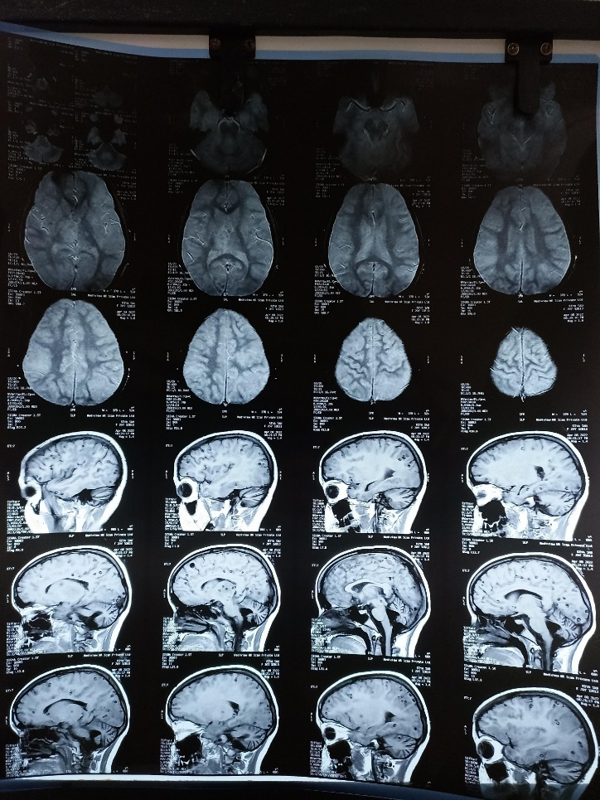
Most pregnancies in women with NCC are associated with good pregnancy outcomes and there is no study suggests that maternal NCC itself causes fetal malformations or brain damage. However, sustained seizures may pose a major risk to the foetus due to hypoxia ⁴. The drugs like Valproate, though may have the risk of congenital malformations specially if consumed during organogenesis period but not always⁵. This patient too had episodes of convulsions in the antenatal period and the possible explanation is likely due to irregular intake of antiepileptic drugs. This in turn might have avoided the anomalous transformation in the foetus. Follow up and management during pregnancy can be challenging, but prompt interventions are crucial for better maternal and foetal outcomes. Women with new onset seizures between the second trimester and the postpartum are often considered to have Eclampsia. However, in the absence of high blood pressure or other signs of preeclampsia, a differential diagnosis must be suspected and neuroimaging should be advised particularly for women at risk of transmission specially those who are residents of endemic area. Appropriate history taking especially family history and personal history are the key factors for suspecting the diagnosis of NCC. Antiepileptic medications such Leveteracetam which are safer in pregnancy, should be started to avoid seizure recurrence during pregnancy for the wellbeing of mother and her baby.

CONCLUSION

Neurocysticercosis is a very rare disorder in pregnancy. Diagnosis depends on a high degree of suspicion. Management is difficult and prognosis is guarded especially in patients with recurrent convulsions leading to fetal hypoxia. However, it is a relief that NCC in pregnancy is associated with good feto- maternal outcome.

MRI plates of the patient (07/04/2022)
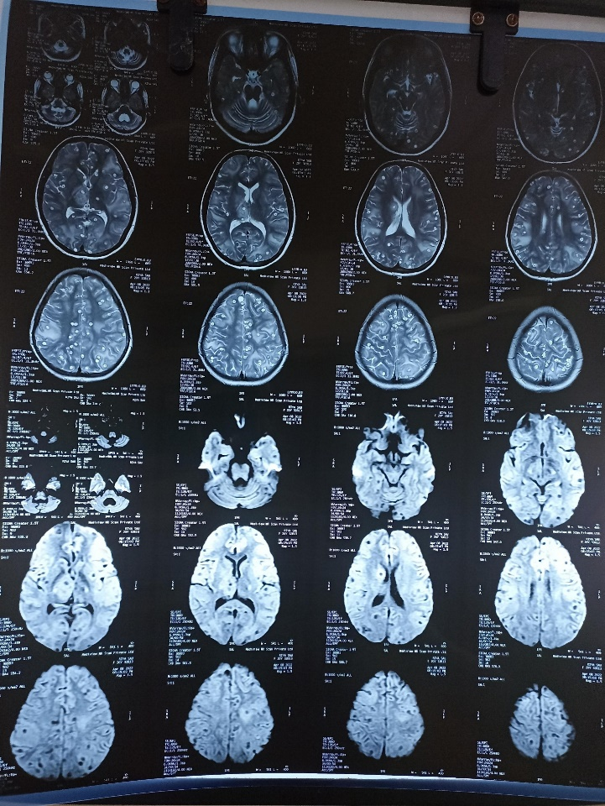

REFERENCES and REVIEW OF LITERATURE

1. Coyle C M, Mahanty S, Zunt J R et al. Neurocysticercosis: neglected but not forgotten. PLoS Negl Trop Dis. 2012;6(05): e150.
2. Garcia H, Coyle C, White A., Jr. Philadelphia: Elsevier-Saunders; 2011. Cysticercosis; pp. 815–823.
3. Budke C M, White A C, Jr, Garcia H H. Zoonotic larval cestode infections: neglected, neglected tropical diseases? PLoS Negl Trop Dis. 2009;3(02): e319.
4. Gardner E, Chang M, Mancuso P, Chaney S E. Neurocysticercosis in pregnancy: not just another headache. Nurs Woman’s Health. 2012;16(02):118–124.
5. Crawford P. Epilepsy and pregnancy Seizure 200211(Suppl A):212–219.

Received: 23.05 .2022
Accepted: 30.06.2022
Published: 15.07.2022
Citation: Patil S, Singh V, Sarkar C, Chowdhury RR, Pal M. A case of seizure disorder (neurocysticercosis) in pregnancy.J Indian Acad Obstet Gynecol. 2022;3(2):30-33.

- Postgraduate Trainee
- Resident medical officer
- Assistant professor
- Associate professor
- Professor
Dept of Obstetrics & Gynecology, COMJNM & Hospital, WBUHS,Kalyani, Nadia
 Mail: sanjyot.patil001@gmail.com

Journal of Indian Academy of Obstetrics and Gynaecology July 2022
Vol. 4, Issue 1
Book Review

Essentials in Gynecology for Undergraduate Medical Students

Manidip Pal

“Essentials in Gynecology for Undergraduate Medical Students” is a textbook of Gynecology for MBBS course written by Prof Snehamay Chaudhuri, published by CBS Publishers and Distributors, New Delhi, ISBN 978-81-239-2601-8.
This book has 36 chapters covering from applied anatomy, development of female genital organs to common major & minor gynecological operations. All the topics taught in MBBS curriculum are been covered. All the chapters are written in a concise but precise manner.
Starting each chapter with a case-based scenario makes the reading interesting. Easy facilitation is provided by factsheets, clinical pearls, key words, self-assessment questions – hence it becomes a very good book for self-directed learning. Topics are made self-explanatory by providing ample illustrations, photographs, tables and flowcharts.
Each chapter’s learning objectives are mentioned at the beginning of the chapter which is a unique quality of this book.
Received: 23.05 .2022
Accepted: 30.06.2022
Published: 15.07.2022
Citation: Pal M . Essentials in Gynecology for Undergraduate Medical Students.
J Indian Acad Obstet Gynecol. 2022;3(2):34

1 Manidip Pal
Professor
Dept of Obstetrics & Gynecology, COMJNM & Hospital, WBUHS,Kalyani, Nadia
 Mail: manidip2b@yahoo.com

Journal of Indian Academy of Obstetrics and Gynaecology July 2022
Vol. 4, Issue 1

Author’s Guidelines

Original quality works only deserves the acceptance. All manuscripts will be reviewed by two anonymous peer reviewers and Editorial members, unless otherwise specified. If the quality is not maintained and subject of work is beyond the scope of this journal, then the Editorial board will not consider the article for publication. Editorial Board’s decision is final.
COVERING LETTER
Covering letter should clearly mentioned that this article is not been submitted elsewhere for publication. If more than one author, then each author’s contribution should be quantified properly. All authors must approve the content of the article. Research work should have approval of the Ethics Committee of the respective institution, and within the provisions of the Declaration of Helsinki (current version). Everything should be done after obtaining informed consent and identity of the patient & human subject should not be disclosed – these have to be mentioned in the covering letter. All animal experiments should be within the respective country’s National Guidelines. Any conflict of interest, which may arise due to financial assistance or any other kind of help taken, should be informed.

MANUSCRIPTS PREPARATION
Manuscript is to be written in English. Use 12 font size for heading and 11 font size for others, in Times New Roman. Maximum word limit for an ORIGINAL ARTICLE AND REVIEW ARTICLE is 5000, inclusive of everything. The article has to be submitted in A4 paper format with double spaced lining and 30 mm margin all around. Numbering of the pages should be done in Arabic numerals using the ‘Footer’ at right corner; start from the title page. All the new paragraphs are to be indented. Don’t use hyphenation except where the word itself is hyphenated.

caSe rePortS
Interesting and rare cases are to be submitted and these should provide valuable information to the readers. The Case reports, without any significant carry forward message to the readers, will not be considered. Patient’s identification must not be disclosed. Maximum word limit for a case report is 2000.

LETTER TO THE EDITOR
Two types of Letters to the Editor will be accepted –

1) Referencing any article published in the recent past 3 consecutive issues of the Journal of Indian Academy of Obstetrics & Gynaecology.
2) Discourse that illuminates us on the various works on Obstetrics & Gynaecology, and another related arena.
Brief and precise communications are welcomed; maximum word limit is 400 with 1-4 references. Maximum three authors together can send a Letter to the Editor.

STYLE
1) Vancouver system is solicited. For guidance author can look at the International Committee of Medical Journal Editors revised ‘Uniform Requirements for Manuscripts Submitted to Biomedical Journals: Writing and Editing for Biomedical Publication’.
2) Only universally accepted standard abbreviation, acronyms and symbols are accepted. For other abbreviations, write the full form at least once at first use.
3) SI units are to be used for measurements.
4) Only generic names of the drugs are to be written.
5) Variables should be written in italics.

PARTS OF MANUSCRIPTS
The manuscripts should contain the following headings and arranged in this order –
1) Title page
2) Abstract and Key words
3) Text
4) Acknowledgments
5) References
6) Appendices
7) Tables
8) Figures

TITLE PAGE
It should contain –
1) Title of the article which should be precise and contain the major key words
2) Full name of author(s) with surname underlined
3) Designation of author(s)
4) Full address of corresponding author which should include e-mail ID, phone no.
5) Concise title (maximum 40 characters including spaces)

This information, except the title of the article, should not appear in any other part of the manuscript.
ABSTRACT AND KEY WORDS
A structured abstract of 250 words or less is needed for all original articles. The headings are Background/Objectives, Methods, Results and Conclusion. An unstructured abstract of 200 words or less for review article and 150 words or less for Case reports is to be submitted. No abbreviation and references should appear in this stage.
Title of the article should be written on the top and 3-5 key words are to be supplied at the end, in alphabetical order. If any doubt occurs regarding key words, then the help of US National Library of Medicine’s Medical Subject Headings (MeSH) browser list can be taken.

TEXT
It should be written under following subheadings –
1) Introduction
2) Materials & Methods
3) Results
4) Discussion (mention the limitation of the study, if any)
5) Conclusion

Use 12 font size for headings and 11 font size for others, in Times New Roman. Limit the conclusion within few sentences.
ACKNOWLEDGMENTS
Contribution of colleague(s), institution(s), financial and other helps, if any, are to be acknowledged.

REFERENCES
1. Vancouver system is to be followed
2. Number them according to their first appearance in the text by superscripting with Arabic numerals. Tables and figures referencing also should be numbered according to their appearance in the text.
3. Write all the name of the author’s up to six (6) authors.
4. In case of more than six (6) authors, write first three (3) author’s name and followed by et al.
5. Journal’s abbreviation is according to Index Medicus
6. Personal communication and unpublished data should be cited in the text (e.g. Manglem Ch, 2007, unpublished data); not in the references.

Journal
- Frederick J, Fletcher H, Simeon D, Mullings A, Hardie M. Intramyometrial vasopressin as a haemostatic agent during myomectomy. Br J Obstet Gynaecol 1994; 101(5):435-7.

booK
- Shaw RW, Soutter WP, Stanton SL (eds) Gynaecology, 3rd edn. Philadelphia: Churchill Livingstone, 2003.

chaPter in a booK
- Menefeee SA, Wall LL. Incontinence, prolapse, and disorders of the pelvic floor. In: Berek JS (eds) Novak’s Gynecology, 13th edn. Philadelphia: Lippincott Williams & Wilkins, 2002; p 645-710.

WebSite linK
http://www.pfizer.com/files/products/uspi_ gelfoam_plus.pdf. accessed on 25-05-19
aPPendiceS
Abbreviation’s full form is to be written here. If any other kind of appendices are used, those are also to be mentioned here. The consequences should be their appearance in the text.
tableS
- Table should have a small, precise heading.
- Column headings may be supplemented by units, if applicable, in parentheses.
- Full form of the abbreviations should be supplied in the footnote and refer to the table by superscripting a,b,c……
- *, **, *** symbols are reserved for ‘p’ values
Consequences of the tables are according to their appearance in the text and number them in Roman numerals.

FIGURES
Figure means all illustrations (600 d.p.i.) – line drawing as well as photograph. Line drawing should be sharp and well defined. It can be professionally drawn and scanned or drawn on computer graphics. Proper labeling should be done. Photograph can be sent as jpeg file. All illustrations should bear heading at footnote and they should be numbered by Arabic numerals (e.g. Fig.1) according to their appearance in the text. Photograph is, preferably, to be associated with a linear scale or magnification mentioned.

PEER REVIEW
Double blind peer review. All the manuscripts will be peer reviewed by 2 independent peer reviewers. Decision of the manuscript will be communicated to the corresponding authors within 4-6 weeks.
PROOF CORRECTION
After checking, proof will be sent back to the corresponding author by e-mail for resubmission, if any correction needed. In case he/she is not available, then an alternative e-mail ID should be provided.

PUBLICATION
There will be online and print version of the journal. Online version is freely accessible and downloadable to the authors. The corresponding author will receive one hard copy of the journal.

REPRINT REQUEST
Reprints and additional copies are available on request after payment of requisite fees.

Subscription Form

I want to subscribe to Journal of Indian Academy of Obstetrics and Gynaecology.


- Name –
- Qualification –
- Occupation –
- Postal address –
5. -----------------------------------------------------------------------------------------------
-----------------------------------------------------------------------------------------------
-----------------------------------------------------------------------------------------------

Ph No - Whattsapp No - Email ID -

6. Cheque No / DD No Cheque in favor of Indian Academy of
Obstetrics & Gynaecology, payable at Kalyani

Subscription Rate
Journal of Indian  Academy of Obstetrics & Gynaecology | Periodicity | 1 issue | 1 year | 3 years
 | Half yearly | Rs. 200 | Rs. 400 | Rs. 1000
Subscription may increase if the periodicity of the journal increases.


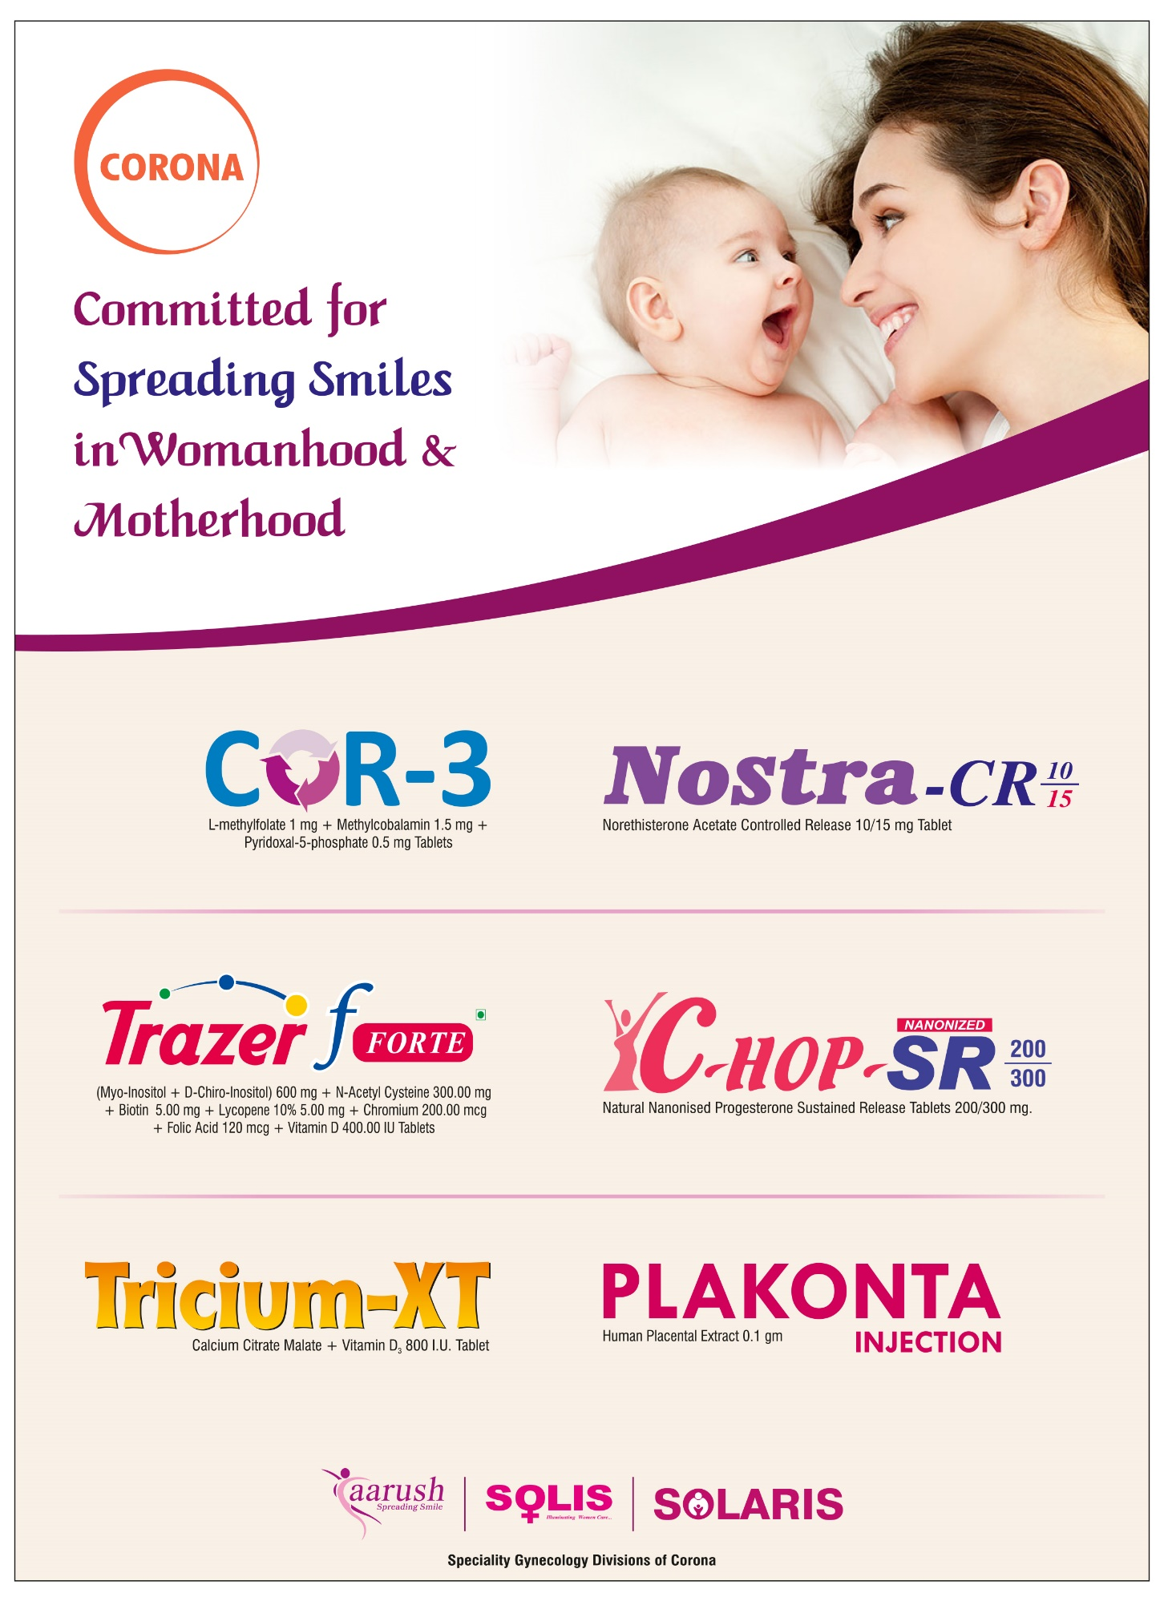

Indian Academy of Obstetrics & Gynaecology
A – 9/7, Kalyani, Nadia, West Bengal 741235 India
Email: jiaog@iaog.in
website: www.iaog.in

